Name Date
Practice A
8.4
Find the area of the figure.
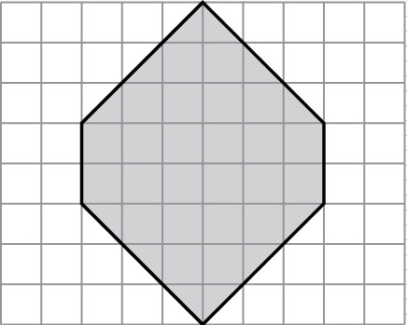
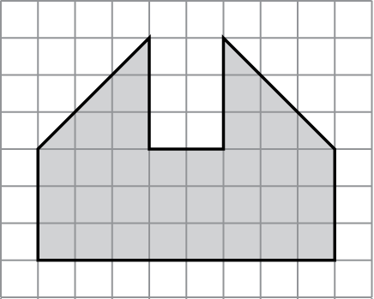
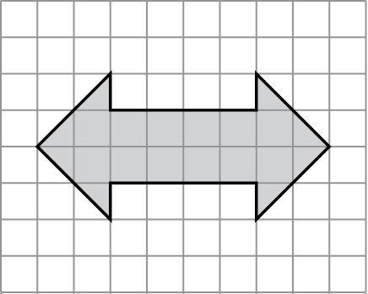
1. 2. 3.
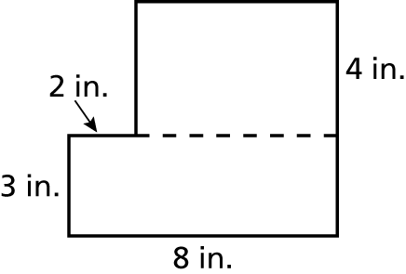
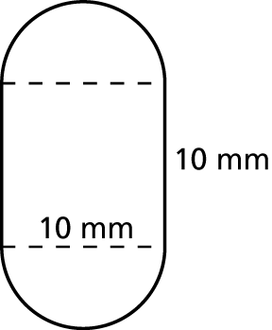
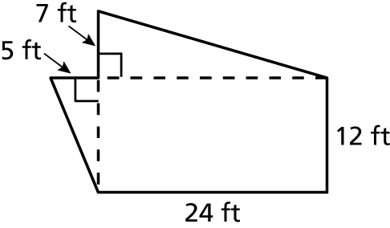
4. 5. 6.
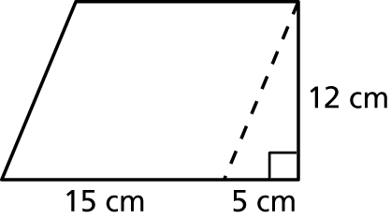
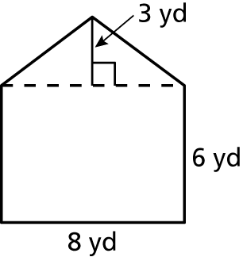
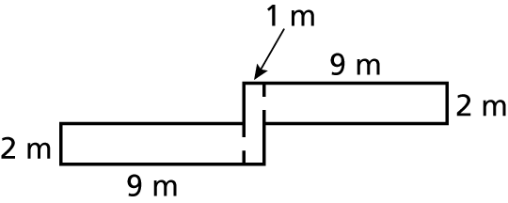
7. 8. 9.
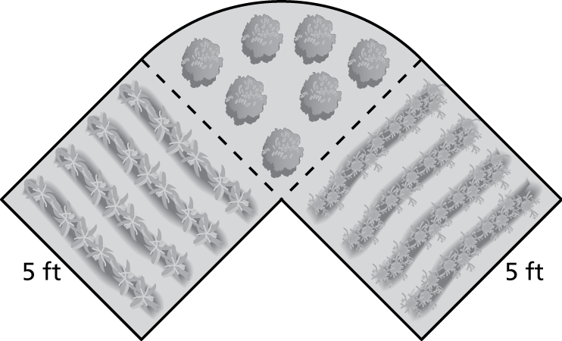
10. A garden is made up of two squares and a quarter
circle. What are the perimeter and area of the
garden?

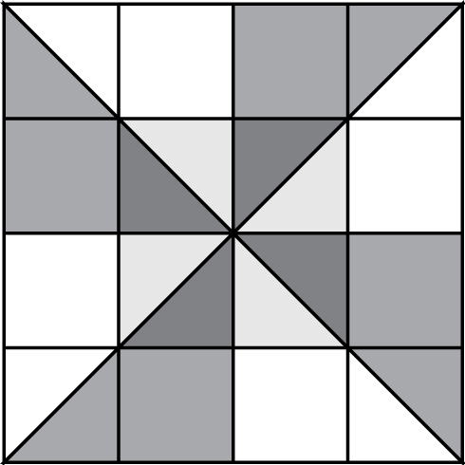
11. A pinwheel design for a quilt is shown at the right.
Each square of the design has a side length of 3 inches.
a. Find the total area of the design.
b. Find the total area of the four large shaded triangles.
c. The quilt will be made of 30 pinwheel designs. The material to make the large triangles costs $0.08 per square inch. How much will it cost to purchase the material to make the triangles for the quilt?
Name Date
Practice B
8.4
Find the perimeter and area of the figure.
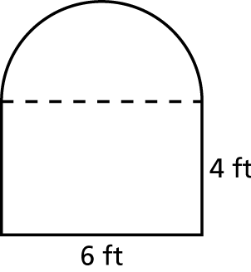
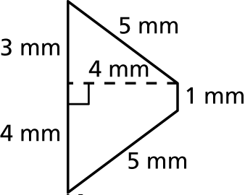
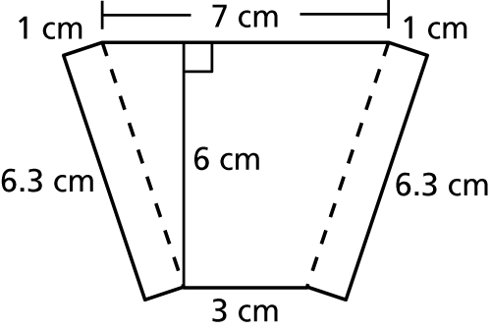
1. 2. 3.
Find the area of the shaded region of the figure.
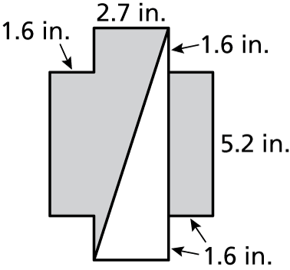
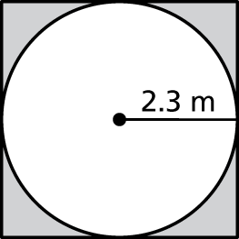
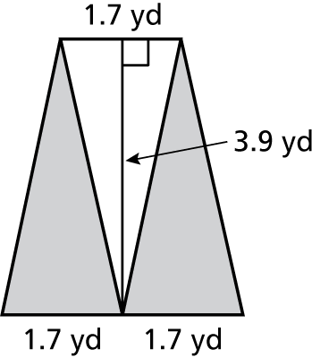
4. 5. 6.
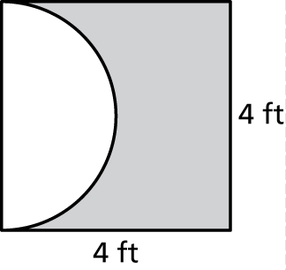
7. Describe and correct the error in finding the area of the
shaded region of the figure.
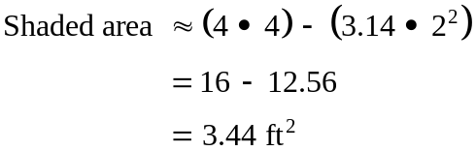

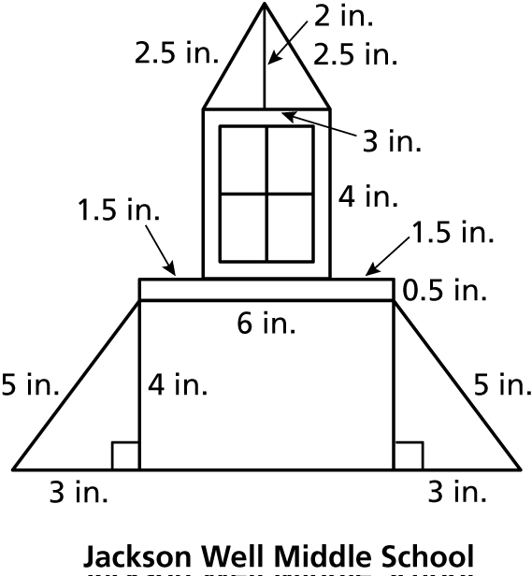
8. Jackson Well Middle School’s logo is shown
at the right.
a. Find the perimeter of the logo.
b. Find the area of the logo.
c. Will the logo fit on a notebook cover
that is 11 inches long and 8.5 inches
wide? Explain.

