Name Date
Practice A
8.2
Estimate the perimeter of the figure.
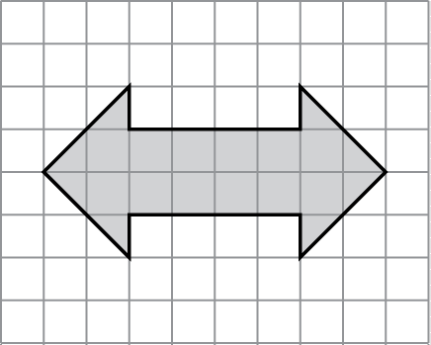
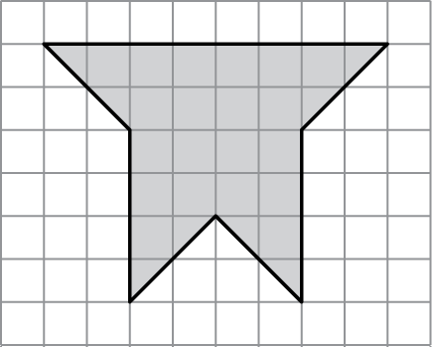
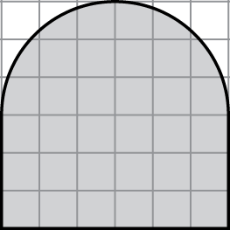
1. 2. 3.
Find the perimeter of the figure.
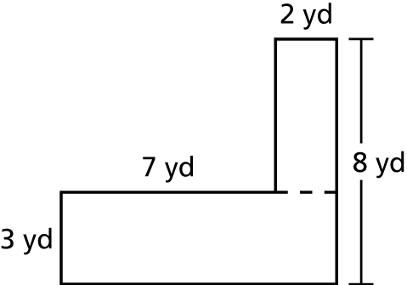
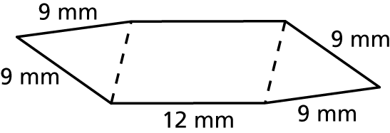
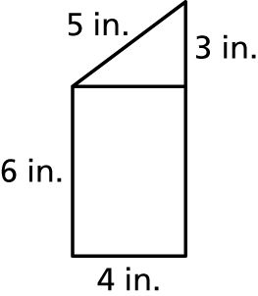
4. 5. 6.
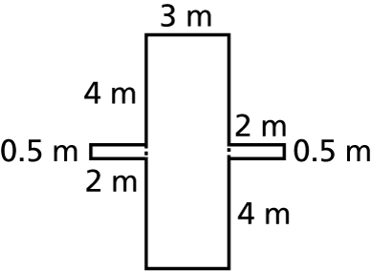
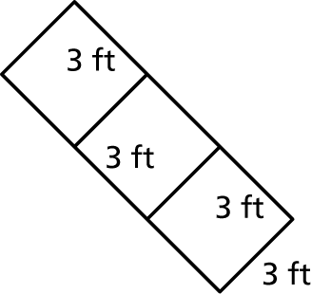
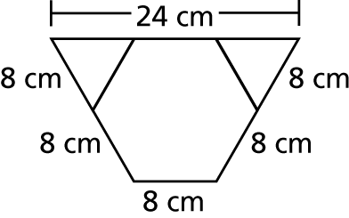
7. 8. 9.
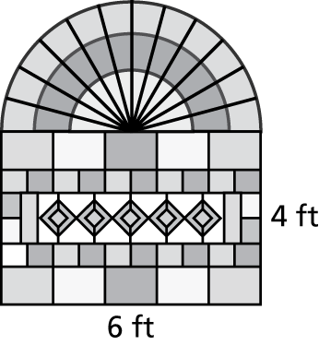
10. A stained glass window has the dimensions
shown. What is the perimeter of the hole
that should be cut in the wall in order for
the window to be installed?
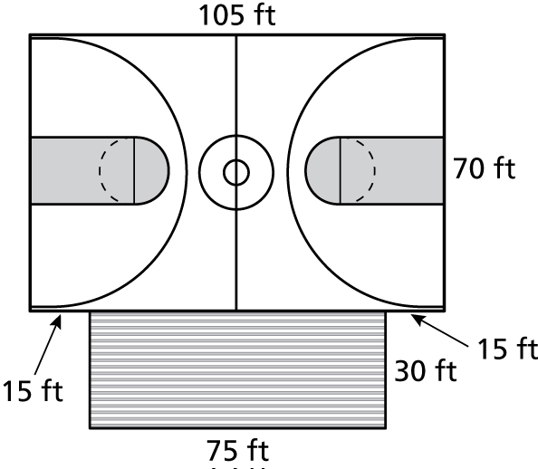
11. The dimensions of a new city park
basketball court are shown at the
right. A fence is to be built around
the court and bleachers. The fence
costs $8.99 per foot. How much will
it cost to install the fence?
Name Date
Practice B
8.2
Estimate the perimeter of the figure.
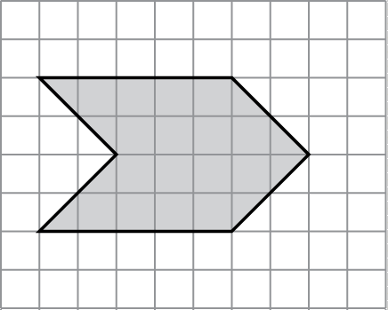
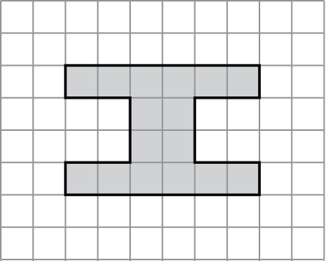
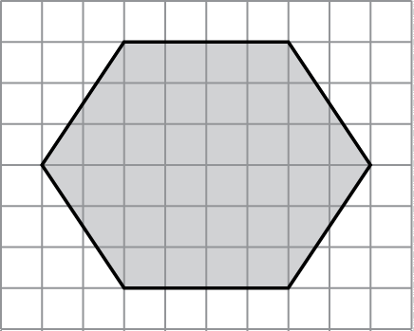
1. 2. 3.
Find the perimeter of the figure.
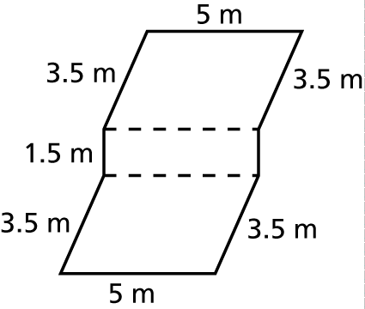
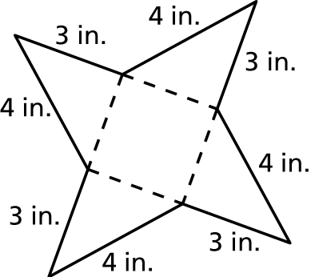
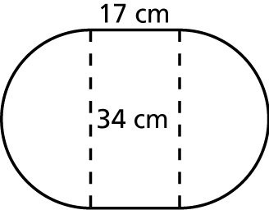
4. 5. 6.
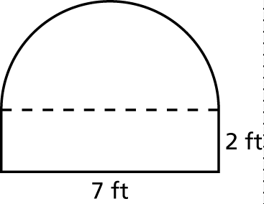
7. Describe and correct the error in finding the perimeter of the figure.
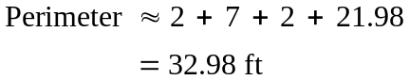
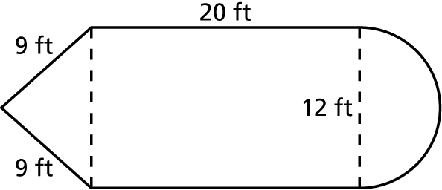
8. A school has a garden in the shape
of a pencil. A fence is to be built
around the garden. The fence costs
$2.75 per foot. How much will it
cost to install the fence?
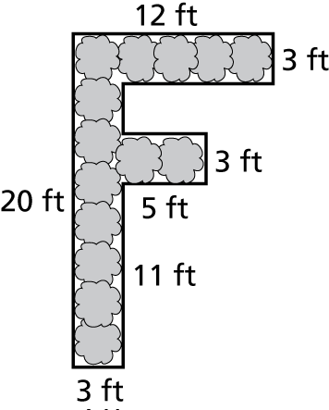
9. A shrub has been cut and trimmed into the shape of an “F.” The owner has hired a landscaper to decrease the perimeter of the shrub by 10 feet. Draw a diagram of how the landscaper might do this. Is there more than one way? Explain.

