Name Date
Enrichment and Extension
10.4
Sandwich Shop
A local sandwich shop is running a sandwich special for lunch. A customer can build his
or her own sandwich using the choices in the table. The customer selects one item from each category.
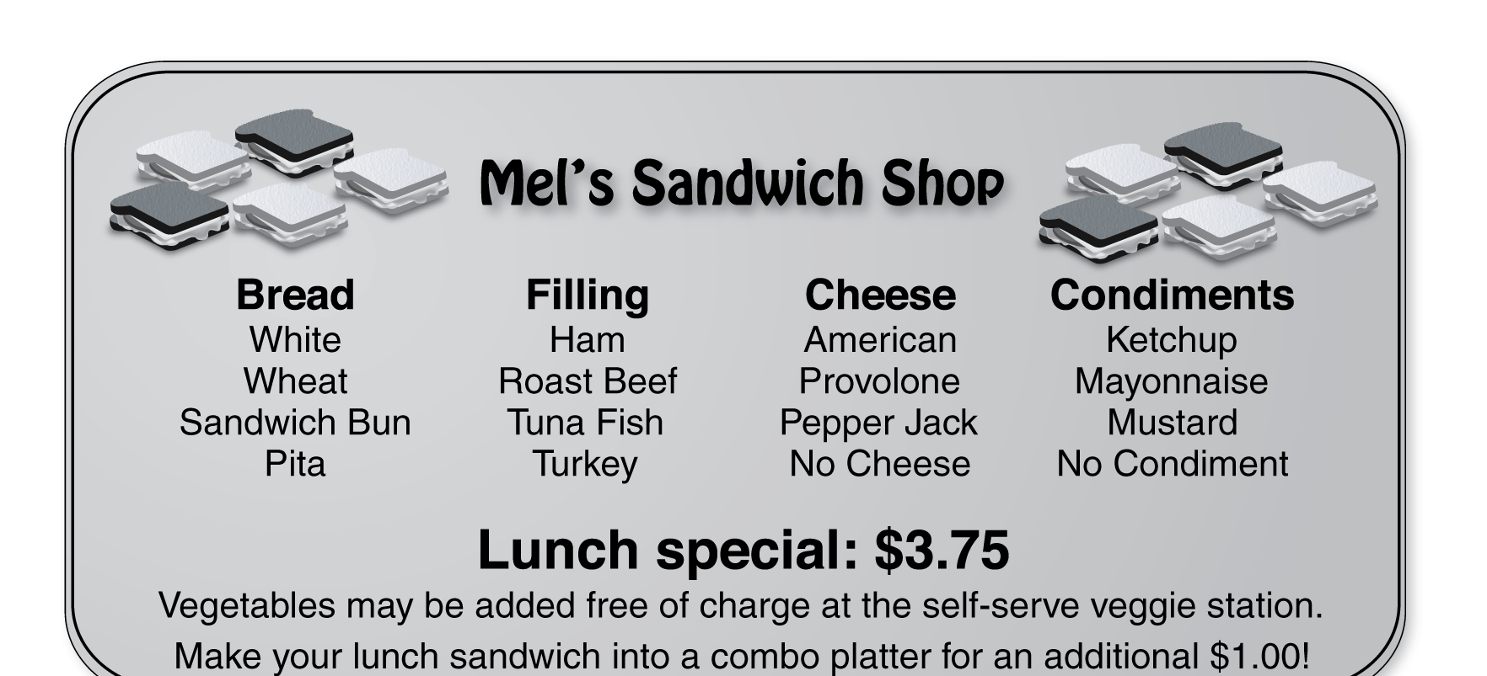
Use the menu board to answer the questions.
1. How many different sandwiches can you make from the choices on the menu board?
2. The sandwich shop has several customers that are vegetarians. In place of the fillings listed on the menu, the sandwich shop uses a vegetable spread on these orders. How many different vegetarian sandwiches can you make from the choices on the menu board?
3. Customers at the sandwich shop have the option of making their sandwiches into combo platters by adding their choice of chips, pretzels, or an apple.
a. How will the addition of the side choices change the total number of combinations calculated in Exercise 1?
b. How many combo platters are possible using the choices on the menu board?
4. A customer orders a ham sandwich on wheat bread. Draw a tree diagram that illustrates the possible sandwiches that could result from the order.
5. What is the probability of a customer ordering a ham sandwich on wheat bread with ketchup and no cheese?

