How to Change Your Apple ID to Your New Email

- Go to iTunes on your computer
- Go to Store, Sign in…
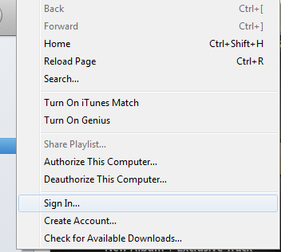
- Sign into your account with your old email and password.
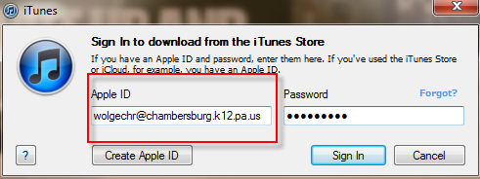
- Go to Store, View My Account
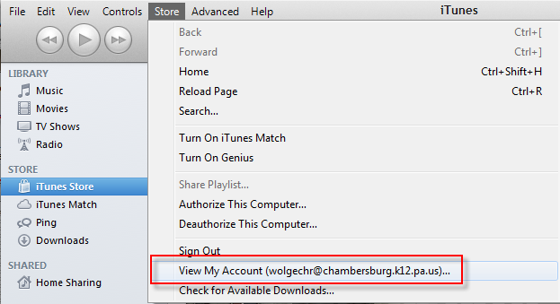
- iTunes will require to you to Sign in again.
- Click on Edit next to your Apple ID
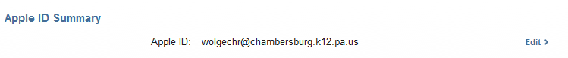
- Enter your new email and click Done
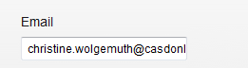
- You will receive a confirmation email. iTunes will prompt you to verify your payment info. Click done and your Apple ID will now be your new email.

