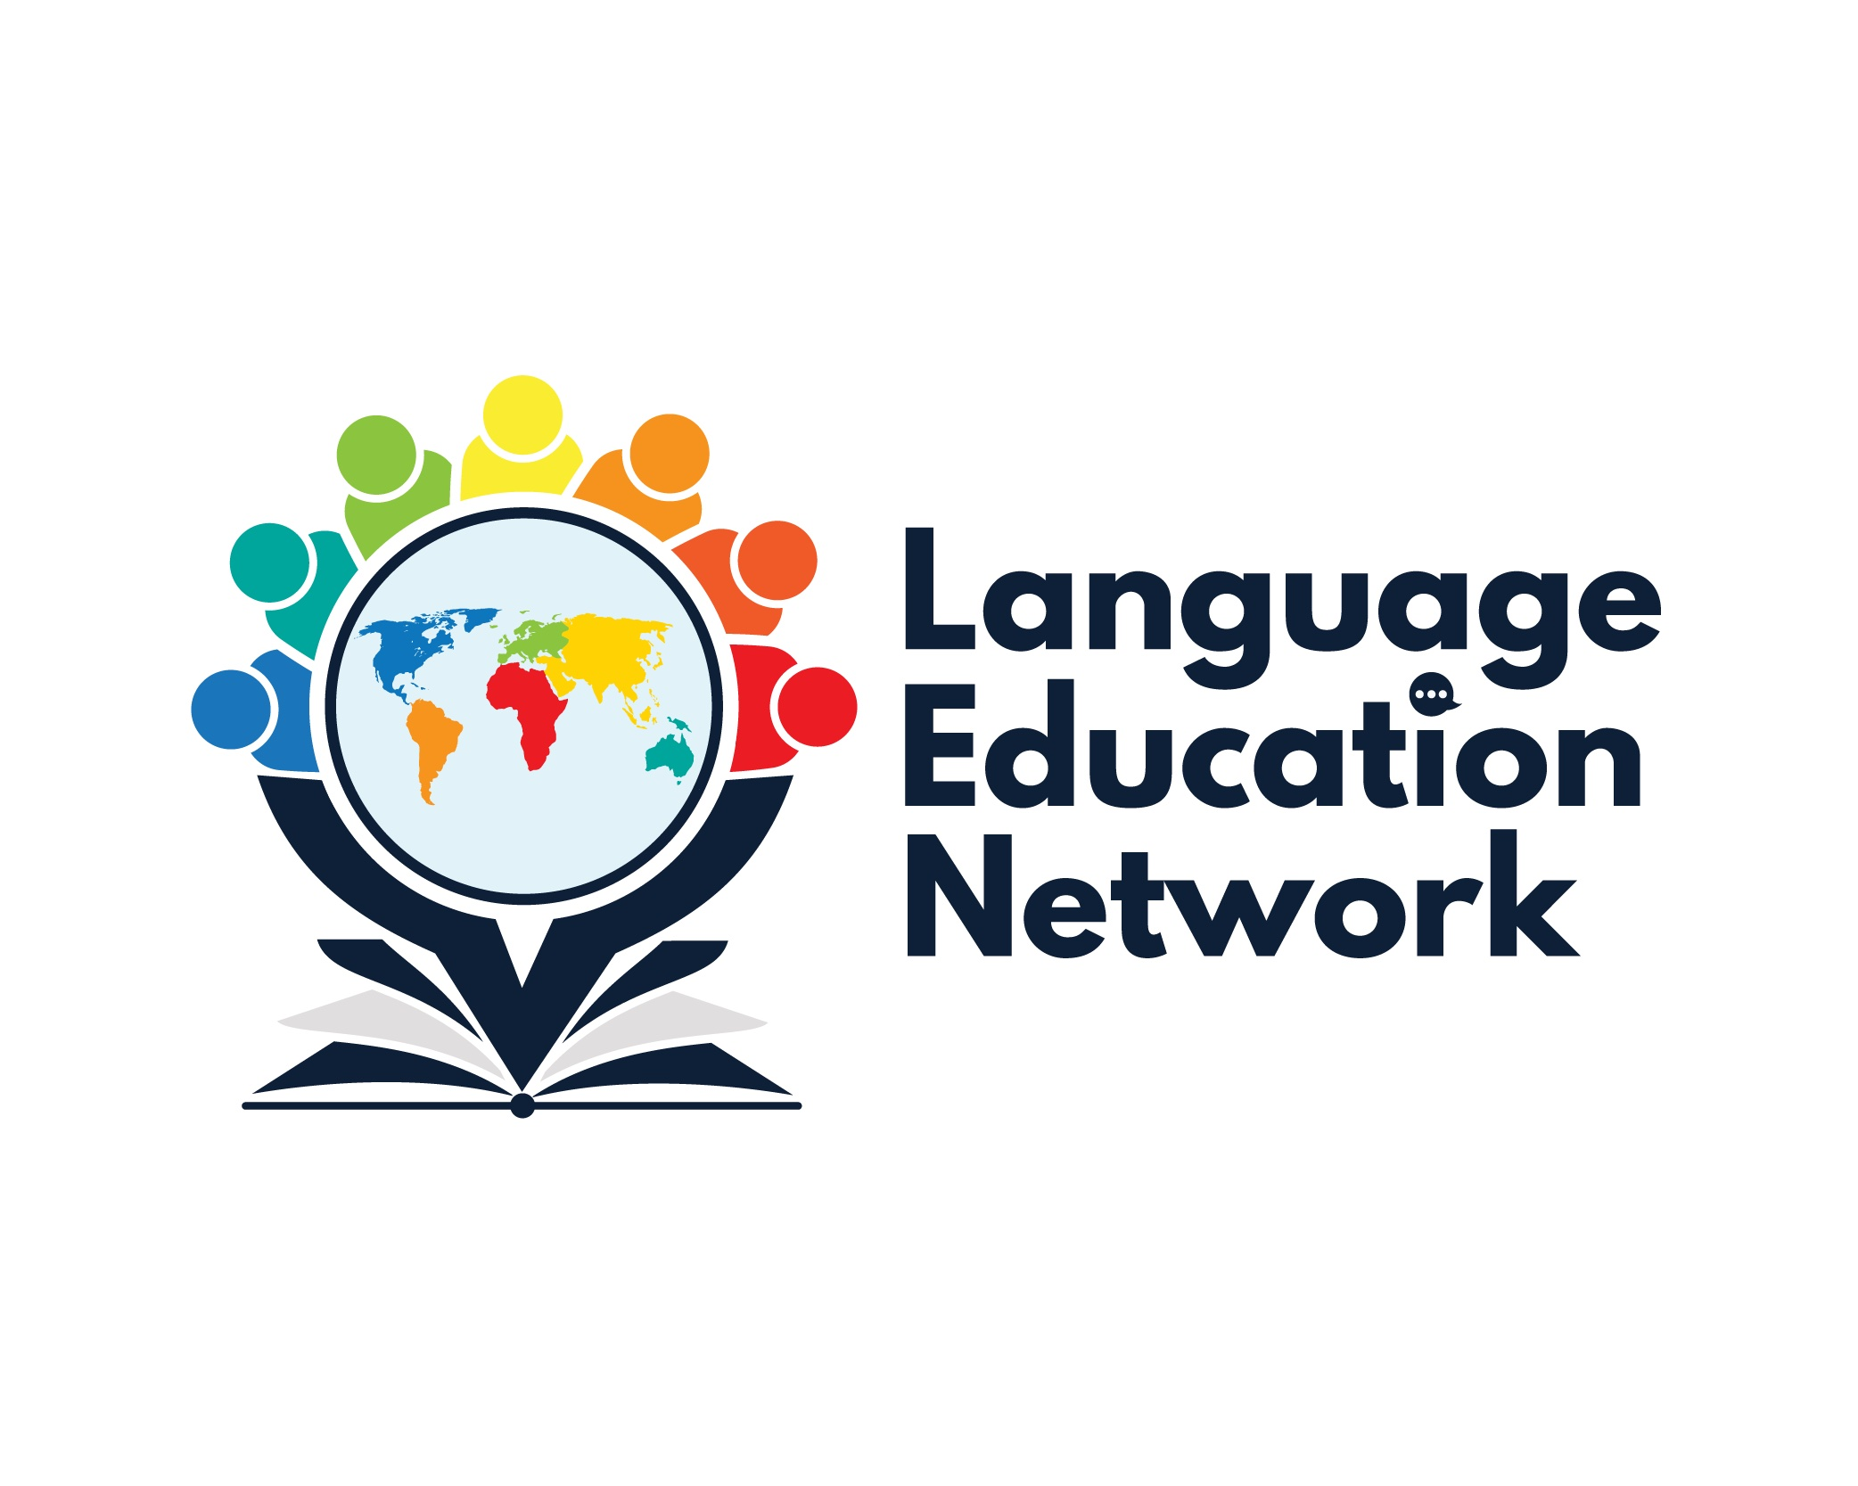

December 15, 2023
1:00 – 2:30 PM
AGENDA

Purpose: The purpose of our network is to come together to align current research and policy with the work that is required to prepare our English learners for college and career.
ZOOM LINK  Passcode: LEN | Facilitators:  Carlos Pagán: cpagan@sbceo.org  Melissa Garcia: mgarcia@sbceo.org

2023-2024 Meeting Dates
(1:00-2:30PM)
- September 8, 2023  - October 26, 2023 (World Languages Day, 8:30-3:30, in-person)  - December 15, 2023  - March 1, 2024  - May 17, 2024 | WELCOME!  ¡BIENVENIDOS!

TOPIC |  | NOTES/LINKS
PROFESSIONAL LEARNING OPPORTUNITIES (Winter-Spring 2024)
- Designated English Language Development  - Integrated English Language Development  - Literacy for Long-term English Learners  - Spanish Literacy – Dr. Jiménez Jiménez  - California Spanish Assessment | Language Education Network
BILINGUAL COORDINATORS NETWORK (BCN) REPORTS & UPDATES
DAY 1: November 30, 2023  - California Multilingual Program Data  - California State Seal of Biliteracy  - California Dashboard – English Learner Progress Indicator (ELPI)  - Educator Workforce Investment Grant (EWIG): Effective Language Acquisition Programs (ELAP)  - ELPAC Updates (Melissa Garcia)  - ELPAC Interim Assessment  - BATALLA DE LOS LIBROS – May 21, 2024  DAY 2: December 1, 2023  - Legislative Update  - Effective Newcomer Tools for Students and Teachers/California Newcomer |  | SBCEO Batalla de los libros webpage
UPDATES & ANNOUNCEMENTS
Bilingual Authorization Program (Approved!)  - Bilingual Authorization Program (BAP)  - Interest Form |  | SBCEO BAP WEBPAGE
INSTRUCTIONAL RESOURCES & PROFESSIONAL LEARNING OPPORTUNITIES
INSTRUCTIONAL RESOURCES:
- EL Toolkit of Strategies
- Designated & Integrated English Language Development Videos
- California ELD Standards
- Multilingual and Multicultural Curriculum Project Grants
PROFESSIONAL LEARNING OPPORTUNITIES:
2024 Scheduled:
- ELPAC Interim Assessments- January 17, 2024
- ELPAC Initial – May 15, 2024

