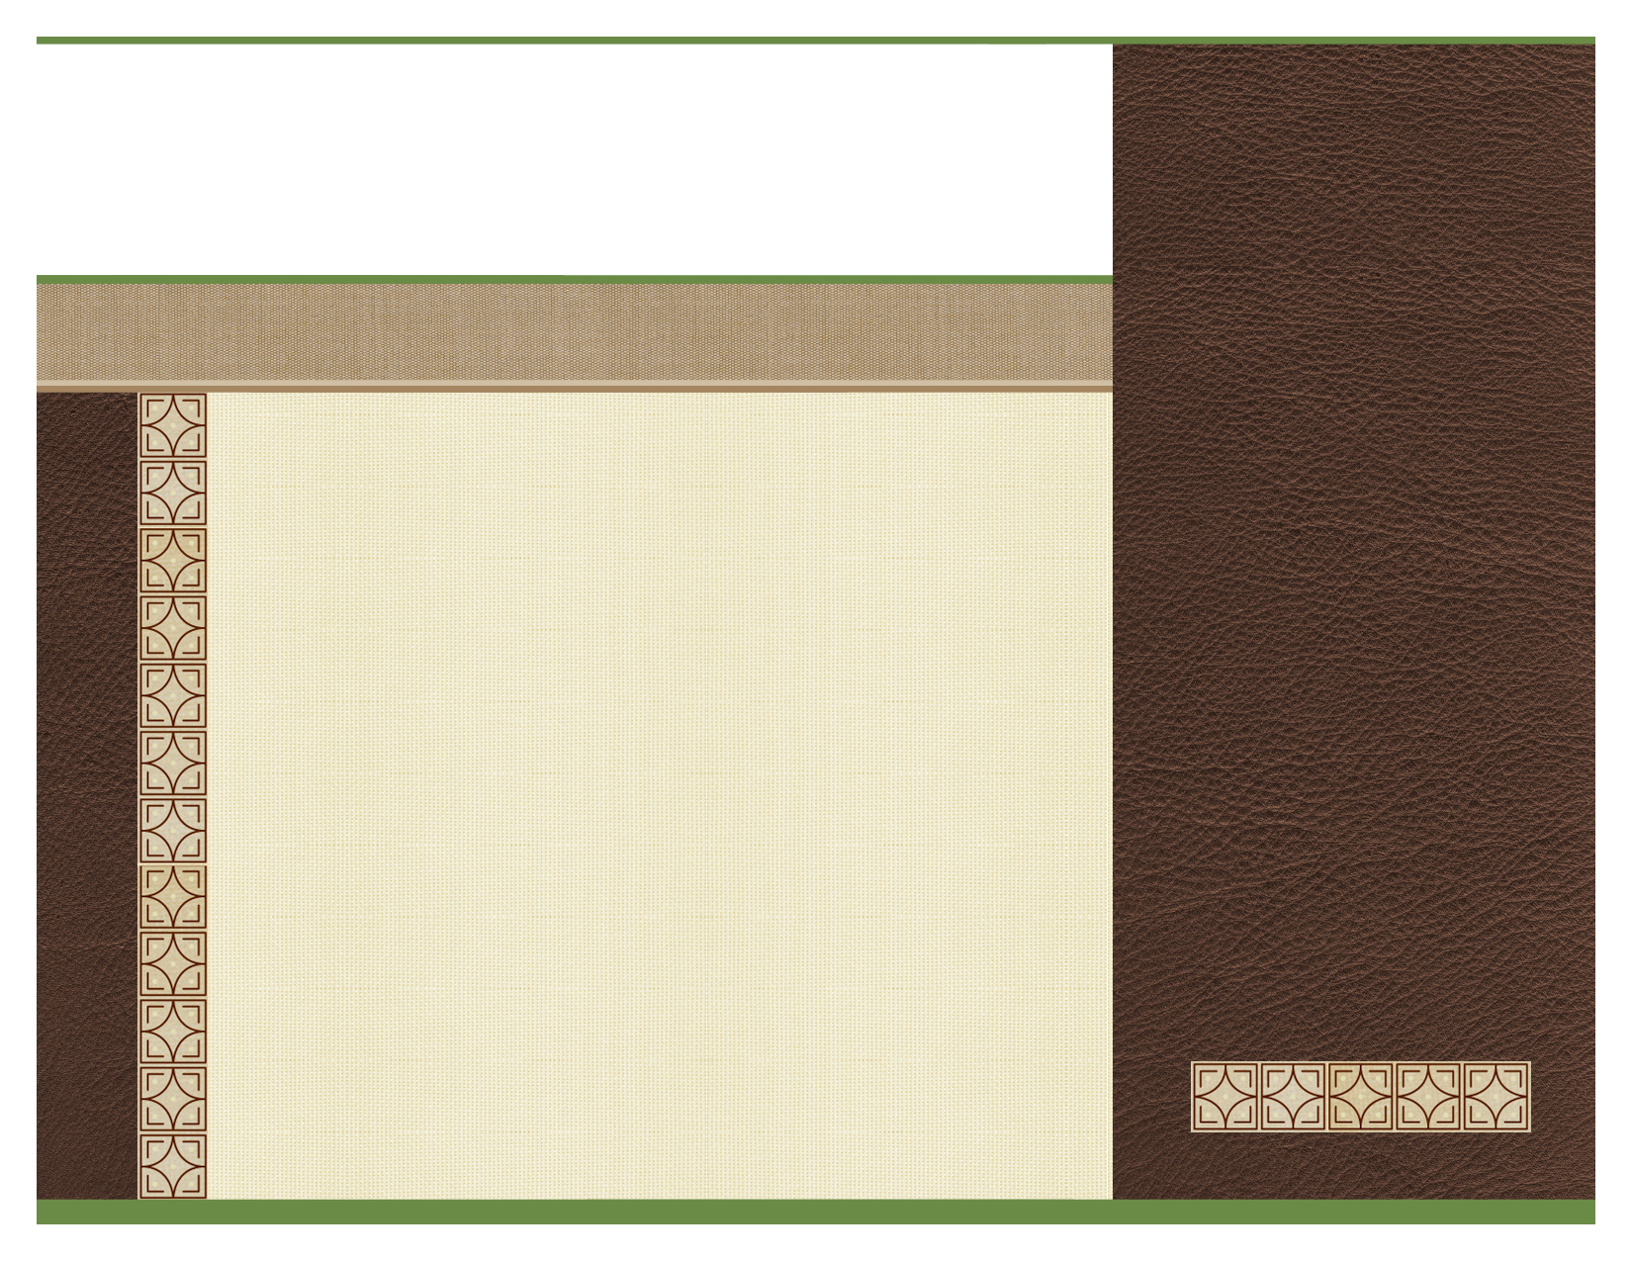

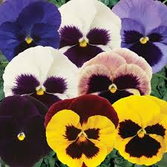

Pansies are one of the most popular and recognizable cool weather annuals. Breeding has produced pansies that are better able to stand up to the cold, but there hasn’t been much luck producing more heat tolerant varieties. Many pansies are bicolored , making them striking plants for their small size.
- Excellent show of color for summer.
- Does well in a container or in the ground.
Plant Spacing:
Space 10-14” (25-36cm) Apart

Grows 10-15” (25-38cm) Tall
by 10-12” (25-30cm) wide

Plant Recommendations:
Avoid wet foliage going into night. Keep well fed for best performance. Occasional cut back will rejuvenate plants.
Special features of this plant:

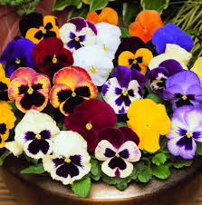

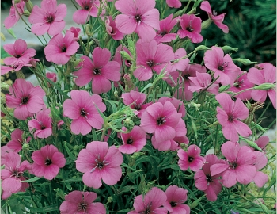
Light Requirement: Plant in Sun (at least 6 hours of sun per day)
Water Requirement: Keep soil moist in the early day and dry in the evening.

Common Garden Pansy

