Schuylkill Technology Center
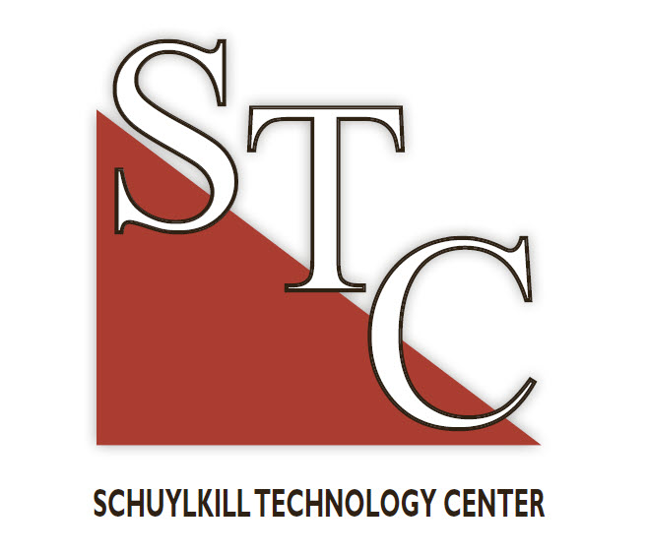

NORTH CAMPUS
101 Technology Drive
Frackville, PA 17931
Ph. (570) 874-1034
Fax: (570) 874-4028
SOUTH CAMPUS
15 Maple Avenue Mar Lin, PA 17951 Ph. (570) 544-4748
Fax: (570) 544-3895

August 16, 2022

Dear Students, Parents & Guardians:

Schuylkill Technology Center will again offer a cashless point of sale (POS) system in the cafeteria at the North and South campuses. We have found that use of the POS has reduced time-consuming cash transactions and time spent in lunch lines. Every student will be given an identification card with their PIN on the first day of school. This PIN number is created for the purpose of the cafeteria POS system, and it is to remain confidential to the student. If the student had a PIN number last year, they would keep the same number for the new school year.

This technology provides your student with the opportunity to purchase meals in the cafeteria using their PIN. The PIN is linked to your student and will track all cafeteria purchases. You can fund your student’s Point of Sale (POS) account by sending deposits directly to your school cafeteria. Cash will be accepted as well as checks/money orders made payable to “Schuylkill Technology Center”. Please identify your payment with your student’s name and STC program for accurate processing. Payments may also be made online at www.schoolcafe.com for a small fee. Additional information is being sent home with your student. Payments made at your home school do not transfer to Schuylkill Technology Center.

Students will not be permitted charges to their account for ala carte or snack items if they have a negative balance. Parents will be sent a monthly statement if the student’s balance is negative. You can check their balance and purchases online at www.schoolcafe.com.

If your son/daughter participates in the free/reduced lunch program, their eligibility has been pre-populated into the POS system until a new application is received (must be received within the first 30 days) and they will simply need to enter their PIN number at checkout.

If you have any questions, you may contact Schuylkill Technology Center directly.

Sincerely,

Shannon M. Brennan, M.Ed.
Director of Career and Technical Education

