~ STC RESUME DEVELOPMENT ~

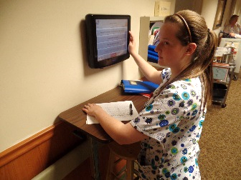
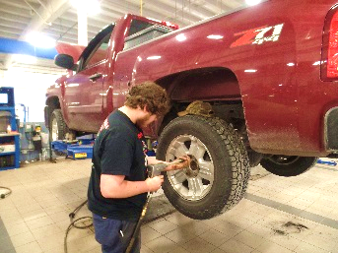
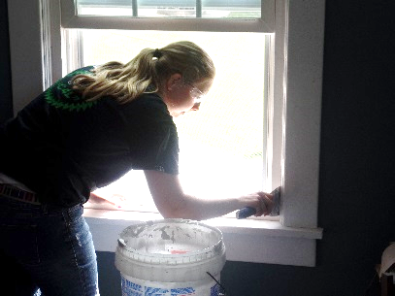


PREPARE A RESUME

A resume is required for participation in STC Cooperative Education programs.

(1) DESCRIPTION: A resume is a summary of your education, work history, experiences, skills, and personal contact information. A resume provides the employer with an overview of your potential as a possible employee. A resume must be neat and complete; it is possibly the first impression that you make with the employer.

(2) INSTRUCTIONS: Start developing a resume by reviewing the format on page 1, and the resume example on pages 2 & 3. Write in all the information required by the “RESUME WORKSHEET” on pages 4 & 5. Do this before using a computer program.

(3) Use Microsoft “Word” program to neatly produce your final resume.

(4) CHECK & SAVE: After completing a first draft, have your Instructor or Teacher Aide evaluate this copy. When the resume meets their standards, save it on a flash drive for the Co-op Coordinator to review.

(5) Make 5 copies - for future job searches, interviews, and networking.

Name: ___________________________________
Program: ____________________________
Date: _____________________

- STC RESUME FORMAT -
ALL EIGHT SECTIONS ARE REQUIRED! | DESCRIPTIONS: | GRADING:
Name, address, phone number, email: | Place at the top of the page. Make sure headings are complete and aligned evenly. All information must be appropriate to present to an employer! | 10
Career Objective: | Be specific when applying for a position: I would like to utilize my skills to obtain a challenging position as an industrial electrician. | 10
Education: | Full information required - Do not abbreviate!  (1) Home School  (2) Schuylkill Technology Center | 20
Experience: | Past employment - could be an internship, or a part-time/summer job. Job experiences do not need to be related to your current STC program. | 10
Skills: | You can use POS Task listings or specific skills prescribed by your Instructor. Bullet each task! | 10
Certifications: | Check with your Instructor for proper certification identifications: (Use a bullet •) CAN / NOCTI / CPR / NIMS / EMT / HILTI / OSHA 10 CAT1 / SP2 / ServSafe / AEP - Heart Saver. | 10
Activities /  Community Service: | Community Projects: with STC, home school, clubs, and volunteer organizations such as fire companies and civic groups - Skills USA, SKIP, Little League Coach, EMT, etc. | 10
References: (need 3) (1) limit to one education reference such as a teacher or counselor - use two community / business references. (2) Include complete address with zip code. | Name  Position / Title  Company  Address  Phone Number | 20
GRADE:

Page 1

Matthew R. Jones
1514 East Spruce Street
Pine Valley, PA 17980
570-690-3214
mrj@fullcast.com

CAREER OBJECTIVE: To obtain a full-time position as an Industrial Electrician.
EDUCATION:
North Burlington High School
1632 Ridge Road
Pine Valley, PA 17980-9474
570-894-9632
Graduation date: June 2017

East Mountain Technical Center
100 Hickory Lane
Pinedale, PA 17951
601-545-6779
Residential & Industrial Electricity (1080 hr. Certificate)
Graduation date: June 2017

EXPERIENCE:
Valley Electric Motor Controls (June - September 2016)
19 Central Avenue
Rennersville, PA 15942
763-238-2969
Job Duties: counter service and prepare job material orders.

SKILLS:
- Safety (proper use of ladders and scaffolding)
- Proper use of hand tools/power tools
- Blueprint reading
- Cable installations
- Switches, receptacles and circuits
- Wiring devices

CERTIFICATIONS:
- NOCTI Electricians Testing (advanced rating)
- OSHA 10 Construction Safety Course
- CPR

Page 2

Matthew R. Jones
1514 East Spruce Street
Pine Valley, PA 17980
(570) 690-3214
mrj@fullcast.com

COMMUNITY SERVICE:
- Danville Volunteer Fireman
- Skills USA member
- SKIP Volunteer

REFERENCES:

Mr. Ron Herbine
RIE Instructor
East Mountain Technical Center
100 Hickory Lane
Pinedale, PA 17951
570-539-2142 Ext. 677

Mr. Norman Lute
Supervisor
Riverton Electrical Supply
51 Willow Drive
Creekside, PA 18953
895-345-9635 Ext. 32

Ms. Ruth Ann Bloomberg
Owner/Manager
J & T Concessions
Lumberton, PA 47803
(845) 825-3929

Page 3

RESUME WORKSHEET
_______________________________________________
Name:
Address:
Phone #:
Email:
_______________________________________________
_______________________________________________
_______________________________________________

________________________________________________________________________
Career Objective:
________________________________________________________________________

___________________________________________________________
Education:
(Home School)
____ ___________________________________________________________
___________________________________________________________
___________________________________________________________

___________________________________________________________
Education:
(STC)
___________________________________________________________
___________________________________________________________
___________________________________________________________
___________________________________________________________
___________________________________________________________

(1) ___________________________________________________________________
___________________________________________________________________
Experience:
___________________________________________________________________
___________________________________________________________________
___________________________________________________________________
(2) ___________________________________________________________________
___________________________________________________________________
___________________________________________________________________
___________________________________________________________________
___________________________________________________________________

        - ________________________________________________________
Skills:
(bullet)
        - ________________________________________________________
        - ________________________________________________________
        - ________________________________________________________
        - ________________________________________________________
        - ________________________________________________________
        - ________________________________________________________
        - ________________________________________________________
        - ________________________________________________________

Page 4

        - _________________________________________________
Certifications:
        - _________________________________________________
        - _________________________________________________
        - _________________________________________________
        - _________________________________________________

___________________________________________________________________
Community Service:
___________________________________________________________________
___________________________________________________________________
___________________________________________________________________
___________________________________________________________________

________________________________________________
References #1:

________________________________________________
________________________________________________
________________________________________________
________________________________________________
________________________________________________

________________________________________________
References #2:

________________________________________________
________________________________________________
________________________________________________
________________________________________________
________________________________________________

________________________________________________
References #3:

________________________________________________
________________________________________________
________________________________________________
________________________________________________
________________________________________________

MOVING ON TO A COMPUTER GENERATED RESUME…
Use Microsoft “Word” program | Capitalize words when required
Use a #12, #13 or #14 size font | Use spell check
Keep all content properly aligned | List three references
Page 5

