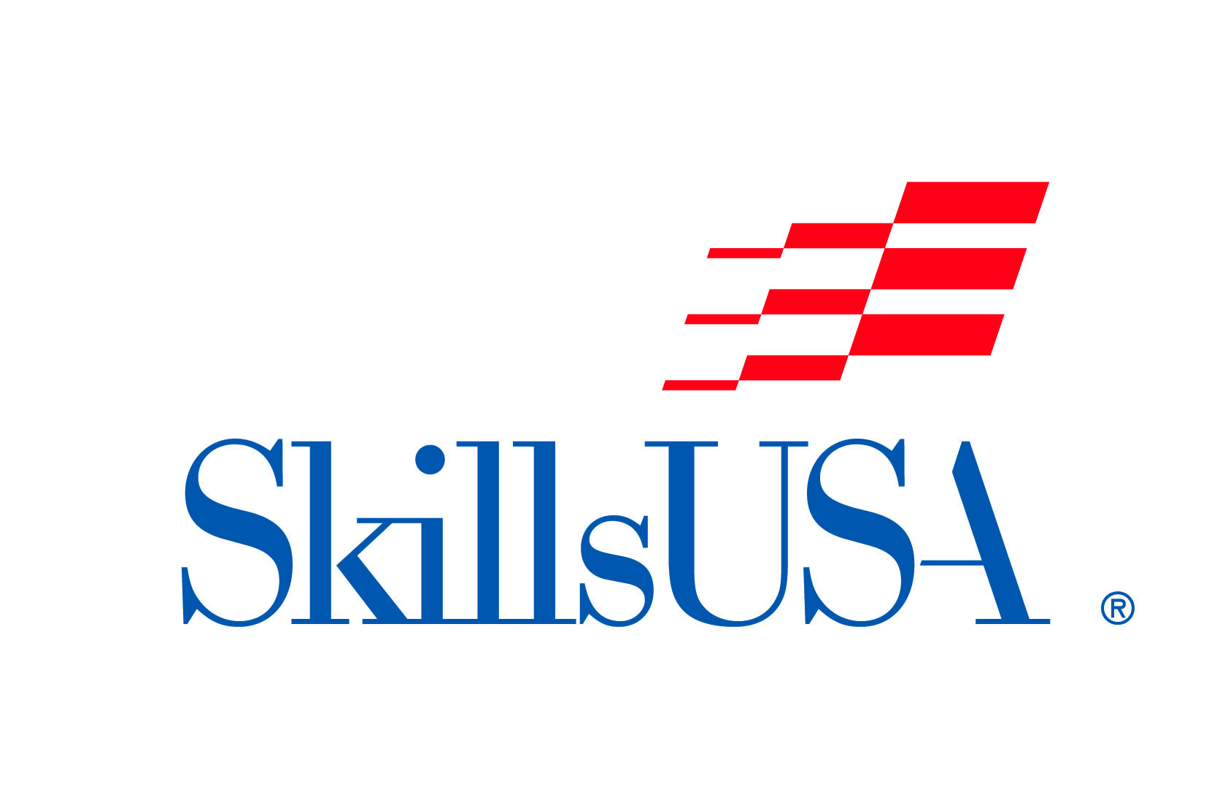Agenda for STC-North Skills USA Meeting
Wednesday October 9, 2019 10:30 A.M.

Call to Order (Opening Ceremony and Pledge of Allegiance to Flag)
Roll Call of Officers
- President-Seth Ames Vice President- David Niedzwiecki Secretary-Alexius Miller
Treasurer-Kayla Walker Reporter-Alyssa Miller Parliamentarian-Angela Micklesavage
Reading and Approval of Minutes
- The secretary will summarize what we discussed at the last meeting

Unfinished Business
- Congratulations to ALL shop programs at STC-North for reaching 100% participation!
  - This is the first time in school history- CERTIFICATES AWARDED TO EACH PROGRAM
- Reminder, Candy Bar Fundraiser (60 candy bars x $1.00 per bar = $60 due to Mr. Mack ASAP)
  - 6 students owe candy money (that’s $360 we don’t have in our treasury)
- The following events are coming up!
  - Open House TONIGHT
  - Blood Drive 10/16/2019
New Business
- SPCA Food and Supply Drive Tuesday October 15th to Friday October 25th (Shop Competitions)
- Penny Wars Monday October 28th to November 8th (Lunch Time)
- Craft Show Saturday November 2nd (FEED A FRIEND)
- COMPETITIONS- Shop Instructors will choose a student from either A or B cycle to compete at the district-level at Penn College of Technology, Williamsport. Winners move on to state-level competitions in Hershey. Winners at states move on to NATIONAL competitions in Louisville, Kentucky!
- Our next SkillsUSA meeting will be on Wednesday October 23, 2019 at 10:30 A.M. in the cafeteria.
- Treasurer’s Report
  - Income Expenses
9/20/2019 Candy Bar Fundraiser $4,145.00 9/25/2019 Candy Bar Company $3,347.50
10/1/2019 Candy Bar Fundraiser $1,790.00
10/1/2019 Outright Dues $2,000.00
10/1/2019 Donation $20.00
Totals $7,955.00 since 9/1/2019 Totals $3,347.50.00 since 9/1/2019
After the report, a student will have to make a “motion” to accept the Treasurer’s Report, followed by another student making a “second” to that motion. The entire student body will then vote to approve the report.
Adjournment

