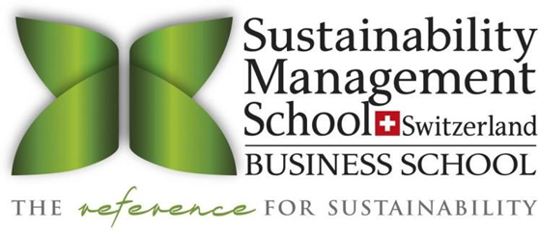

On-Boarding SUMAS CrS Guide / How Can We Help You?
Common Questions & Answers

Below you’ll find answers to the questions we get asked most about on-boarding and delivery of Career-Related Studies at SUMAS.

What is SUMAS?

SUMAS, which stands for the Sustainability Management School, is a pioneering institution with campuses in Switzerland and Italy. We proudly hold the distinction of being the world's premier business school, offering comprehensive undergraduate and graduate programs in Sustainability Management. Our educational approach combines essential business disciplines with a strong emphasis on sustainability, creating a distinctive and valuable academic experience. A significant milestone in our journey occurred in 2016 when we introduced SUMAS Career-related Studies®(CrS) Business & Sustainability for the International Baccalaureate Career-related Programme (IBCP). Recognizing our expertise and commitment, in 2022, we were appointed an Official Strategic Provider of the CrS program by the International Baccalaureate Organization (IBO). This prestigious designation enables a diverse array of IB schools worldwide to benefit from our esteemed CrS program.

How does the SUMAS Team support a School with an IBO (International Baccalaureate® Organization) IBCP Application Process?

As an IBO Official Strategic Provider, we have a deep understanding of the requirements and standards set by the International Baccalaureate Organization. With our expertise and knowledge in the field, we guide schools through the application process, ensuring that the forms are meticulously filled out by the information about Career-related Studies.

How does the SUMAS Team support a School with an IBO Verification Visit?

SUMAS will be a part of an IBO verification visit to discuss assessment processes and procedures, delivery options, quality assurance and content-related questions.

What schools should be communicating on the Website about the SUMAS CrS Program?

Schools should embed the standardized supporting text and visuals of the SUMAS CrS Program to align with the brand identity and consistently communicate the core component of our curriculum design.

Our school partners with the Sustainability Management School (SUMAS), based in Switzerland and in Italy, to provide an academically founded career-related studies program in Business and Sustainability,

SUMAS is an IB CRS Strategic Provider that offers University-based CRS courses bringing together a community of like-minded young leaders in a global classroom to share ideas on sustainable practices.

In this global classroom SUMAS CrS students from all over the world have the opportunity to meet weekly in live-streaming and discuss their projects under careful guidance of SUMAS Professors.

Practical experience pathways in which students develop meaningful company projects in collaboration with industry leaders:

- Sustainable Fashion
- Sustainable Hospitality
- Sustainable Culinary Art
- Nature Conservation
- Sustainable Tourism
- Sustainable Finance and Digitalization

The SUMAS CRS program is appropriate for all students who are interested in becoming responsible leaders in different business fields.

Upon completion of the SUMAS CrS program students will obtain direct entry into the SUMAS Bachelor program and receive 21 US academic credits to fast-track their bachelor studies in only 5 semesters (instead of 6 semesters). SUMAS CrS Alumni have also been accepted to more than 60 prestigious Universities worldwide.

How does SUMAS contribute to the worldwide university recognition of the IBCP?

First, SUMAS is constantly collecting data from schools about their students’ university applications and their acceptance to the Higher Institutions, which is publicly available whilst keeping students’ names anonymity.

Secondly, we gather information of the chosen DP Subjects as part of IBCP program. We gradually accumulate the data about IB students’ profiles and success factors of their application process.

Finally, we support students by approaching universities to familiarize them with the SUMAS CrS Program as part of the IBCP. We provide them with information about assessment, delivery, and content to increase recognition of SUMAS Program and the acceptance of our students into these Higher Institutions.

What is SUMAS CrS (Career-related Studies) ® Business & Sustainability Program?

SUMAS CrS® Business & Sustainability Program is an innovative study course which forms the CRS component of the IBCP certificate and is split into

(i) Foundation Courses (the total of these equivalent to one HL (High Level) subject), which focus on the Fundamentals of Sustainability, Leadership and Sustainable Innovation, and

(ii) Applied Component (equivalent to SL (Standard Level) subjects), divided into the Sustainability Leadership Camp/Experience and the Project Experience.

Who should be studying the SUMAS CrS® Program Business & Sustainability?

We highly recommend that students who have an interest in Business and/or Sustainability consider enrolling in SUMAS CrS® as part of their IBCP certificate. SUMAS CrS® “Business & Sustainability” program is designed for students pursuing career-related education during the last two years of their high-school. This program is suitable for any student who wants to learn about responsible management across various industries. Its primary goal is to equip students with a solid foundation in sustainability management and foster their development as responsible leaders.

What is the profile of a SUMAS CrS® student?

SUMAS CrS Students are the ones Who Know What They Want! SUMAS Career-related Studies® “Business & Sustainability” are designed for self-confident students, who have a clear idea about their career path. Students will pursue career-related education during the last two years of their high-school. This study program is relevant for all students who are interested in responsible management applicable in different fields. Students enrolled on the SUMAS CrS® have a clear area of interest or passion, in this case linked to business and/or sustainability. They are independent and determined, looking to broaden their horizons and discover how they can make lasting change with their education and through their career choice. SUMAS CrS students are high achievers, change agents, inclusive leaders, and visionary thinkers.

For more information, click here

Which DP Courses are recommended by SUMAS to enrich the SUMAS CrS® Program experience?
All DP Courses that are relevant to Sustainable Development are recommended. This encompasses subjects such as business and management, economics, environmental systems and society, and information technology in a global society. Students may also select additional subjects based on the specific requirements of their chosen universities. It is crucial for students to align their DP subject choices with their future career objectives and university preferences. It is essential to apply for the right department as per the Candidate's subjects.

How is SUMAS CrS® Business & Sustainability recognized by universities?

Upon completion of the IBCP, each student is awarded their IBCP certificate and a SUMAS CrS® Certificate of Achievement and transcripts from the Sustainability Management School (SUMAS).

Sample of IBCP Certificate Sample of Final Transcript

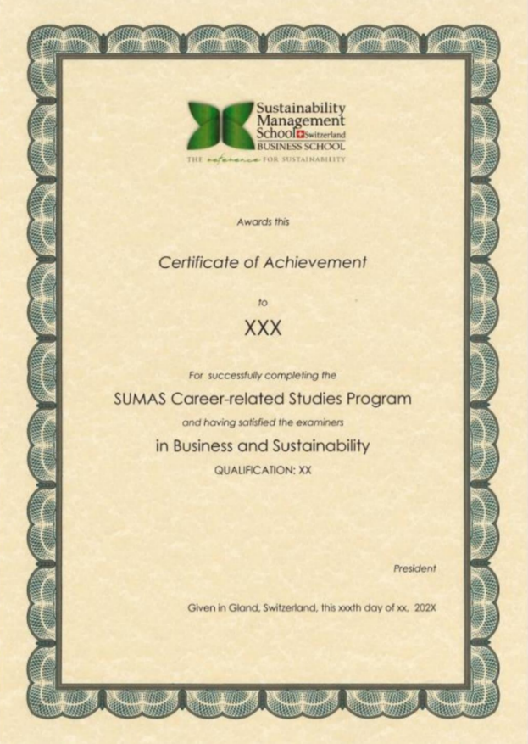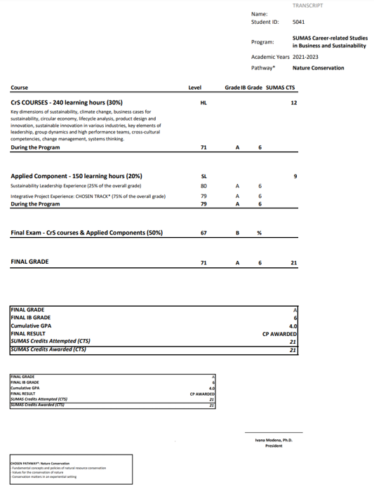

The IBCP with SUMAS CrS® Business & Sustainability, alongside other qualifications, is recognized for entry into Higher Education at the University of Brighton, University of Glasgow, University of Chichester, University of Plymouth, University of Sheffield and Sustainability Management School (SUMAS).
It is also recognized on a case-by-case basis at Keele University, University of Essex, Glion Institute of Higher Education and Berklee College of Music.

Based on individual application, SUMAS CrS® alumni have also gone on to study at Università Bocconi, Instituto Maragoni, John Cabot University, Ecole Hotelière de Lausanne, International University in Geneva, Brunel University London, Durham University, King’s College London, Newcastle University, Loughborough University, Queen Mary University, University of Leeds, University of Kent, University of Sussex, Simon Fraser University, Liverpool University (Suzhou), University of Canterbury (New Zealand), Richmond University (UK), The American International, University in London, St Mary's University, University of La Verne, Arizona State University, Lancaster University, Leeds Beckett University, Hawaii Pacific University.

See the latest list of the universities here

What is the Fast Track of SUMAS CrS students entering the SUMAS BBA (Bachelor of Business Administration) Programs?

Students who successfully complete SUMAS CrS® Business & Sustainability Program are awarded 21 US credits which may be transferred to the SUMAS BBA in Sustainability Management (or another major within our program offerings). SUMAS Academic Credits are earned upon completion of the SUMAS CrS® Program. The last semester of BBA corresponds to 21 US Credits, which translates to 1 semester of the SUMAS BBA Program completed by students during their CrS Studies with SUMAS. This exemption offers them a competitive advantage and a winning start to ours Bachelor programs.

In addition, the cost savings gained from the exemption of 1 semester is equivalent to 9,400 EURO.

What is the Conversion of the SUMAS Academic Credits?

SUMAS credits follow the US credit system. The twenty-one credits achieved upon completion of SUMAS CrS® convert to forty-two ECTS.

The following table shows the grade conversion between SUMAS CrS® Business & Sustainability Courses, IB Grades and UCAS Tariff Points. All three SUMAS CrS® Business & Sustainability Foundation Courses are equivalent to one IB Higher Level. The Applied Component is equivalent to one Standard Level.

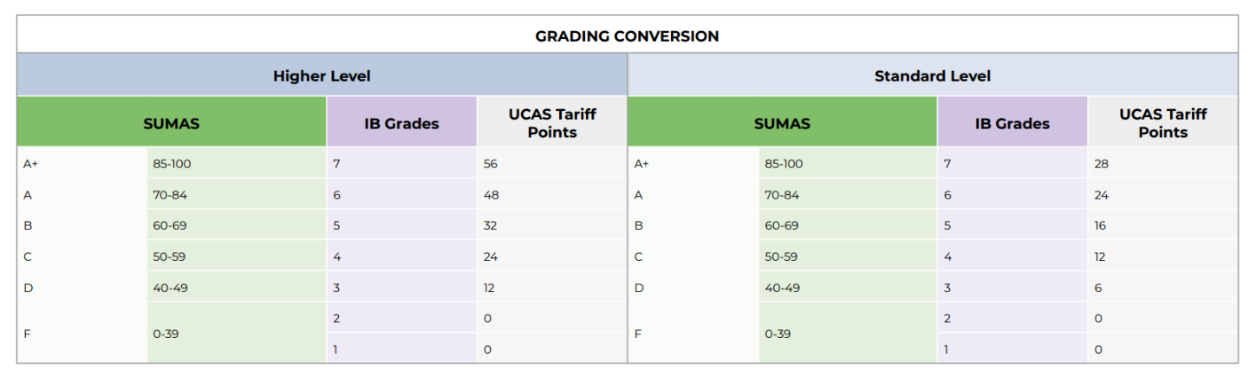

What is the difference between Standard Level and High-Level Courses?

The complete SUMAS CrS® Business & Sustainability consists of 240 guided learning hours (equivalent to one Higher Level Course within the IB Program) and 150 hours of applied learning experience (equivalent to Standard Level Courses within the IB Program).

The guided learning hours in our Foundation Courses: (i)Fundamentals of Sustainability, (ii) Sustainable Innovation, and (iii) Leadership. The applied learning experience is formed by the Applied Component of our courses: Sustainability Leadership Experience and Project Experience in Sustainable Hospitality, Sustainable Culinary Art, Sustainable Fashion, Sustainable Finance and Digital Innovation, Nature Conservation, and Sustainable Tourism.

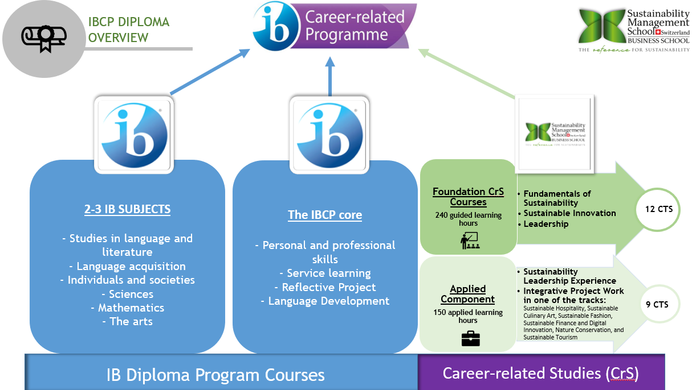

What is the structure and timeline of the SUMAS CrS Program?
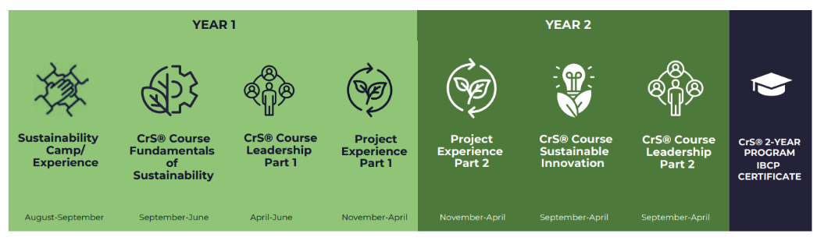

The SUMAS CrS Program follows a specific structure and timeline. To begin, there is a Sustainability Leadership Camp/Experience, which serves as an introduction to the full program. During the 1st Academic Year, the Fundamentals of Sustainability (Foundation Course) is delivered, providing a solid foundation in Business and Sustainability. In the 2nd Academic Year, the Sustainable Innovation (Foundation Course) is taught, covering advanced sustainability concepts like the circular economy and relevant business dimensions. The Project Experience is a choice of one of six pathways (Sustainable Fashion, Sustainable Hospitality, Sustainable Culinary Arts, Nature Conservation, Sustainable Tourism, Sustainable Finance and Digitalization), that can be scheduled at a convenient time within the two years of the program. Lastly, the Leadership (Foundation Course) starts during the 1st Academic Year and concludes in the 2nd Academic Year.

The Foundation Courses are delivered over a duration of 20 weeks (minimum) to 28 weeks (maximum) during the final two years of High School. Each course entails 80 guided learning hours (GLH), resulting in a total of 240 guided learning hours upon completion of all three courses.

What is the difference between Foundation Courses and the Applied Component?

The complete Business and Sustainability program consists of 240 guided learning hours (equivalent to High Level Courses within IB Program/Foundation Courses) and 150 hours applied learning experience (equivalent to Standard Level Courses within IB Program/Applied Component). As part of the Applied Component, students participate in both a Sustainability Leadership Camp/Experience and a Project.

The Foundation Courses are rooted in theoretical background, while Applied Component is more focused on business application based on a real context project with Industry Partners as part of our Sustainability Network. Both, foundation courses and applied component, are broad and draw upon core knowledge and a variety of inter-disciplinary skills that can be transferred to multiple industries.

What are the topics/areas covered in the Foundation Courses?

Fundamentals of Sustainability CrS Course provides students with a solid basic understanding of the main aspects of sustainability and prepares them for the advanced courses.

- Key dimensions of sustainability
- The biosphere, cycles, and ecosystems
- Climate change
- Impact of daily personal and business decisions on the environment
- Tools to quantify energy, climate and water impact
- Pollution, electronic waste and recycling
- Sustainable tourism, best practices in ecotourism and innovative travel destinations
- Environmental Ethics
- Corporate social responsibility
- Sustainable Project Management
Sustainable Innovation CrS Course provides an introduction to sustainable innovation with a main concern on resources, water, energy, human conditions, as well as the economic challenges.

- Circular economy
- Performance economy
- Life-cycle analysis
- Product design and innovation
- Material health and material reutilization
- Sustainable Innovation of Energy
- Sustainable Innovation of Materials
- Supply to value chain Management
- Sustainable innovation in various industries
- Sustainable Project Management
Leadership CrS Course designed to raise awareness of the importance of new leadership styles to meet the challenges facing decision-makers today, in times of fast changes and crisis.

- Leadership & Behavior Traits
- Contemporary issues in leadership
- Power, authority and conformity
- Group dynamics and high-performance teams
- Contingency Theories
- Effective Leadership Styles
- Cross-cultural competencies
- Change management
- Systems thinking
- Sustainable Project Management

What is the SUMAS CrS® Applied Component?

It is divided into two parts. The first part is the Leadership Camp/Experience. The second part is a Project with Industry Partners. Both parts are explained in detail below:

1st Part: Applied Component (Leadership Camp/Experience)

The Sustainability Leadership Camp is designed by SUMAS to be completed in one of its campus regions in Gland (Switzerland) or Milan (Italy). A school can choose one of these destinations for a 6-day camp or opt for a 10-day camp where students spend equal time in both locations.

Alternatively, SUMAS offers The Sustainability Leadership Experience which is delivered real time to students online. For this option, SUMAS works with the partner school to design the online program taught over 4-8 weeks.

Sustainability Leadership Experience/Camp is designed to introduce the concepts, styles, and practices of leadership. Students will be encouraged to develop and improve a range of managerial, personal sustainability and leadership skills. This part of the program aims to

- Develop own self-confidence
- Develop presentation skills
- Learn Communication and Barriers of Communication
- Manage intercultural contexts
- Develop personal Sustainability
- Learn Sustainable Consumption & Zero-waste management
- Exercise well-being and healthy lifestyles
SUMAS CrS® students can come to our campuses for the Sustainability Leadership Camp, according to the program decided by their school. Schools would submit an official request for the camp at least 6 months in advance of the dates proposed.

Leadership Camp

The SUMAS Leadership Camp is based on dynamic and engaging courses, different visits to International Organizations, Swiss and Italian cultural experiences, and adventurous outdoors activities. The objective of this camp is for students to experience real-life sustainable projects in Switzerland and Milan to fully appreciate that we can live in the present without compromising the future. Each day is focused on a different and exciting topic, such as Personal Sustainability, Sustainable Food & Drinks, Leadership Skills, Team Building or Wellbeing and Healthy Lifestyles. During the camp you will be encouraged to improve a range of leadership skills as well as to gain knowledge about personal sustainability. Leadership theories will be analyzed and applied in real world situations. You will develop competencies that are essential to be coming responsible managers in business, while also cultivating the intercultural skills, confidence, self- esteem and team-work abilities that will be built through role-play activities and games.

2nd Part: Applied Component (Project Experience)

The Project Experience is an essential part of SUMAS CrS®'s Applied Component. It provides students with an opportunity to apply their theoretical knowledge to practical projects within their chosen pathway. By actively engaging in fieldwork, students will analyze complex problems, identify stakeholders, and develop solutions. Our teaching approach emphasizes interactivity, incorporating role-play activities, in-class discussions using real cases, and video examples.

The Applied Component offers specialized pathways in Sustainable Fashion, Nature Conservation, Sustainable Hospitality, Sustainable Culinary Arts, Sustainable Tourism or Sustainable Finance and Digitalization to cater to students’ specific career interests. Should a school have a request for an alternative pathway, we are happy to work with you to create a bespoke program at an additional fee.

What exactly would be covered as part of the Applied Component?

Project Experience in one of the following six pathways:

Pathway 1: Sustainable Hospitality pathway will help to develop leadership and intercultural skills by being engaged in field trips to leading hospitality companies under the careful guidance of experts.
- Core issues and challenges of Sustainable Hospitality
- Cutting-edge theories in the field of eco-tourism
- Responsible leadership and intercultural skills.
- Conscientious guests and eco-travellers in the hospitality sector

Pathway 2: Sustainable Culinary Arts pathway focuses on the philosophy from farm to table and life cycle management.
“Healthy people, healthy societies, healthy planet” is the buzz sentence of responsible chefs. Students will recognize the benefits of responsible cooking, from food sourcing methods, cooking techniques, waste management to intercultural food experiences. Student will learn tools and techniques helping to meet environmental, social and economic objectives.
• From farm to fork
• Sustainable practices in food and beverage management
• Zero-waste gastronomy

Pathway 3: Sustainable Fashion pathway provides cutting edge knowledge about the core issues and challenges of sustainable fashion and integrates responsible leadership applied to the fashion sector.

- Core issues and challenges of sustainable fashion
- Responsible leadership
- Design operations and production of eco-materials
- Green Marketing
- Hands-on projects guided by academics, consultants, and professionals

Pathway 4: Sustainable Finance and Digitalization pathway will offer the opportunity to explore Green of Finance, Digital Innovation, and Sustainable Investments.
Students will learn the crucial role of finance to address sustainable challenges and explore both the investment portfolio toward climate-friendly assets and the transition to a green economy. Thus, students will engage in practical applications of blockchain technologies.
- Greening of Finance
- Digital Innovation
- Sustainable Investments

Pathway 5: Sustainable Tourism pathway provides best practices in Eco-tourism, Protected Areas, and Recreation Management. Protected areas are intrinsically connected to the concept of biodiversity conservation and eco-tourism. Students will be trained to understand concepts of sustainable tourism development, parks and recreation management, and best practices for responsible visitors. This pathway also explores how local communities can benefit from sustainable management of touristic areas in the long term.
- Best practices in Eco-tourism
- Impact of tourism on the local communities
- Protected Areas and Recreation Management
Pathway 6: Nature Conservation pathway will offer the opportunity to explore fundamental values for the preservation of biological diversity and includes guided visits to local protected areas or other important sites around the world.
- Fundamental values for the preservation of biological diversity
- Nature conservation theory and practice
- Physical and human drivers of environmental changes.
- Guided visits to local protected areas sites.

How do you run Project Experience?

SUMAS CrS® provides hands-on experience for students to lead by example through global executive connections and company projects. Project Experience is divided into three stages:
Stage 1: Preparatory - Project Briefing & Team Building, Tools & Best Practices.
The preparatory stage is crucial for laying a strong foundation for the project and corresponds to the first two Project Management phases: Initiation and Planning. It begins with a comprehensive Project Briefing where students are introduced to the project's objectives, expectations, and context. This ensures that every team member understands the project's purpose and significance. This phase will familiarize students with the Tools & Best Practices necessary for the project, such as Risk Analysis, Activities Planning, and Scheduling (Gantt chart). Team Building through fun and instructive activities is another essential component of this stage. This ensures that students not only get to know each other better but also understand their strengths, weaknesses, and how they can best collaborate.
Stage 2: Action - Work-in-Progress, Collaboration with the team & the Partner.
During the action stage, the emphasis is on execution. Students actively work on the project, applying the knowledge and skills acquired during the preparatory stage. Regular check-ins will be scheduled to monitor progress, address concerns, and provide feedback. Collaboration is key during this phase. Group work is an effective method to motivate students and encourage active learning, as it helps in developing key critical thinking, communication, and decision-making skills. Working with a Partner offers students a real-world perspective and expert guidance.
Stage 3: Consolidation - Final Presentation, Report with recommendations
In the final stage, students consolidate what they've learned and their work into tangible deliverables. The Final Presentation is an opportunity for students to showcase their projects to their peers, instructors, and partners. This presentation tests their understanding, their teamwork, and their ability to convey complex ideas. Following the presentation, students will submit a Report that details the entire project process, the challenges faced, the solutions devised, the lessons learned and recommendations for future endeavours. Creating this report reinforces the learning experience and critical thinking, providing a valuable document for assessment and feedback.
Can a school deliver an alternative pathway for Project Experience (alternative to Nature Conservation, Sustainable Fashion, Sustainable Hospitality, Sustainable Culinary Arts, etc.)?

Currently, the Project Experience is available with 6 pathways: Sustainable Hospitality, Sustainable Culinary Art, Sustainable Fashion, Sustainable Finance and Digital Innovation, Nature Conservation, and Sustainable Tourism. We welcome new proposals if a school has an idea of novel Project Experiences within the scope of Business and Sustainability and will do our best to accommodate an alternative pathway.

Would schools and students be connected to industry leaders in business and sustainability?

Yes! This is one of SUMAS’ core teaching methodologies for all our programs and in SUMAS CrS®, demonstrated through the Applied Component’s Project Experience. We have a network of industry leaders worldwide and connect students to a project directly related to their chosen Applied Component pathway. For example, for one of our partner schools in Thailand, students worked with world-renowned hospitality group Shangri-La, contributing to on-site activities in multiple departments to develop their Project.

Who are SUMAS CrS® Professors? What is their background?

Here you can find the detailed information about SUMAS CrS® Team and Faculty profiles Career-related Studies for IB Schools | SUMAS

At SUMAS CrS®, our professors are drawn from our esteemed teaching faculty, where they also actively instruct courses in both our Bachelor and Master programs. The course content is organized and overseen by our main CrS® professor and Course Content Manager, Julia Koroleva.
These professors bring their expertise and knowledge in shaping the course content of our Business & Sustainability program. They are specialized in the Applied Component pathways.

Can you give examples of careers in Sustainability?

Careers in Sustainability can be generally divided into two categories: sustainability functions in companies (non-specific industry) and business functions in “green” companies.
Sustainability functions in companies (non-specific industry) are roles such as Sustainability Analyst, Sustainable Procurement Manager, Sustainable Communications Director and Chief Sustainability Officer. These roles will be found in companies that have or are in the process of creating their dedicated sustainability department.
Business functions in “green” companies can be similar roles – Data Analysts, Supply Chain Manager, Communications Director, Chief Operating Officer – but will be sustainability-focused according to the specific company. Examples of companies and organizations are World Business Council for Sustainable Development, TerraCycle, Lime and Too Good To Go.

Where are SUMAS Partners – Schools that run the SUMAS CrS® Program located?

SUMAS has CP partner schools in Europe, Asia and the Middle East. Schools vary in size, demographic and IB program and we adapt the SUMAS CrS® program to each school’s specific requirements.
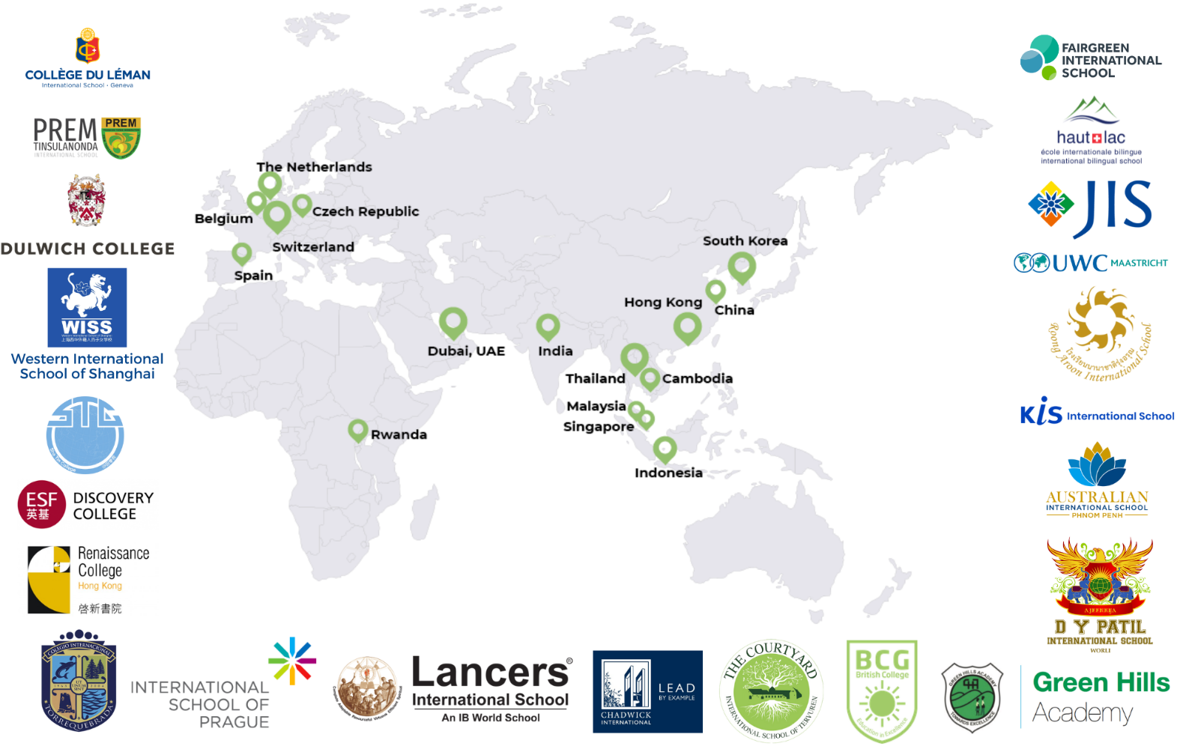

How is the SUMAS CrS Program delivered?

SUMAS online CrS® Business & Sustainability is delivered through distance learning with a variety of tools: simulations, forums, case studies, video analysis, live-streaming classes, Q&A sessions and continuous work-in-progress that imitates a business environment.

Each topic includes live streaming Q&A session and debates to stimulate students’ critical thinking. Students’ participation and contribution are central in the course. Relevant personal experience and examples from external sources brought by students are actively encouraged.

We deliver 20 topics for each foundation course with a dedication of 4 GLH per topic: 3 hours (135 minutes) online learning activities and 1 hour (45 minutes) live-streaming sessions (direct engagement with students).

If students are a part of the SUMAS CrS® Online Program, would they be connected to the other SUMAS CrS® Students across the globe?

Yes! Students are connected through Moodle and live-streaming sessions with other students from across the world in our partner schools to form our global classroom.

What is the SUMAS Application Process?
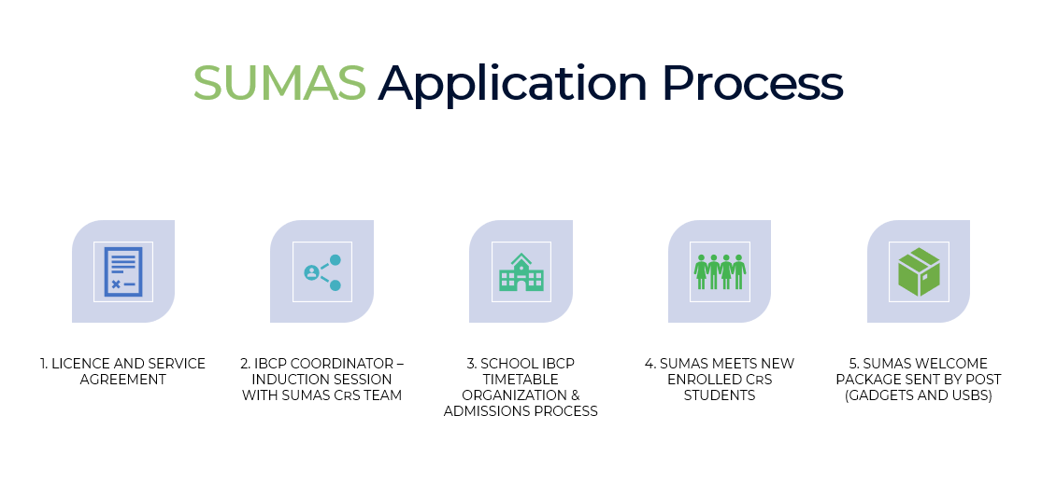
Once the license and service agreement with a new partner school is signed, we will initiate an Induction Session with SUMAS CrS Team and IBCP Coordinator to start a gradual integration of the SUMAS CrS Program as part of the IBCP. Concurrently, we support schools with their marketing part through SUMAS Team presentations to the potential CrS students and their parents. Following this, we will proceed with School IBCP timetable organization and admissions process. Upon completion of the admissions process, SUMAS meets the newly enrolled CrS students for an Induction Session about the academic structure, including assignments, weekly classes, and participation. As the final step, SUMAS Welcome Package will be sent by post.

What is the Admissions Procedure in detail?

SUMAS will initiate the Admissions Procedure by emailing to the CP Coordinator of SUMAS Partner Schools an official Registration Form and General Photography Release Form to be completed and signed by the students and their Parents/Guardians. The CP Coordinator should collect and email SUMAS with the following documents for every student:

- Completed and Signed official Registration Form
- Completed and Signed General Photography Release Form
- Scanned Copy of IGCSE/GCSE results
- Scanned Copy of student’s passport

Upon collection of these documents for all the students, SUMAS will email the Official Admissions Letter to the students.

What is included in Teacher Training Pack?

In order to ensure adequate delivery standards by the high school teacher, SUMAS will provide the candidates delivering the CRS a teacher training pack prior to the start of the Studies. SUMAS Teacher support includes:

● E-learning Induction (up to 10 hours)
● Technical Support for the Online E-learning Platform (up to 10 hours)
● Teacher Tutoring on CrS Courses and Applied Component (up to 20 hours)
● Training pack that includes schemes of work, assessment criteria, grading rubrics, guidelines, and other essential documents for successful program delivery.

The content of the Teacher Training pack consists out of the following 5 units:

Unit 1 - Fundamentals of Sustainability
Unit 2 - Sustainable Innovation
Unit 3 – Leadership
Unit 4 – Leadership Camp
Unit 5 – Project Experience

Does SUMAS have a CrS® Training Program for Teachers?

Teachers delivering SUMAS CrS® courses will have to either accomplish the professional development training through SUMAS E-learning Platform or show a relevant degree in the field. The Teacher Training Program is organized either on SUMAS campus or remotely via a multimedia seminar room equipped with an Interactive Board, HD webcam and video conferencing system as an additional service. After completion of the training, teachers will receive a Certificate of Expertise in "Business and Sustainability". Teachers with proven knowledge in the field of Business and Sustainability do not need to complete the teacher training.

What it the SUMAS Assessment Outline?

SUMAS Assessment Outline is the overall SUMAS CrS® Assessment that is composed of all grading activities during the Program and the results of the Final End-of-the-Program Exam:

50% - Foundation Courses & Applied Component  Based on all grading activities During the Program |  | 50% - Final End-of-the-Program Exam  Based on the results of the End-of-the Program Exam
30% Foundation Courses:  10% Fundamentals of Sustainability  10% Leadership  10% Sustainable Innovation | 20% Applied Component:  5% Leadership Camp/Experience  15% Project Experience | 30% Foundation Courses:  10% Fundamentals of Sustainability  10% Leadership  10% Sustainable Innovation | 20% Applied Component:  Project Experience in one of the 6 pathways as per student' individual chosen pathway.

How is SUMAS CrS® assessment reporting organized?

In order to facilitate effective communication with parents, we establish a designated contact person at your school, typically the CP coordinator. Together, we determine the reporting calendar that aligns with your school's preferences, and we provide reports accordingly. Each school has the flexibility to define their preferred frequency of reporting.

Additionally, the designated contact person, serving as the focal point, is granted access to the SUMAS e-learning platform. This enables them to monitor and track students' progress at any given time, ensuring comprehensive oversight of their educational journey.
How can teachers and students prepare for the Final SUMAS CrS® Exam?

There is one final exam prepared and assessed by SUMAS for a duration of two hours. The final exam will test the knowledge of the syllabus covered in class, and the ability to apply them to specific cases. The exam may consist of multiple choice, short answers, and essay questions.

SUMAS will provide your school with final exam sample papers to demonstrate the necessary requirements in order to test the knowledge, understanding, and skills of students. The SUMAS Exam Commision will review, compare, and evaluate whether the CrS learning outcomes were met by the external assessment of the final exam of students.

A step-by-step guide to conducting the Final Examination at your School is made available on the E-Learning platform. SUMAS will assess the final exam, which contributes to 50% of the overall external assessment.

