
VPortal Log In & Navigation

- To access your VPortal, navigate to the Volusia County Schools webpage at www.vcsedu.org
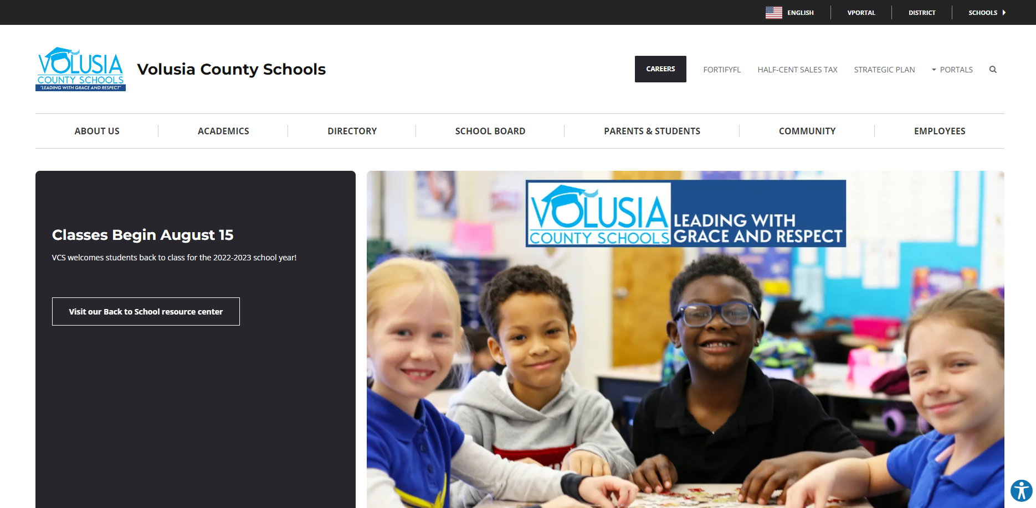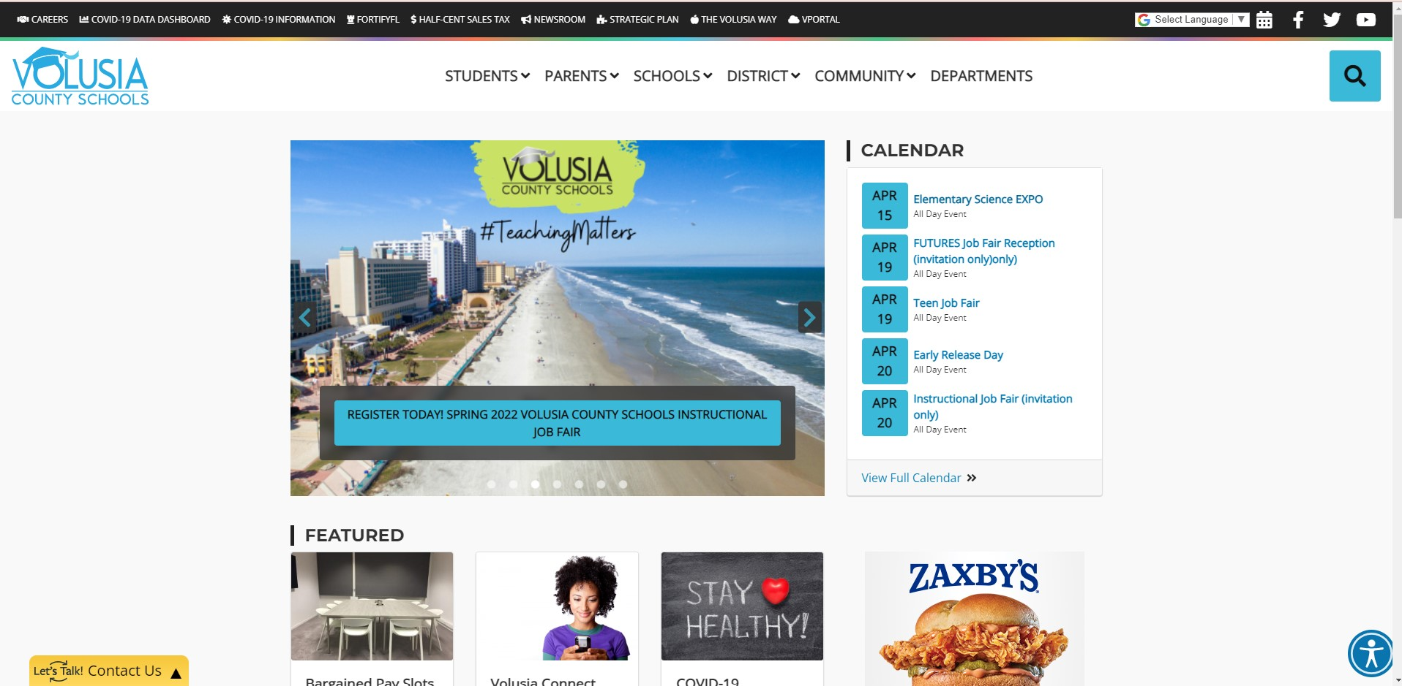

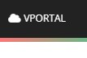
- At the top of the page search for the VPortal icon in the black banner.

- If you are on the school network, click on the Login blue button to automatically sign into VPortal.
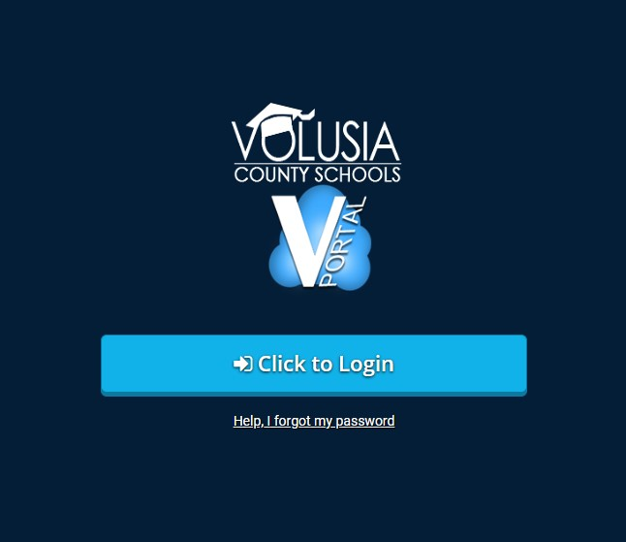

- If you are off the school network or you are at home, you will be prompted to type in your work email credentials (VCS email & password) to access VPortal.
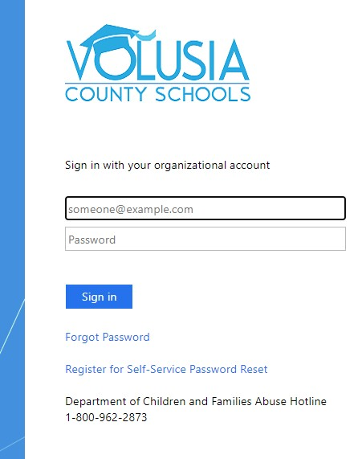

- Once you log into your VPortal, you will be brought to your dashboard where you will see all of your apps and customized VPortal.
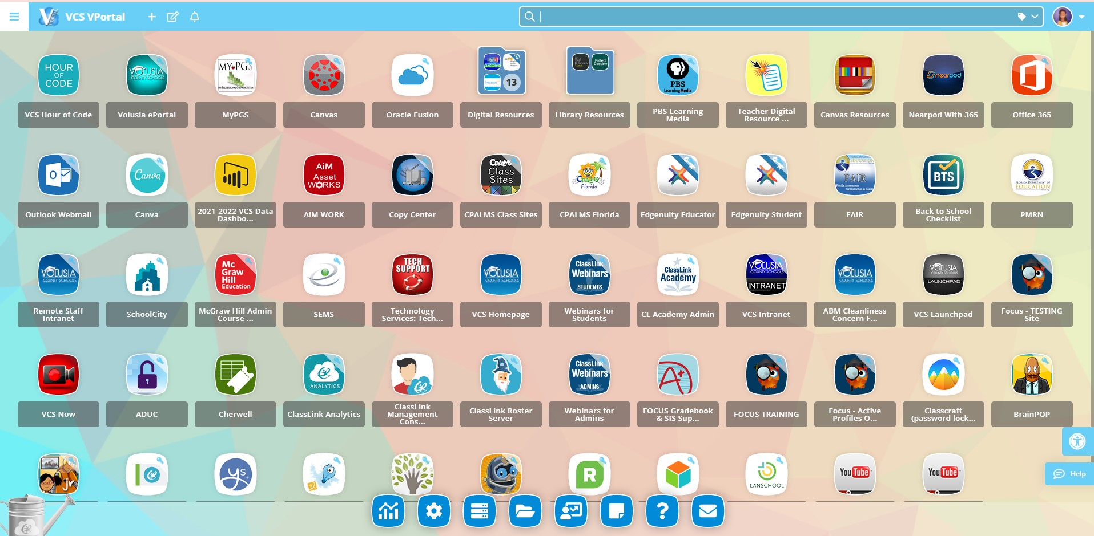

- To access one of the main menus, navigate to the three horizontal bars icon found at the upper left-hand corner of your dashboard.
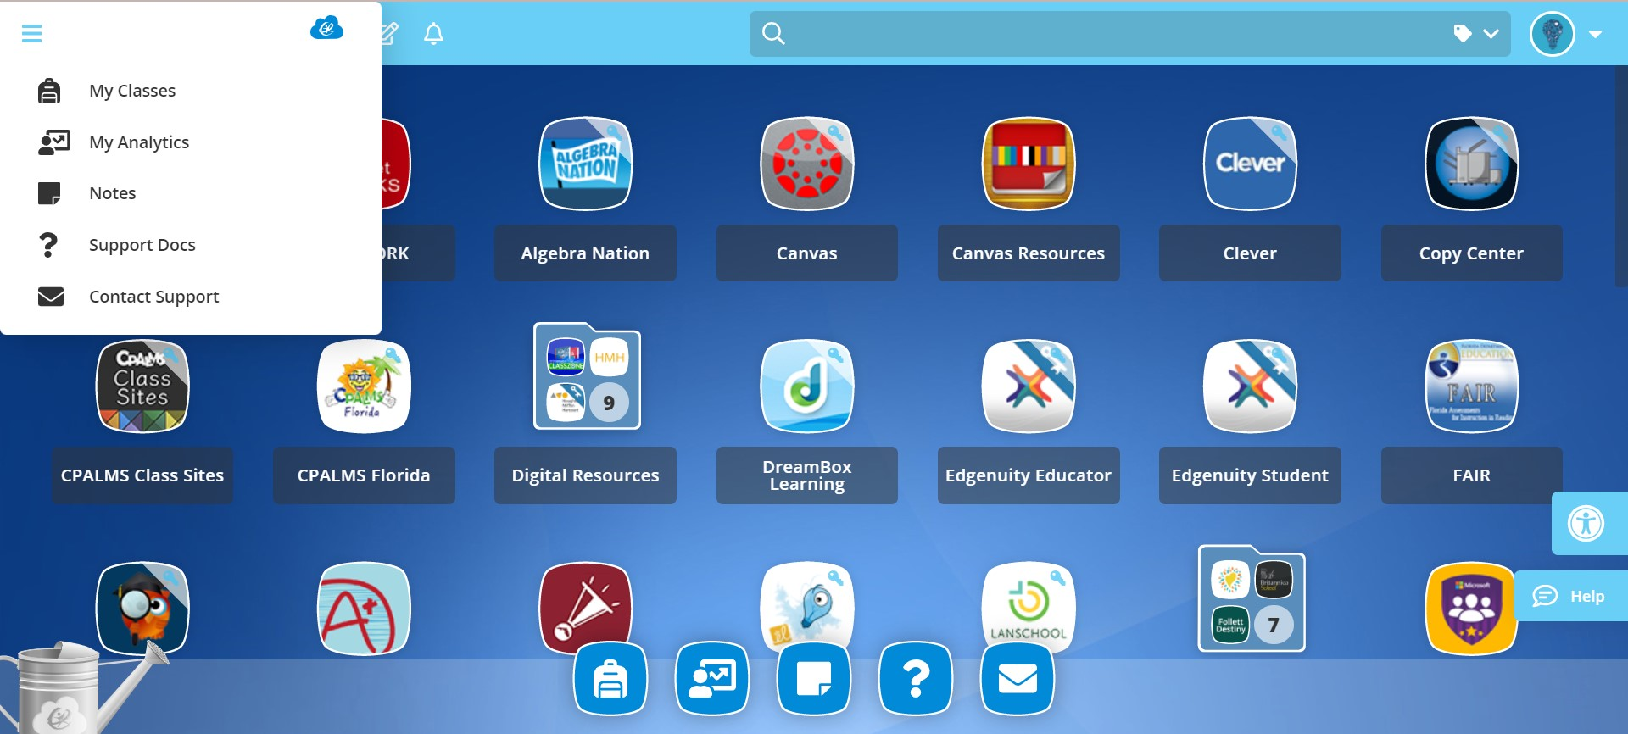

- You will be able to search your classes, analytics, notes, and contact support. Access this main menu in the bottom bar of your VPortal dashboard.

