  What is a School-Parent Compact?
  A School-Parent Compact is jointly developed by our parent involvement team and school leadership team. This document, as required by Title 1-A of the Elementary and Secondary Education Act, outlines how parents, school staff, and students will share responsibility for improved academic achievement at our school, and the means by which the school and parents will build and develop partnerships that help children achieve Idaho’s high standards.
  Activities
  to Build Partnerships
  Communication about
  Student Learning
  - Parent- Teacher Conferences in Fall and Spring
  - Parent Involvement Team meetings as needed
  - School Panther Tracks Newsletter
  - Grade Level, and Classroom Newsletters
  - Progress Monitoring Letters and Calls
  - Class Dojo & Remind
  - Teacher Emails
  - Translated Documents, notes, and forms as well as Interpreters at Meetings and Conferences
  - District Website with School Specific information
  - School Reader Board and Assemblies
  Maxine Johnson Elementary School
  2023-2024
  Parma School District #137
  
  REVISED 10/13/2023

  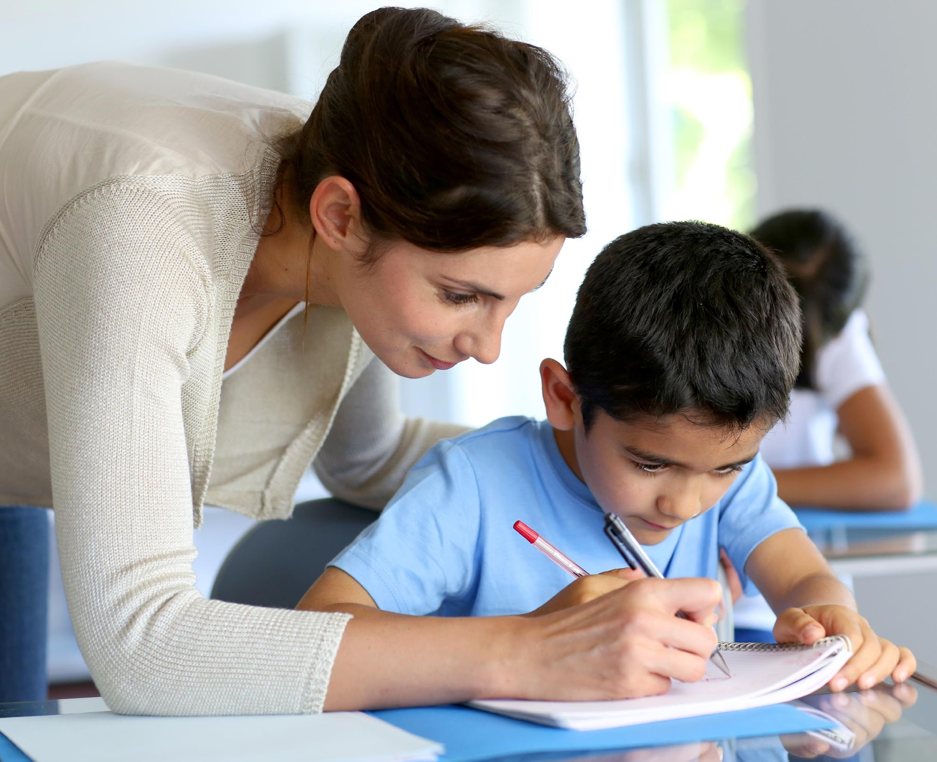
  Goals for Student Achievement
  District Goal
  The Parma School District will provide a solid foundation of knowledge and skills on which students can build a rewarding career and life of purpose. Our teachers will provide a learning environment of excellence while communicating regularly about student needs in order to improve programs, instruction, and student performance.
  School Goals and Focus areas
  We believe reading and writing are of highest importance. MJE students spend a great deal of time learning to read, so that when they leave our building, they have the skills in place to read in order to learn. We also believe in providing a broad range of skills for future academic or vocational pursuits, as well as enrichment in music and physical activity.
  Teachers, Parents, and Students — Together for Success
  Teacher/School Responsibilities
  We provide parents reasonable access to staff and encourage communication with teachers about needs and strengths of their children.
  We provide parents opportunities to volunteer and participate in their child’s classroom and school activities.
  We provide educationally focused events geared toward parents’ abilities to help their children succeed as learners and individuals.
  Student Responsibilities
  Panther PRIDE
  Be Positive
  Be Respectful
  Show Individual Responsibility
  Demonstrate Excellence
  Ensure Safety
  Family Responsibilities
  * Encourage “PRIDE”
  * Support school discipline policies and work with teachers if any issues arise
  * Make sure children attend school regularly
  * Encourage ample sleep, nutrition, and non-screen time activities
  * Establish a time and place for study and reading time
  * Make positive use of family time--engage in conversation and activities with kids.
  * Know it is okay to go back to basics—unstructured time, family dinner with no technology, and spending time outside.
  Contact Us
  Maxine Johnson Elementary
  607 E McConnell Ave
  Parma ID 83660
  208 779 4069 x 1102
  Visit us on the Web:
  parmaschools.org

