2023
New Teacher Orientation
E-Notebook

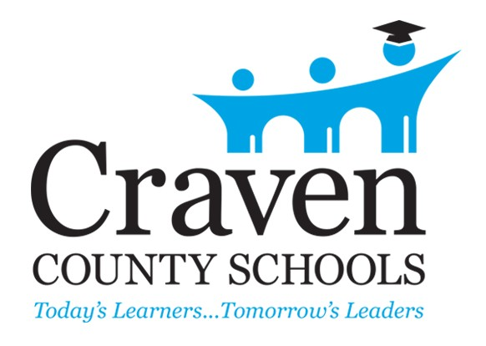

www.cravenk12.org

3600 Trent Road New Bern, North Carolina
(252) 514-6300

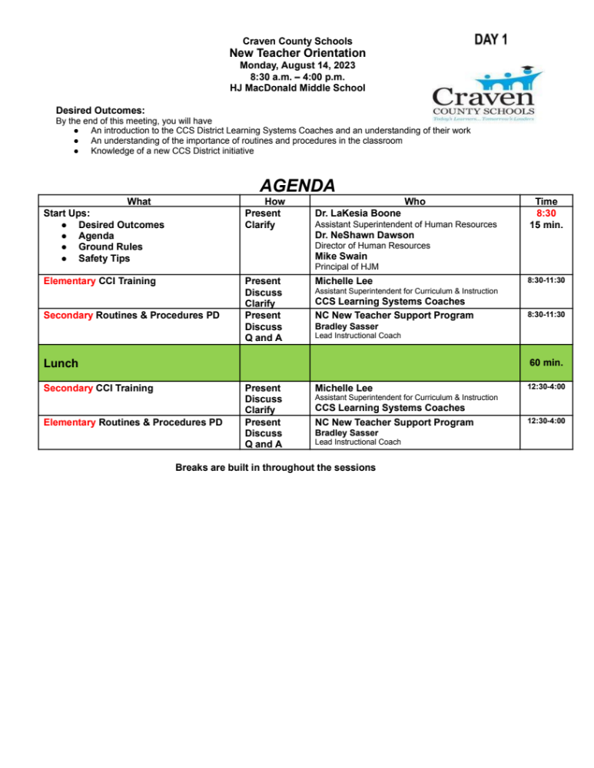
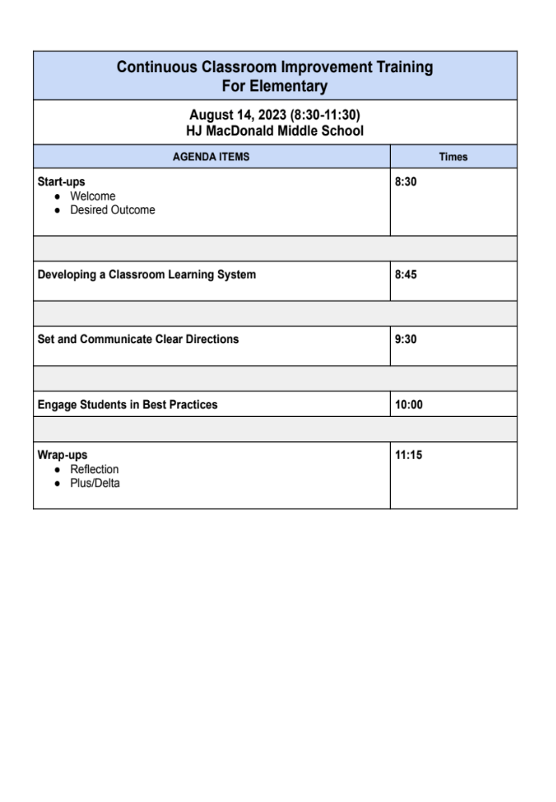

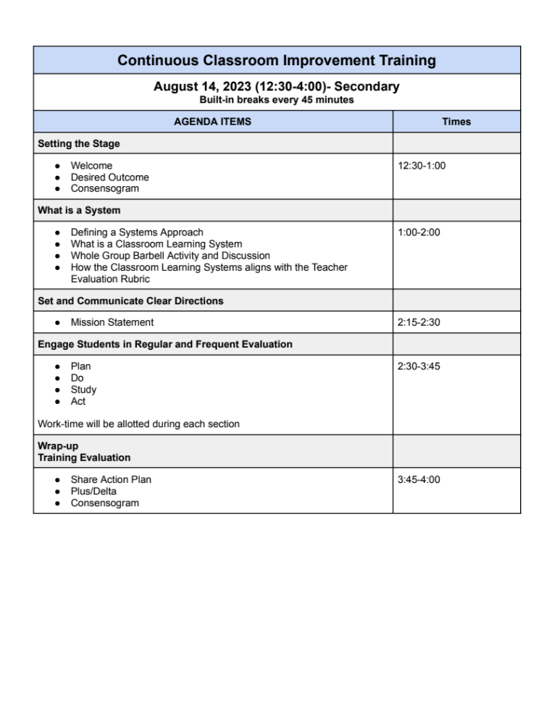




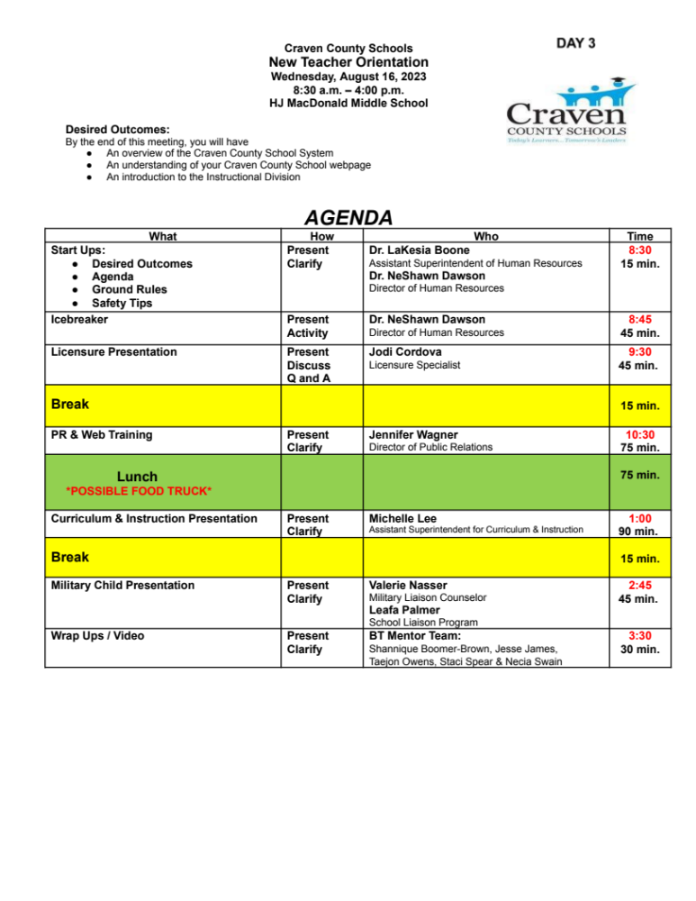

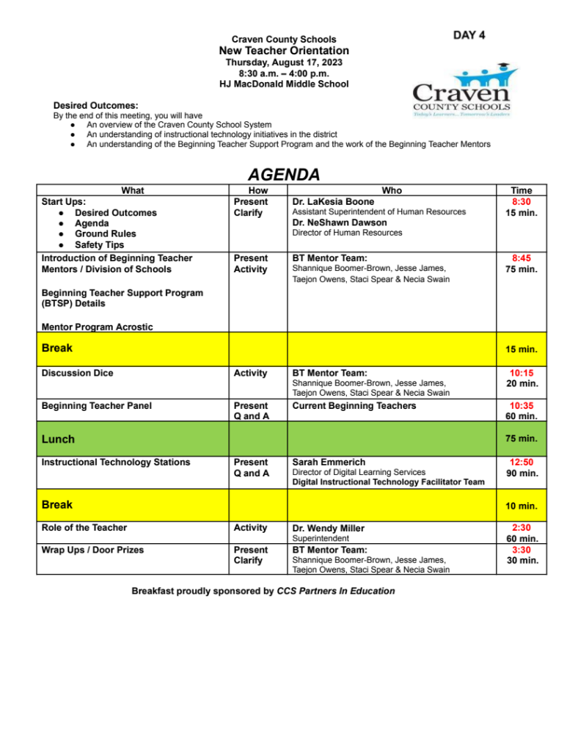
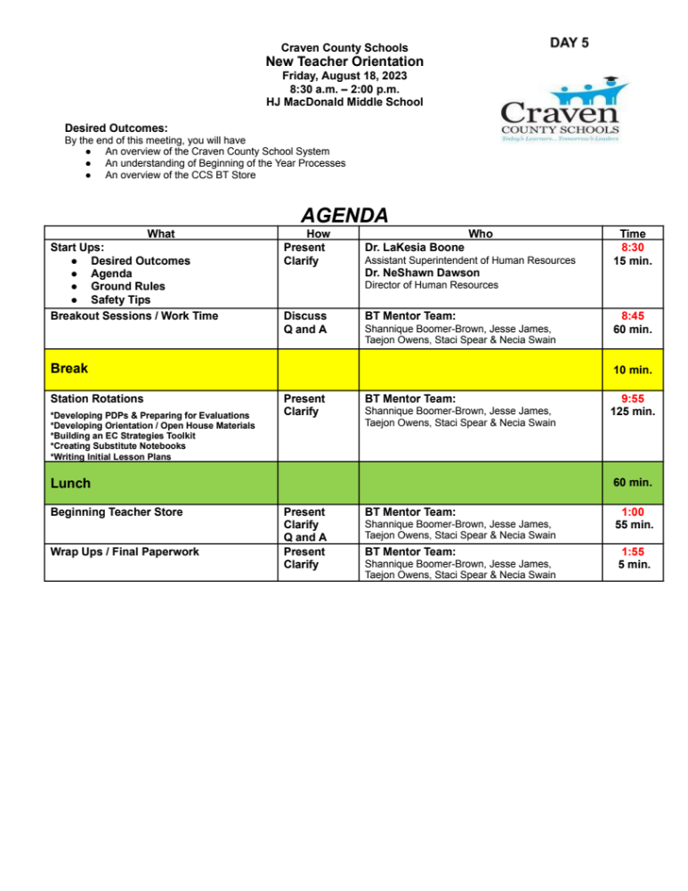

START-UPS

Welcome/Introductions Context-Purpose
Desired Outcomes
Agenda
Roles
Ground Rules Bin
Safety Tips

CRAVEN COUNTY SCHOOLS

Ground Rules For Meetings

Post and approve the agenda Listen as an ally
One person speaks at a time Respect each other Everyone participates
Stay on task Start and stop on time
Schedule appropriate breaks Evaluate at end of each meeting

Overview of
Craven County Schools

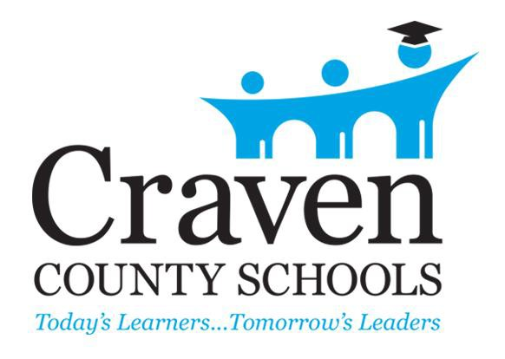

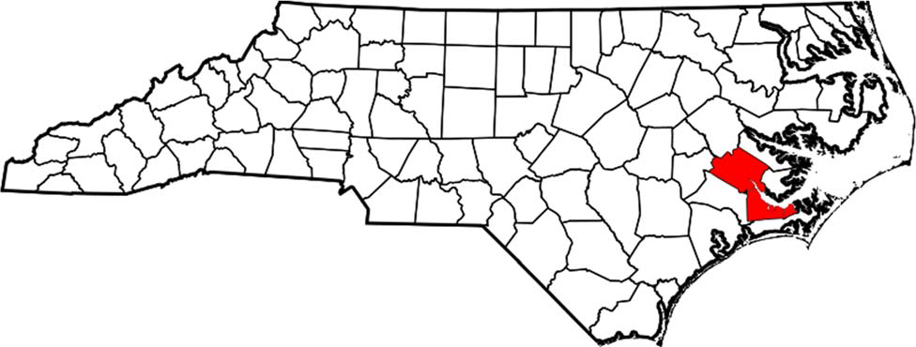

Craven County is located midway along North Carolina’s coastal fringe. Located approximately 40 miles from the coast, the district covers approximately 695 square miles with a total population of 104,770 residents.

Our Vision
We envision a public education system that challenges all students as learners and prepares them to imagine and create a successful life; values educators and empowers them to inspire and spark innovation in every student; leads in education and community engagement; and invites all students, their families, and all members of the community to work together to support public education to the benefit of our students, our community, our nation and our world.

Our Mission
Together with OUR families and community, Craven County Schools will educate all learners to personal, professional, and civic success through challenging and personalized instruction.

Strategic Priorities Goal I – The Learner Goal II – The Educator
Goal III – Teaching and Learning
Goal IV – Instructional Data Information System Goal V – Community Engagement and Leadership Goal VI – Operations and Resources
Goal VII – Digital Resource Purchasing Standards

Core Values
Visionary Leadership Student-Centered Excellence
Organizational Learning and Agility Valuing People
Focus on Success Managing for Innovation Management by Fact Societal Responsibility
Delivering Value and Results
Ethics and Transparency
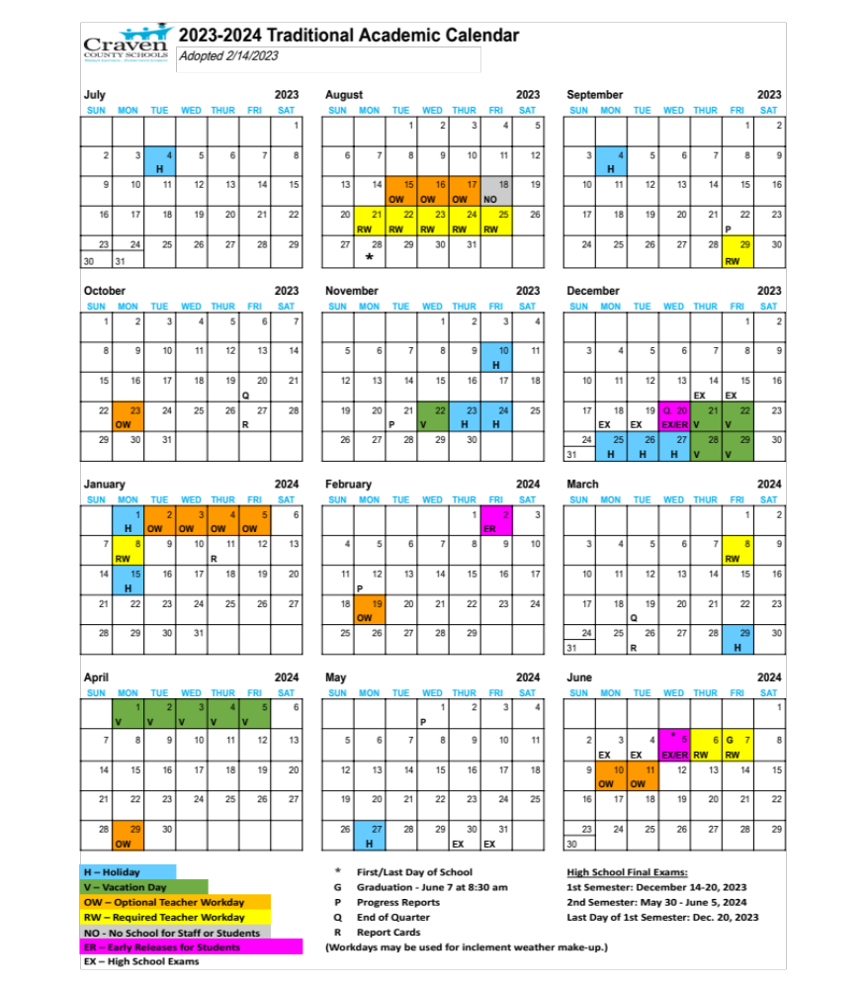
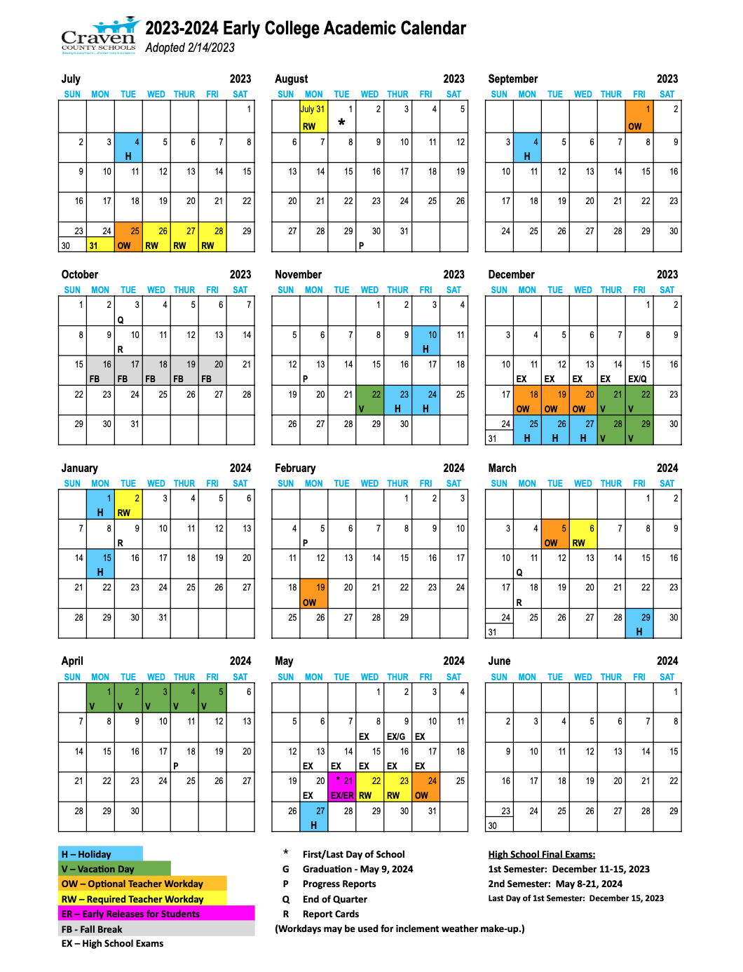

Baldrige
(PDSA/Continuous Improvement)

Baldrige National Quality Program

History

The Malcolm Baldrige National Quality Award was signed into law on August 20, 1987, and created by Public Law 100-107. It was named for Malcolm Baldrige, who served as Secretary of Commerce during the Reagan administration from 1981 until his death in 1987. The program first began in business and then expanded to health care and education in 1998. A public non-profit sector has recently been added.

What is the purpose of the quality award in education?

- Promote quality in education awareness
- Recognize quality achievement in education
- Publicize successful educational strategies
- Help improve educational performance practices, capabilities, and results
- Facilitate communication and sharing of educational best practices
- Serve as a framework for understanding how to lead and manage high performance and guide planning and opportunities for improvement
- Provide districts and schools with a systems approach to improvement

Why did Craven County adopt Baldrige as its systems approach to improvement?

The federal No Child Left Behind Act required all states to:

- Set high standards of achievement
- Create a system to identify and share teaching methods that work
- Create a system of accountability to measure results

Craven County Schools is committed to meeting all state, federal, and district requirements and expectations to assure a quality learning system is in place for all students.

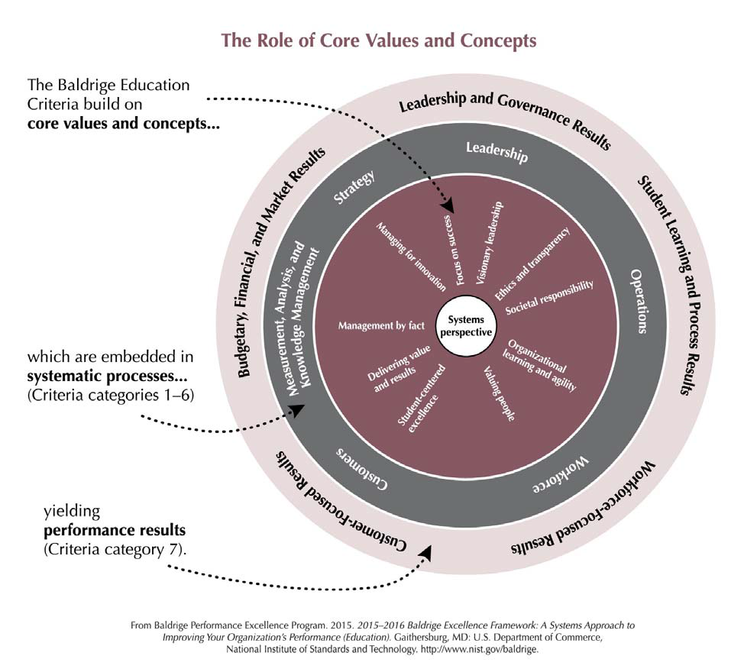

PDSA / Continuous Improvement

ACT
PLAN

STUDY DO

PDSA (Plan, Do, Study, Act) refers to a four‐step improvement cycle for organizing and managing change and continuous improvement. The PDSA cycle is a strategy that can be used to encourage groups to determine goals, monitor progress, and make rapid changes when results are not achieved. The PDSA cycle for continuous improvement can be utilized by the class as a whole or individual students to:

- determine areas that need to be improved to guide the development of an improvement plan (Plan)
- implement the improvement plan (Do)
- analyze whether or not the improvement strategy is making a difference (Study)
- use the data to make decisions (Act)

When acting upon the results of the PDSA cycle, it is equally important to sustain an action that brings the desired results as it is to reinitiate the PDSA cycle when the desired results are not obtained.

Craven County
Policies

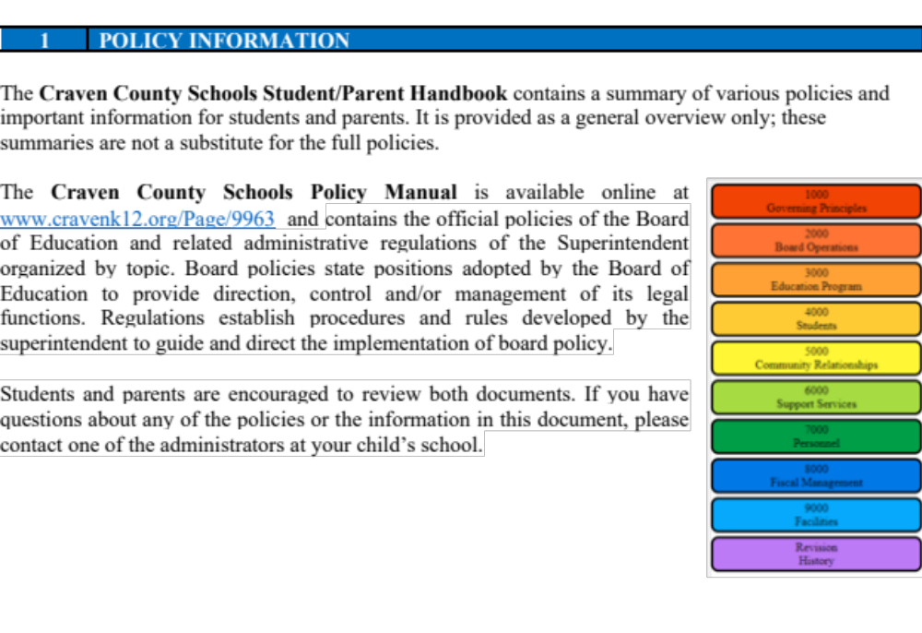


Policy Review for the 2023-2024 School Year

** a more extensive policy review will take place at your school site**

Workday and Overtime – 7500
Leave – 7510
Excessive Absenteeism – 7515
Smoking and Tobacco Products– 5026/7250
Drug-Free and Alcohol-Free Workplace – 7240
Employee Dress and Appearance – 7340
Responding to Concerns – 1742/5060
Student and Parent Grievance Procedure – 1740/4010
with - Prohibition Against Discrimination, Harassment and Bullying
with - Discrimination, Harassment and Bullying Complaint Procedure
Prohibition Against Retaliation – 1760/7280
Technology Responsible Use – 3225/4312/7320
School Volunteers - 5015
Occupational Exposure To Bloodborne Pathogens – 7260
Communicable Diseases – Employees - 7262
Student Health Services – 6120
Concussion and Head Injury – 4270-6145
Administering Medicines to Students – 6125
School Trips – 3320
Employee Use of Social Media –7335
Staff Responsibilities
Duty to Report Child Abuse and Neglect (NCGS 7B-301)

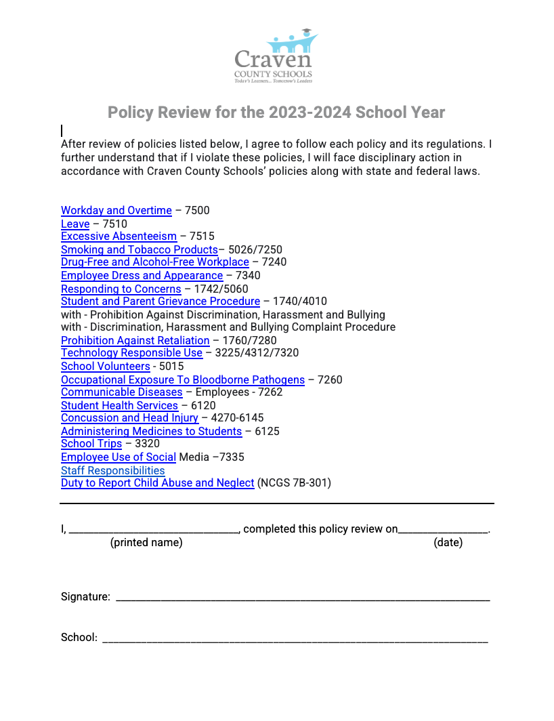

Evaluation
Information

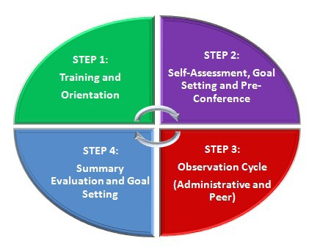
Teacher Evaluation Process

4 Stages of the Evaluation Process
8 Components within the process

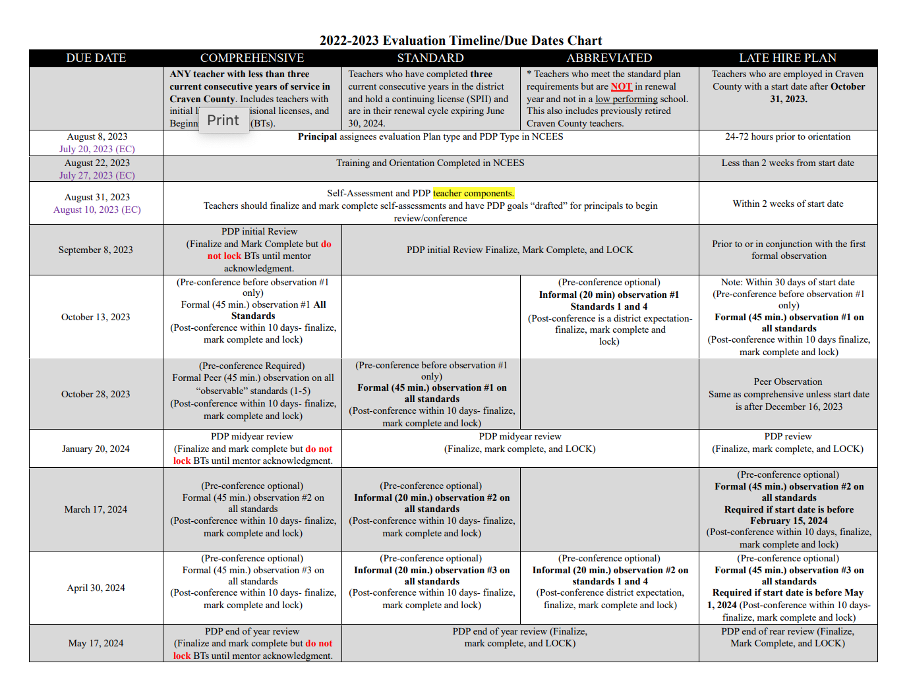
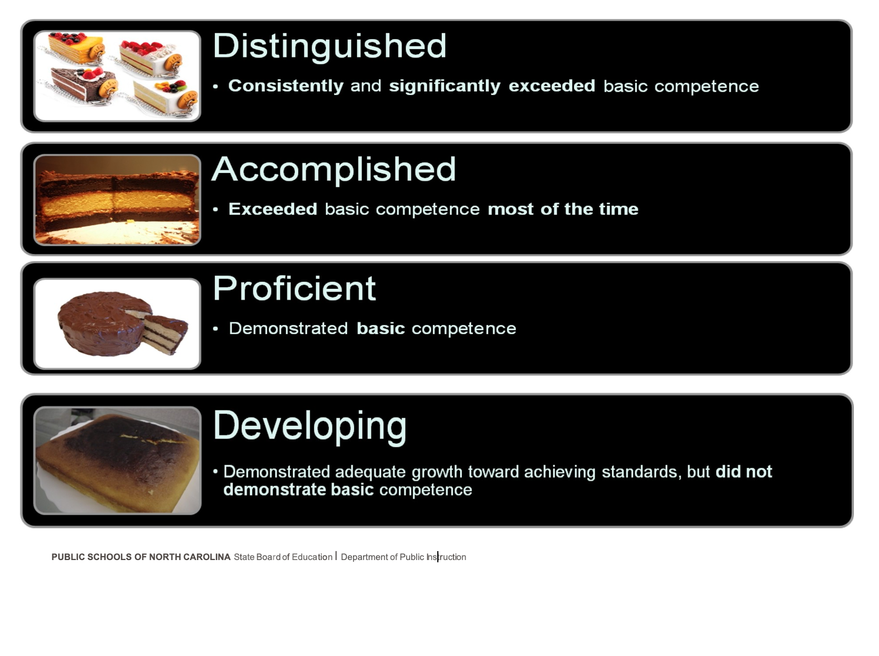

Teacher Performance Appraisal process

Item | Description
Policy Title | Teacher Performance Appraisal process
Policy Category | Evaluations & Qualifications (EVAL)
Policy ID | EVAL-004
Policy Date | 2016-04-07
Previous Policy Dates | 07/07/1987, 07/11/1996, 11/05/1998,10/02/2008, 08/04/2011,  09/01/2011, 02/05/2015, 12/03/2015
Statutory Reference | GS 115C-333

Formerly TCP-C-004

Purpose

The intended purpose of the North Carolina Teacher Evaluation Process is to assess the teacher’s performance in relation to the North Carolina Professional Teaching Standards and to design a plan for professional growth. The principal or a designee (hereinafter “principal”) will conduct the evaluation process in which the teacher will actively participate through the use of self- assessment, reflection, presentation of artifacts, and classroom demonstration(s).
A local board shall use the North Carolina Professional Teaching Standards and North Carolina Teacher Evaluation Process unless it develops an alternative evaluation that is properly validated and that includes standards and criteria similar to those in the North Carolina Professional Teaching Standards and North Carolina Teacher Evaluation Process.
The North Carolina Teacher Evaluation Process shall be conducted annually, according to one of the following cycle types: The North Carolina Professional Teaching Standards are:
Standard I: Teachers Demonstrate Leadership
Standard II: Teachers Establish a Respectful Environment for a Diverse Population of Students Standard III: Teachers Know the Content They Teach
Standard IV: Teachers Facilitate Learning for Their Students Standard V: Teachers Reflect on Their Practice
The North Carolina Teacher Evaluation process shall be conducted annually, according to one of the following cycle types:
Comprehensive Evaluation Cycle

Teacher Self-Assessment

Professional Development Plan

Formal Observation (with pre and post-conference)

Formal Observation (with post-conference)

Formal Observation (with post-conference)

Peer Observation (with post-conference)

Summative Evaluation Conference

Summary Rating Form

Standard Evaluation Cycle

Teacher Self-Assessment

Professional Development Plan

Formal Observation (with pre and post-conference)

Observation (Formal or Informal)

Observation (Formal or Informal)

Summative Evaluation Conference

Summary Rating Form

Abbreviated Evaluation Cycle

Teacher Self-Assessment

Professional Development Plan

Observation on Standards 1 and 4 (Formal or Informal)

Observation on Standards 1 and 4 (Formal or Informal)

Summative Evaluation Conference on Standards 1 and 4

Summary Rating Form on Standards 1 and 4

Process
The North Carolina Teacher Evaluation Process shall include the following components:
Component 1: Training
Before participating in the evaluation process, all teachers, principals and peer evaluators must complete training on the evaluation process.
Component 2: Orientation
Within two weeks of a teacher’s first day of work in any school year, the principal will provide the teacher with a copy of or directions for obtaining access to a copy of:
  - The Rubric for Evaluating North Carolina Teachers;
  - This policy; and
  - A schedule for completing all the components of the evaluation process. Copies may be provided by electronic means.
Component 3: Teacher Self-Assessment
Using the Rubric for Evaluating North Carolina Teachers, the teacher shall rate his or her own performance at the beginning of the year and reflect on his or her performance throughout the year.
Component 4: Pre-Observation Conference
Before the first formal observation, the principal shall meet with the teacher to discuss the teacher’s self- assessment based on the Rubric for Evaluating North Carolina Teachers, the teacher’s most recent professional growth plan, and the lesson(s) to be observed. The teacher will provide the principal with a written description of the lesson(s). The goal of this conference is to prepare the principal for the observation. Pre-Observation conferences are not required for subsequent observations.
Component 5: Observations
- A formal observation shall last at least forty-five minutes or an entire class period. An informal observation shall be at least 20 minutes in duration
- New teachers who have not been employed for at least three consecutive years
  - The principal shall conduct a Comprehensive Evaluation Cycle which includes at least three formal observations

of all new teachers.
  - A peer shall conduct one formal observation of a new teacher.
- Experienced Teachers (including those with career status) who have been employed for three or more years
  - The principal shall conduct observations in accordance with one of the evaluation cycle types above for all teachers with greater than three years of experience.
During observations, the principal and peer (in the case of a new teacher) shall note the teacher’s performance in relationship to the applicable Standards on the Rubric for Evaluating North Carolina Teachers. Additional observations may occur at the discretion of the principal consistent with local board of education policy.
Component 6: Post-Observation Conference
The principal shall conduct a post-observation conference no later than ten school days after each formal observation. During the post-observation conference, the principal and teacher shall discuss and document on the Rubric the strengths and weaknesses of the teacher’s performance during the observed lesson.
Component 7: Summary Evaluation Conference and Scoring the Teacher Summary Rating Form

Prior to the end of the school year and in accordance with LEA timelines, the principal shall conduct a summary evaluation conference with the teacher. During the summary evaluation conference, the principal and teacher shall discuss the teacher’s self-assessment, the teacher’s most recent Professional Growth Plan, the components of the North Carolina Teacher Evaluation Process completed during the year, classroom observations, artifacts submitted or collected during the evaluation process and other evidence of the teacher’s performance on the Rubric.
At the conclusion of the North Carolina Teacher Evaluation Process, the principal shall:
- Give a rating for each Element in the Rubric;
- Make a written comment on any Element marked “Not Demonstrated”;
- Give an overall rating of each Standard in the Rubric;
- Provide the teacher with the opportunity to add comments to the Teacher Summary Rating Form;
- Review the completed Teacher Summary Rating Form with the teacher; and
- Secure the teacher’s signature on the Record of Teacher Evaluation Activities and Teacher Summary Rating Form.
Component 8: Professional Development Plans
Individual Growth Plans
Teachers who are rated at least “Proficient” on all the Standards on the Teacher Summary Rating Form shall develop an Individual Growth Plan designed to improve performance on specifically identified Standards and Elements.
Monitored Growth Plans
A teacher shall be placed on a Monitored Growth Plan whenever he or she:
- Is rated “Developing” on one or more Standards on the Teacher Summary Rating Form; and
- Is not recommended for dismissal, demotion or nonrenewal.
A Monitored Growth Plan shall, at a minimum, identify the Standards and Elements to be improved, the goals to be accomplished and the activities the teacher should undertake to achieve Proficiency, and a timeline which allows the teacher one school year to achieve Proficiency. A Monitored Growth Plan that meets those criteria shall be deemed to satisfy the requirements of N.C. Gen. Stat. § 115C-333(b).
Directed Growth Plans

A teacher shall be placed on a Directed Growth Plan whenever he or she:
  - Is rated
    - Not Demonstrated” on any Standard on the Teacher Summary Rating Form; or
    - “Developing” on one or more Standards on the Teacher Summary Rating Form for two sequential years; and
  - Is not recommended for dismissal, demotion or nonrenewal.
The Directed Growth Plan shall, at a minimum, identify the Standards and Elements to be improved, the goals to be accomplished, the activities the teacher shall complete to achieve Proficiency, a timeline for achieving Proficiency within one school year or such shorter time as determined by the LEA. A Directed Growth Plan that meets those criteria shall be deemed to satisfy the requirements of N.C. Gen. Stat. § 115C-333(b).

Component 9: Effective Dates and Effect on Licensing
Effective with the 2008-2009 school year, LEAs may evaluate teachers using this policy.
Effective with the 2010-2011 school year, all teachers in North Carolina will be evaluated using this policy unless a local board develops an alternative evaluation that is properly validated and that includes standards and criteria similar to those in the North Carolina Professional Teaching Standards and North Carolina Teacher Evaluation Process in which case the local board shall use that instrument.
Beginning Teachers
Effective with the 2016-2017 school year, initially teachers must teach three years in order to move from an Initial to Continuing License.
Process for Abbreviated Annual Evaluations
The annual evaluation requirement for experienced teachers (including those with career status), who have been employed for three or more years can be met through either, a comprehensive, standard, or an abbreviated evaluation cycle.
An abbreviated evaluation cycle consists of evaluator ratings only on Standards One and Four of the Teacher Evaluation Process.
The abbreviated evaluation process for Standards One and Four remains consistent with the Teacher Evaluation Process described above with the exception of the requirement for observations.
Teachers receiving an abbreviated evaluation should receive two informal observations of a minimum of twenty minutes
each. Observers shall note the teacher’s performance in relationship to Standards One and Four on the Rubric for Evaluating North Carolina Teachers.
Teachers receiving an abbreviated evaluation may request that the evaluator conduct a formal observation as described above.
Process for Evaluation of Licensed Staff in Low-Performing Schools
For schools designated as low performing, school administrators shall evaluate, as early in the school year as possible, all licensed employees for the purpose of providing adequate time for the development and implementation of a mandatory improvement plan.
The evaluation of licensed staff in a low-performing school shall consist of the prior year summative evaluation (where available), all available student-growth data (EVAAS or ASW, if applicable), the staff member’s Professional Development Plan (PDP), a pre-observation conference (as defined in Component 4 of this policy), a formal observation (as defined in Component 5 of this policy), and a post-observation conference (as defined in Component 6 of this policy).
Based on the formal observation and other available evaluation data, the administrator shall assign performance ratings in accordance with Component 7 of this policy. If the licensed staff member is determined to have an area of deficiency (less than “Proficient” on Standards 1-5, then the evaluator shall recommend to the superintendent that:

the employee receive a mandatory improvement plan, or

the employee be dismissed, demoted, or not be recommended for contract renewal, or

the employee be removed immediately for conduct that causes substantial harm to the educational environment, or

no recommendation be made (with explanation to superintendent).

If a mandatory improvement plan is recommended for a licensed staff member, then the PDP may function as the mandatory improvement plan provided it addresses all areas of deficiency surfaced by the evaluation and contains recommendations and specific supports for satisfactorily resolving such deficiencies. A PDP that meets those criteria shall be deemed to satisfy the requirements of N.C. Gen. Stat. § 115C-333(b).
Licensed staff with no deficiencies in practice documented in their evaluations may return to the appropriate evaluation plan type (Comprehensive, Standard, or Abbreviated) for the remainder of the school year. The evaluation process described above does not meet the requirements of an annual evaluation for licensed staff, but can be used to satisfy one observational requirement for an annual evaluation.
LEAs that recommend a licensed staff member for dismissal or demotion should consult their local board attorney and follow the procedures outlined in N.C. Gen. Stat. § 115C-333(b)(2a).

Beginning
Teacher Support

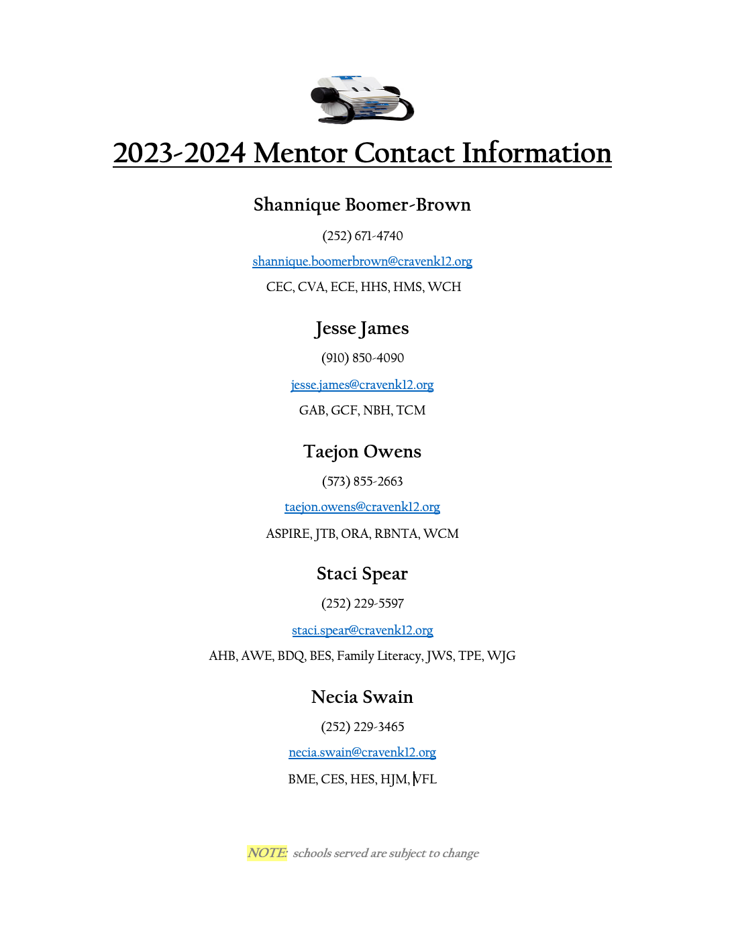

Mentoring Goals
- District Lead Mentors will provide and maintain consistent and supportive communication.
- District Lead Mentors will establish positive and trusting relationships.
- District Lead Mentors will support and assist in the areas of organization, collaboration, classroom management and instructional practice.
- District Lead Mentors will share relevant professional and instructional resources.
- District Lead Mentors will serve as advocates.

Mentor Services:

Provide guidance and motivational support

Offer classroom management strategies

Assist with parent conferences

Write letters of recommendation

Provide relevant educational
websites/resources/articles

Assist with clerical services

Provide emergency coverage

Assist with differentiation of instruction

Conduct informal classroom observations

Provide guidance in disaggregating data

Assist with New Teacher Orientation

Maintain and submit BT contact logs

Create and disseminate BT newsletters

Provide guidance in the completion of self-assessment and the development of PDPs

Serve as a liaison with Central Services, Administration and Partners In Education

Plan activities that correlate with the standards

Survey BTs

Model professionalism

Provide short breaks

Listen supportively

Assist with grant writing

Help BTs locate needed forms

Recognize BT successes

Disseminate lightbulbs and manage the BT store

Monitor BT workload

Provide local monthly trainings and notify BTs of other available PD opportunities

Facilitate reflective dialogue

Provide effective communication strategies to foster collaboration

Serve as BT support during team, grade level and/or curriculum planning

Encourage rigor and relevance

Verse teachers on the expectations of regular course curriculum vs Honors/AP course curriculum

Promote high expectations

Offer suggestions for remediation and enrichment

Communicate Residency requirements

Serve as a mediator for BT issues

Support technology needs
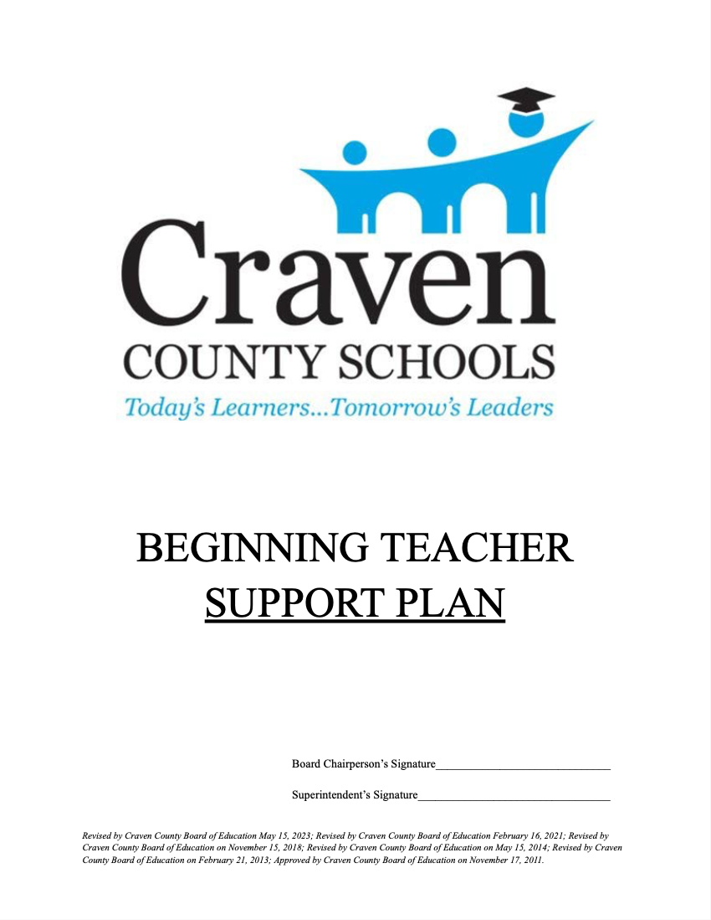

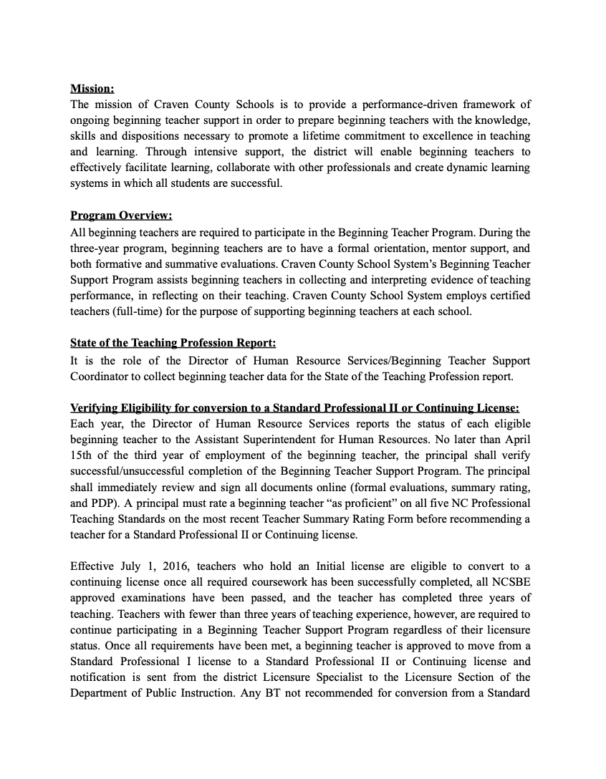
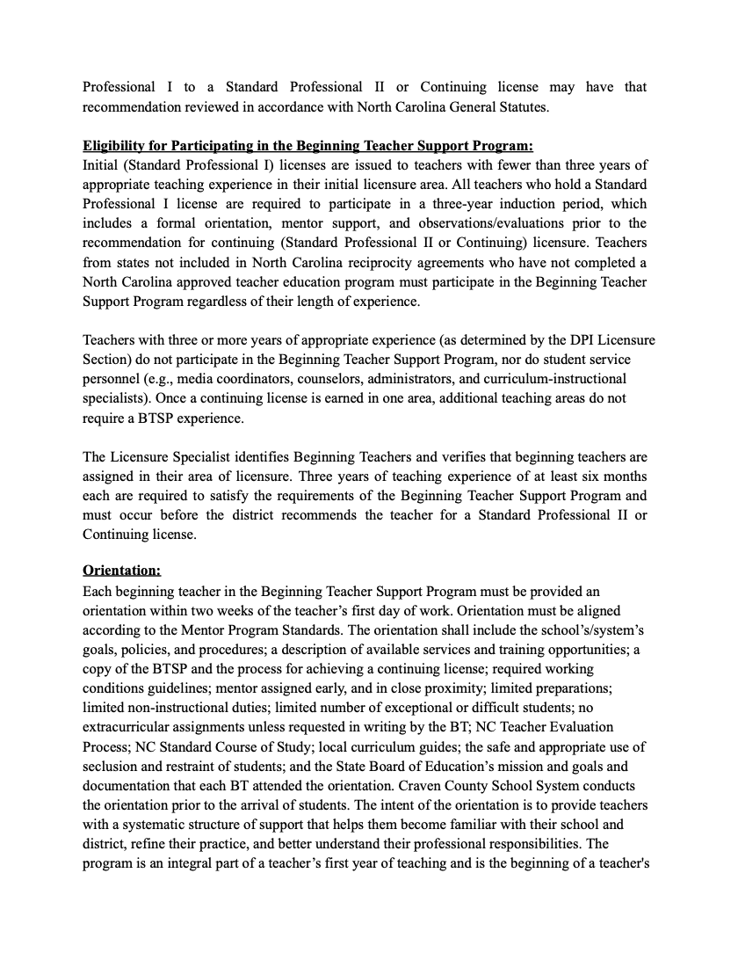
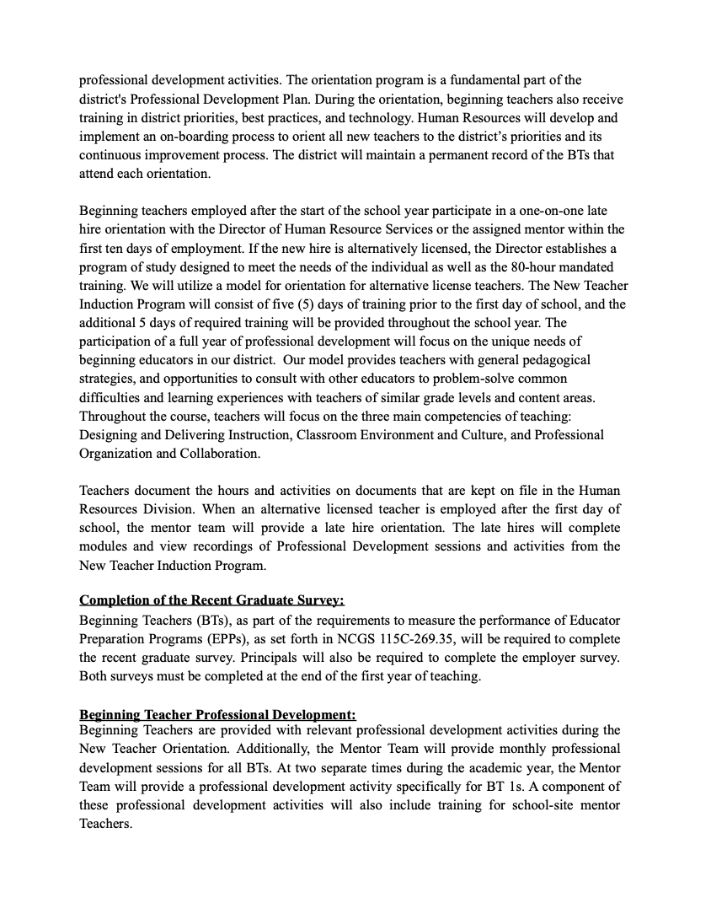
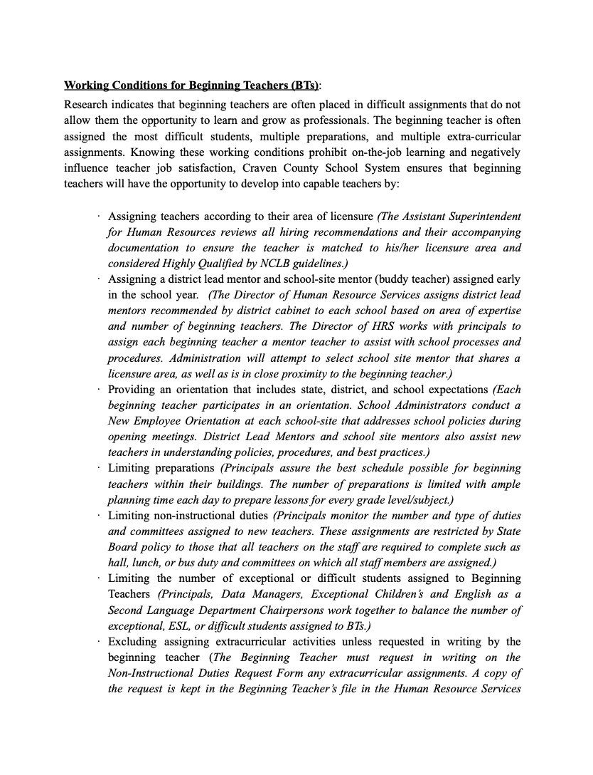

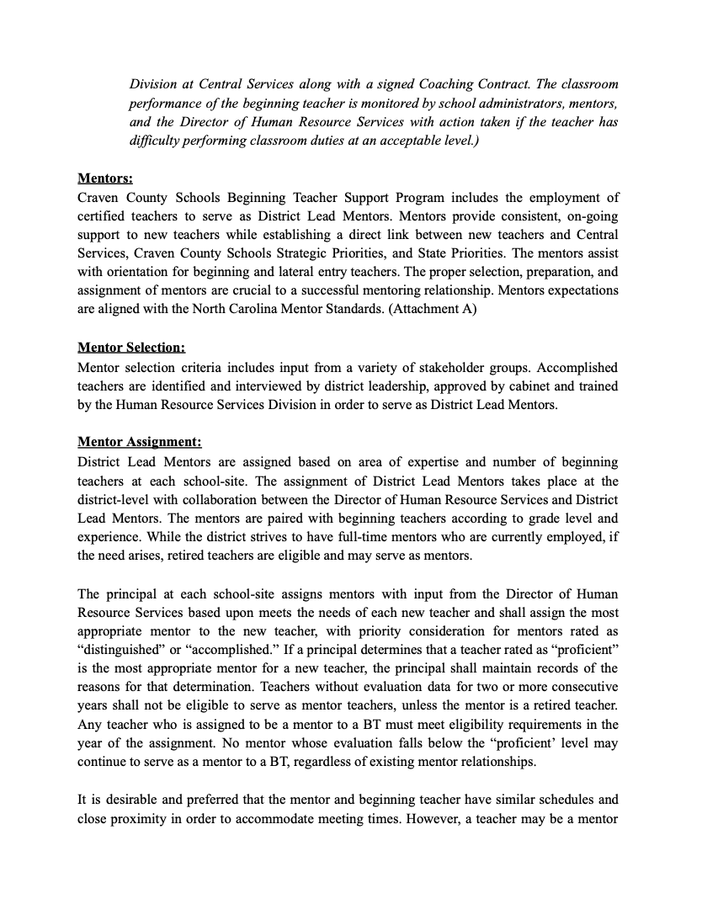

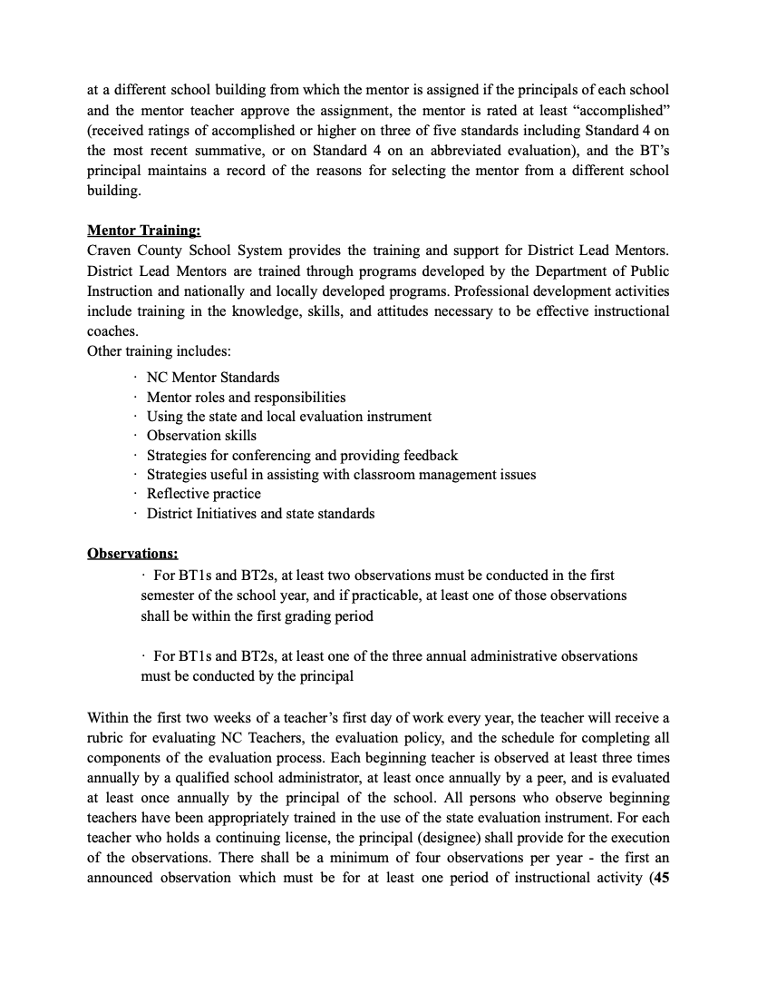



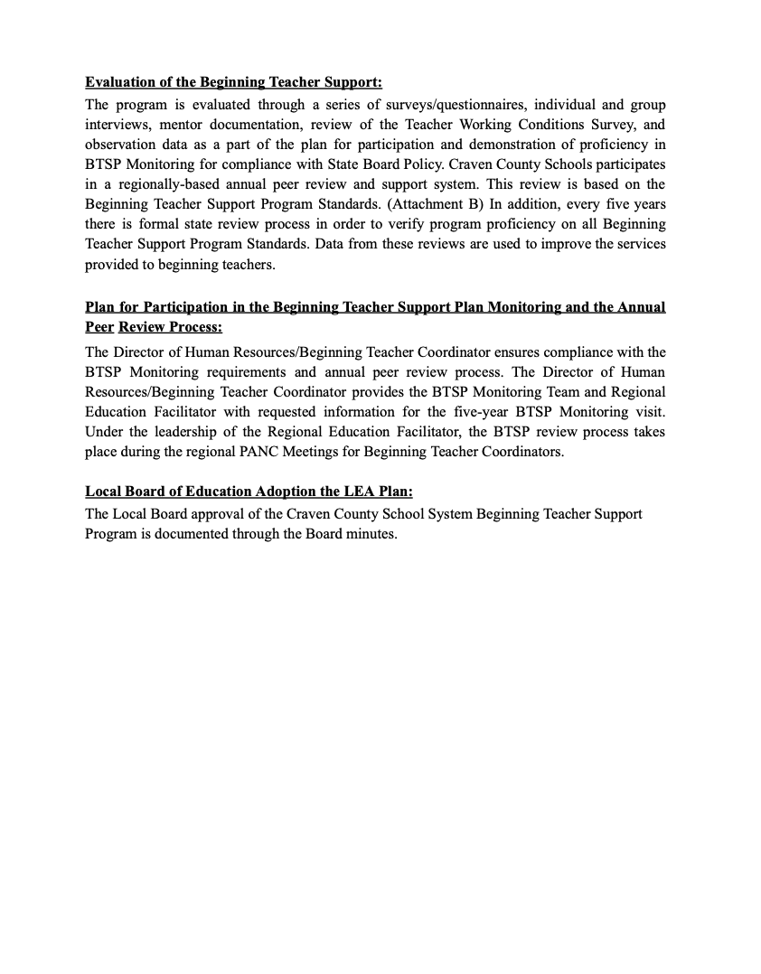

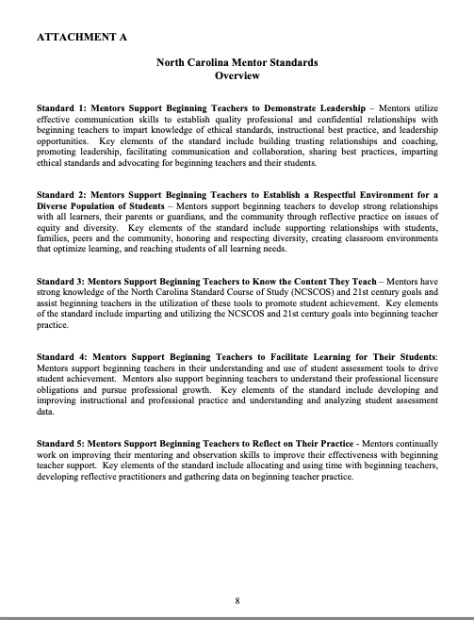



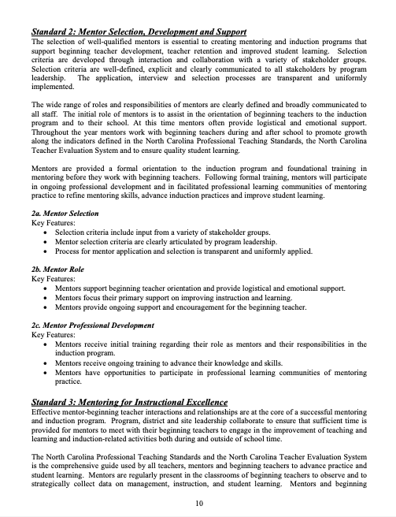

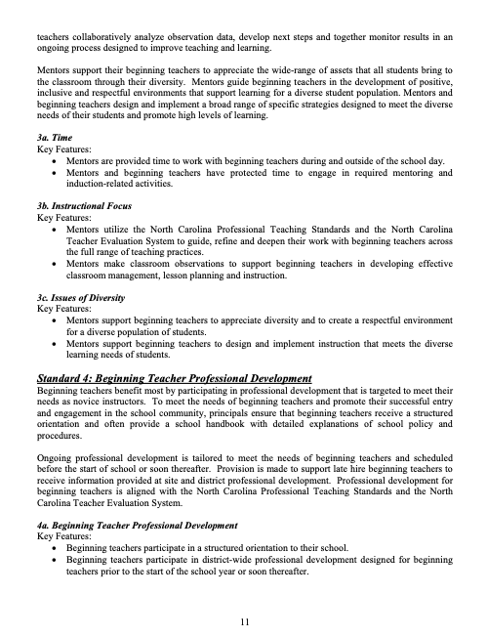

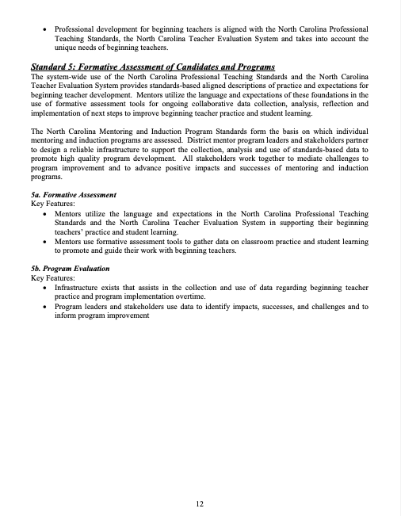

14





Beginning Teacher Information Sheet

Name:

Address:

Phone/Cell #:

Text Capability? Yes / No

Email: . @cravenk12.org

Birth date:

School:

Subject/Grade:

Current Status: BT0 BT1 BT2 BT3

Alternate License: YES or NO

Planning Period:

Notes:

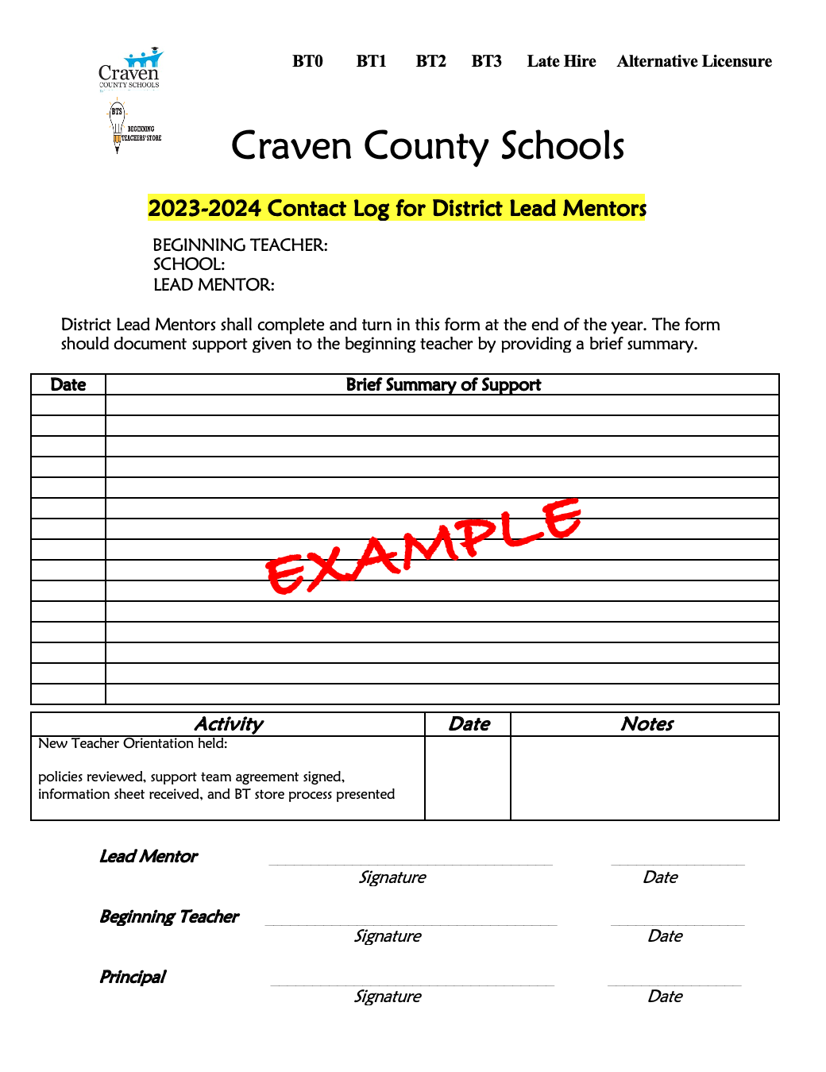
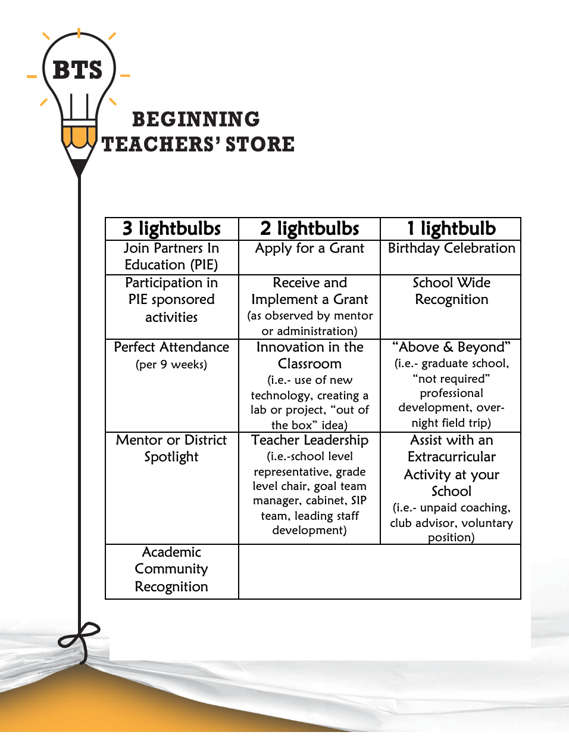

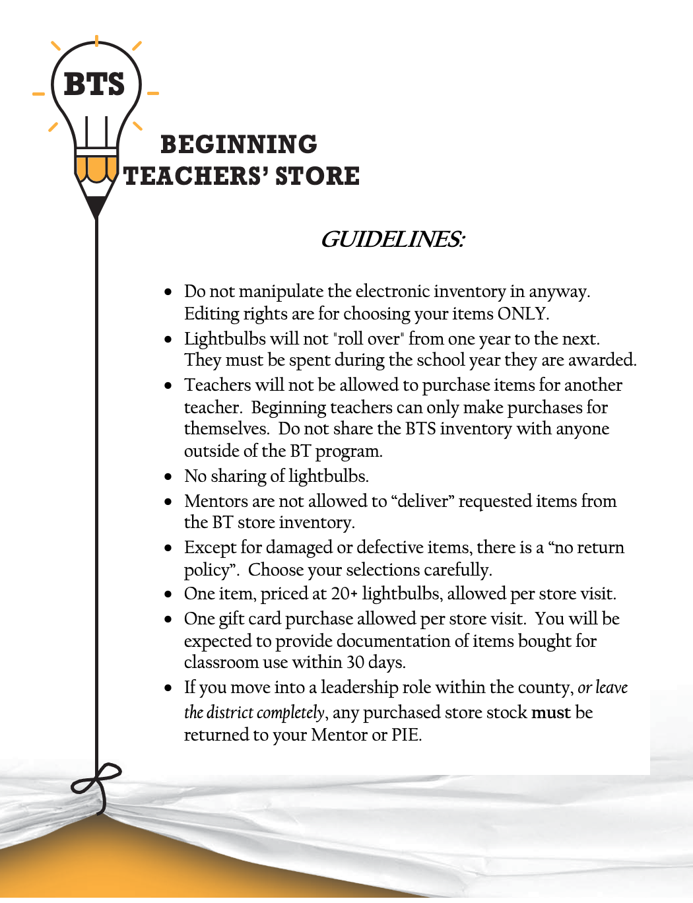



NORTH CAROLINA MENTOR PROGRAM

BEGINNING TEACHER GUIDELINES FOR THE 21ST CENTURY PROFESSIONAL


Educator Recruitment and Development Division September 2010

Definitions
- Beginning Teacher - Teachers who are in their first three years of teaching and who hold a Standard Professional 1 License

- Career Teachers - Teachers who have received a Standard Professional 2 license

- Formal Observation – an observation of a teacher’s performance for a minimum of 45 minutes or one complete lesson

- Performance Standard – The distinct aspect of leadership or realm of activities which form the basis for the evaluation of a teacher

- Performance Elements – The sub-categories of performance embedded within the performance standard

- Performance Descriptors – The specific performance responsibilities embedded within the components of each performance standard

- Performance Goals - Goals for improvement in professional practice based on the self- evaluation and/or supervisor recommendation

- Developing – Demonstrated adequate growth but did not demonstrate competence on standard(s) of performance

- Proficient – Demonstrated basic competence on standard(s) for performance

- Accomplished – Exceeded basic competence on standard(s) of performance most of the time

- Distinguished - Consistently and significantly exceeded basic competence on standard(s) of performance

- Self-assessment – Personal reflection about one’s professional practice to identify strengths and areas for improvement (conducted w/out input from others)

- Informal Observation - an informal observation may take place as an evaluator visits classrooms, helps a student, or "drops in" on the teacher's classroom for a minimum of 20 minutes in one sitting

Active Mentoring – Beginning Teacher Guidelines for the 21st Century Professionals
Underlying the Mentor Standards are the personal and professional habits and dispositions of a mentor that allow him or her to serve effectively in the role. As school leaders consider who should serve as a mentor, it is encouraged to select mentors who demonstrate the following attributes:


A sense of optimism for teaching; Ability to listen well;

Capacity to engage in reflective dialogue that nurtures the independent ability of a beginning teacher to assess and enhance his or her practice;
Commitment to continuous professional development;

Desire to serve all students equitably regardless of socio-economic status, first language, exceptionality or race;
Facility to adapt instructional methods to the individual needs of students; Commitment to collaboration; and
Ability to utilize multiple types of assessment of student work and adapt instruction from the analysis of assessment data.

Mentors should have a demonstrated record of success on the North Carolina Teacher Evaluation and the support of school leadership and their peers. Mentors willing to serve need to work in an environment that facilitates their success, including close proximity and scheduling that allows time to plan and collaborate with beginning teachers.

North Carolina Mentor Standards Overview

Standard 1: Mentors Support Beginning Teachers to Demonstrate Leadership – Mentors utilize effective communication skills to establish quality professional and confidential relationships with beginning teachers to impart knowledge of ethical standards, instructional best practice, and leadership opportunities. Key elements of the standard include building trusting relationships and coaching, promoting leadership, facilitating communication and collaboration, sharing best practices, imparting ethical standards and advocating for beginning teachers and their students.

Standard 2: Mentors Support Beginning Teachers to Establish a Respectful Environment for a Diverse Population of Students – Mentors support beginning teachers to develop strong relationships with all learners, their parents or guardians, and the community through reflective practice on issues of equity and diversity. Key elements of the standard include supporting relationships with students, families, peers and the community, honoring and respecting diversity, creating classroom environments that optimize learning, and reaching students of all learning needs.

Standard 3: Mentors Support Beginning Teachers to Know the Content They Teach – Mentors have strong knowledge of the North Carolina Standard Course of Study (NCSCOS) and 21st century goals and assist beginning teachers in the utilization of these tools to promote student achievement. Key elements of the standard include imparting and utilizing the NCSCOS and 21st century goals into beginning teacher practice.

Standard 4: Mentors Support Beginning Teachers to Facilitate Learning for Their Students: Mentors support beginning teachers in their understanding and use of student assessment tools to drive student achievement. Mentors also support beginning teachers to understand their professional licensure obligations and pursue professional growth. Key elements of the standard include developing and improving instructional and professional practice and understanding and analyzing student assessment data.

Standard 5: Mentors Support Beginning Teachers to Reflect on Their Practice - Mentors continually work on improving their mentoring and observation skills to improve their effectiveness with beginning teacher support. Key elements of the standard include allocating and using time with beginning teachers, developing reflective practitioners and gathering data on beginning teacher practice.

Mentor Standard 1: Mentors support beginning teachers to demonstrate leadership.

1a Trusting Relationship and Coaching
- Mentors establish and maintain confidential relationships with beginning teachers.
- Mentors develop a range of coaching skills to support beginning teachers.
- Mentors adapt their use of coaching skills and strategies to effectively support beginning teachers.

1b Leadership
- Mentors ensure that beginning teachers are aware of leadership opportunities.
- Mentors encourage and support beginning teachers to engage in leadership at the school and district levels.
- Mentors guide beginning teacher’s reflection on leadership experiences to promote leadership development.

1c Communication and Collaboration
- Mentors utilize effective communication skills with beginning teachers.
- Mentors support beginning teachers to develop effective communication skills in collaborative interactions with colleagues and administration.
- Mentors support beginning teachers to engage in collaborative dialogue to improve professional practice and school effectiveness.

1d Best Practices
- Mentors possess knowledge of best practices with a primary focus on student learning.
- Mentors provide resources for and modeling of best practices for beginning teachers.
- Mentors support beginning teachers’ implementation of best practices.

1e Ethical Standards
- Mentors are knowledgeable about the ethical and professional standards.
- Mentors demonstrate ethical and professional behavior in interactions with beginning teachers, staff, administration, community members and students.
- Mentors initiate collaborative dialogue with beginning teachers regarding ethical and professional behavior

1f Advocacy for Beginning Teachers and Students
- Mentors advocate for beginning teachers to ensure they have appropriate instructional resources and supportive working conditions.
- Mentors coach beginning teachers on methods of advocacy for themselves and their students.
- Mentors advocate for initiatives and policies to improve education for all students and promote positive change practices.

Mentor Standard 2: Mentors support beginning teachers to establish a respectful environment for a diverse population of students.

2a Relationships with Students
- Mentors support beginning teachers to be aware of the importance of building strong relationships with their students and share ways to get to know them.
- Mentors provide beginning teachers with strategies and methods to communicate effectively with students in a variety of settings and situations.
- Mentors collaborate with beginning teachers to assess the effectiveness of communications and interactions with students and their impact on relationships and learning.

2b Relationships with Families
- Mentors support beginning teachers to develop relationships with families and significant adults in the lives of their students
- Mentors collaborate with beginning teachers to design and implement effective ways of connecting and communicating with parents and guardians in formal and informal settings.
- Mentors facilitate the beginning teacher’s development of methods to support inclusion of families in the on-going process of identifying and improving student achievement.

2c Relationships at School and in Community
- Mentors assist beginning teachers in learning about the context of the school and community.
- Mentors support beginning teachers to meet and engage with school colleagues and partners in the community.
- Mentors support beginning teachers to develop activities that foster positive collaboration between school and community.

2d Honor and Respect for Diversity
- Mentors support beginning teachers to know the cultural, ethnic, gender and socioeconomic characteristics of their classroom, the school and the community.
- Mentors collaborate with beginning teachers to expand self-awareness regarding issues of diversity as they impact teaching and learning.
- Mentors support beginning teachers to expand their awareness of culturally inclusive practices and to include them in planning, implementing, and reflecting on lessons.

2e Classroom Environments that Optimize Learning
- Mentors possess a broad knowledge of systems and techniques for classroom management.
- Mentors support beginning teachers in developing effective designs for classroom management to create and maintain a respectful inviting classroom community.
- Mentors support beginning teachers to better understand the specific behaviors of their students and ways to adjust strategies to meet student needs and maintain engagement in learning.

2f Reaching Students of all Learning Needs
- Mentors engage in dialogue with beginning teachers regarding the individual learning needs of their students and corresponding labels that might be assigned to them.
- Mentors support beginning teachers’ understandings of diversity and appropriate instructional strategies to meet individual learning needs.
- Mentors collaborate with beginning teachers to implement and assess differentiated lessons designed to meet learning needs and promote student success.

Mentor Standard 3: Mentors support beginning teachers to know the content they teach.

3a NCSCOS and 21st Century Goals
- Mentors demonstrate strong knowledge of NCSCOS for own grade levels/subjects and support beginning teachers to become knowledgeable of NCSCOS for their grade levels/subjects.
- Mentors demonstrate vertical alignment of NCSCOS so can understand where came from
- Mentors support beginning teachers to design lessons that integrate 21st century goals and skill development with NCSCOS and to reflect on implementation.
- Mentors support beginning teachers’ participation in professional learning communities focused on full implementation of NCSCOS and achievement of 21st century goals.

3b Content and Curriculum
- Mentors ensure that beginning teachers receive necessary NCSCOS and state/district curriculum resources.
- Mentors assist beginning teachers in the use and implementation of NCSCOS and required curriculum.
- Mentors collaborate with beginning teachers to develop standards-based short and long term curriculum plans that show application of content and connections to the lives of students.

Mentor Standard 4: Mentors support beginning teachers to facilitate learning for their students.

4a Instructional Practice
- Mentors support the planning, implementation and assessment efforts of beginning teachers.
- Mentors collaborate with beginning teachers to improve instruction and learning.
- Mentors provide additional assistance and professional development to beginning teachers in areas of need.

4b Professional Practice
- Mentors ensure that beginning teachers are fully aware of professional licensure requirements.
- Mentors model behaviors that demonstrate professional practice and support beginning teachers to pursue professional growth and to maintain professional practice.
- Mentors facilitate on-going dialogue with beginning teachers to reflect on and enhance professional practice.

4c Student Assessment
- Mentors support beginning teachers to have and use required student assessments.
- Mentors assist beginning teachers in the analysis of student assessment data from a variety of sources and to make adjustments in instructional delivery based on results.
- Mentors support beginning teachers to design and use student assessment tools to inform the planning of differentiated lessons that are responsive to identified student needs.

Mentor Standard 5: Mentors support beginning teachers to reflect on their practice.

5a Allocation and Use of Time with Beginning Teachers
- Mentors initiate making connections with beginning teachers and learning about their needs before or near the start of school or at the time of hire if later in the year.
- Mentors support beginning teachers to attend a program orientation and support clarification of program information.
- Mentors meet regularly with beginning teachers and focus their efforts on effective coaching and time management to meet individual needs.

5b Reflective Practice
- Mentors become highly skilled in the use of instructive, collaborative and facilitative approaches to coaching.
- Mentors support beginning teachers to reflect on practice and self identify their instructional strengths and challenges.
- Mentors collaborate with beginning teachers in the on-going improvement of teaching and learning through reflection.

5c Mentor Data Collection
- Mentors observe in beginning teachers’ classrooms to gather data and reflect on instructional practice.
- Mentors expand their repertoire of observation tools to be responsive to the needs and interests of beginning teachers.
- Mentors collaborate with beginning teachers to select a focus for data collection, to reflect on results, and plan next steps.

Beginning Teacher Support Program
Vision for Mentoring and Induction


The North Carolina Professional Teaching Standards establish a powerful vision for the roles of teachers in their classrooms and schools in the 21st century. The standards challenge teachers to:
Pursue leadership opportunities in their school, district, and community
Make the content they teach engaging, relevant, and meaningful to students’ lives
Teach existing core content that is revised to foster the abilities of students to think critically, problem solve and use information technology responsibly
 Nurture classroom environments that help students discover how to learn, innovate, collaborate, and communicate their ideas
Incorporate global awareness, civic literacy, financial literacy, and health awareness in the core content areas
Utilize interdisciplinary instructional approaches and relationships with home and community in the learning process
Reflect on their practice and craft assessments that are authentic and structured and place an emphasis on the demonstration of knowledge
Develop the value of lifelong learning and the joy of encouraging their students to learn and grow

The attainment of this vision is challenging for all educators and is particularly daunting for the newest teachers in the profession. Close to twenty-five percent, over 22,000, of North Carolina’s teachers are in their first three years in the profession. Of these beginning teachers, twenty-six percent, approximately 6,000, are starting their teaching careers prior to earning a Standard Professional I license. If the beginning teachers of North Carolina are going to be able to meet the state’s professional teaching standards, impact the learning of all students in distinguished ways, choose to remain in the profession and become future master teachers, teacher leaders and skilled administrators and superintendents, then a quality induction program to support the instructional growth of beginning teachers must be in place in each of the 115 school districts in the state.

Beginning Teacher Support Program Standards Overview
Standard 1: Systematic Support for High Quality Induction Programs – This standard is designed to promote the commitment of all stakeholders in seeing mentoring and induction programs succeed. Key program elements include the creation of an institutional plan, demonstrating institutional commitment and support and principal engagement.

Standard 2: Mentor Selection, Development, and Support – This standard articulates the process and criteria for mentor selection, discusses mentor roles and responsibilities, and delineates foundational mentor training. Key program elements include mentor selection, defining the role of mentors and mentor professional development.

Standard 3: Mentoring for Instructional Excellence – Mentors are given protected time to provide beginning teachers with support to achieve success in the areas set forth by the North Carolina Professional Teaching Standards. Key program elements include providing time for mentors and beginning teachers, ensuring mentoring is focused on instruction and addresses issues of diversity.

Standard 4: Beginning Teacher Professional Development: Professional development is provided to beginning teachers that orients them to their new career and supports their efforts to meet the North Carolina Professional Teaching Standards. Key program elements include structured orientation to school site and professional development designed to meet the unique needs of beginning teachers and aligned with the North Carolina Professional Teaching Standards and the North Carolina Teacher Evaluation System.

Standard 5: Formative Assessment of Candidates and Programs – New teachers and mentoring programs are monitored and supported using a formative assessment system to guide their work. Key program elements include formative assessment systems and program evaluation.

Standard 1: Systemic Support for High Quality Induction Programs
The commitment of all stakeholders, beginning teachers, mentors, faculty members, school level administrators, district-level administrators, school boards, State Boards of Education, Department of Public Instruction, post-secondary education institutions, professional organizations to the effectiveness, sustainability, and success of the mentoring and induction program is felt system-wide. Stakeholders foster a climate that values the support of beginning teachers through mentoring and induction and promote conditions for high quality mentoring and induction by evaluating, designing, and revising related policy and practices. Stakeholders support ongoing program improvement and accountability through multiple processes including data analysis and program review.

The leadership of the principal is instrumental in ensuring the success of mentoring and induction program at the site level. Principals establish and maintain a positive school environment that supports mentor-beginning teacher interactions and targeted professional development. Principals provide clear and consistent communication to staff regarding the role of mentor and the multiple facets of mentoring, including the essential component of confidentiality.

1a. Institutional Plan
Key Features:
- Plan is approved by the Board of Education
- Plan is based on State Board Policy
- Plan clearly outlines responsibilities and procedures for all stakeholders

1b. Institutional Commitment and Support
Key Features:
- Stakeholders acknowledge the value and importance of mentoring and induction.
- Stakeholders appoint and support designated leadership for oversight of the mentoring and induction program.
- Stakeholders support the creation of policies and practices that meet state mentoring-induction program standards.
- Stakeholders advocate for conditions that promote high quality mentoring and induction. Stakeholders support data collection, program improvement and program accountability.
1c. Principal Engagement
Key Features:
- Principals provide positive working conditions for beginning teachers.
- Principals provide a positive context for beginning teacher work with mentor.
- Principals endorse and/or support the development of a mentor role that encompasses a range of dimensions.
- Principals clearly communicate mentor’s role to staff.
- Principals respect the nature of the mentor’s relationship with the beginning teacher.

Standard 2: Mentor Selection, Development and Support
The selection of well-qualified mentors is essential to creating mentoring and induction programs that support beginning teacher development, teacher retention and improved student learning. Selection criteria are developed through interaction and collaboration with a variety of stakeholder groups. Selection criteria are well-defined, explicit, and clearly communicated to all stakeholders by program leadership. The application, interview and selection processes are transparent and uniformly implemented.

The wide range of roles and responsibilities of mentors are clearly defined and broadly communicated to all staff. The initial role of mentors is to assist in the orientation of beginning teachers to the induction program and to their school. At this time mentors often provide logistical and emotional support. Throughout the year mentors work with beginning teachers during and after school to promote growth along the indicators defined in the North Carolina Professional Teaching Standards, the North Carolina Teacher Evaluation System and to ensure quality student learning.

Mentors are provided a formal orientation to the induction program and foundational training in mentoring before they work with beginning teachers. Following formal training, mentors will participate in ongoing professional development and in facilitated professional learning communities of mentoring practice to refine mentoring skills, advance induction practices and improve student learning.

2a. Mentor Selection
Key Features:
- Selection criteria include input from a variety of stakeholder groups.
- Mentor selection criteria are clearly articulated by program leadership.
- Process for mentor application and selection is transparent and uniformly applied.

2b. Mentor Role
Key Features:
- Mentors support beginning teacher orientation and provide logistical and emotional support.
- Mentors focus their primary support on improving instruction and learning.
- Mentors provide ongoing support and encouragement for the beginning teacher.

2c. Mentor Professional Development
Key Features:
- Mentors receive initial training regarding their role as mentors and their responsibilities in the induction program.
- Mentors receive ongoing training to advance their knowledge and skills.
- Mentors have opportunities to participate in professional learning communities of mentoring practice.

Standard 3: Mentoring for Instructional Excellence
Effective mentor-beginning teacher interactions and relationships are at the core of a successful mentoring and induction program. Program, district, and site leadership collaborate to ensure that sufficient time is provided for mentors to meet with their beginning teachers to engage in the improvement of teaching and learning and induction-related activities both during and outside of school time.

The North Carolina Professional Teaching Standards and the North Carolina Teacher Evaluation System is the comprehensive guide used by all teachers, mentors and beginning teachers to advance practice and student learning. Mentors are regularly present in the classrooms of beginning teachers to observe and to strategically collect data on management, instruction, and student learning. Mentors and beginning teachers collaboratively analyze observation data, develop next steps, and together monitor results in an ongoing process designed to continuously improve teaching and learning.

Mentors support their beginning teachers to appreciate the wide range of assets that all students bring to the classroom through their diversity. Mentors guide beginning teachers in the development of positive, inclusive, and respectful environments that support learning for a diverse student population. Mentors and beginning teachers design and implement a broad range of specific strategies designed to meet the diverse needs of their students and promote high levels of learning.

3a. Time
Key Features:
- Mentors are provided time to work with beginning teachers during and outside of the school day.
- Mentors and beginning teachers have protected time to engage in required mentoring and induction-related activities.

3b. Instructional Focus
Key Features:
- Mentors utilize the North Carolina Professional Teaching Standards and the North Carolina Teacher Evaluation System to guide, refine and deepen their work with beginning teachers across the full range of teaching practices.
- Mentors make classroom observations to support beginning teachers in developing effective classroom management, lesson planning and instruction.

3c. Issues of Diversity
Key Features:
- Mentors support beginning teachers to appreciate diversity and to create a respectful environment for a diverse population of students.
- Mentors support beginning teachers to design and implement instruction that meets the diverse learning needs of students.

Standard 4: Beginning Teacher Professional Development
Beginning teachers benefit most by participating in professional development that is targeted to meet their needs as novice instructors. To meet the needs of beginning teachers and promote their successful entry and engagement in the school community, principals ensure that beginning teachers receive a structured orientation and often provide a school handbook with detailed explanations of school policy and procedures.

Ongoing professional development is tailored to meet the needs of beginning teachers and scheduled before the start of school or soon thereafter. Provision is made to support late hire beginning teachers to receive information provided at site and district professional development. Professional development for beginning teachers is aligned with the North Carolina Professional Teaching Standards and the North Carolina Teacher Evaluation System.

4a. Beginning Teacher Professional Development
Key Features:
- Beginning teachers participate in a structured orientation to their school.
- Beginning teachers participate in district-wide professional development designed for beginning teachers prior to the start of the school year or soon thereafter.
- Professional development for beginning teachers is aligned with the North Carolina Professional Teaching Standards, the North Carolina Teacher Evaluation System and considers the unique needs of beginning teachers.

Standard 5: Formative Assessment of Candidates and Programs
The system-wide use of the North Carolina Professional Teaching Standards and the North Carolina Teacher Evaluation System provides standards-based aligned descriptions of practice and expectations for beginning teacher development. Mentors utilize the language and expectations of these foundations in the use of formative assessment tools for ongoing collaborative data collection, analysis, reflection, and implementation of next steps to improve beginning teacher practice and student learning.

The North Carolina Mentoring and Induction Program Standards form the basis on which individual mentoring and induction programs are assessed. District mentor program leaders and stakeholders’ partner to design a reliable infrastructure to support the collection, analysis and use of standards- based data to promote continuous high quality program improvement. All stakeholders work together to mediate challenges to program improvement and to advance positive impacts and successes of mentoring and induction programs.

5a. Formative Assessment
Key Features:
- Mentors utilize the language and expectations in the North Carolina Professional Teaching Standards and the North Carolina Teacher Evaluation System in supporting their beginning teachers’ practice and student learning.
- Mentors use formative assessment tools to gather data on classroom practice and student learning to promote and guide their work with beginning teachers.

5b. Program Evaluation
Key Features:
- Infrastructure exists that assists in the collection and use of data regarding beginning teacher practice and program implementation overtime.
- Program leaders and stakeholders use data to identify impacts, successes, and challenges and to inform program improvement

North Carolina Professional Teaching Standards

Standard 1: Teachers Demonstrate Leadership
Teachers lead in their classrooms.
Teachers demonstrate leadership in the school. Teachers lead the teaching profession.
Teachers advocate for schools and students. Teachers demonstrate high ethical standards.

Standard 2: Teachers Establish a Respectful Environment for a Diverse Population of Students

Teachers provide an environment in which each child has a positive, nurturing relationship with caring adults.
Teachers embrace diversity in the school community and in the world. Teachers treat students as individuals.
Teachers adapt their teaching for the benefit of students with special needs.
Teachers work collaboratively with the families and significant adults in the lives of their students.

Standard 3: Teachers Know the Content They Teach
Teachers align their instruction with the North Carolina Standard Course of Study. Teachers know the content appropriate to their teaching specialty.
Teachers recognize the interconnectedness of content areas/disciplines. Teachers make instruction relevant to learners.

Standard 4: Teachers Facilitate Learning for Their Students

Teachers know the ways in which learning takes place and they know the appropriate levels of intellectual, physical, social, and emotional development of their students.
Teachers plan instruction appropriate for their students. Teachers use a variety of instructional methods.
Teachers integrate and utilize technology in their instruction.
Teachers help students develop critical thinking and problem solving skills. Teachers help students work in teams and develop leadership qualities.
Teachers communicate effectively.
Teachers use a variety of methods to assess what each student has learned.


Standard 5: Teacher Reflect on Their Practice
Teachers analyze student learning.
Teachers link professional growth to their professional goals. Teachers function effectively in a complex, dynamic environment.

NORTH CAROLINA STATE BOARD OF EDUCATION
Policy Manual

Policy Identification
Priority: Twenty-first Century Professionals
Category: Licensure
Policy ID Number: TCP-A-004

Policy Title: Policies on the Beginning Teacher Support Program

Current Policy Date: 04/07/2016

Other Historical Information: Previous Board dates: 03/05/1998, 11/05/1998, 06/11/2003, 2/5/2004, 01/05/2006/08/03/2006. 11/04/2010

Statutory Reference:

Administrative Procedures Act (APA) Reference Number and Category:

POLICIES ON THE BEGINNING TEACHER SUPPORT PROGRAM

4.00 Induction Requirements

Initial licenses (formerly known as Standard Professional 1) are issued to teachers with fewer than three years of appropriate teaching experience (normally considered to be public school experience) in their initial licensure area. All teachers (including lateral entry and Career and Technical Education (CTE) teachers) who hold Initial licenses after January 1, 1998, are required to participate in a three year induction period with a formal orientation, mentor support, observations, and evaluation prior to converting to a Continuing (formerly known as defined in Section 1.20 of the Policies on General Licensure Requirements, TCP-A-001Standard Professional 2) license.

Teachers with three or more years of appropriate experience are not required to participate in the Beginning Teacher Support Program, nor are student service personnel (e.g., media coordinators, counselors), administrators, and curriculum-instructional specialists. Employers may request an exemption from the Beginning Teacher Support Program for teachers with equivalent non-public experience. It is the responsibility of the employer requesting the exemption to verify experience.

Completion of the Beginning Teacher Support Program requirements in one teaching area satisfies the Beginning Teacher Support Program requirement for all other teaching areas. Once
a continuing license has been earned in one teaching area; additional teaching areas do not require a Beginning Teacher Support Program experience.

Year 1 | The beginning teacher:  § is assigned a mentor  § is provided an orientation  § develops a Professional Development Plan  § completes any professional development required/prescribed by the LEA  § is observed at least four times culminating with a summative evaluation
Year 2 | The beginning teacher:  § continues to have a mentor teacher  § updates the Professional Development Plan  § completes any professional development required/prescribed by the LEA  § is observed at least four times culminating with a summative evaluation
Year 3 | The beginning teacher:  § continues to have a mentor teacher  § updates Professional Development Plan  § completes any professional development required/prescribed by the LEA  § is observed at least four times culminating with a summative evaluation

4.90 Conversion Process

Effective July 1, 2016, teachers who hold an Initial license are eligible to convert to a Continuing license once all required coursework has been successfully completed AND all NCSBE approved examinations have been passed AND the teacher has completed three years of teaching. Conversion from an Initial license to a Continuing license does not require the recommendation of the employing local education agency (LEA). Teachers with fewer than three years of teaching experience, however, are required to continue participating in a Beginning Teacher Support Program regardless of their licensure status.

4.100 Due Process

Licensing is a state decision and cannot be appealed at the local level. Any teacher not successfully converting from an Initial license to a Continuing license may have that action reviewed by filing a contested case petition in accordance with Article 3 of Chapter 150B of the General Statutes. Except when the denial is based on reasons of conduct or character, as an alternative, the teacher may affiliate with an IHE with an approved teacher education program and complete a program of study as prescribed by the IHE to address identified deficiencies. After the prescribed program is successfully completed, the IHE must recommend the person for another initial (Initial) license. The teacher is then required to complete another Beginning Teacher Support Program when employed. Local boards of education are responsible for explaining appeal rights to teachers not qualifying for continuing licensure when employed.

  - Beginning Teacher Support Program Plans

Each LEA must develop an annual plan and to provide a comprehensive program for beginning teachers. This plan must meet the Beginning Teacher Support Program Standards. Plans must demonstrate that the Beginning Teacher Support Program is proficient on each standard and element. The Beginning Teacher Support Program is aligned to the standards and assessed according to the continuum.

This plan must be approved by the local board of education. Charter schools and non-public institutions that have a state-approved plan to administer the licensure renewal program shall submit a Beginning Teacher Support Program Plan to the SBE for approval. The plans must:

    - describe adequate provisions for efficient management of the program.
    - designate, at the local level, an official to verify eligibility of beginning teachers for a continuing license.
    - provide for a formal orientation for beginning teachers which includes a description of available services, training opportunities, the teacher evaluation process, and the process for achieving a continuing license.
    - address compliance with the optimum working conditions for beginning teachers identified by the SBE.
    - address compliance with the mentor selection, assignment, and training guidelines identified by the SBE.
    - provide for the involvement of the principal or the principal's designee in supporting the beginning teacher.
    - provide for a minimum of 4 observations per year in accordance GS 115C-333, using the instruments adopted by the SBE for such purposes. The plan must address the appropriate spacing of observations throughout the year and specify a date by which the annual summative evaluation is to be completed.
    - provide for the preparation of a Professional Development Plan (PDP) by each beginning teacher in collaboration with the principal or the principal's designee, and the mentor teacher.
    - provide for a formal means of identifying and delivering services and technical assistance needed by beginning teachers.
    - provide for the maintenance of a cumulative beginning teacher file that contains the PDP and evaluation report(s).
    - provide for the timely transfer of the cumulative beginning teacher file to successive employing LEAs, charter schools, or non-public institutions within the state upon the authorization of the beginning teacher.
    - describe a plan for the systematic evaluation of the Beginning Teacher Support Program to assure program quality, effectiveness, and efficient management.
    - document that the local board of education has adopted the LEA plan, or that the charter school or non-public institution plan has been approved by the SBE.

The plan must be on file for review at the LEA, charter school, or non-public institution.

4.130 Beginning Teacher Support Program Annual Reports Annual Peer Review and Process and Five Year Formal Review Report

Each LEA, charter school, or non-public institution with an approved Beginning Teacher Support Program plan must submit an annual report on its Beginning Teacher Support Program to the Department of Public Instruction by October 1 that includes evidence of demonstrated proficiency on the Beginning Teacher Support Program Standards and of mentor success in meeting Mentor Standards. The format of the report follows.

Every fifth year the Department of Public Instruction will formally review Beginning Teacher Support Programs to review evidence and verify that program proficiency is demonstrated on all Beginning Teacher Support Program Standards. The monitoring team should report ay standards and key elements where programs are not deemed at least proficient to the Department of Public Instruction. Programs that are rated developing on the standards continuum should be put on an improvement plan and re-reviewed more frequently to ensure that all beginning teachers are supported.

In order to assist LEAs in progressing along the Beginning Teacher Support Program continuum to provide the highest quality support to beginning teachers. LEAs will participate in implementing a regionally based annual peer review and support
4.130 Beginning Teacher Support Program Annual Reports Annual Peer Review and Process and Five Year Formal Review Report

Each LEA, charter school, or non-public institution with an approved Beginning Teacher Support Program plan must submit an annual report on its Beginning Teacher Support Program to the Department of Public Instruction by October 1 that includes evidence of demonstrated proficiency on the Beginning Teacher Support Program Standards and of mentor success in meeting Mentor Standards. The format of the report follows.

Every fifth year the Department of Public Instruction will formally review Beginning Teacher Support Programs to review evidence and verify that program proficiency is demonstrated on all Beginning Teacher Support Program Standards. The monitoring team should report ay standards and key elements where programs are not deemed at least proficient to the Department of Public Instruction. Programs that are rated developing on the standards continuum should be put on an improvement plan and re-reviewed more frequently to ensure that all beginning teachers are supported.

In order to assist LEAs in progressing along the Beginning Teacher Support Program continuum to provide the highest quality support to beginning teachers. LEAs will participate in implementing a regionally based annual peer review and support.

