CRAVEN COUNTY SCHOOLS
SCHOOL HEALTH PROGRAM

Emergency Health Care Plan for Severe Allergies

Allergy: ____________________________________________________________________________
Life threatening: Yes ⧠ No⧠ If yes, please check: Ingestion ⧠ Contact⧠ Inhalation⧠

Student’s Name:___________________________________________ DOB:________________________

Asthma: ⃞ YES*( Indicates high risk for severe reaction) ⃞ NO Current Weight: ___________
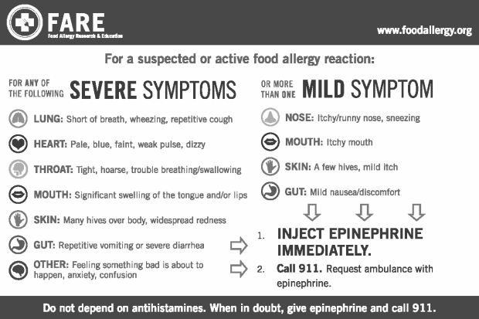
DO NOT HESITATE TO ADMINISTER MEDICATION OR CALL 911 EVEN IF PARENTS OR DOCTOR CANNOT BE REACHED
Minor Reaction
- If only one mild symptoms present, give _____________________________________________
  - If symptoms do not improve within 10 minutes, follow steps for Major Reaction below
Major Reaction
- If severe symptoms present or more than two mild symptoms present, give
____________________________________ and follow manufacturer's instructions.
- Have another staff member call 911 immediately then call parents/guardians.

_______________________________ __________ ______________________________ ________
Parent/Guardian Signature Date Licensed Health Care Provider Date

DO NOT LEAVE STUDENT ALONE AT ANY TIME

