School Improvement Plan
Meece Middle School
2023

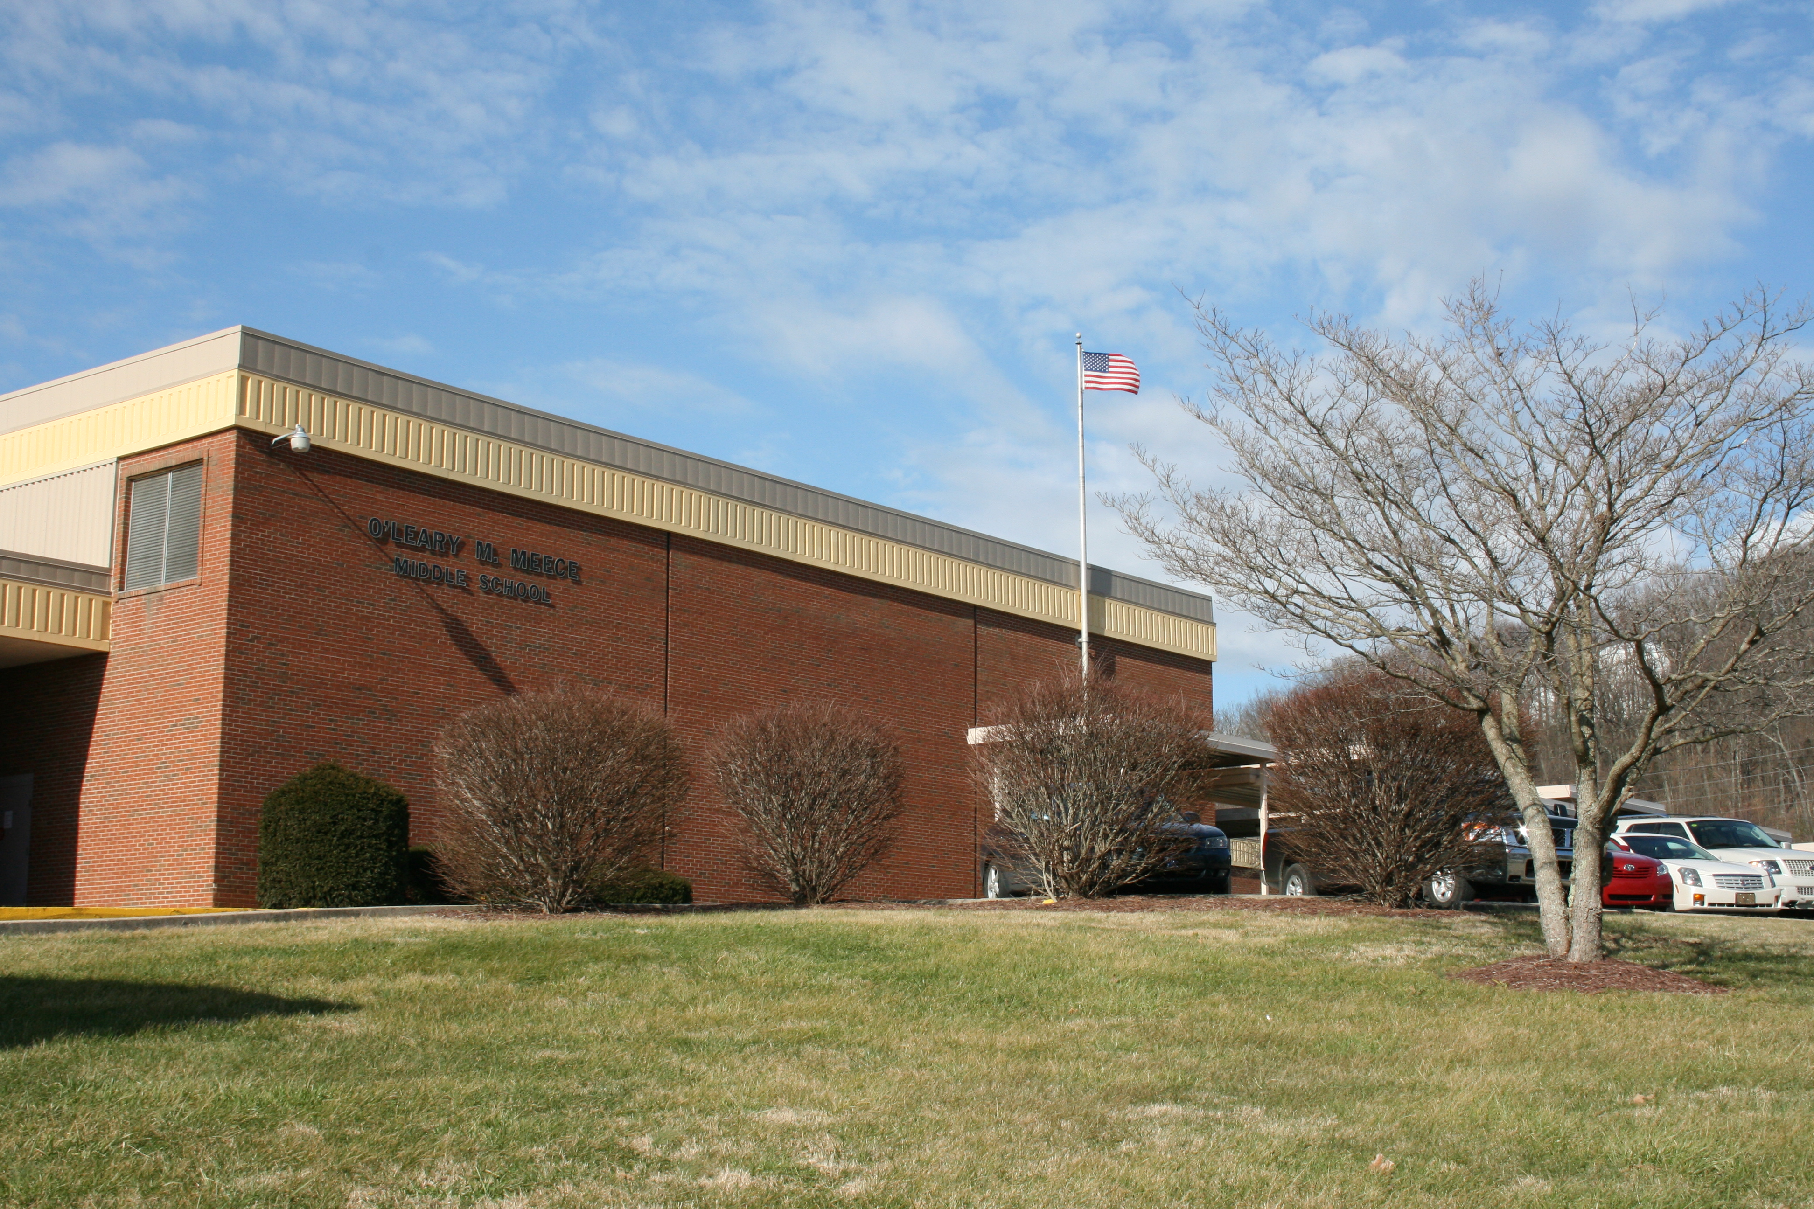

Rationale
​School improvement efforts are a collaborative process involving multiple stakeholders. Through the improvement planning process, leaders focus on priority needs, funding, and closing achievement gaps among identified subgroups of students. When implemented with fidelity, the Comprehensive School Improvement Plan (CSIP) cultivates an environment that promotes student growth and achievement.
While the focus of continuous improvement is student performance, the work must be guided by the aspects of teaching and learning that affect performance. An effective improvement process should address the contributing factors creating the learning environment (inputs) and the performance data (outcomes). Through the Needs Assessment for Schools, priorities were identified and processes, practices, and/or conditions were chosen for focus. This goal building template will assist your improvement team to address those priorities and outline your targets and the activities intended to produce the desired changes. Progress monitoring details will ensure that your plan is being reviewed regularly to determine the success of each strategy.
Please note that the objectives (short-term targets) set by your school under the Achievement Gap section of this planning template will be used by the district’s superintendent to determine whether or not your school met its targets to reduce the gap in student achievement for any student group for two consecutive years as required by KRS 158.649. Likewise, operational definitions for each required planning component can be found on page 2 of the planning template.

Requirements for Building an Improvement Plan
- The required goals for elementary/middle schools include the following:
  - State Assessment Results in reading and mathematics
  - State Assessment Results in science, social studies and writing
  - Achievement Gap
  - English Learner Progress
  - Quality of School Climate and Safety

1: State Assessment Results in Reading and Math

Goal 1: By 2025, our school will increase the indicator score for reading to 69 and the indicator score for math to 60.
Objective | Strategy | Activities to Deploy Strategy | Measure of Success | Progress Monitoring Date & Notes | Funding
Objective 1:  By 2023, increase percentage of students scoring proficient and distinguished to 50 in reading and 41 in math. | Curriculum  KCWP 1: Design and Deploy Standards  KCWP 2: Design and Deliver Instruction | Continue the implementation of school-wide use of supplemental resources in-school and during after school tutoring to help close the learning gap in reading and math. | Increased KSA Scores |  | 12,000  ESS  Title V
 |  | Schedule and monitor vertical content meetings with HES and SHS. | Increased Curriculum Alignment |  | 0
 |  | Conduct frequent walk-throughs and provide teachers with feedback so each may make informed instructional decisions. | Increased KSA Scores |  | 1,000  Title V
 |  | Ensure the daily content learning target in each class is communicated and understood by all students.(I can statement is written down daily in online agenda book and goal setting discussions during the school year) | Increased KSA Scores |  | 0
 |  | Continue classroom activities and lessons based on student engagement strategies (i.e Thoughtful Education/KAGAN, Google classroom, computer based, hands-on, and/or small groups, instead of lecturing). | Increased KSA Scores |  | 0
 |  | Investigate updated resources for math. | Increased KSA Scores |  | ESSER Textbook
 |  | Offer literacy night for students and their families (during Book Fair Week). |  |  | Gear Up
 |  | Meet in Professional Learning Communities and/or grade levels at least monthly or as needed to discuss students learning activities and analyze data to drive/change instruction to best meet student needs. | Increased KSA Scores |  | 0
 | Assessment  KCWP 3: Design and Deliver Assessment Literacy  KCWP 4: Review, Analyze and Apply Data | Assess and analyze student data three to four times yearly with the universal screener and formative assessments (MAP, STAR Reading and monthly proficiency assessments). | Increased KSA Scores |  | Title V
 |  | Continue to assess and monitor student performance using Proficiency Measures and other classroom instruments giving teachers information to plan/revise instruction based on student needs. (Turn in assessments for standards congruency checks as needed). | Increased KSA Scores |  | 0
 |  | Implement technology for collection of student data in Proficiency Measures and other formative assessments (Grade Cam, Google classroom, Go Guardian, computer lab, etc). | Increased KSA Scores |  | 1,000  Title V  KETS
 |  | Provide student opportunities to communicate their knowledge through writing. (Extended response, short answer for reading and math, and other meaningful writing pieces throughout the year in all classes.) | Increased KSA Scores |  | 0
 |  | Include language mechanics items on English Language Arts Proficiency Measures and other classroom assessments. | Increased KSA Scores |  | 0
 | Professional Development  KCWP 5: Design, Align and Deliver Support  KCWP 6: Establishing Learning Culture and Environment | Provide on-going technology professional development for staff. | Increased technology skills |  | 1,000  PD
 |  | Provide on-going professional development for middle school best practices (Thoughtful Education, student engagement, differentiation classroom management, curriculum alignment, novice reduction strategies). | Increased student involvement in class |  | 1,000  PD  Title II

2: State Assessment Results in Science, Social Studies and Writing

Goal 2: By 2025, our school will increase content index scores- social studies score to 64; Science to 47 and writing to 62.
Objective | Strategy | Activities to Deploy Strategy | Measure of Success | Progress Monitoring Date & Notes | Funding
Objective 1:  By 2023, increase percentage of students scoring proficient and distinguished to 45 in social studies, 27 in science and 39 in writing. | Curriculum  KCWP 1: Design and Deploy Standards  KCWP 2: Design and Deliver Instruction | Continue the implementation of school-wide use of supplemental resources in-school to help close the learning gap in social studies and science. | Increased KSA Scores |  | 12,000  ESS  Title V
 |  | Schedule and monitor vertical content meetings with HES and SHS. | Increased Curriculum Alignment |  | 0
 |  | Conduct frequent walk-throughs and provide teachers with feedback so each may make informed instructional decisions. | Increased KSA Scores |  | 1,000  Title V
 |  | Ensure the daily content learning target in each class is communicated and understood by all students (I can statement is written down daily in the online agenda book goal setting discussions during the school year) | Increased KSA Scores |  | 0
 |  | Continue classroom activities and lessons based on student engagement strategies, for example Thoughtful Education/KAGAN, Google classroom, hands-on, and/or small groups, instead of lecturing. | Increased KSA Scores |  | 0
 |  | Have a STEM (Science, Technology, Engineering and Math) night for students and families. | Increased KSA Scores |  | Gear-Up
 |  | Meet in Professional Learning Communities and/or grade levels at least monthly or as needed to discuss students learning activities and analyze data to drive/change instruction to best meet student needs. | Increased KSA Scores |  | 0
 | Assessment  KCWP 3: Design and Deliver Assessment Literacy  KCWP 4: Review, Analyze and Apply Data | Assess and analyze student data three to four times yearly with the universal screener and formative assessments (MAP and monthly proficiency assessments). | Increased KSA Scores |  | Title V
 |  | Continue to assess and monitor student performance using Proficiency Measures and other classroom instruments giving teachers information to plan/revise instruction based on student needs. (Turn in assessments for standards congruency checks as needed). | Increased KSA Scores |  | 0
 |  | Implement technology for collection of student data in Proficiency Measures and other formative assessments (Grade Cam, Google classrooms, Go Guardian, computer lab, etc.). | Increased KSA Scores |  | 1,000  Title V  KETS
 |  | Provide student opportunities to communicate their knowledge through writing. (Extended response, short answer for science, social studies and other meaningful writing pieces throughout the year in all classes.) | Increased KSA Scores |  | 0
 |  | Provide students with the opportunity to practice on-demand writing pieces (including stand alone and passage-based prompts) in English Language Arts classes. | Increased KSA Scores |  | 0
 | Professional Development  KCWP 5: Design, Align and Deliver Support  KCWP 6: Establishing Learning Culture and Environment | Provide on-going technology professional development for staff. | Increased technology skills |  | 1,000  PD
 |  | Provide on-going professional development for middle school best practices (Thoughtful Education, student engagement, differentiation classroom management, curriculum alignment, novice reduction strategies). | Increased student involvement in class |  | 1,000  PD  Title II

3: Achievement Gap

Goal 3: By 2025, reduce the achievement Gap in reading and math proficiency rates for students with disabilities (IEP) compared to all students.
Objective | Strategy | Activities to Deploy Strategy | Measure of Success | Progress Monitoring Date & Notes | Funding
Objective 1:  By 2023 reduce the percentage of students from the subgroup “students with Disabilities (IEP)” scoring Novice to 52 in reading and 52 in math. | Student Support  KCWP 5: Design, Align and Deliver Support | Using data from various formative assessments, teachers will identify and implement differentiated instructional strategies with students who are not achieving proficiency. | Increased KSA scores |  | 0
 | Student Support  KCWP 5: Design, Align and Deliver Support | Utilize our PLC protocol to analyze student performance and to share strategies and monitor feedback to help reduce any learning gaps identified. | Increased KSA scores
 | Student Support  KCWP 5: Design, Align and Deliver Support | Continue to implement interventions for all grade levels to focus on math and/or reading skills for students that are not proficient (reduce novice) and to reduce any learning gaps identified. | Decreased Novice in Special Education |  | 1,000  Section 6  ESS
 | Student Support  KCWP 5: Design, Align and Deliver Support | Restructure PLC teams so that Special education teachers will start meeting with content area teachers during PLC (Professional Learning Communities) on a monthly basis to share instructional strategies/ activities with other teachers. | Decreased Novice in Special Education |  | 0
 | Student Support  KCWP 5: Design, Align and Deliver Support | Train all teachers on High Leverage Practices in Special Education. | Decreased Novice in Special Education |  | 0

4: English Language Learners

Goal 4: By 2025, increase the English Language scores of identified EL students.
Objective | Strategy | Activities to Deploy Strategy | Measure of Success | Progress Monitoring Date & Notes | Funding
Objective 1:  By 2023 increase the score of students on the ACCESS test. | KCWP 5: Design, Align and Deliver Support | Utilizing our Migrant staff to implement interventions and strategies to focus on improving the students reading comprehension and skills. | Best practice strategies implemented in class |  | Migrant (with PC)
 | KCWP 5: Design, Align and Deliver Support | Train teachers in best practice strategies to increase academic performance in all ESL students. | Best practice strategies implemented in class |  | 0
 | KCWP 5: Design, Align and Deliver Support | Utilize our PLC protocol to analyze student performance and to share strategies and monitor feedback to help reduce any learning gaps identified. | Increased use of best practices observed in classes |  | 0
 | KCWP 5: Design, Align and Deliver Support | Provide ESL staff for small group instruction of English. | Increased ACCESS scores. |  | Title IV  ESSER

5: Quality of School Climate and Safety

Goal 6: Provide a safe and enriching environment for student learning.

Objective | Strategy | Activities to Deploy Strategy | Measure of Success | Progress Monitoring Date & Notes | Funding
Objective 1:  Provide a safe and enriching environment for student learning by reducing barriers to learning. | Student Support  KCWP 5: Design, Align and Deliver Support  KCWP 6: Establishing Learning Culture and Environment | Continue developing the mentoring program for students identified as being at-risk and those who have barriers to effective learning. | Increased KSA scores |  | 0
 |  | Continue to implement a school-wide incentive program that rewards students who maintain or increase academic achievement, attendance and/or good behavior. | Increased Achievement  Increased Attendance |  | 500  SBDM
 |  | Continue monthly character salute program to recognize students and staff members for the character attribute of the month. | Increased Positive Behavior |  | 175  SBDM
 |  | Continue to focus staff and students on MMS expectation to provide a safe/engaging classroom and school environment. | Increased Positive Behavior |  | 0
 |  | Continue to provide expected teacher supervision of students during non-instructional time-periods: to and from exploratory classes, to and from lunch, between classes, recess or outside breaks, morning duty and evening student release. | Increased Positive Behavior |  | 0
 |  | Provide monthly guidance lessons for each grade, focused on respect and other positive character traits. | Increased Positive Behavior |  | 0
 |  | Continue parent/teacher communication and parent involvement in various aspects of school through grade level/classroom and school newsletters, teacher and school webpages, updated grades in Infinite Campus Portal, open house, parent-teacher conferences and One-Call system. | Increased Involvement |  | 600  District  Section 6
 |  | Support and utilize Family Resource/Youth Service Center resources. | Increased Involvement |  | FRYSC
 |  | Monitor to ensure effective learning is occurring throughout the school. | Maintain a safe and effective learning environment for all students. |  | 0

Special Considerations for Targeted Support and Improvement (TSI) including Additional Targeted Support and Improvement (ATSI) Schools
TSI schools (including ATSI schools) must embed their subgroup(s) plan for improvement within their CSIPs. TSI stakeholders, including the principal and other school leaders, teachers, and parents, should carefully consider what must be done to ensure the subgroup(s) perform(s) at high levels in the state accountability system. In addition to identifying strategies and activities within the CSIP that address the specific needs of underperforming groups, provide narrative information regarding the additional requirements for TSI schools in the following chart:

Components of Turnaround Leadership Development and Support:
Consider: How will you ensure that school leadership has or develops the skills and disposition to achieve accelerated, meaningful, and sustainable increases in student achievement for underperforming subgroups?
Response:
Meece Middle School’s leadership team consisting of Dr. Donnie Combs (Principal), Ms. Andrea Keeney (School Counselor), Ms. Robin Crawford (Curriculum Coach), Ms. Karen Coldiron (Special Education Teacher), Ms. Becky Hays (Director of Special Education Somerset Independent Schools), and Ms. Cindy Ham ( ) attended the Jim Shipley & Associates School Improvement Planning for Performance Excellence provided by the Kentucky Department of Education. During this training the leadership team completed the Jim Shipley & Associates System Check Level 2 and Level 3.

Identification of Critical Resources Inequities:
Consider: Describe the process used to review the allocation and use of resources (people, time, and money), any resource inequities that were identified that may contribute to underperformance, and how identified resource inequities will be addressed.
Response:
Meece Middle School’s leadership team has reviewed the allocation and use of resources for people, time, and money. During this review the leadership team did not find any significant inequities in these areas. We do know that there is inequities in home life and attendance of students who are identified as having a learning disability however, these are not circumstances in direct control of the school.

Additional Actions That Address the Causes of Consistently Underperforming Subgroups of Students
Consider: Describe the process used to review the learning culture related to your targeted subgroup(s) and any additional actions that were determined to address the causes of underperformance.
Response:
Meece Middle School’s leadership team reviewed school data on sub groups from previous school year looking for relationships within the data. The main discrepancy in the data was with the current 7th and 8th grade students. Data was reviewed farther to find correlations in scores and identify students whose scores were boarder line to moving to the next level. Data was also reviewed with students before their MAP assessment and students were relayed information on their scores and how close their scores were to moving them to the next level. Student survey data was also reviewed and this review did not lead to any insight on sub group (Students with learning disabilities).

Targeted Subgroups and Evidence-Based Interventions:
Consider: Identify the areas of need revealed by the analysis of academic and non-academic data that will be addressed through CSIP activities for your targeted subgroup(s). What evidence-based practice(s) will the school incorporate that specifically targets the subgroup(s) achievement that contributed to the TSI identification? How will we monitor the evidence-based practice to ensure it is implemented with fidelity?
Response:
Non-academic data that will be addressed are:
- Student attendance. At the current time Meece does attendance rewards with the students to try and foster better attendance.
- Emotional support: Kindness week, emotional relevant activities within classroom (Bell Ringers, activities in PLVS class)
- Community relation activities: Literacy Night, STEM night, Jump Start, Winter Festival
Academic data:
- Monitoring curriculum maps
- Monitoring subject standards (Mid-Year standards check.)
See TIS/ATSI Evidence-based Practice Chart

Complete the table below to document the evidence that supports the Activities outlined in this plan. Additional rows may be added to accommodate additional pieces of evidence.

TSI/ATSI Evidence-based Practices

The Every Student Succeeds Act (2015) created new expectations for evidence-based decision making at school and district levels. More specific information regarding evidence-based practices and requirements can be found on the Kentucky Department of Education’s Evidence-based Practices website. While evidence documentation in the CSIP is only required for schools identified for Targeted Support and Improvement (TSI) including Additional Targeted Support and Improvement (ATSI) and Comprehensive Support and Improvement (CSI), KDE encourages all school leaders to review evidence related to new programs, practices, or interventions being implemented in the school. In addition to documenting the evidence below, TSI, ATSI and CSI schools are expected to upload a description of their evidence review process, the findings of their evidence review, and a discussion of the local implications into eProve. Specific directions regarding the documentation requirements can be found in the “Compliance Requirements” resource available on KDE’s Evidence-based Practices website.

Complete the table below to document the evidence that supports the Activities outlined in this plan. Additional rows may be added to accommodate additional pieces of evidence.

Evidence-based Activity | Evidence Citation | Uploaded in eProve
Train staff to implement inductive teaching strategies. | Hattie, J. (2009). Visible Learning: a synthesis of over 800 meta-analyses relating to achievement. Routledge: New York, NY. | ☒
Jim Shipley & Associates School Improvement Planning for Performance Excellence | Jim Shipley & Associates Systems Check Level 2 (Provided by Kentucky Department of Education) | ☐
Train all teachers in High Leverage Practices in Special Education. | Council for Exceptional Children (2017) CEEDAR Center | ☐
MAP assessment and goal setting for all students | NWEA (2022, December 6) | ☐
 |  | ☐
Special Education classes using the Lexia Core 5 Reading program | Baron, L.S., Hogan, T.P., Schechter, R.L., Hook, P.E., & Brooke, E.C. (2019). Can educational technology effectively differentiate instruction for reader profiles?. Reading and Writing, 32, 2327-2352 | ☐
Special Education classes as well as RTI classes and regular education classes using the Reading Plus program. | Reading Plus. (2008). Reading improvement report: Miami-Dade regions II and III. Huntington Station, NY: Taylor Associates/Communications, Inc. | ☐

