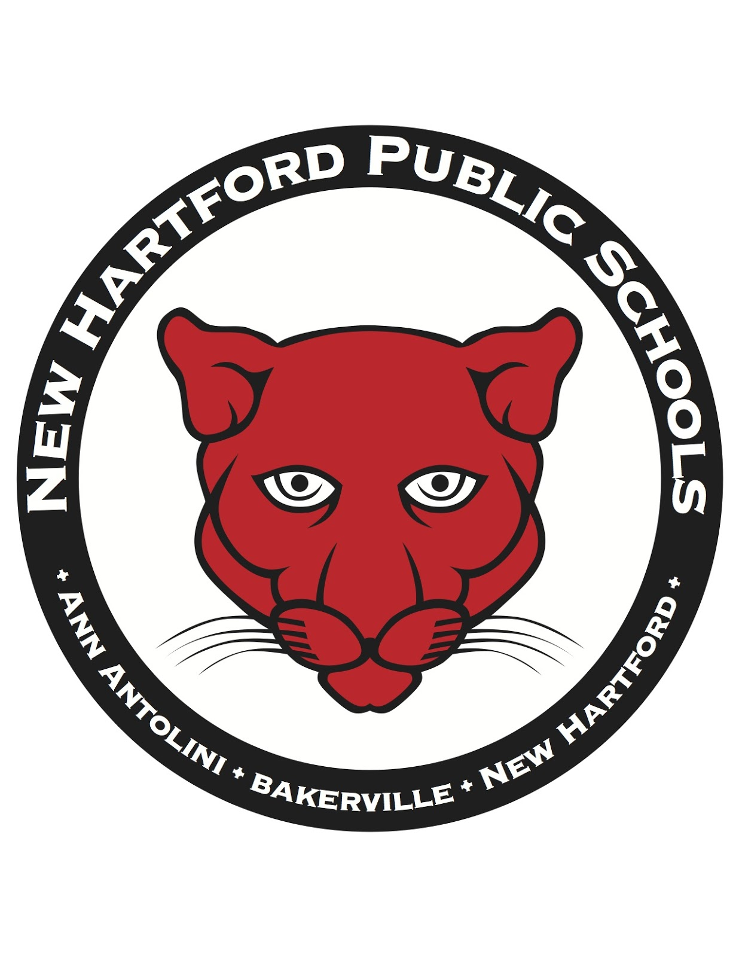
NEW HARTFORD PUBLIC SCHOOLS

Board of Education – Regular Meeting
Antolini School/Multi-Purpose Room
November 15, 2022 @ 7:00 p.m.
Agenda
https://www.youtube.com/channel/UCX-_ZlomWmjG81dc_QM3rfg

- Chair to Open Meeting

B. Pledge of Allegiance

C. Chair to Select Order of Business

D. Board of Education Chair's Report

E. Superintendent's Report/Administrator's Report
1. CSDE’s September 29th Memorandum
2. Teacher Negotiations Update
3. School Resource Officer Survey
4. Director of Student Services Update

F. Consent Agenda
1. Approval of Minutes—October 18, 2022 and November 3, 2022
2. Financial Report
3. Personnel
G. Communications to the Board of Education
H. Public Comment
I. New Business – Meet and Greet of Newly Appointed Superintendent, Jeffrey Sousa
J. Adjournment

