Wellness Data – Survey 2022 (Staff)

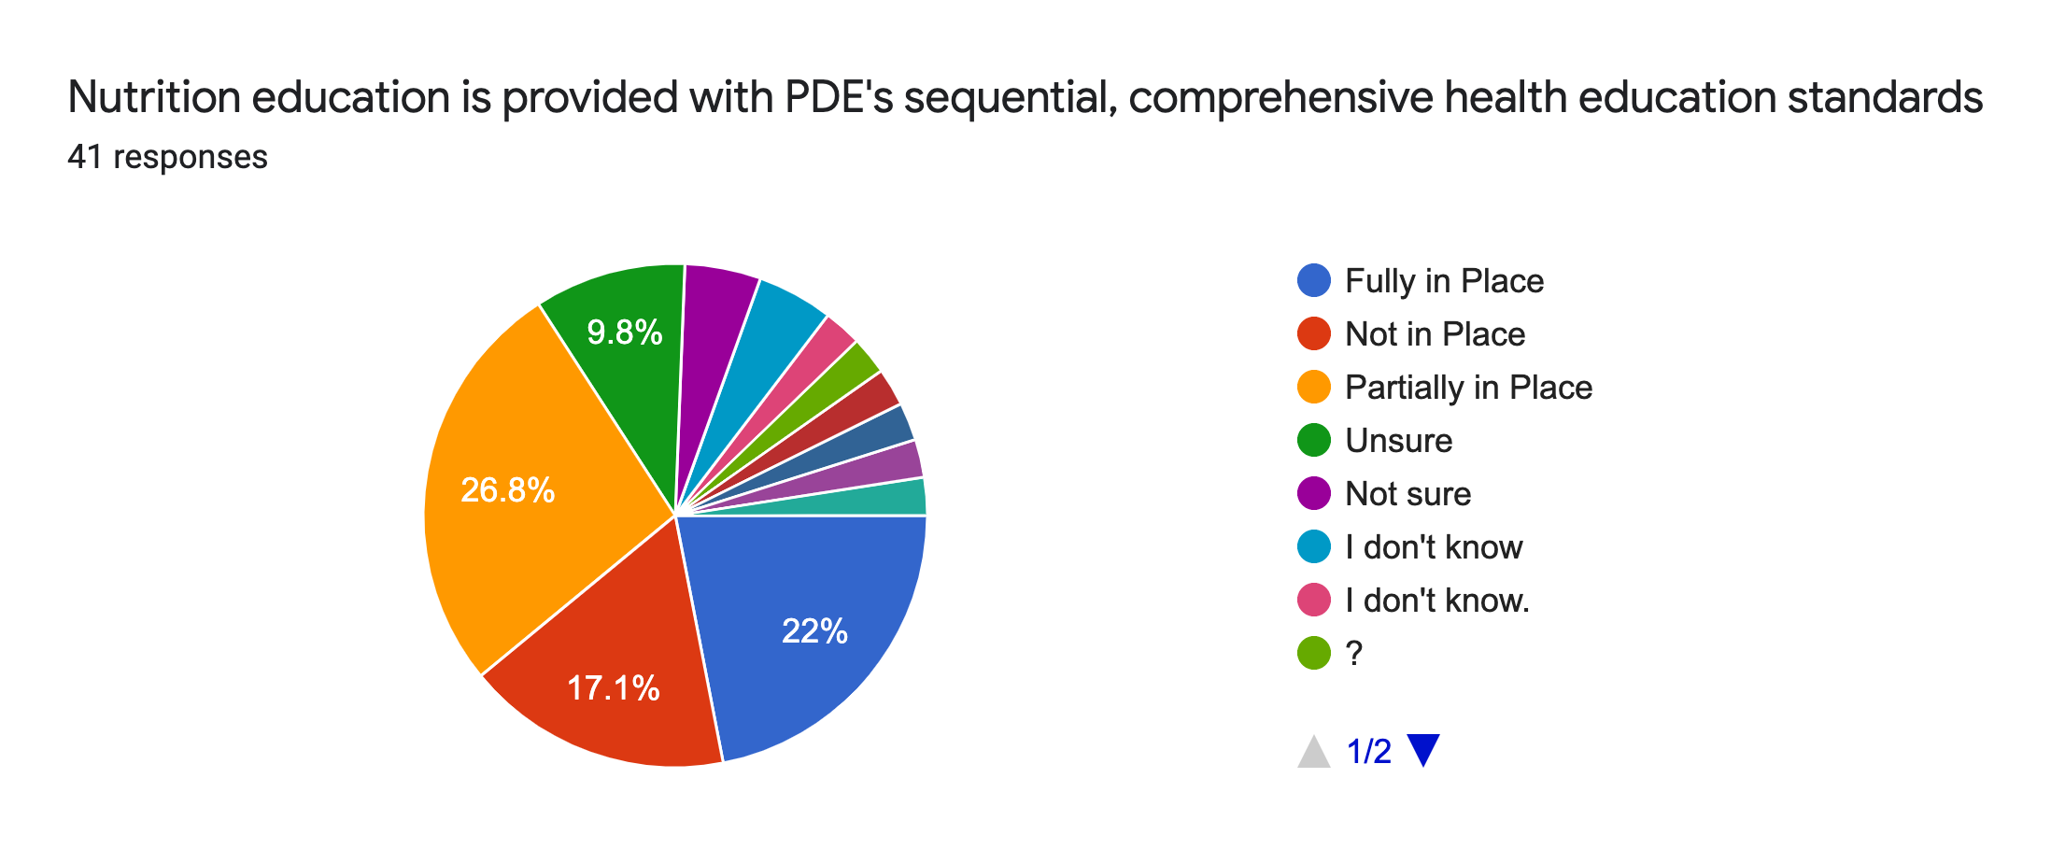
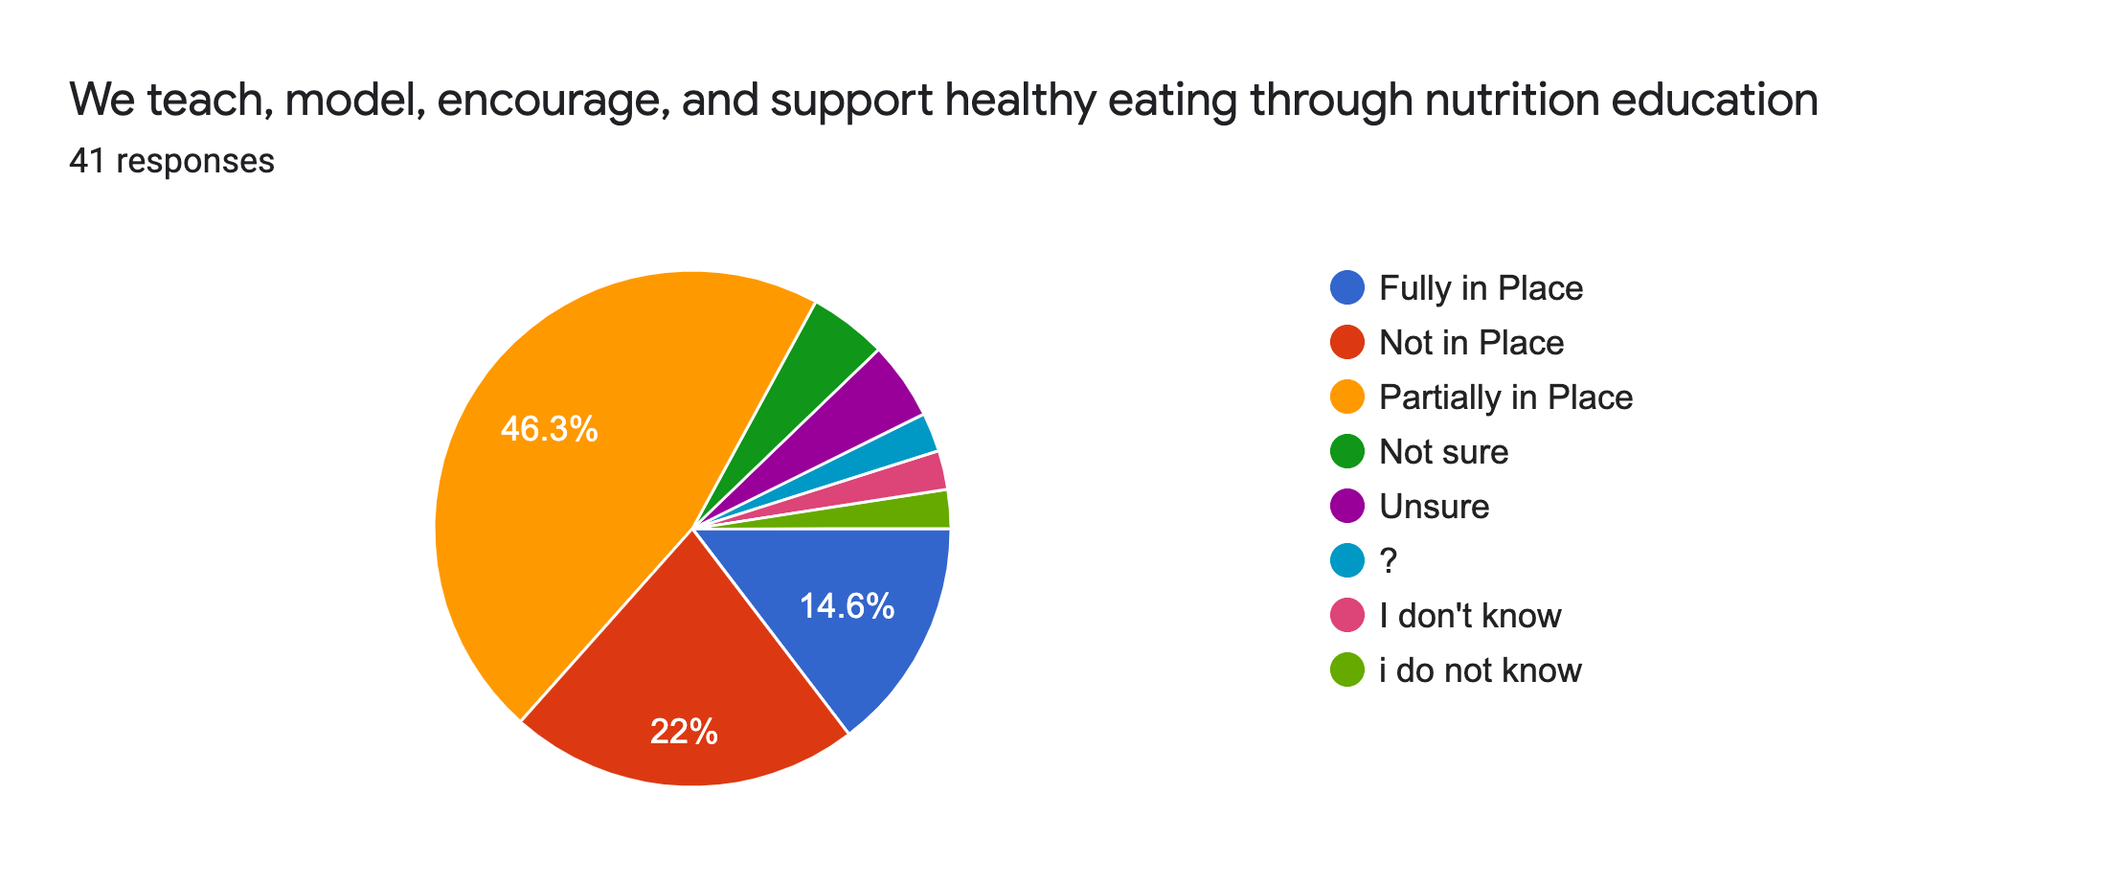
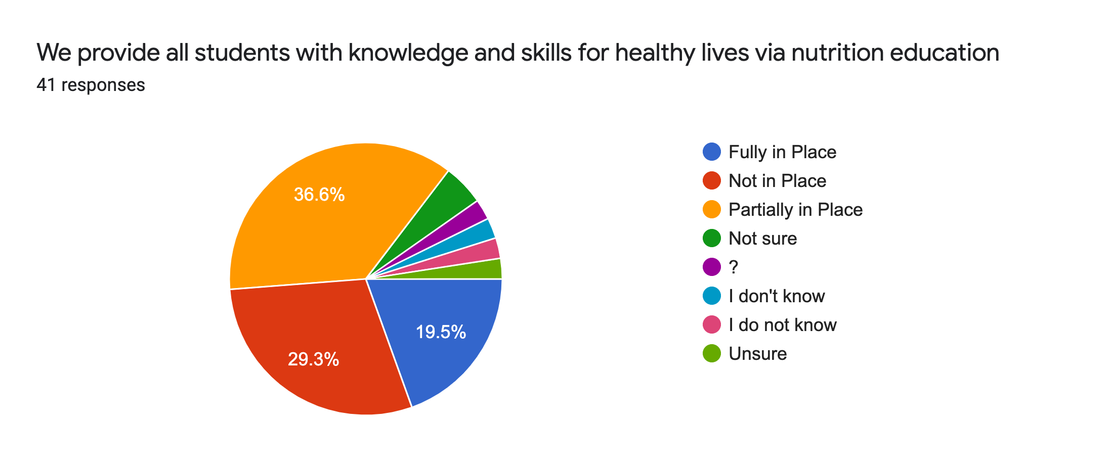

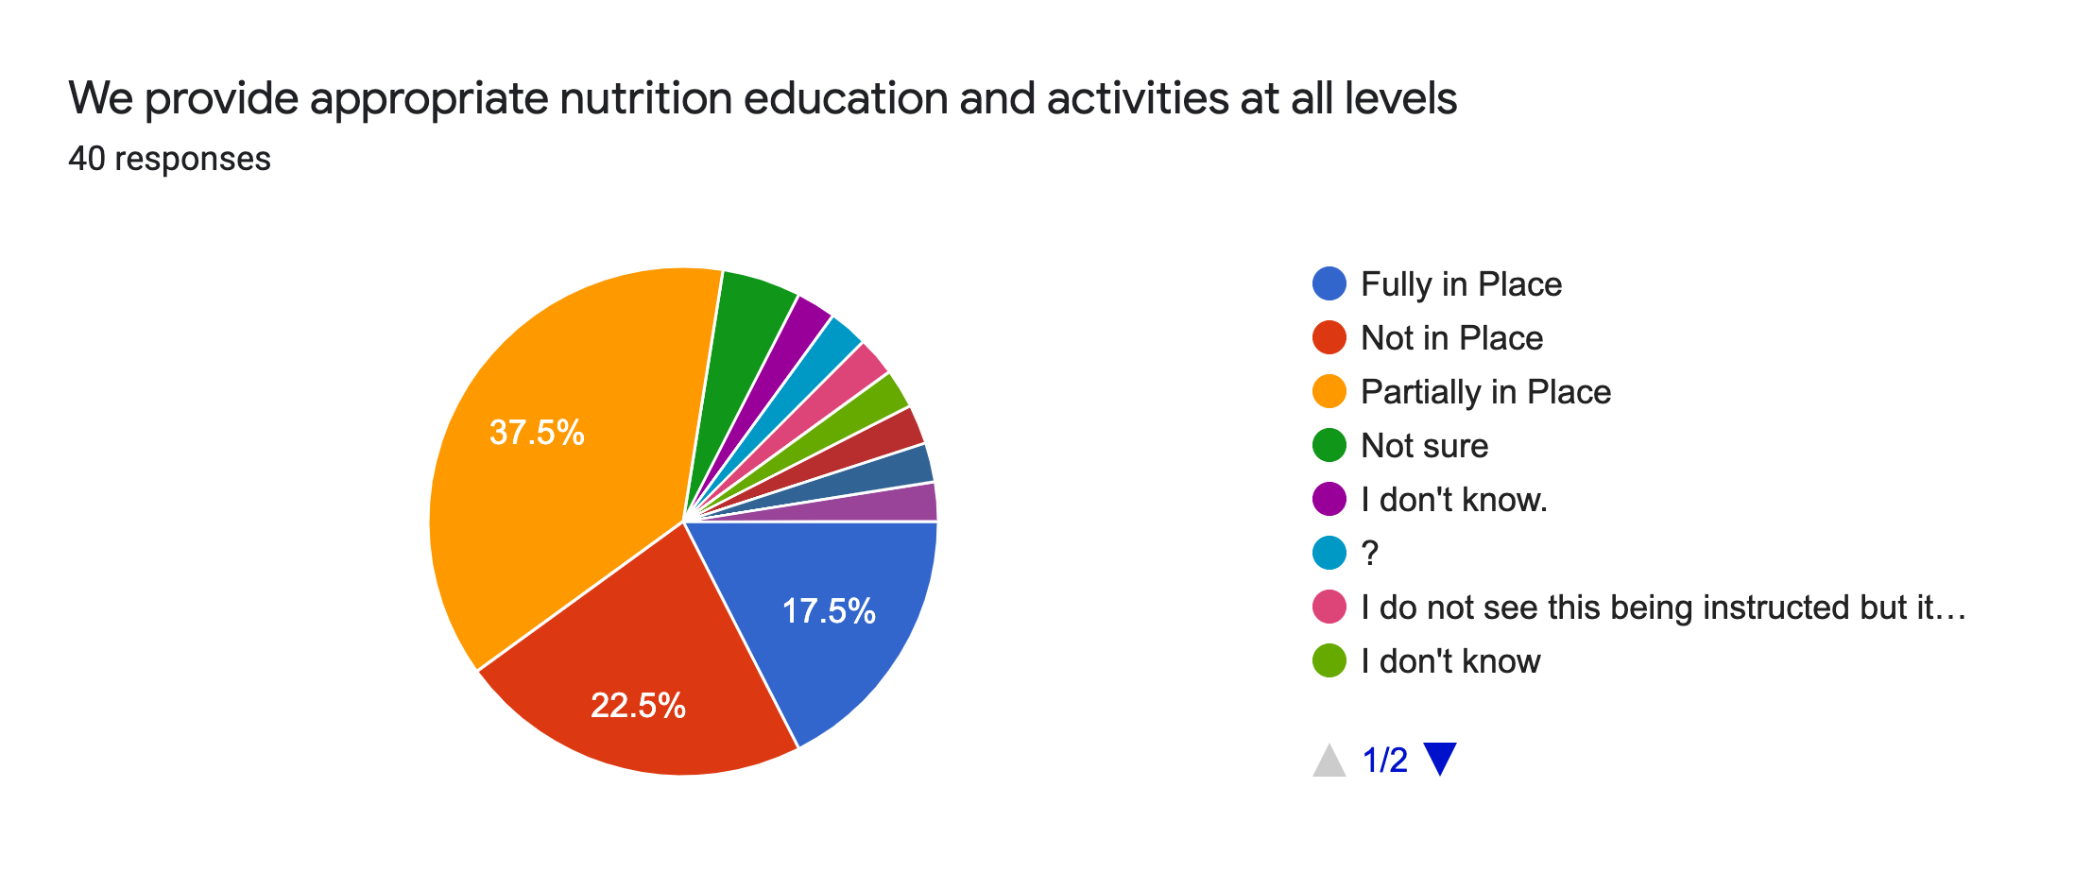

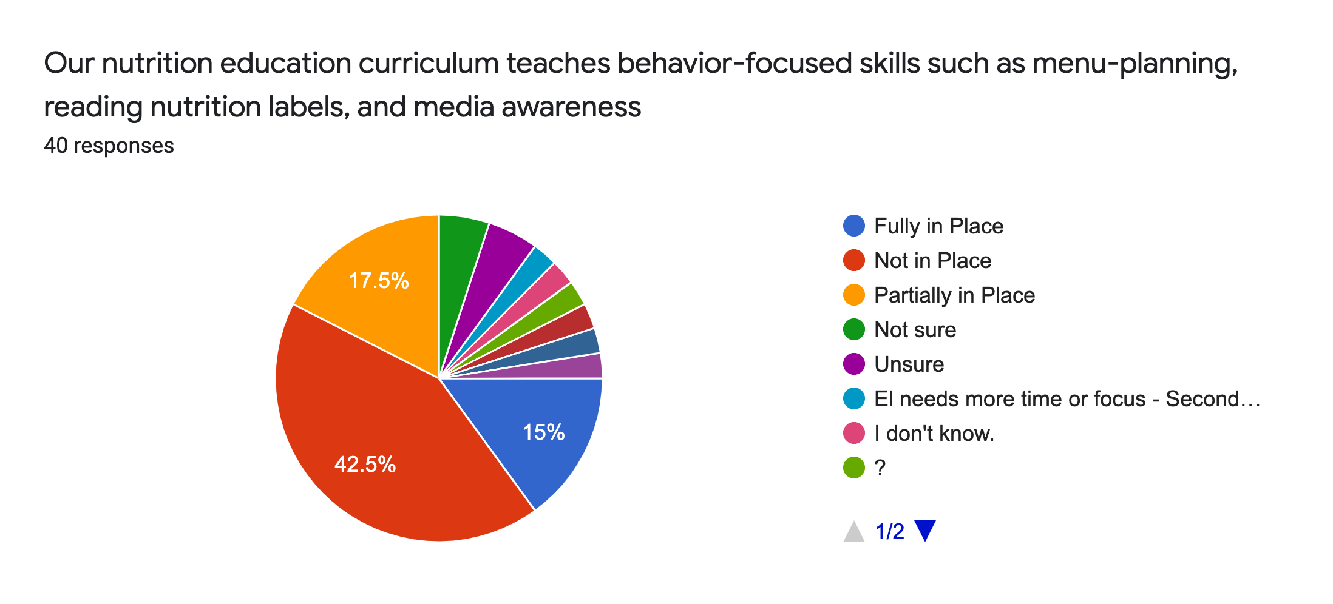

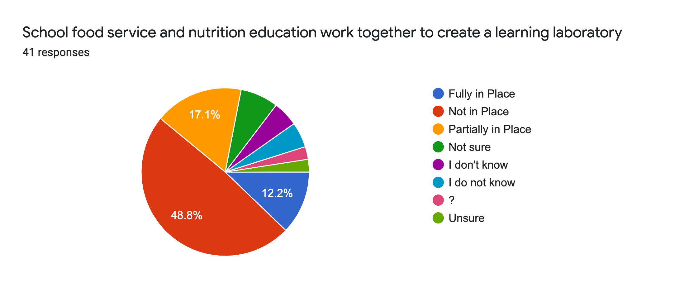
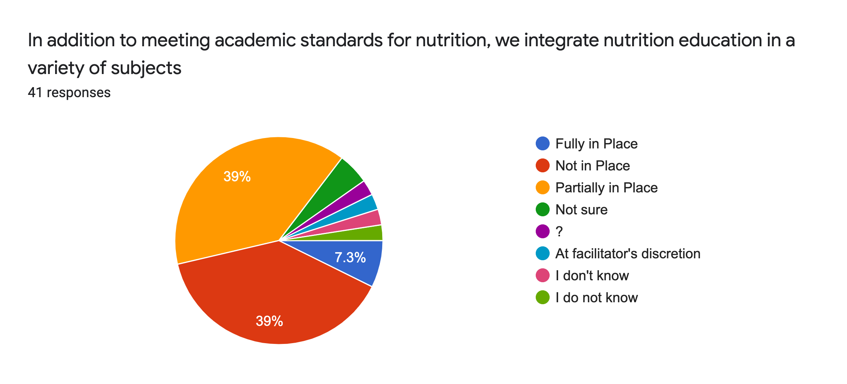
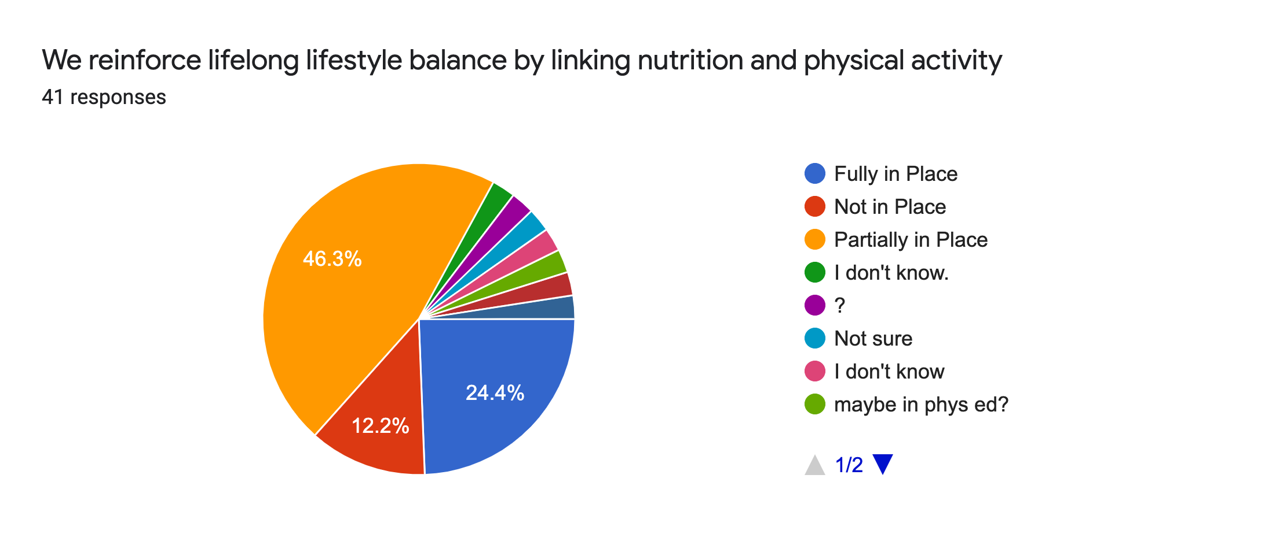

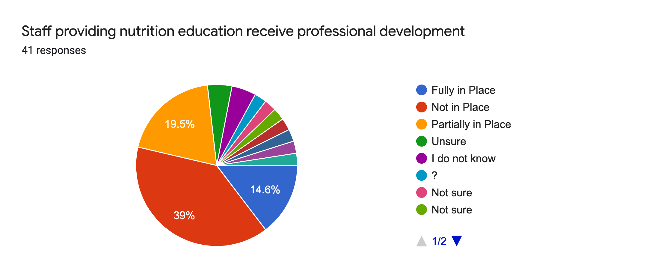
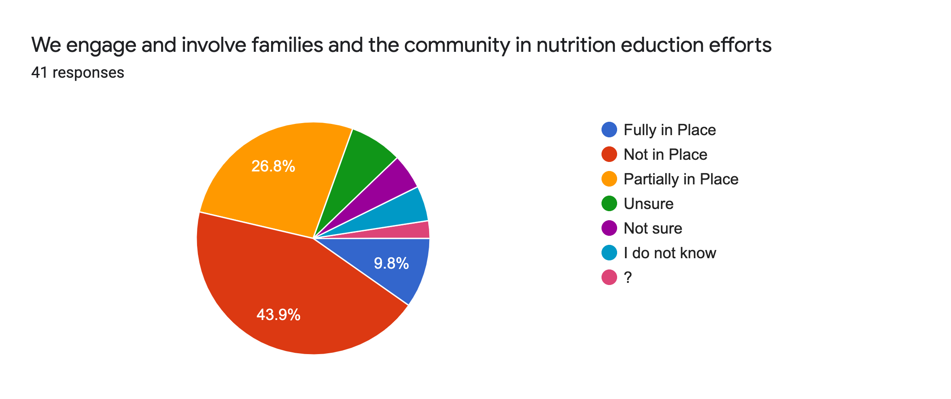
Recommendation for Goals in the Nutrition Education:

- Communication between health facilitator and facilitators to encourage nutrition and physical education.
- We can do a better job of linking the different areas- Health, PE, food services and the community for nutrition education.
- Maybe a school wide program for a week like red ribbon week
- I do not feel that we have a comprehensive nutrition education program.
- Educate the staff K-6 on what were are currently doing.
- Continued integration of Nutrition Education
- Healthy, easy, affordable meal planning for families.
- Discussing healthy lifestyle choices and healthy food. Also, healthy snacks would be great for learners in lower grades to help with early lunches and to improve attention/focus to learning.
- If we are going to provide Nutrition Education, we need to be able provide healthy meal options for kids. The food options are highly processed and full of sugar.
- More PD and guidance for all staff related to the questions above/Nutrition Education.
- I do feel these are in place. I understand we could do more to make sure meals provided to students are healthy.
- curriculum or a plan to teach nutrition education in the classrooms, more nutritional options for breakfast
- Further communication between the health and wellness department and how we can further support this in the classroom.
- Communicate goals/activities with all classroom facilitators so we are aware of what is in place
- label food choices in the cafeteria (food group they pertain to or simply 'healthy choice or non-healthy choice')

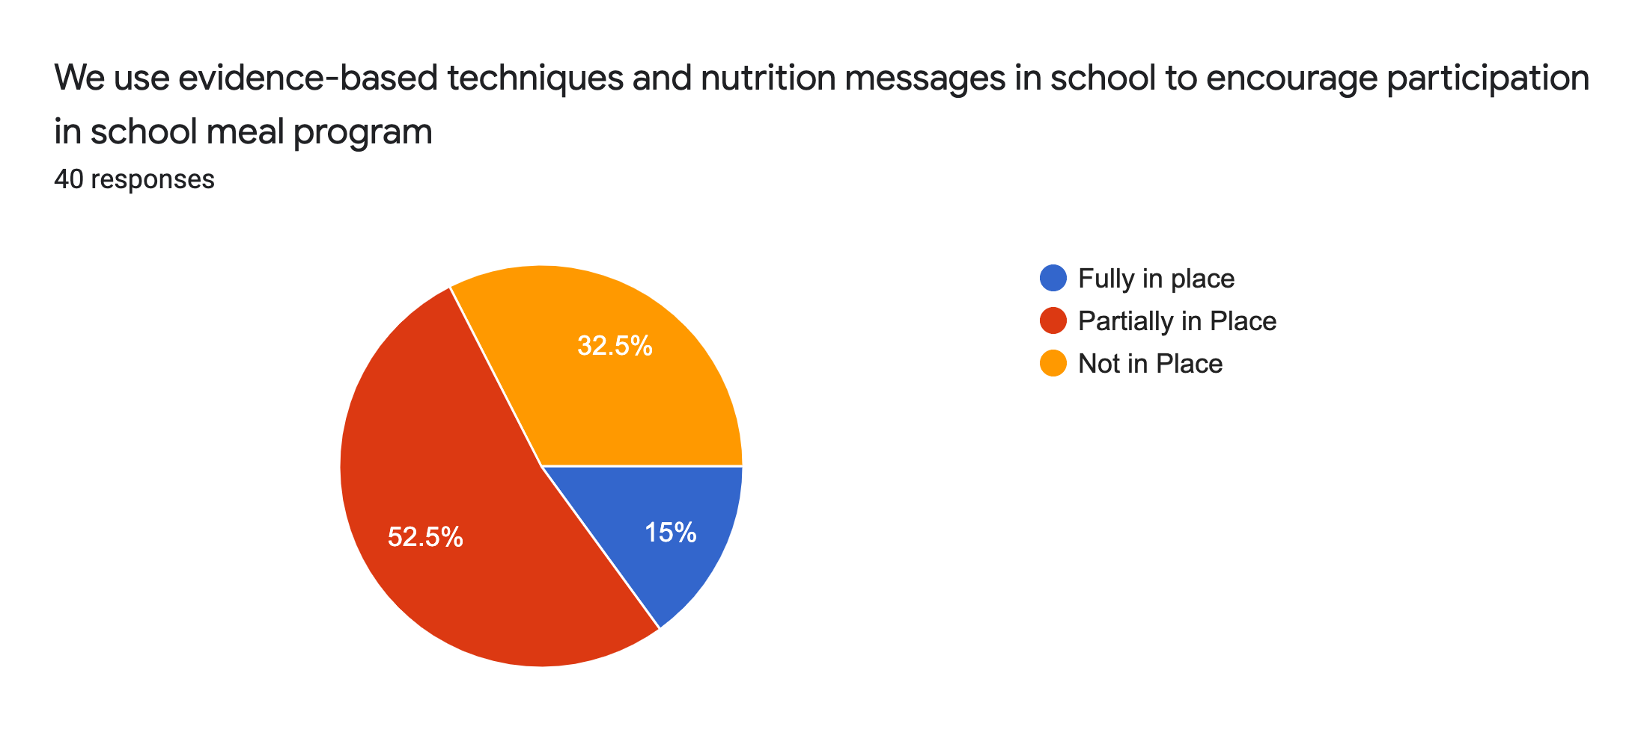
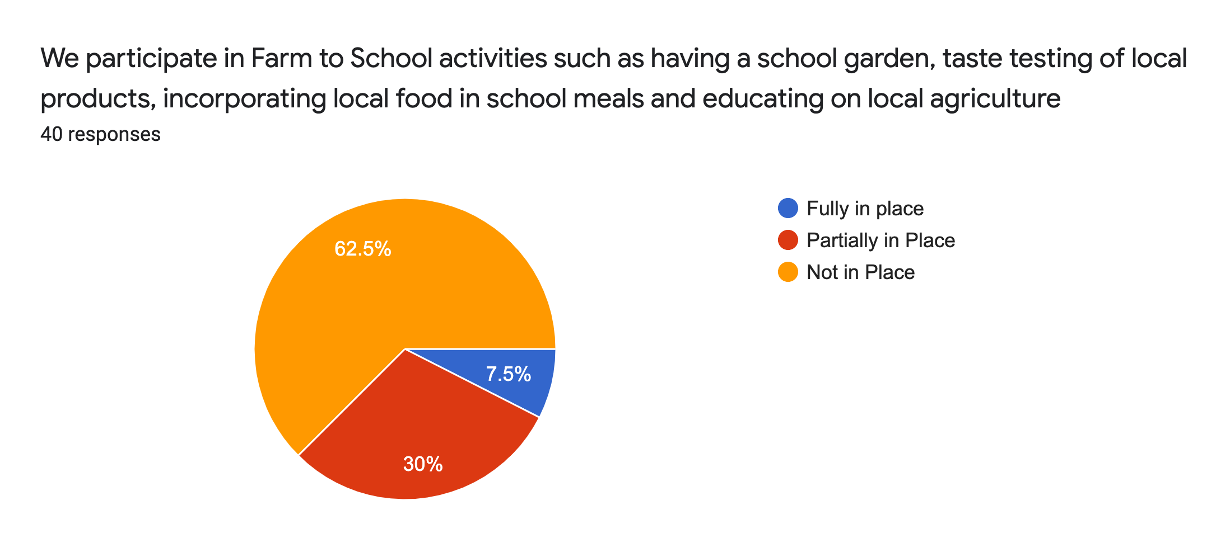

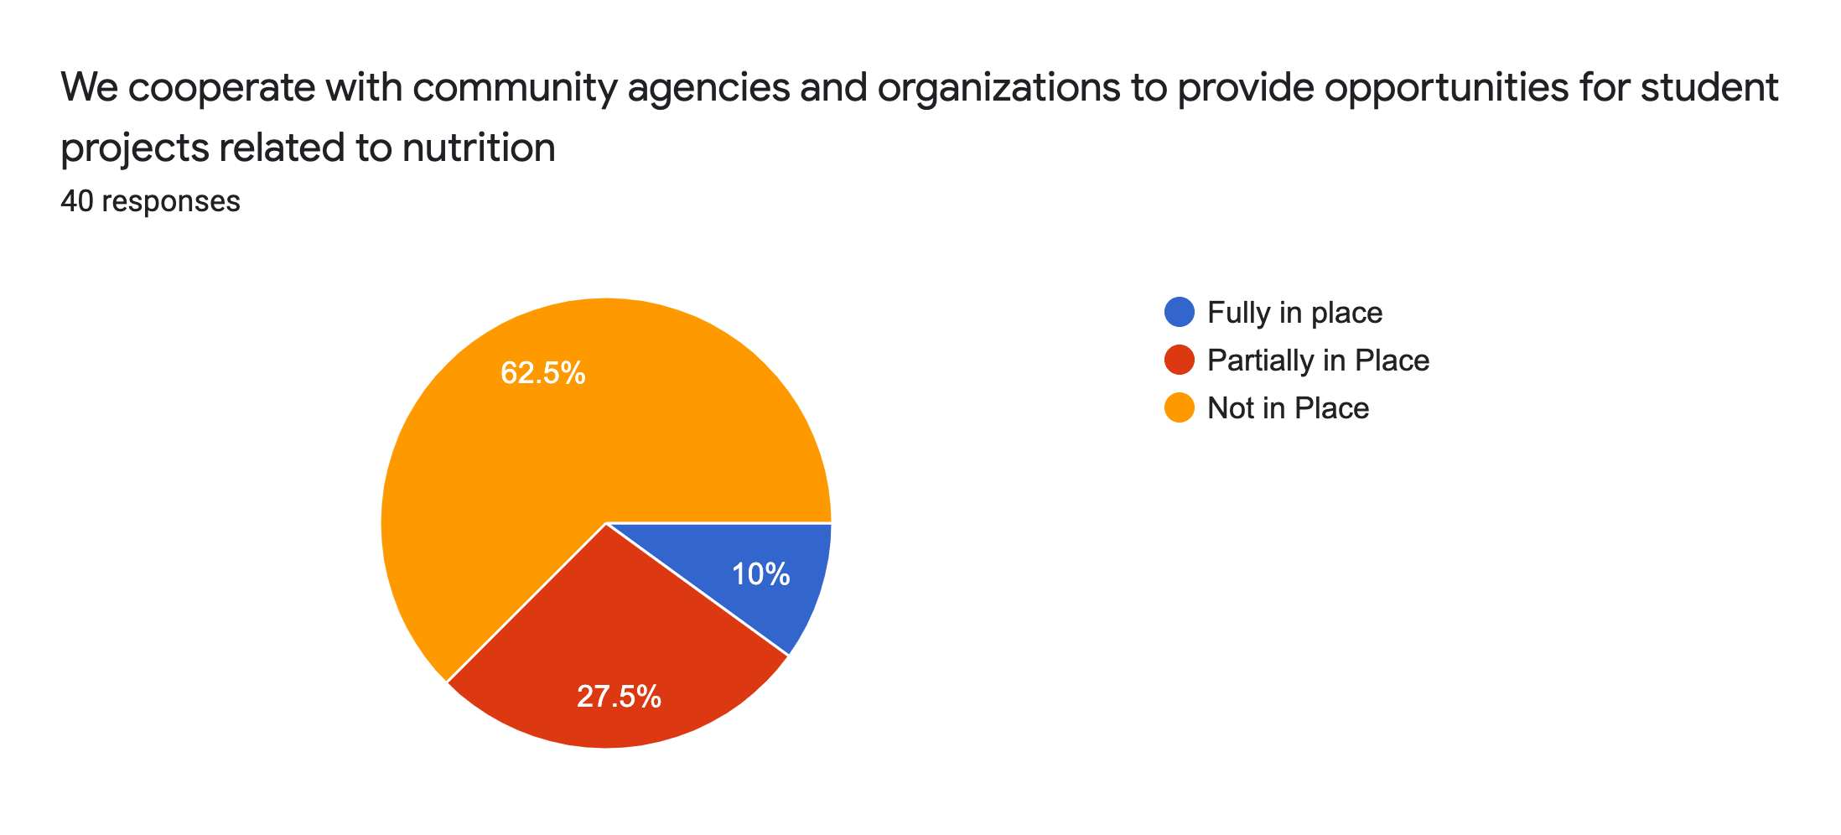
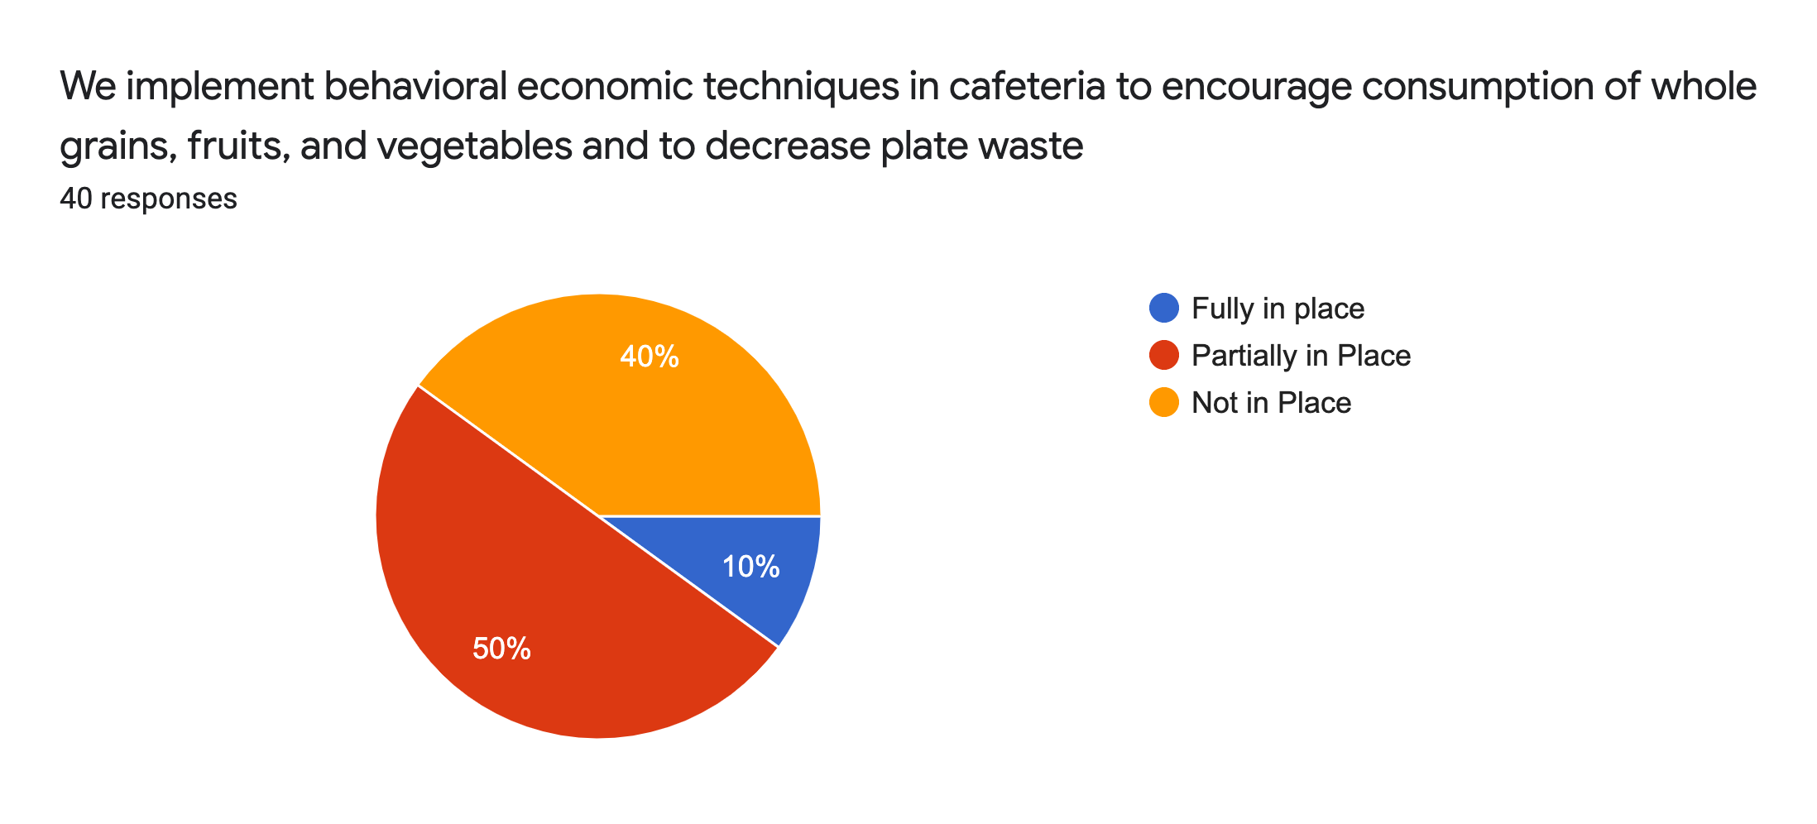
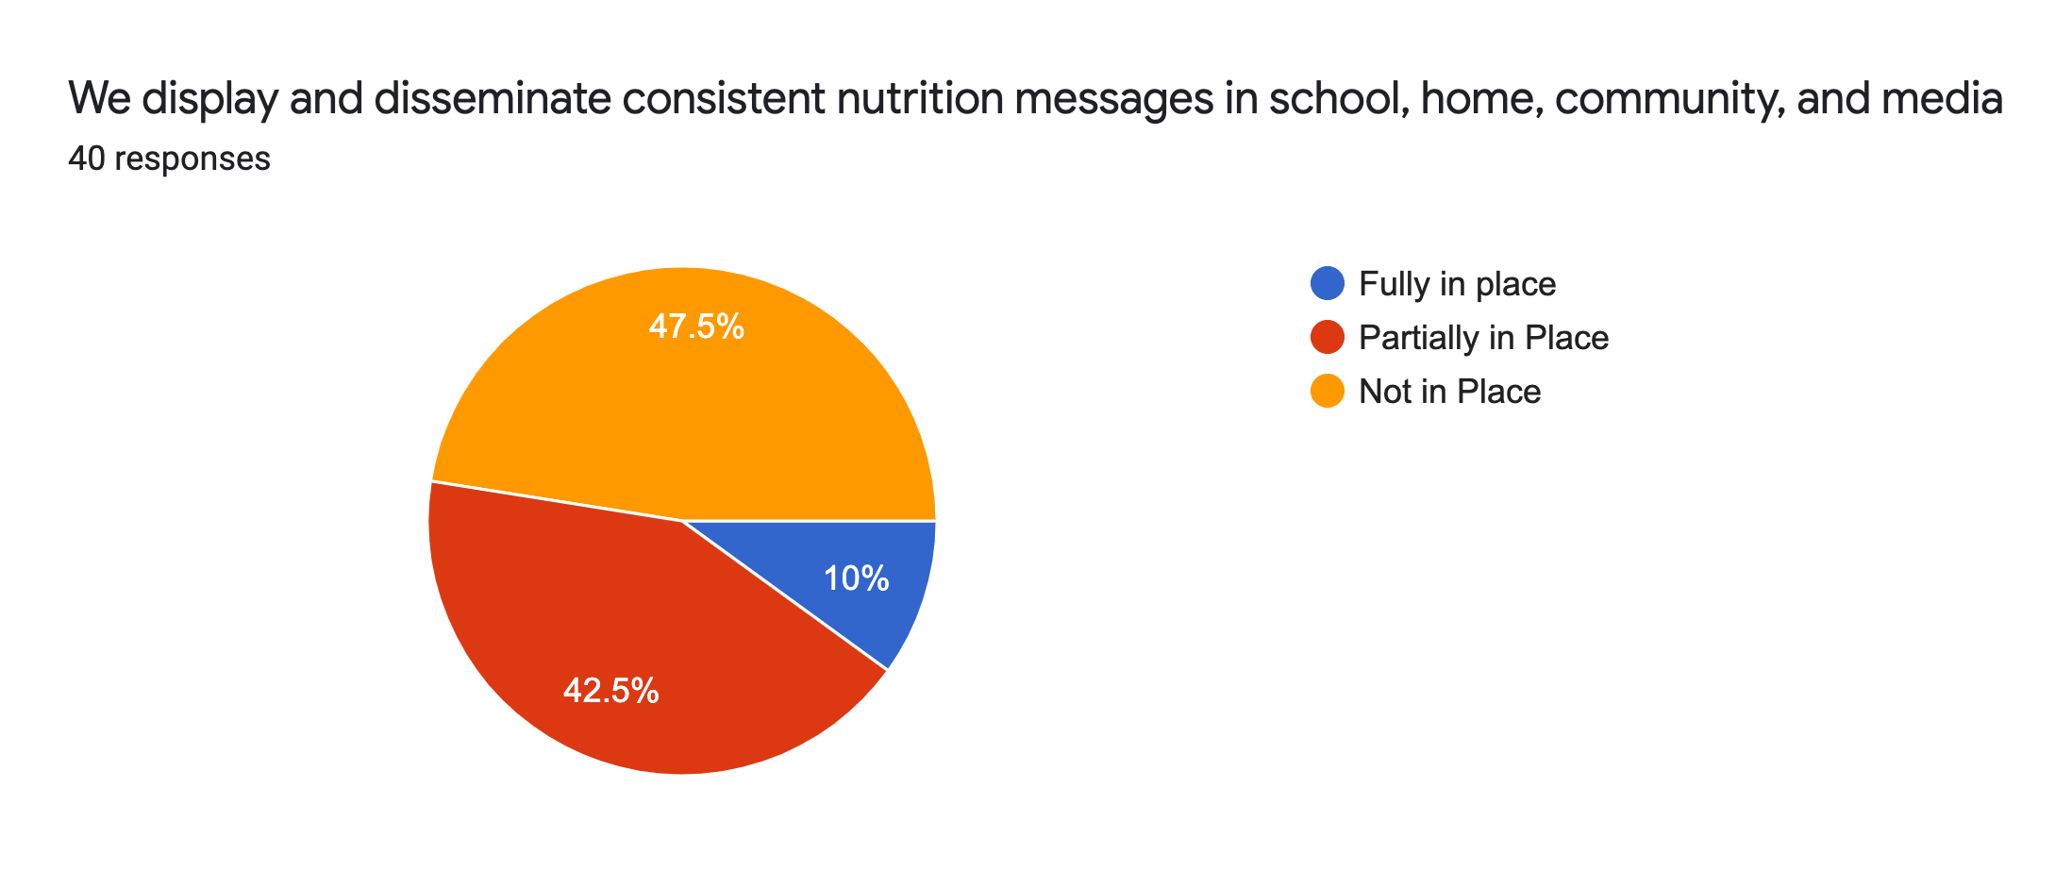
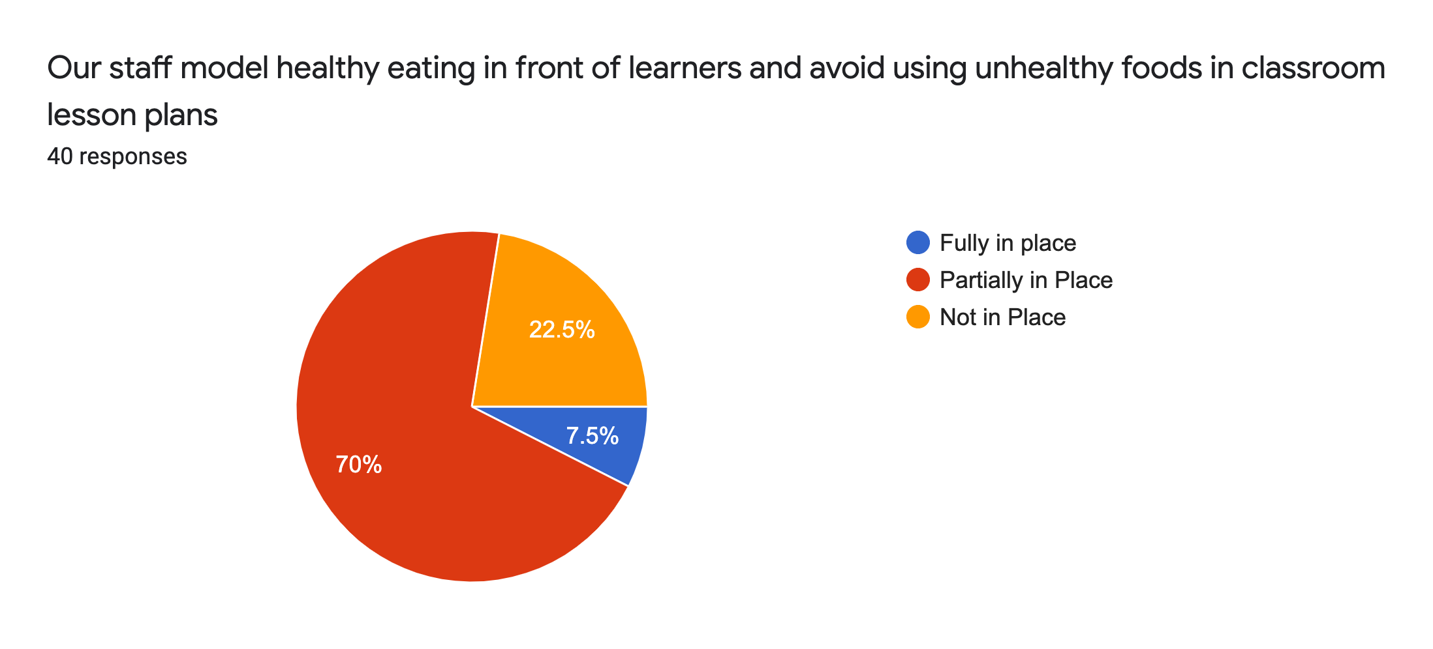
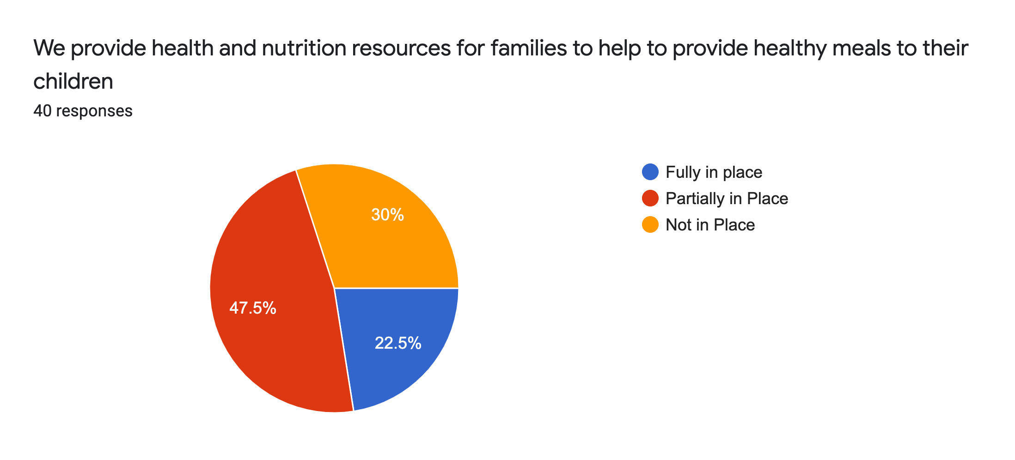
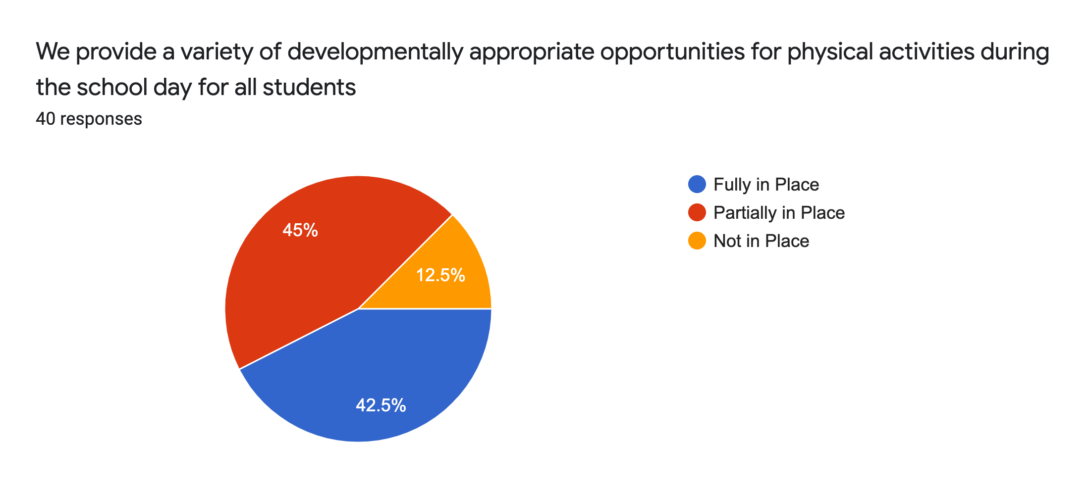
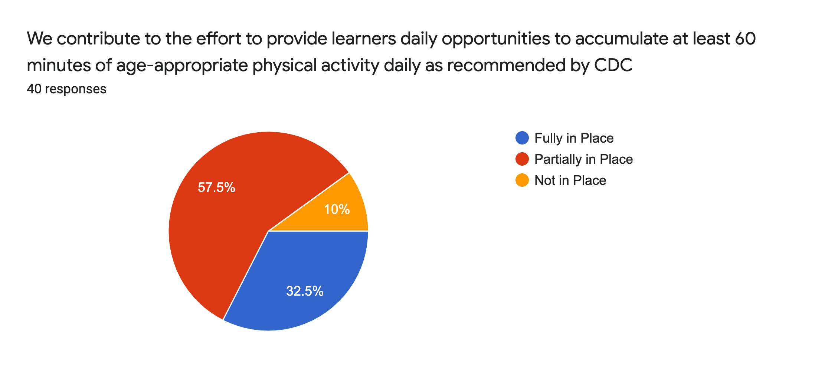
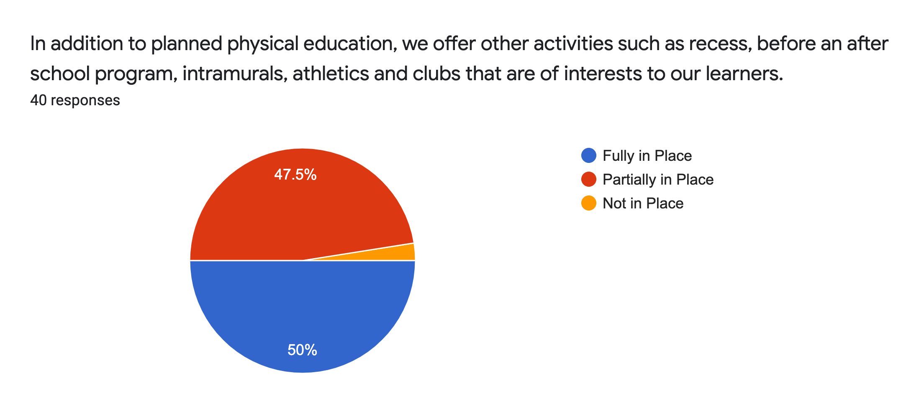
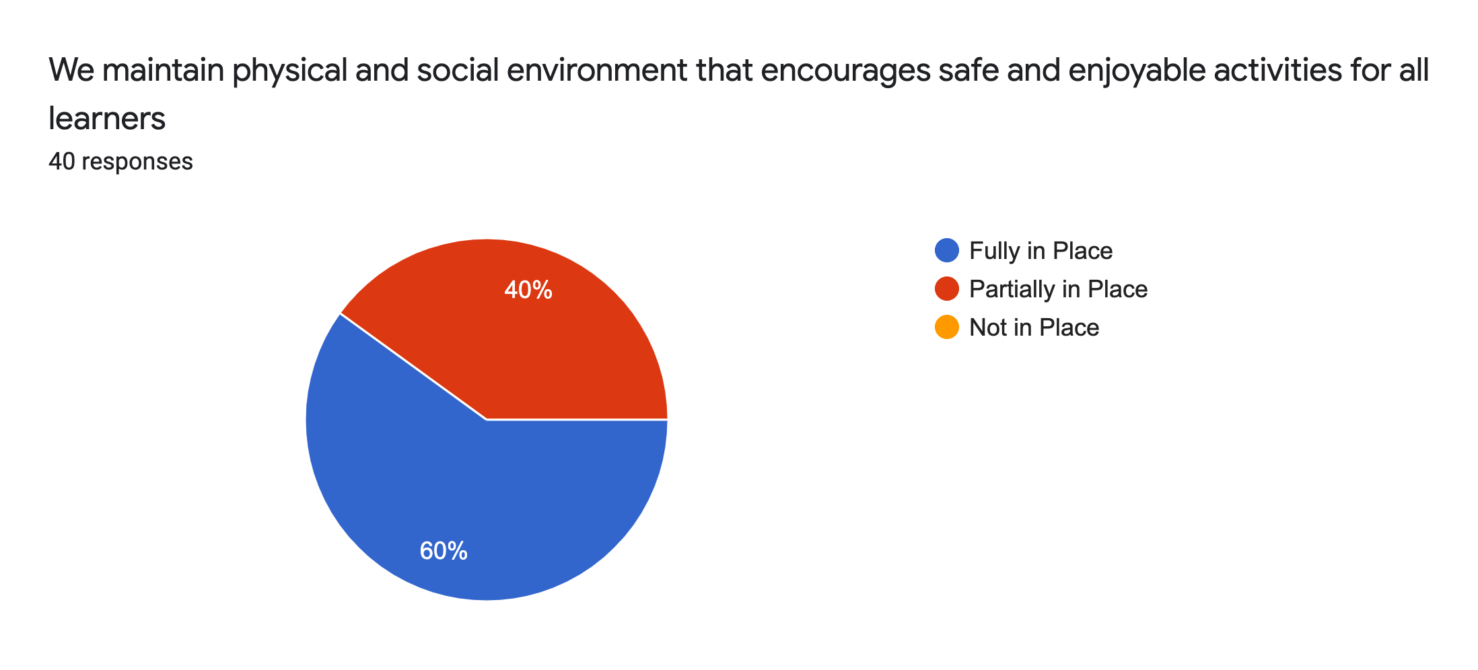
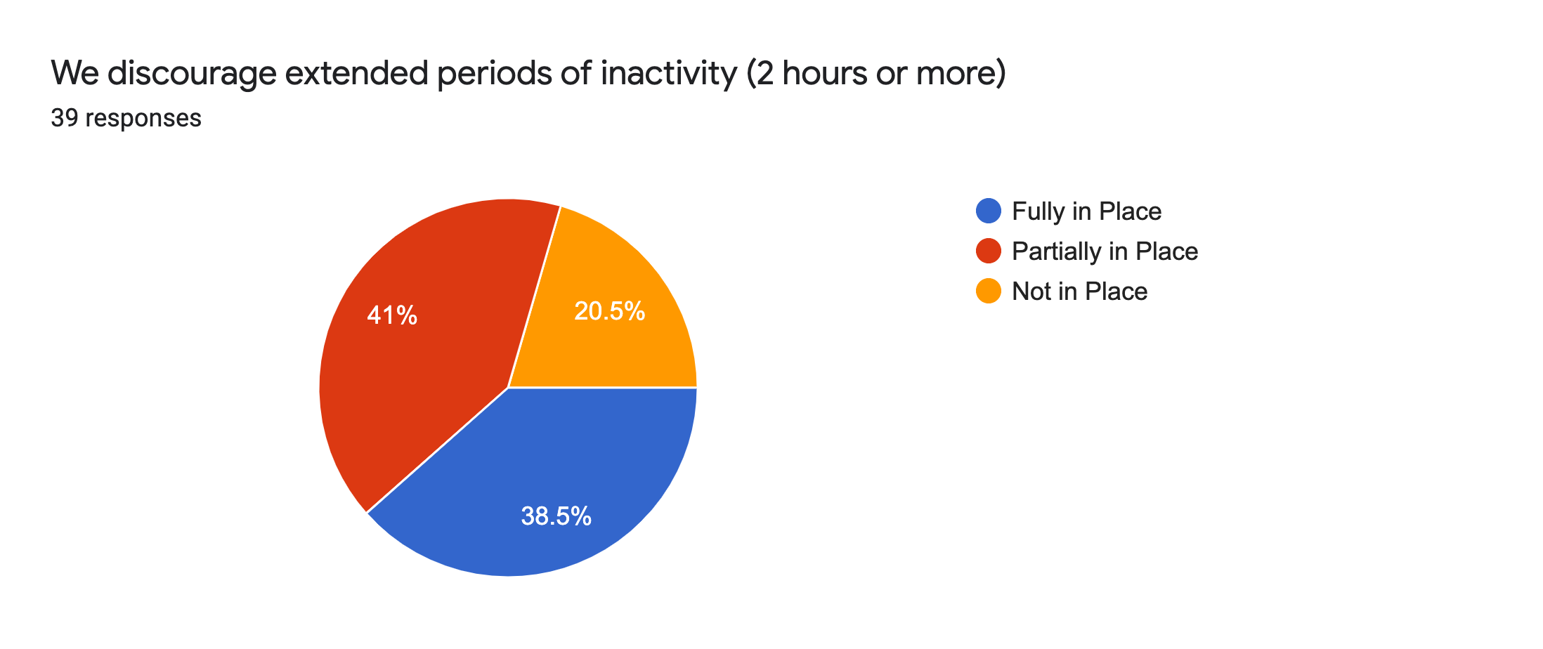
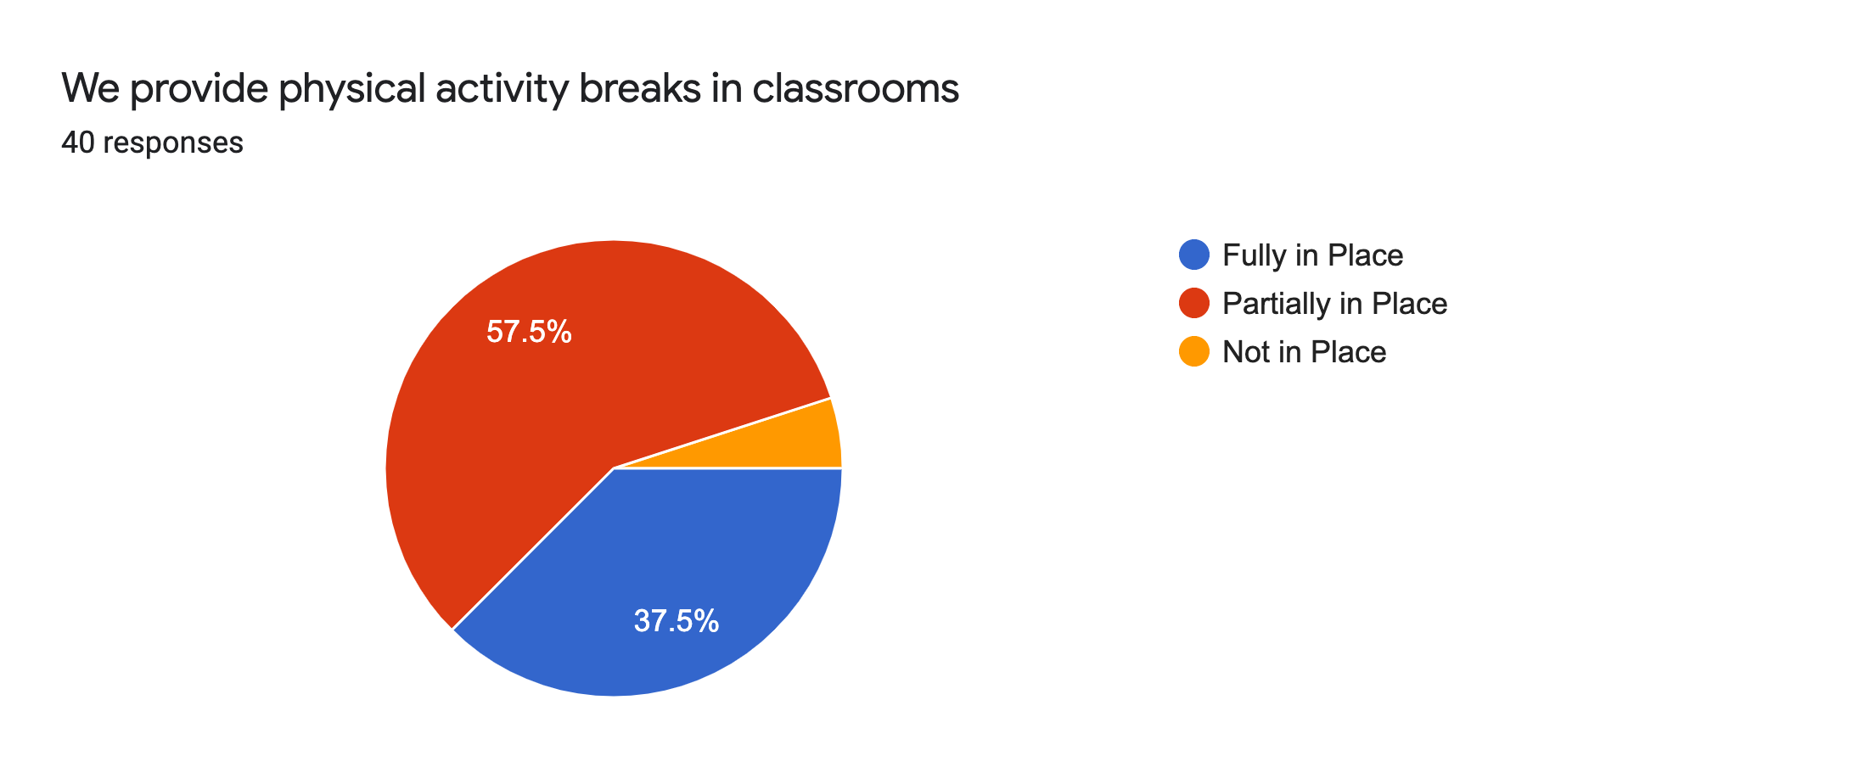
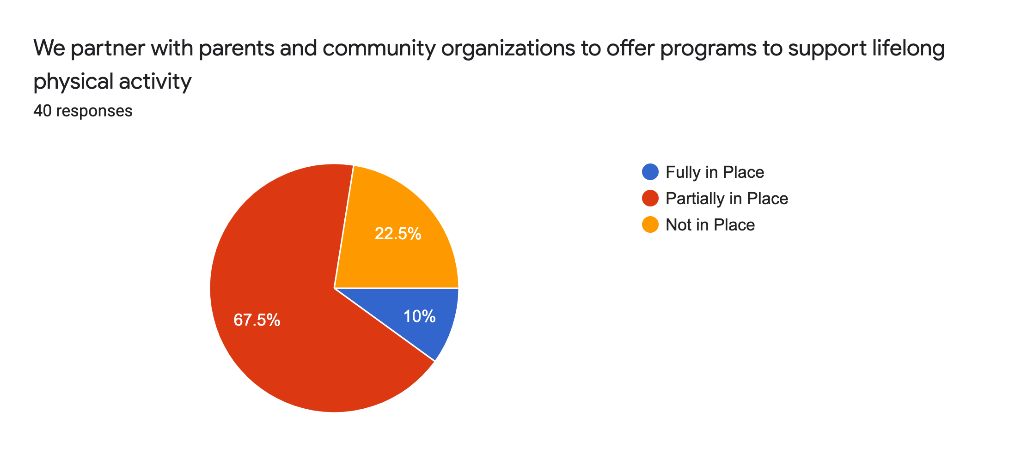
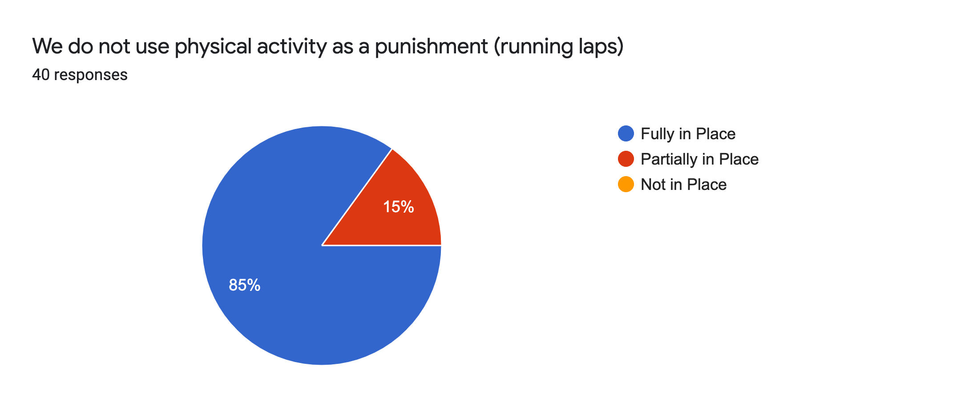
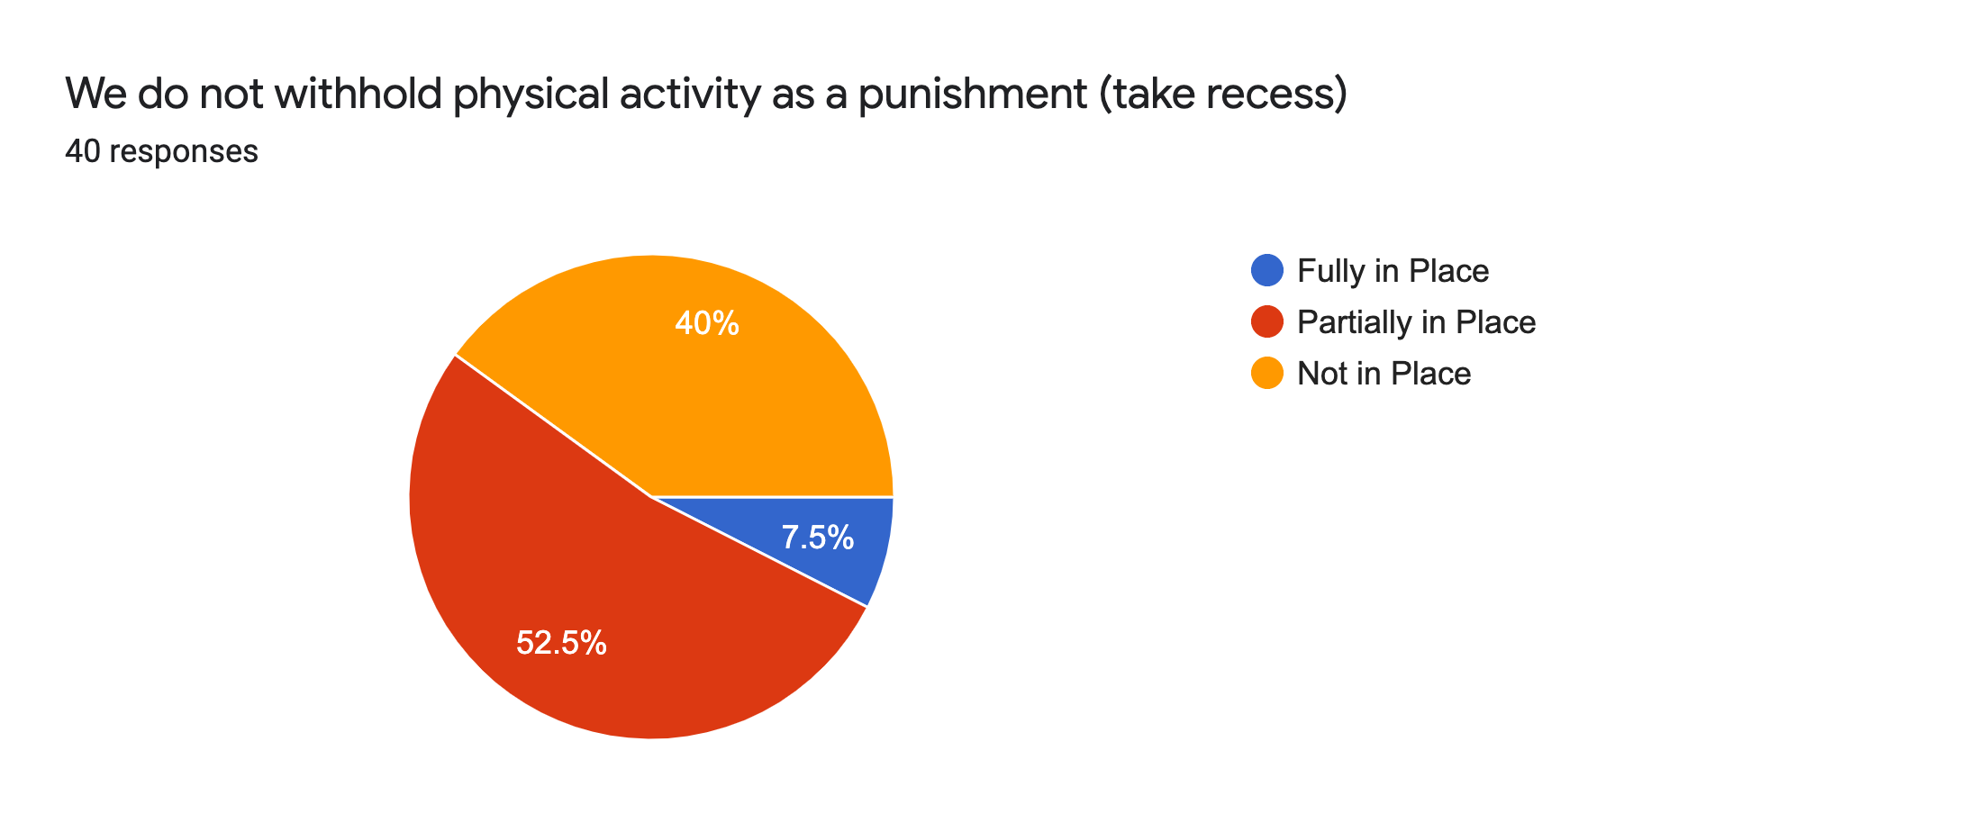
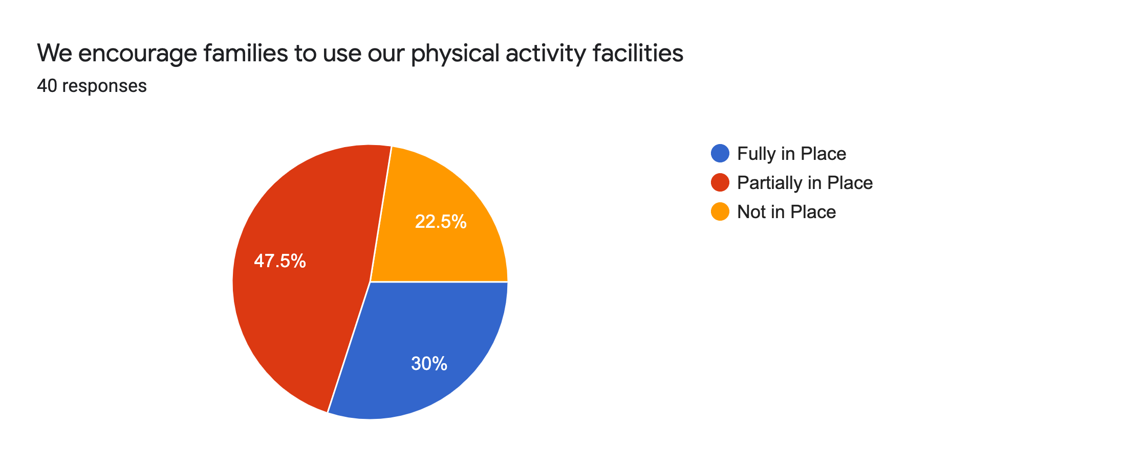

Recommendation for Goals in the Physical Activity

- Further support clubs after school.
- We can do a better job creating a link between physical activity at school and the community.
- Continue to work towards 60 minutes activity each day.
- Provide more options for learners to engage in physical activity

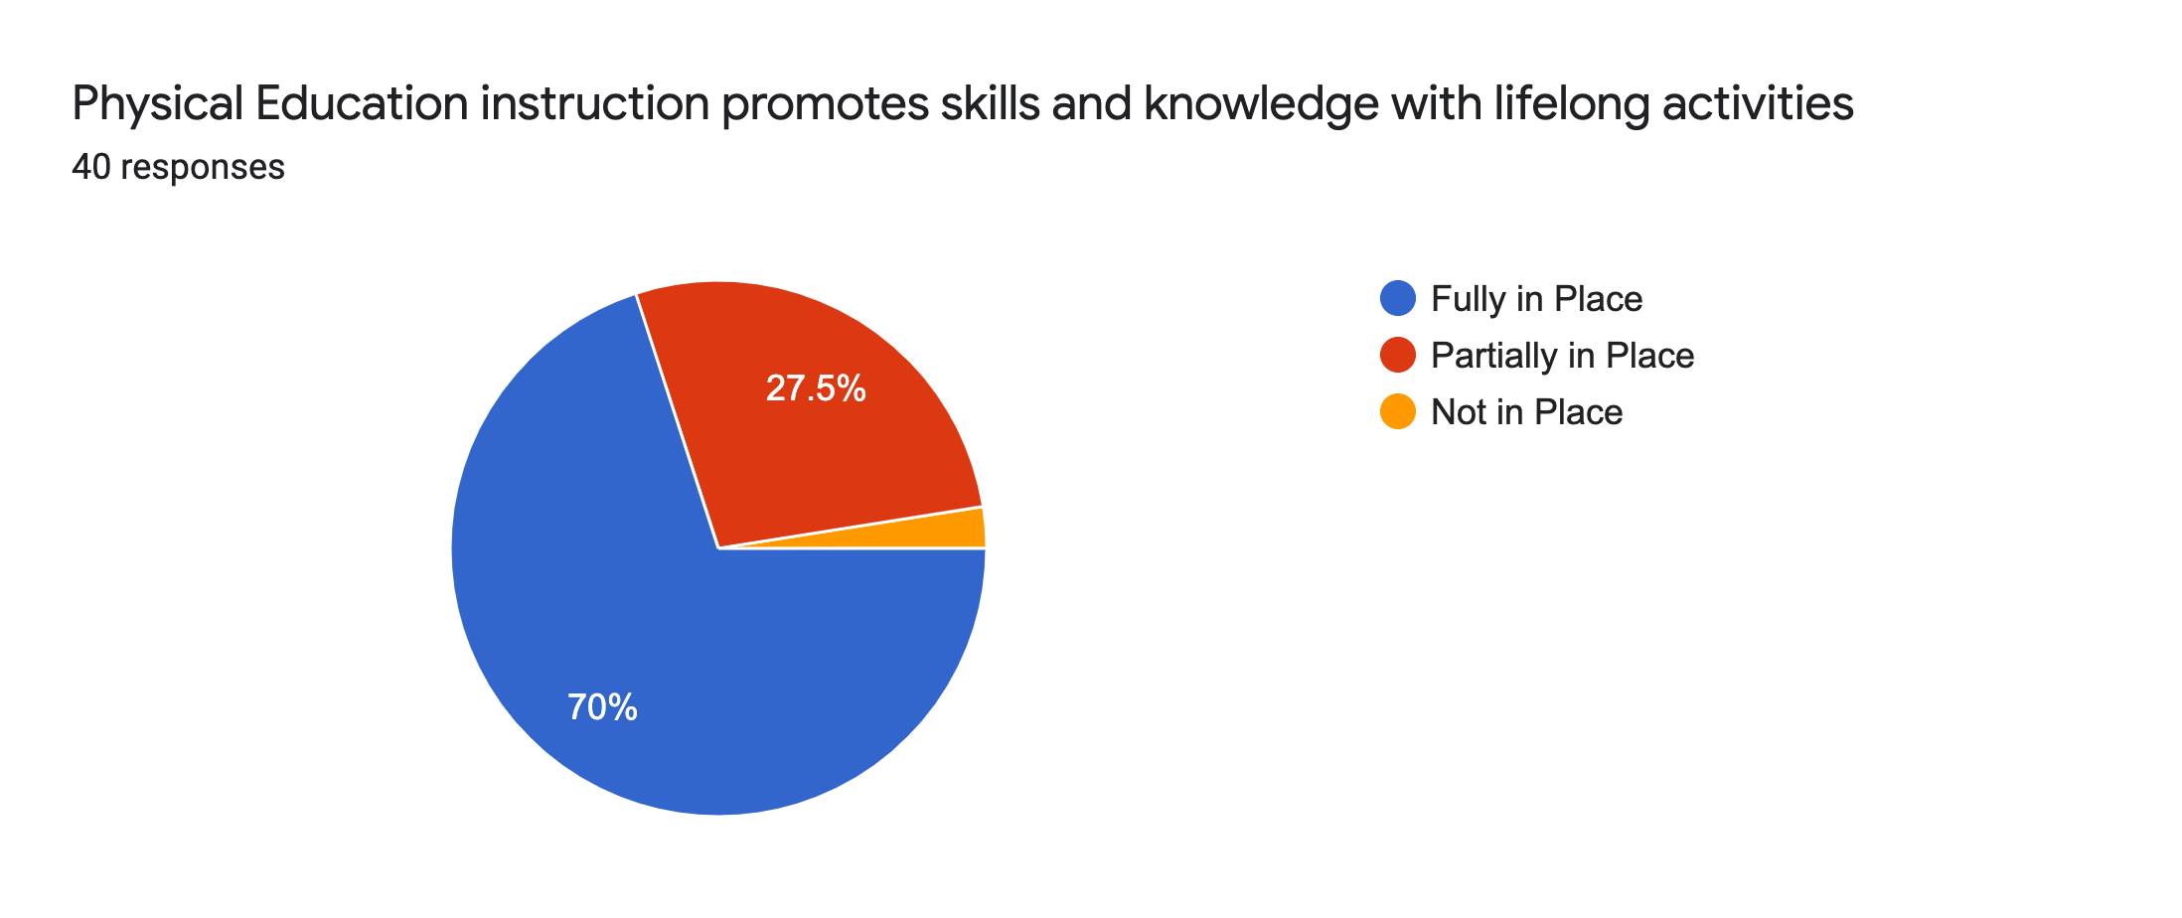
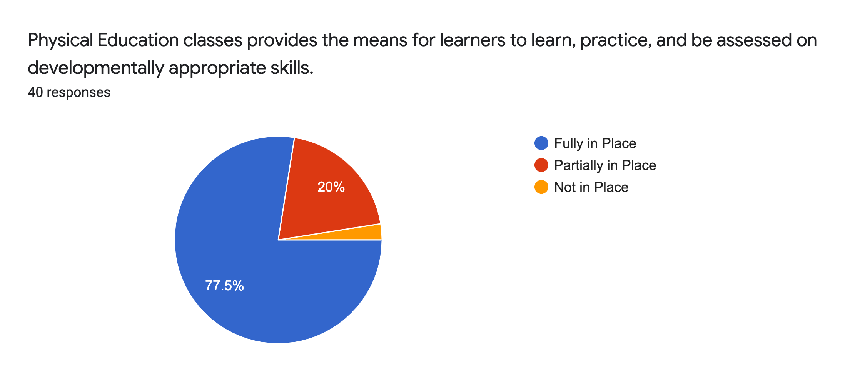
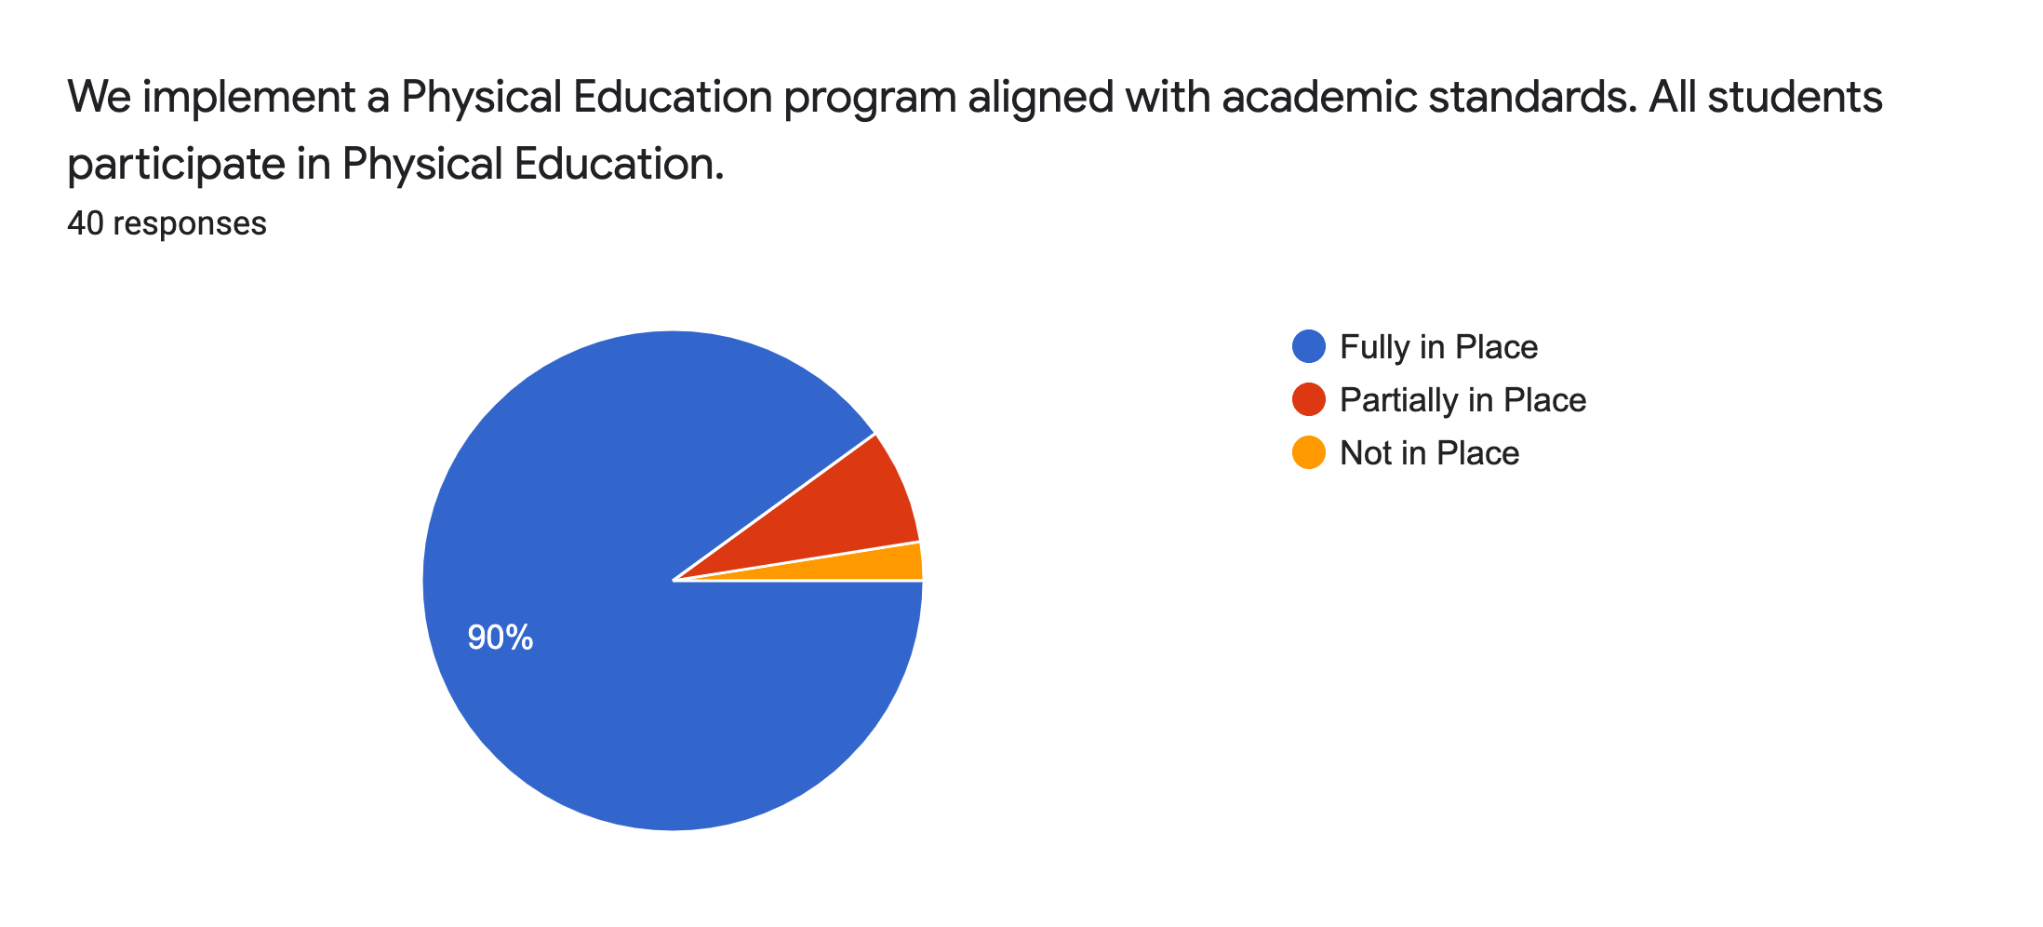
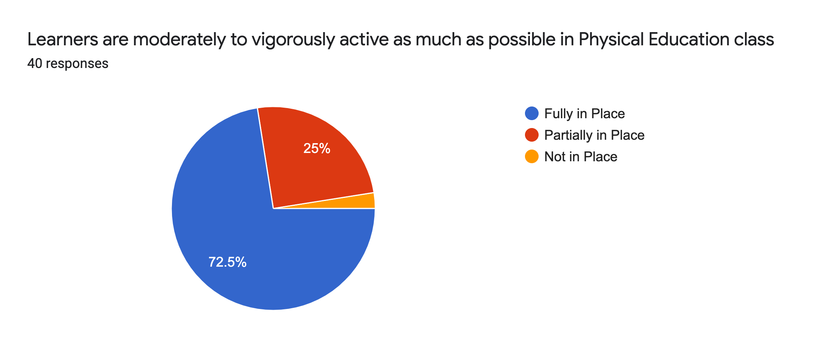
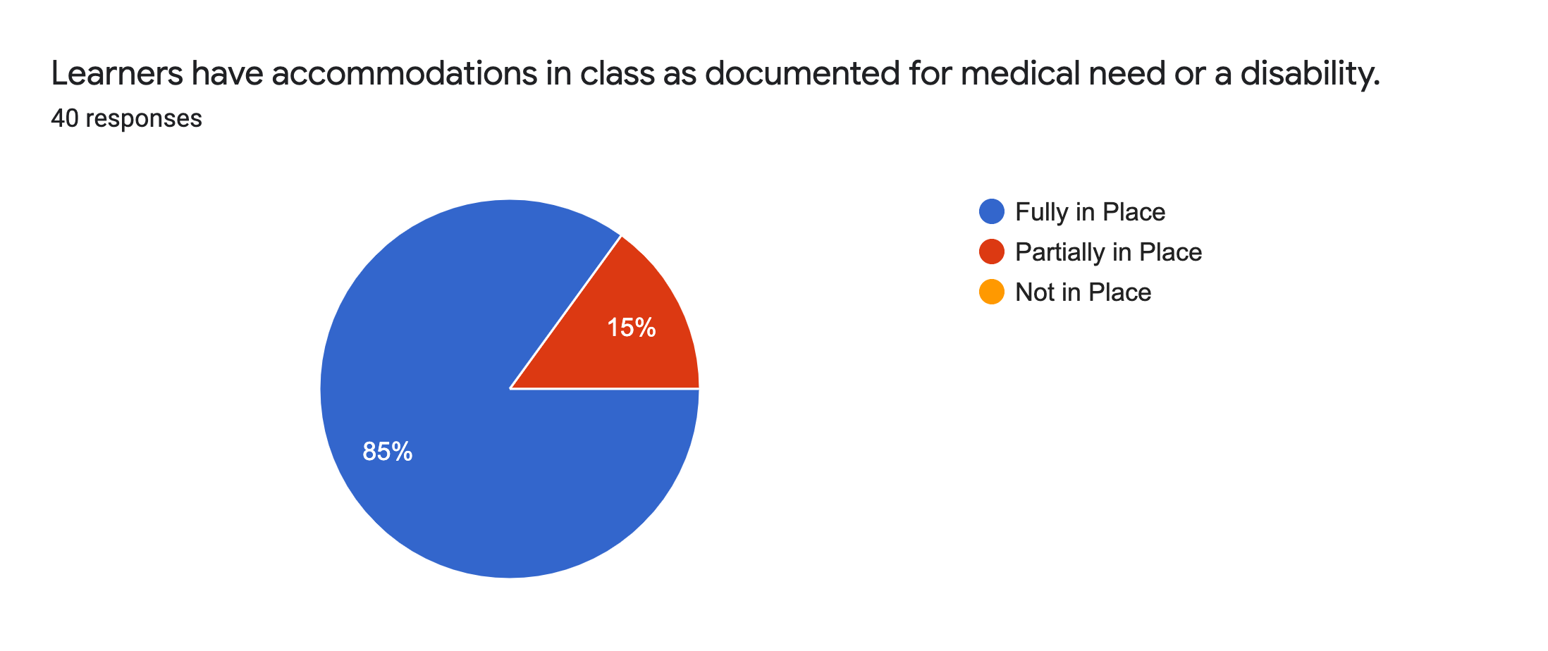
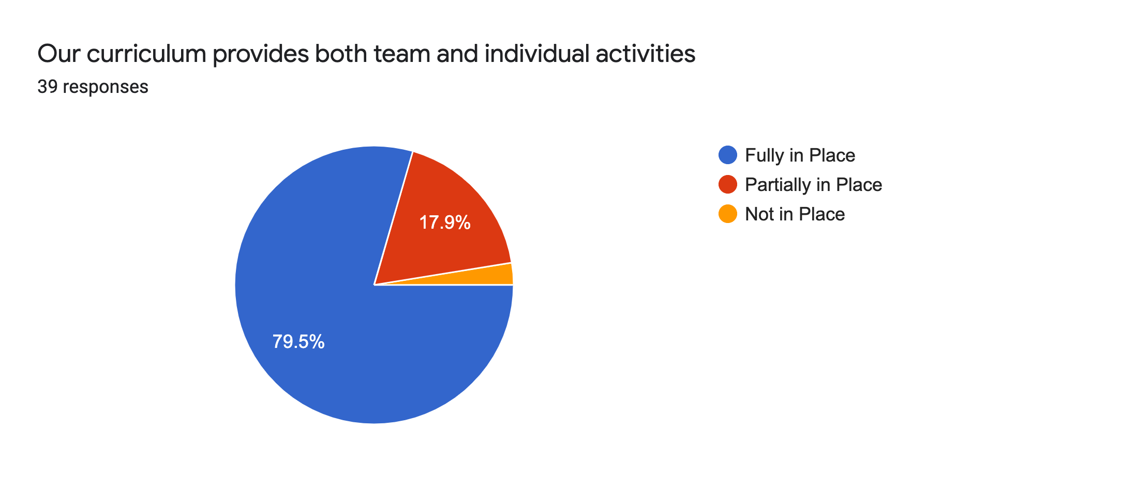
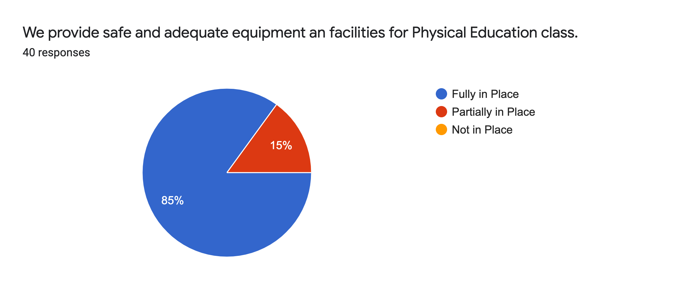
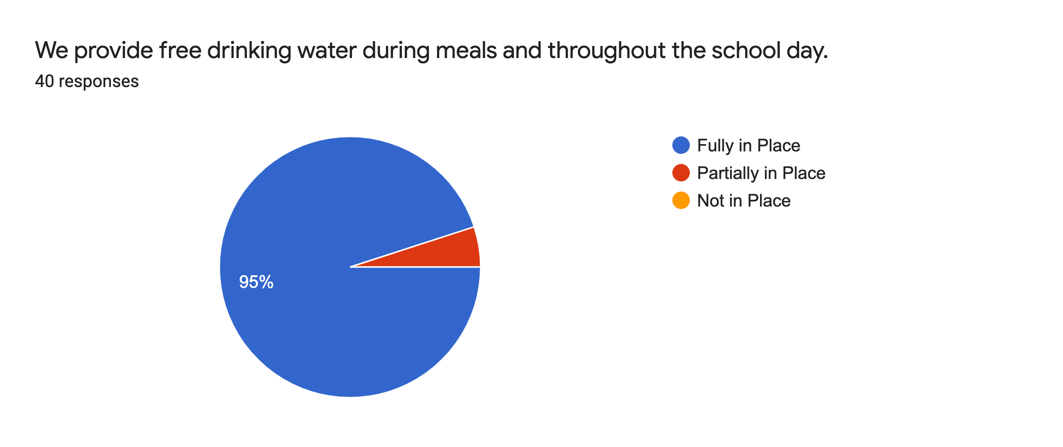
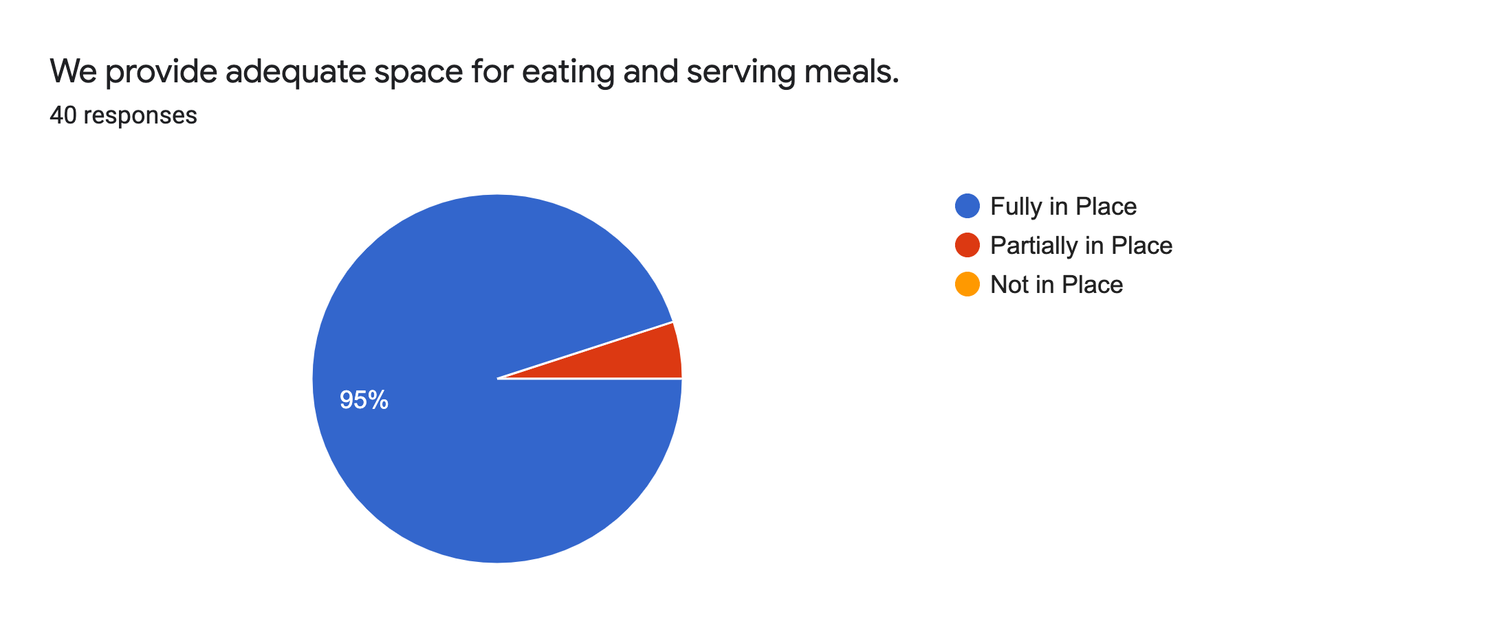
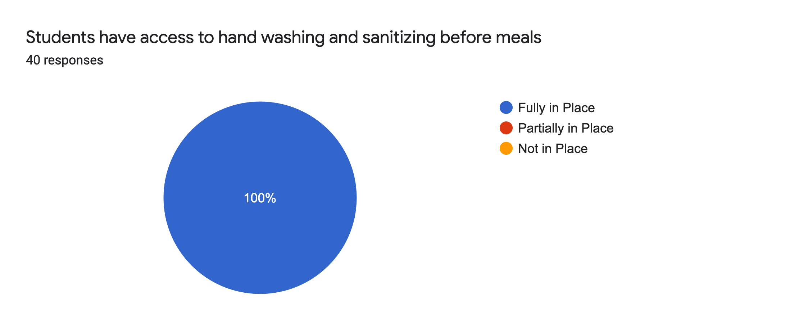
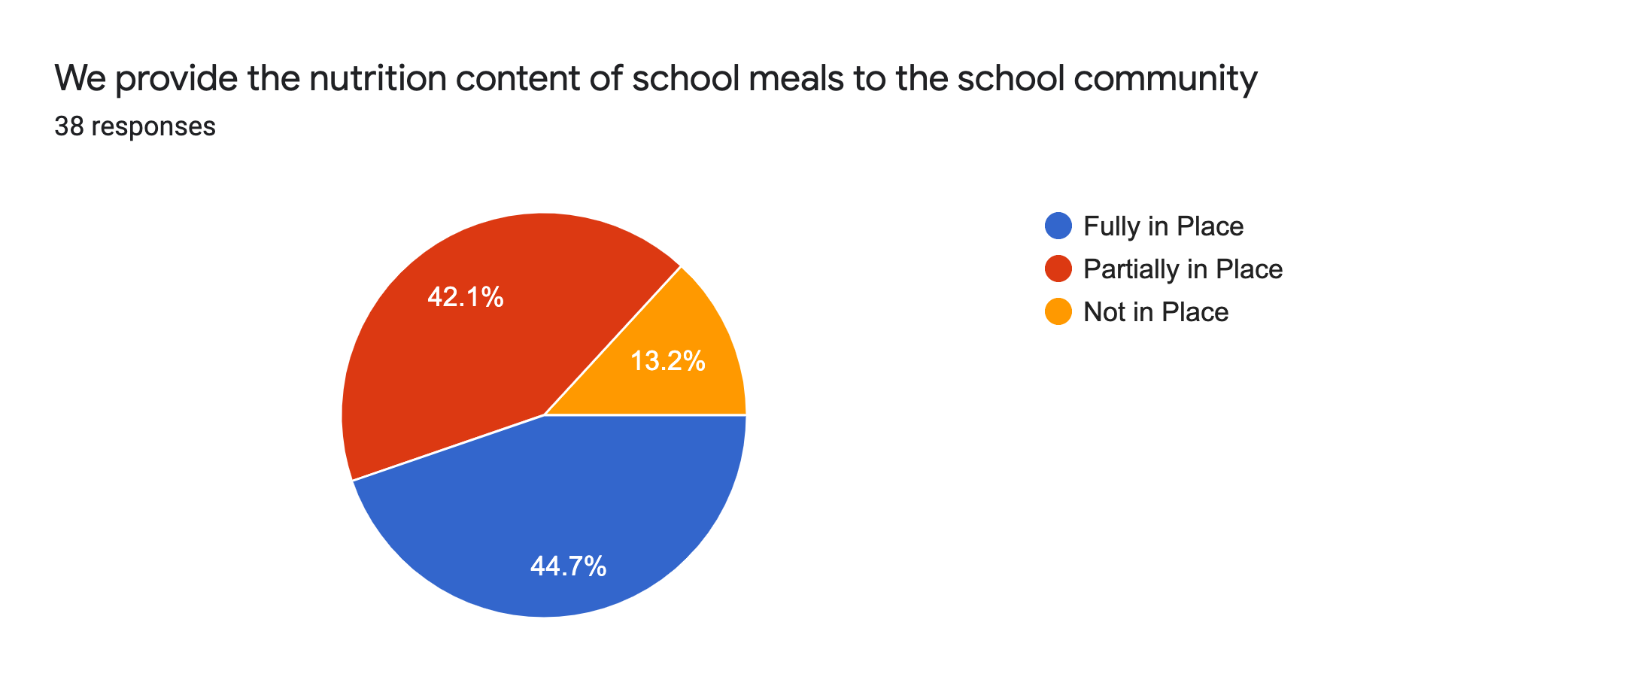
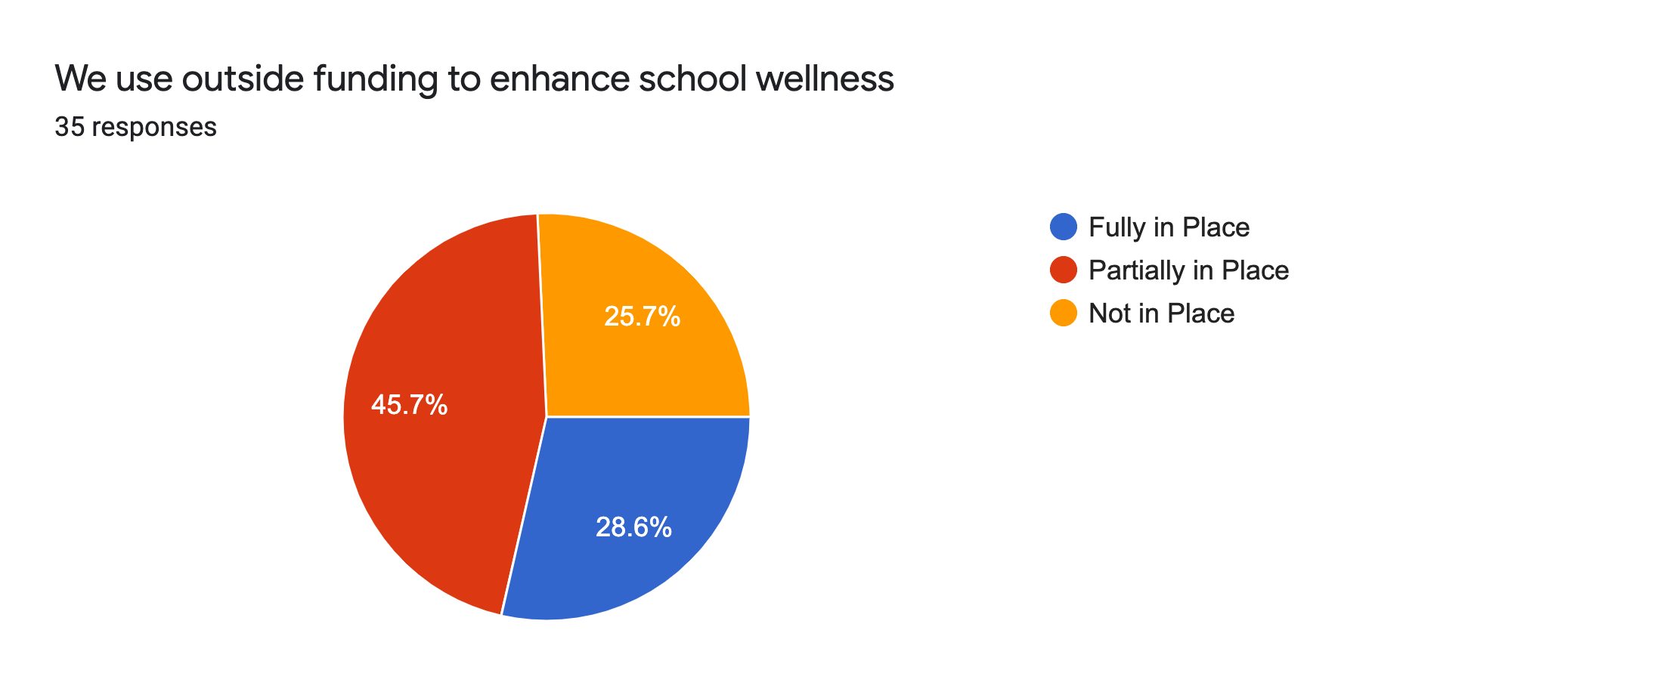
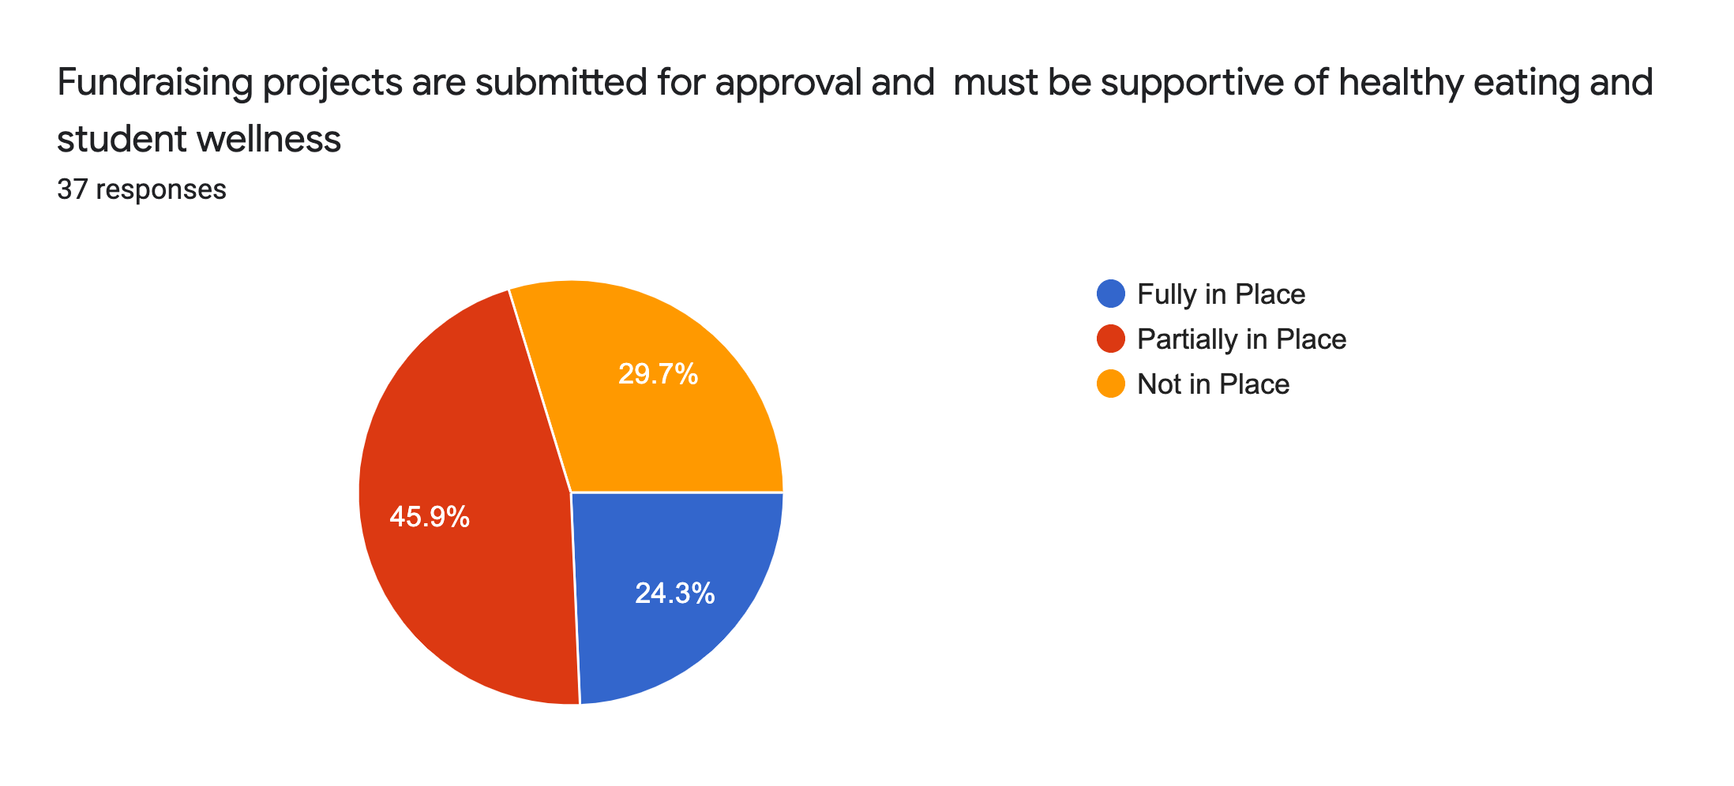
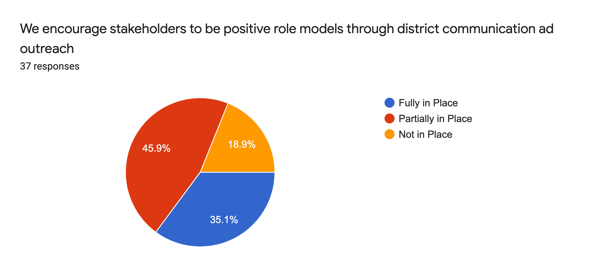
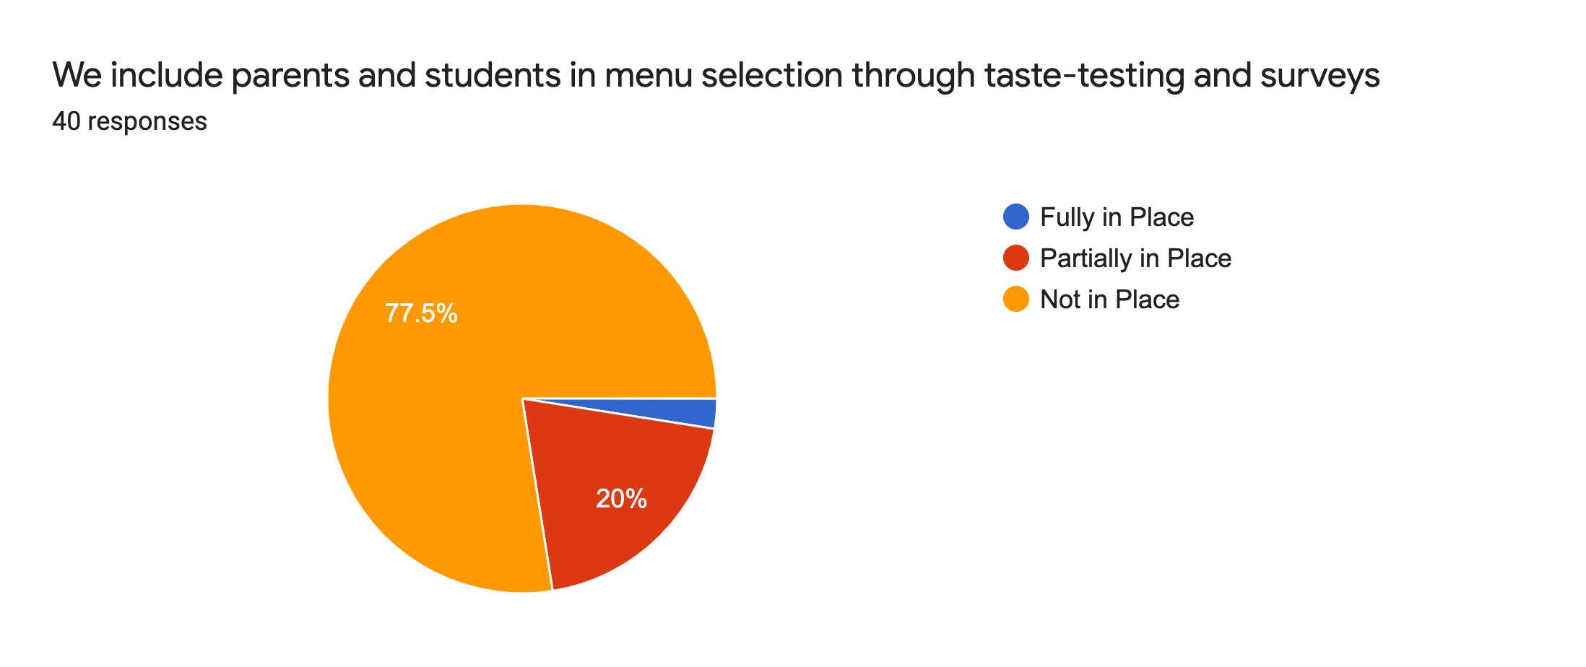
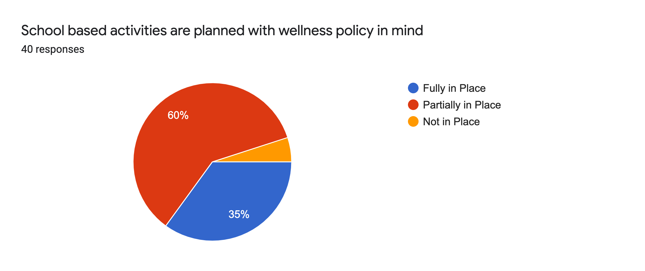
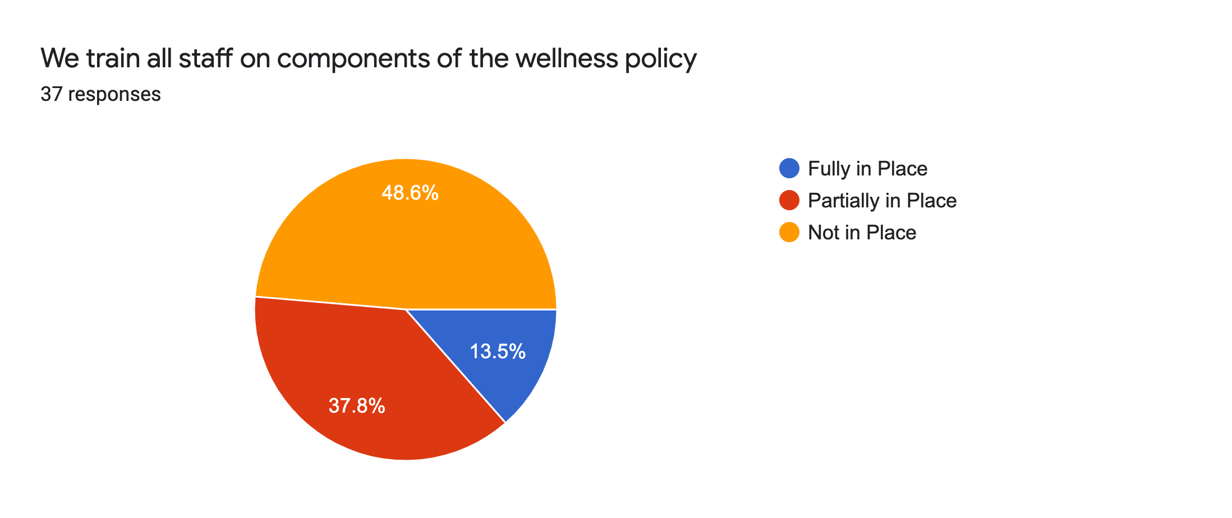
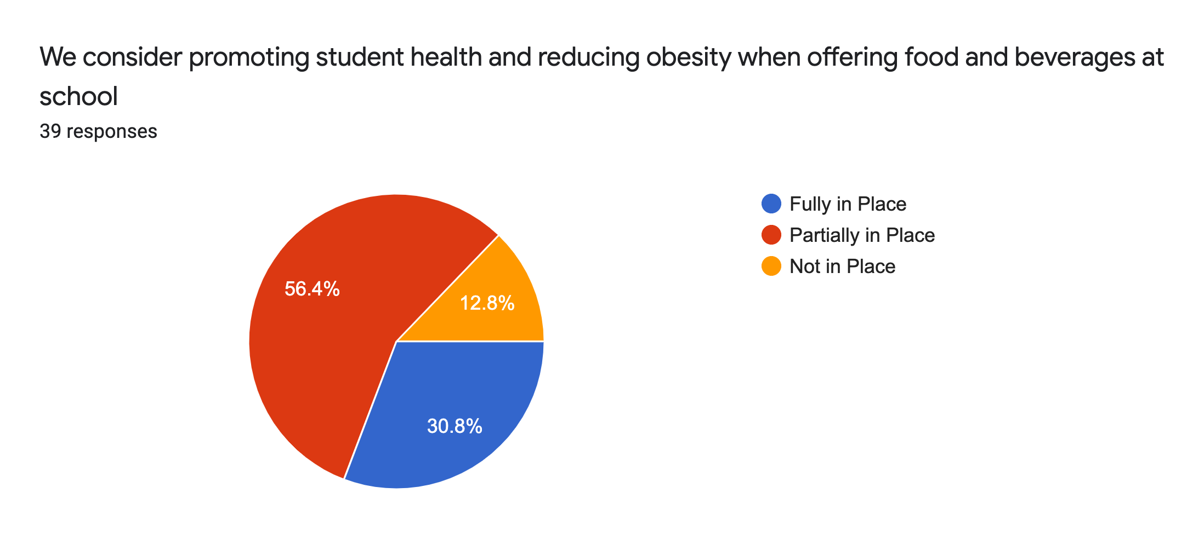
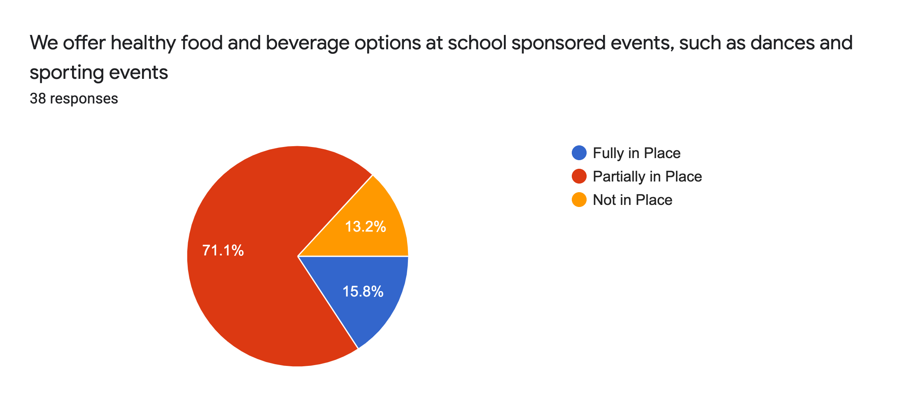
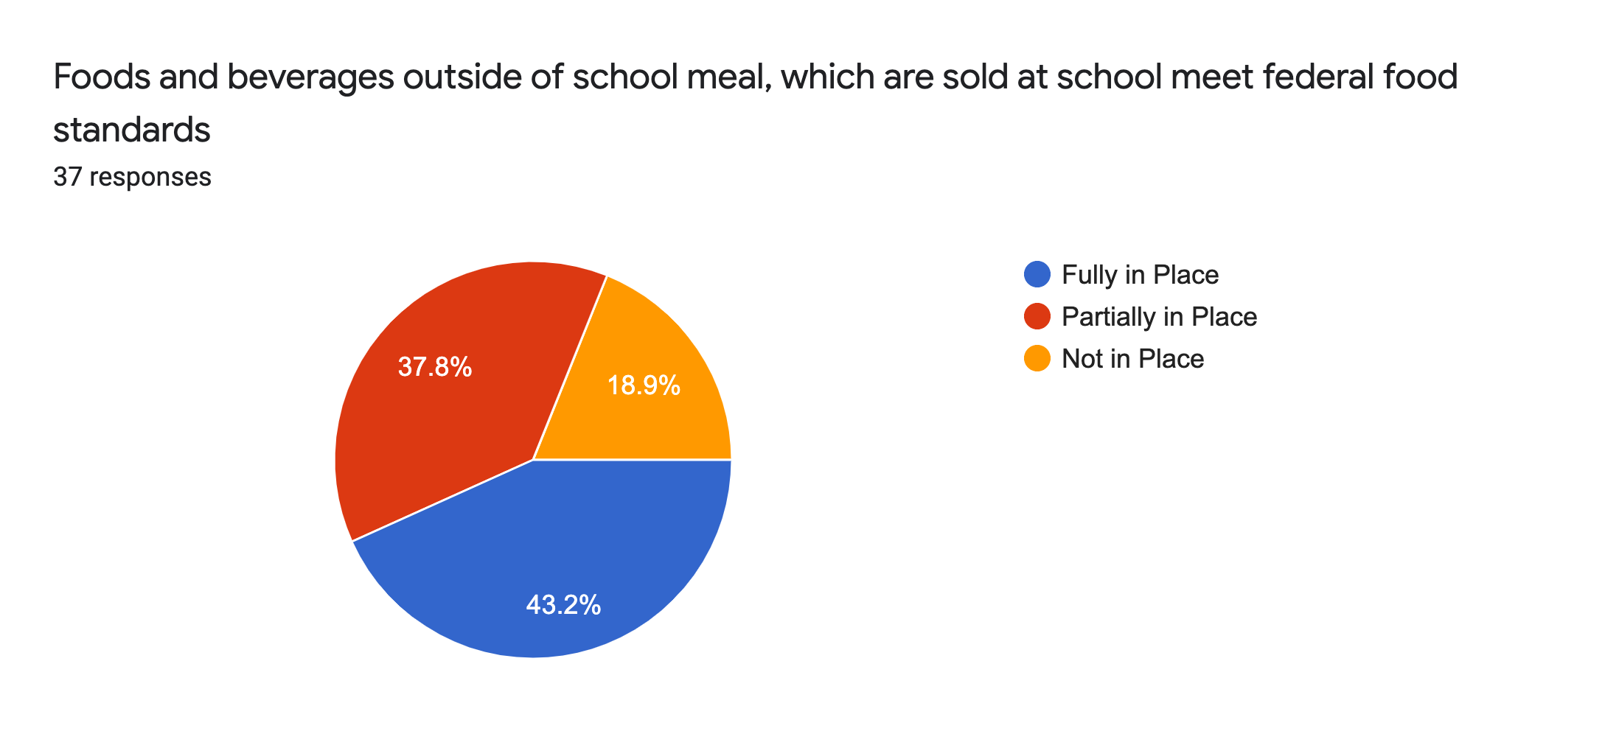
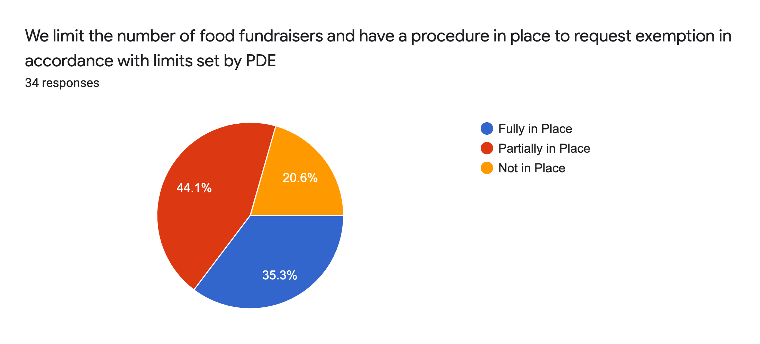
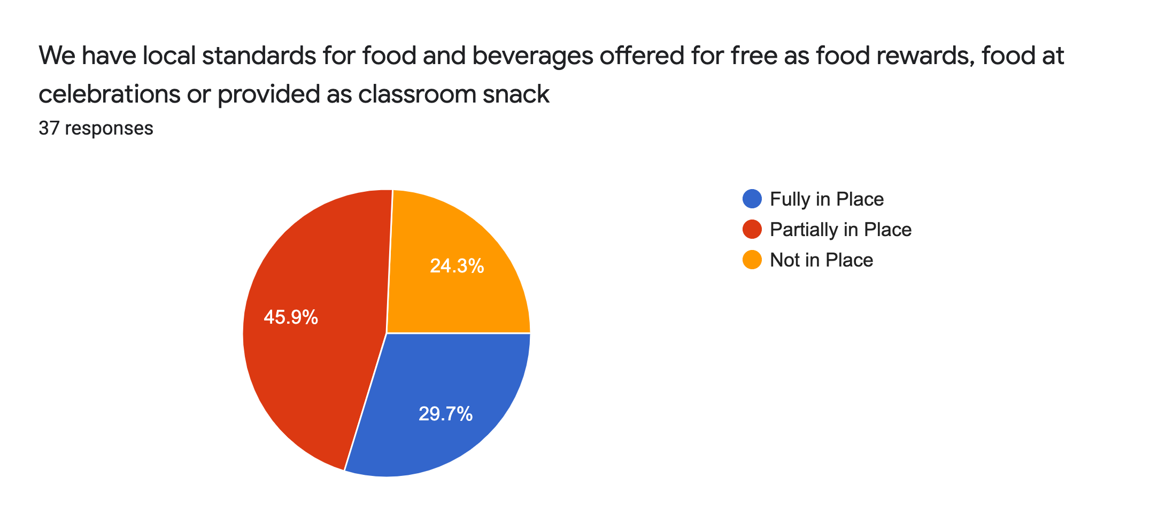
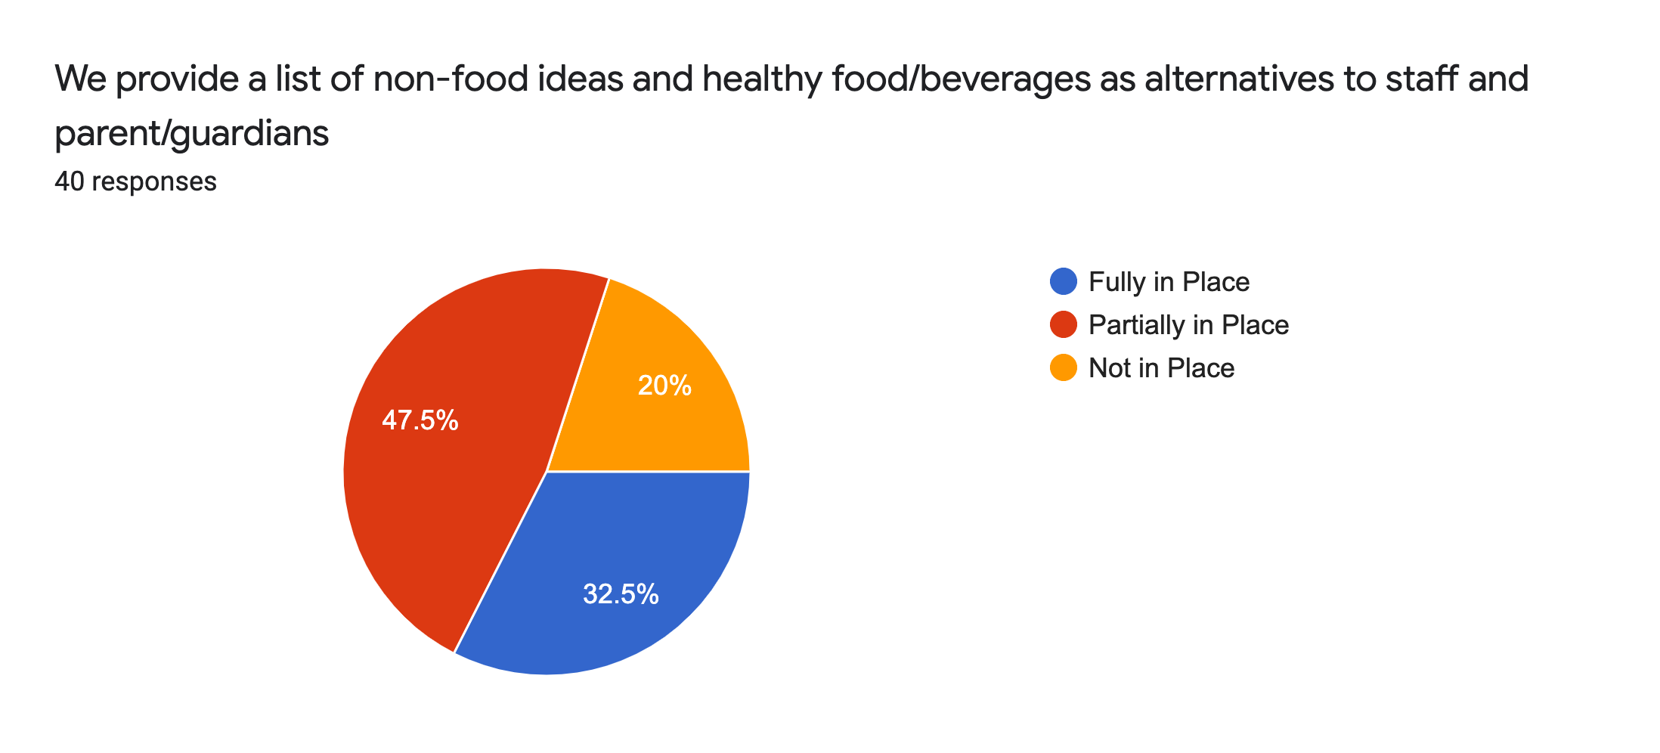
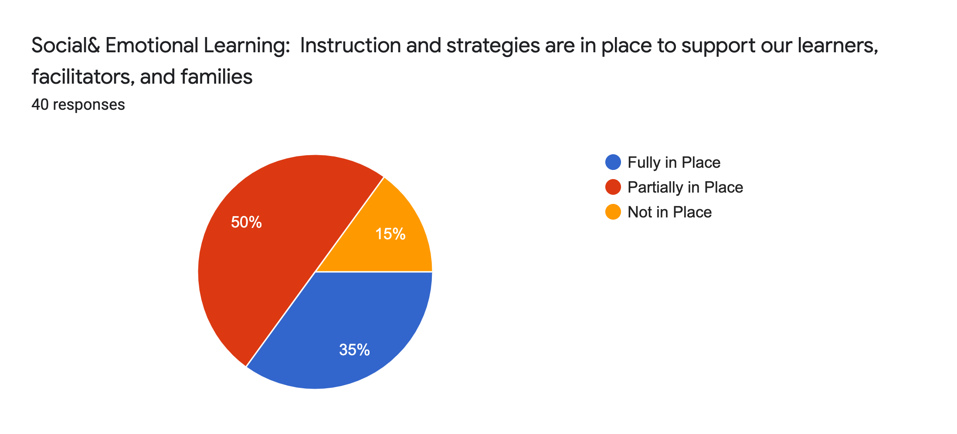
- Please list any ideas for goals for this committee for next year for staff, families, community or learners

- Clear alignment of health and wellness goals that facilitators should be helping to reiterate in the classroom and how we should do so.
- We need to involve all our stakeholders in the wellness planning process- parents, students, staff and community.
- Healthy eating is an important goal to share with our learners. Unhealthy food is cheap, so many of our learners, being economically disadvantaged, lack the support system at home for healthy eating, physical activity, technology use, and sleep management.
- Students have shared that they do not get enough food at lunch to satisfy their need for the day;
- If I have to say something… More fruit 🙂
- Provide information on how the district incorporates nutritional awareness to families
- Incorporating snack time for K to 3 - can spend time educating families on healthy snack choices Reiterating that loss of recess isn't a good consequence as it reduces physical activity in a child's day which is necessary
- SEL curriculum for all learners.
- SEL direct instruction in the classroom, more time for movement and kinesthetics through learning, healthier breakfast options for students to start their day, air quality of classrooms needs improvement as well as proper ventilation and dust removal in the filters and vents.
- Clearer alignment of health and wellness goals that can be translated from phys. ed classroom to recess games, as well as a school-wide approach for healthy practices.
- More collaboration with local farmers/resources for lunch options; start some kind of garden project with age appropriate roles/responsibilities incorporated into curriculum

Any other information you would like to elaborate on from your responses

- Offering parent lessons on health or technology balance to mental/social/emotional well being would be a great asset to the district community.
- In this survey, a “not sure” button.

Wellness Data 2022 --Student Data (Only 1 student -12th grader)

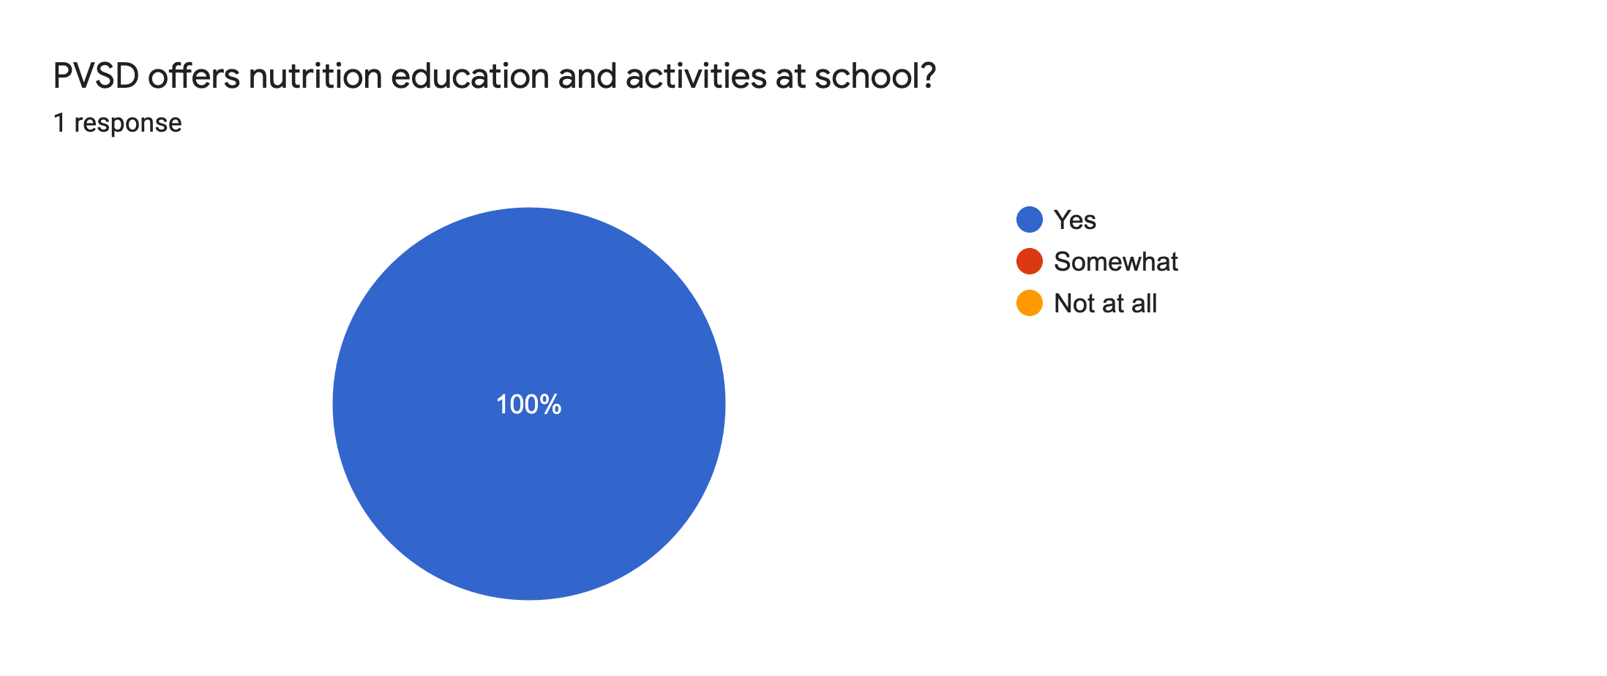
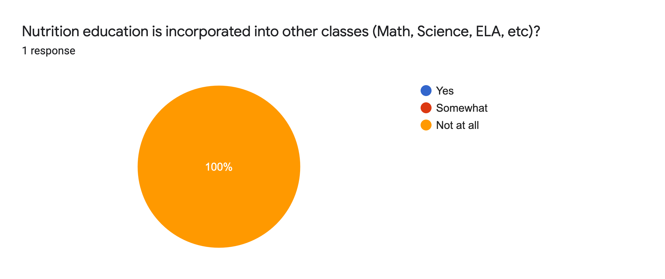
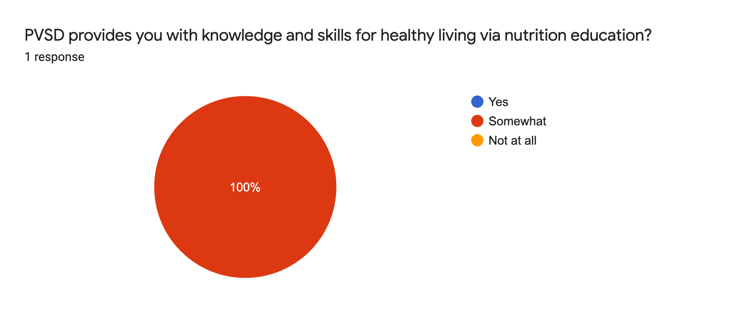
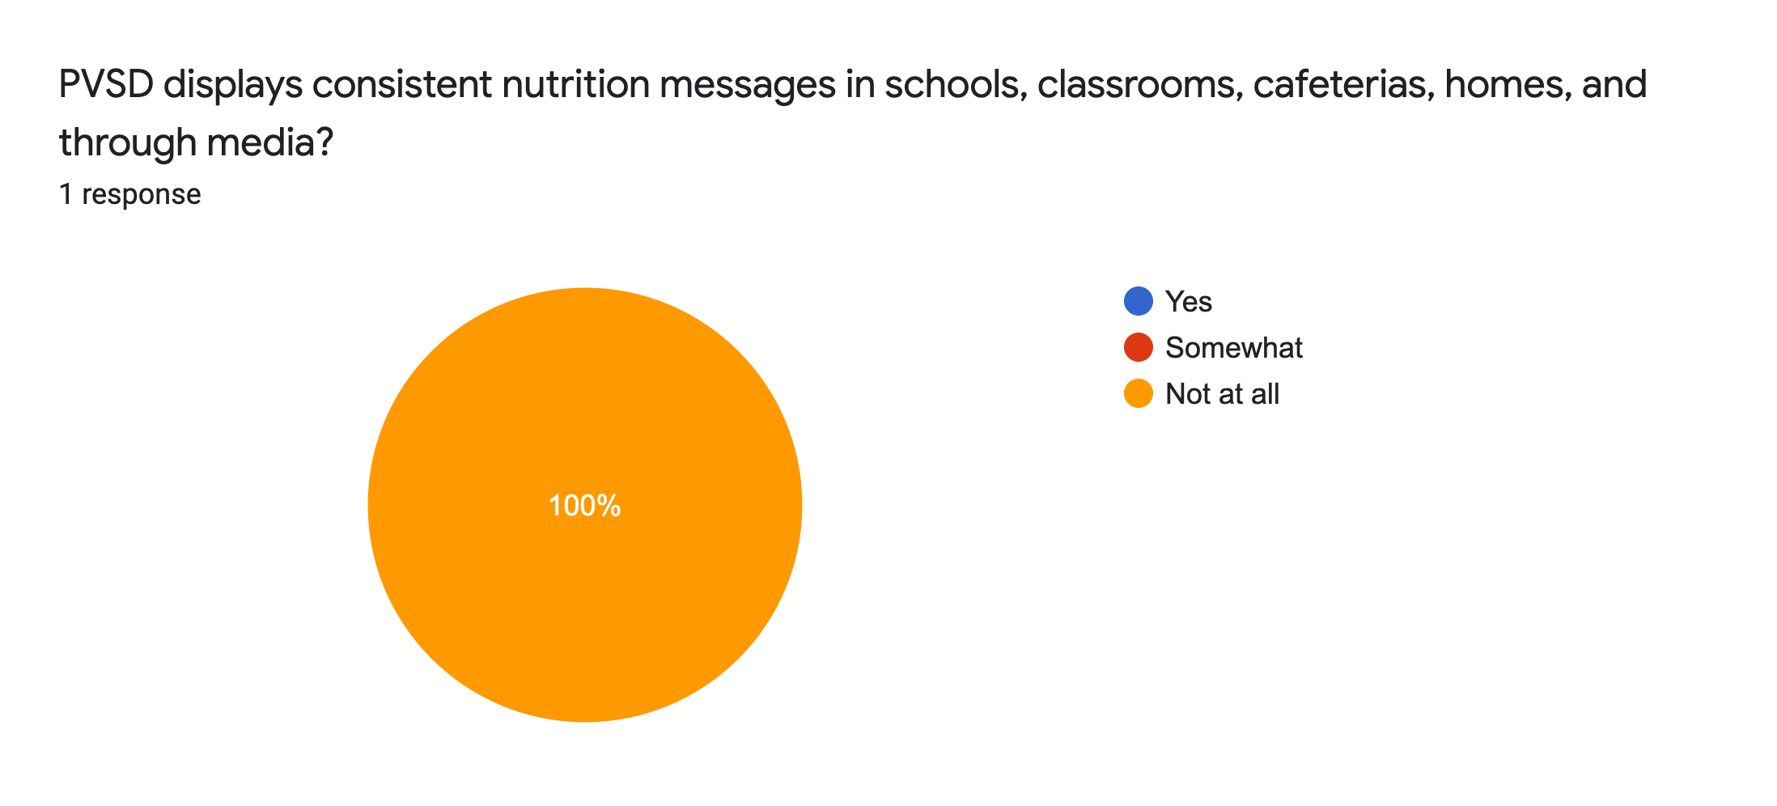
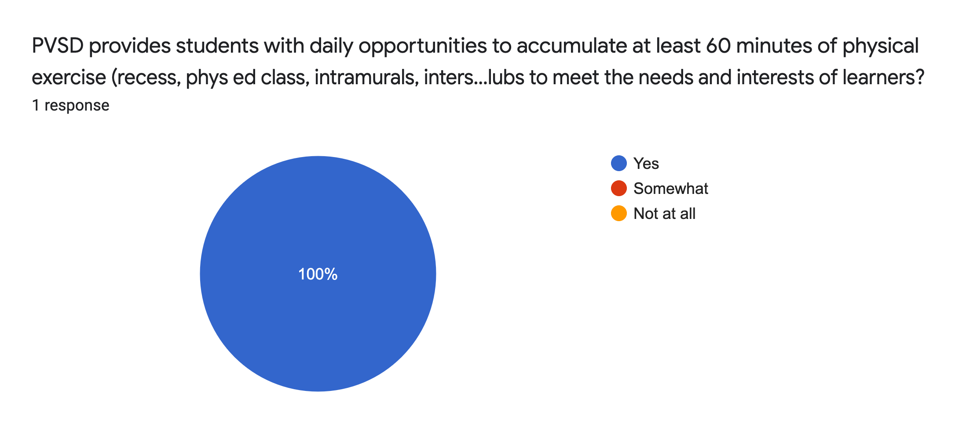
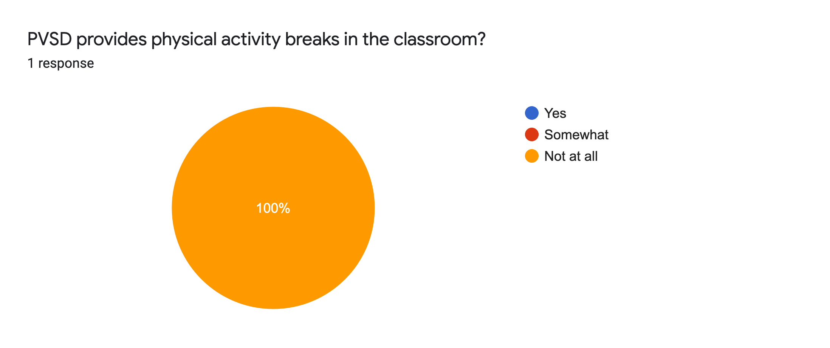
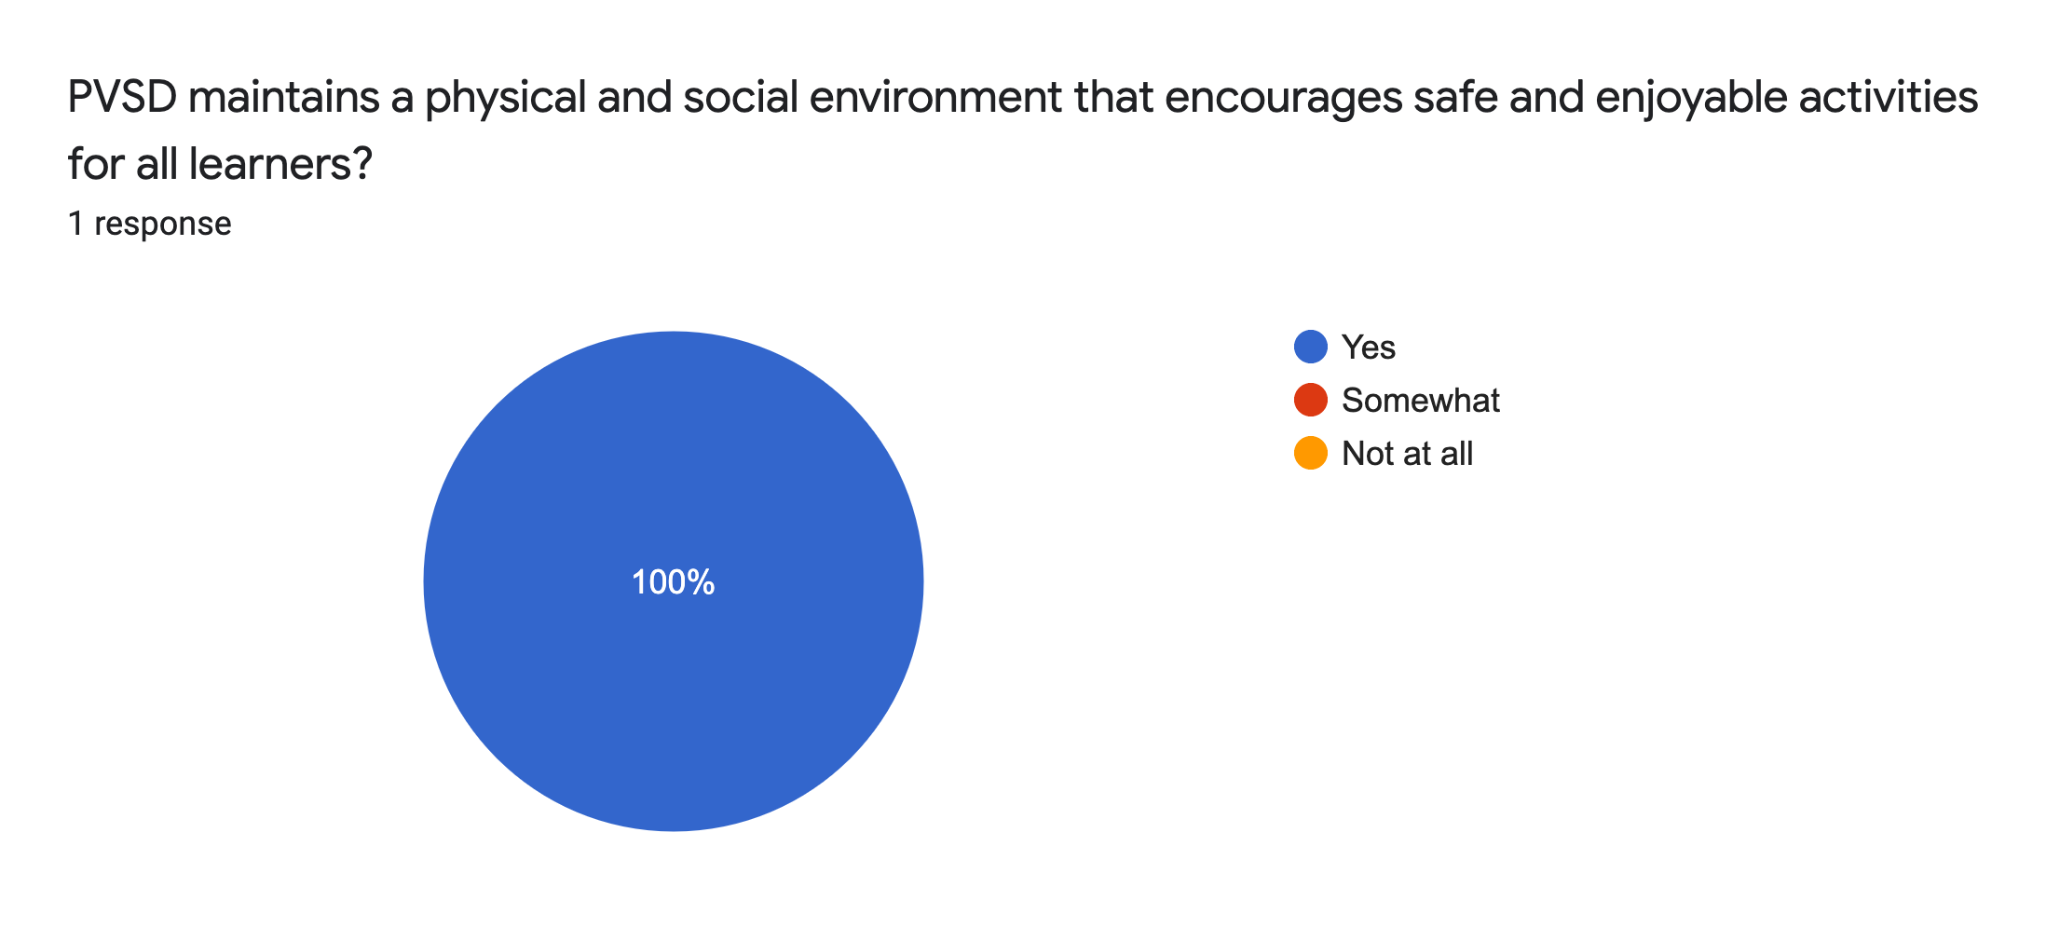
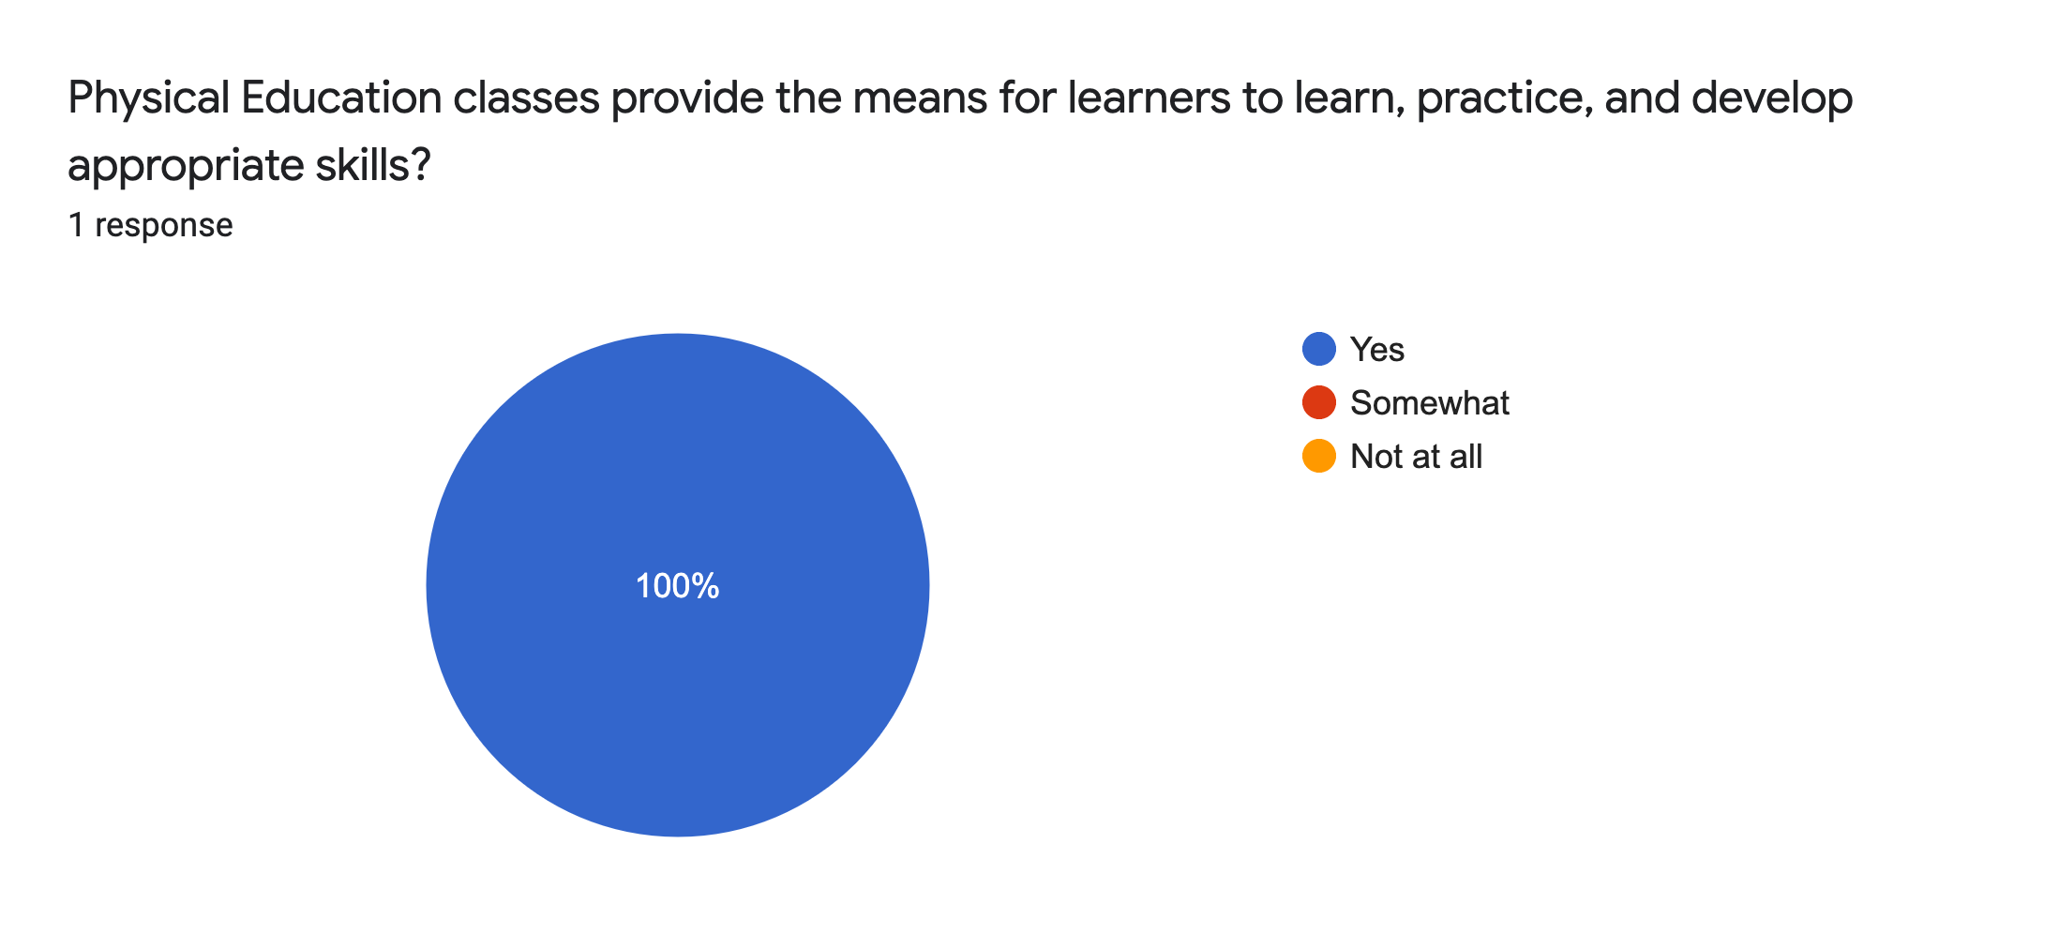
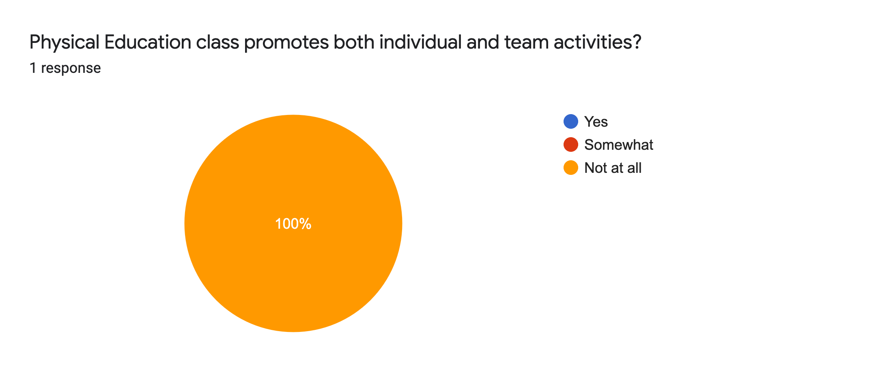
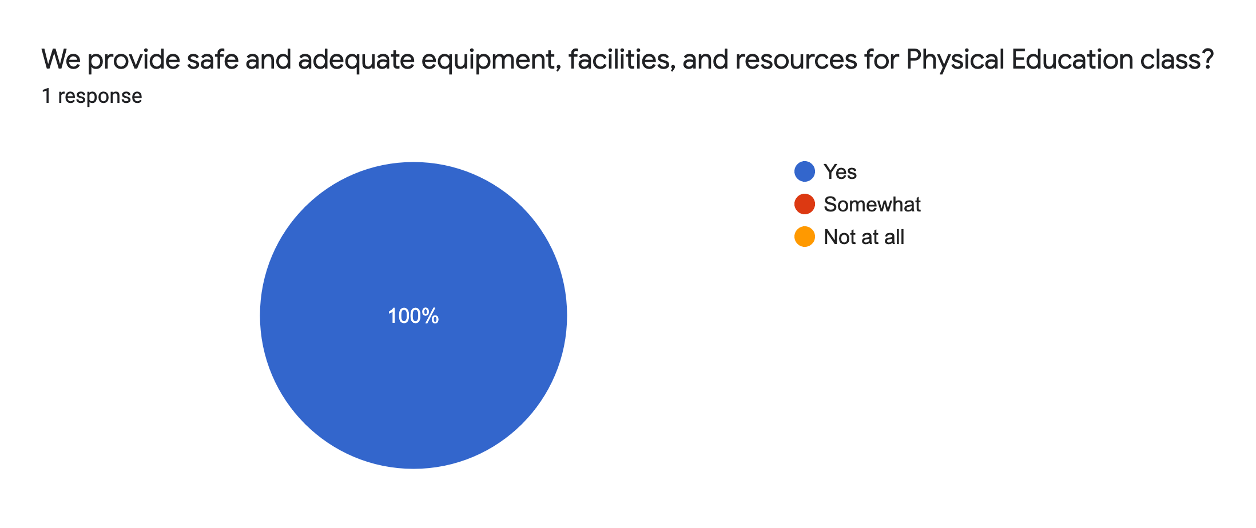
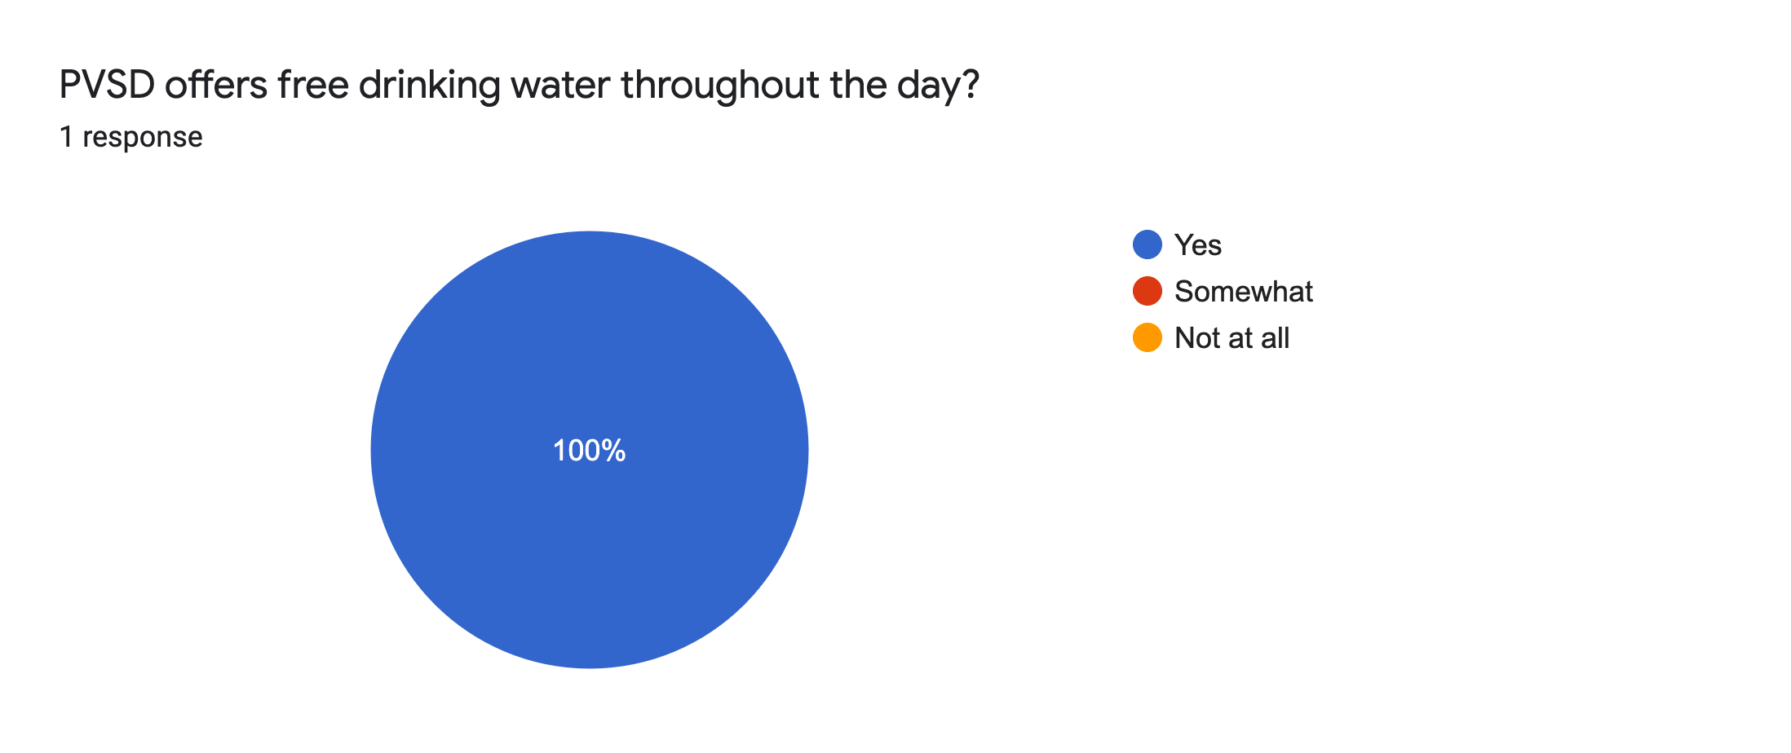
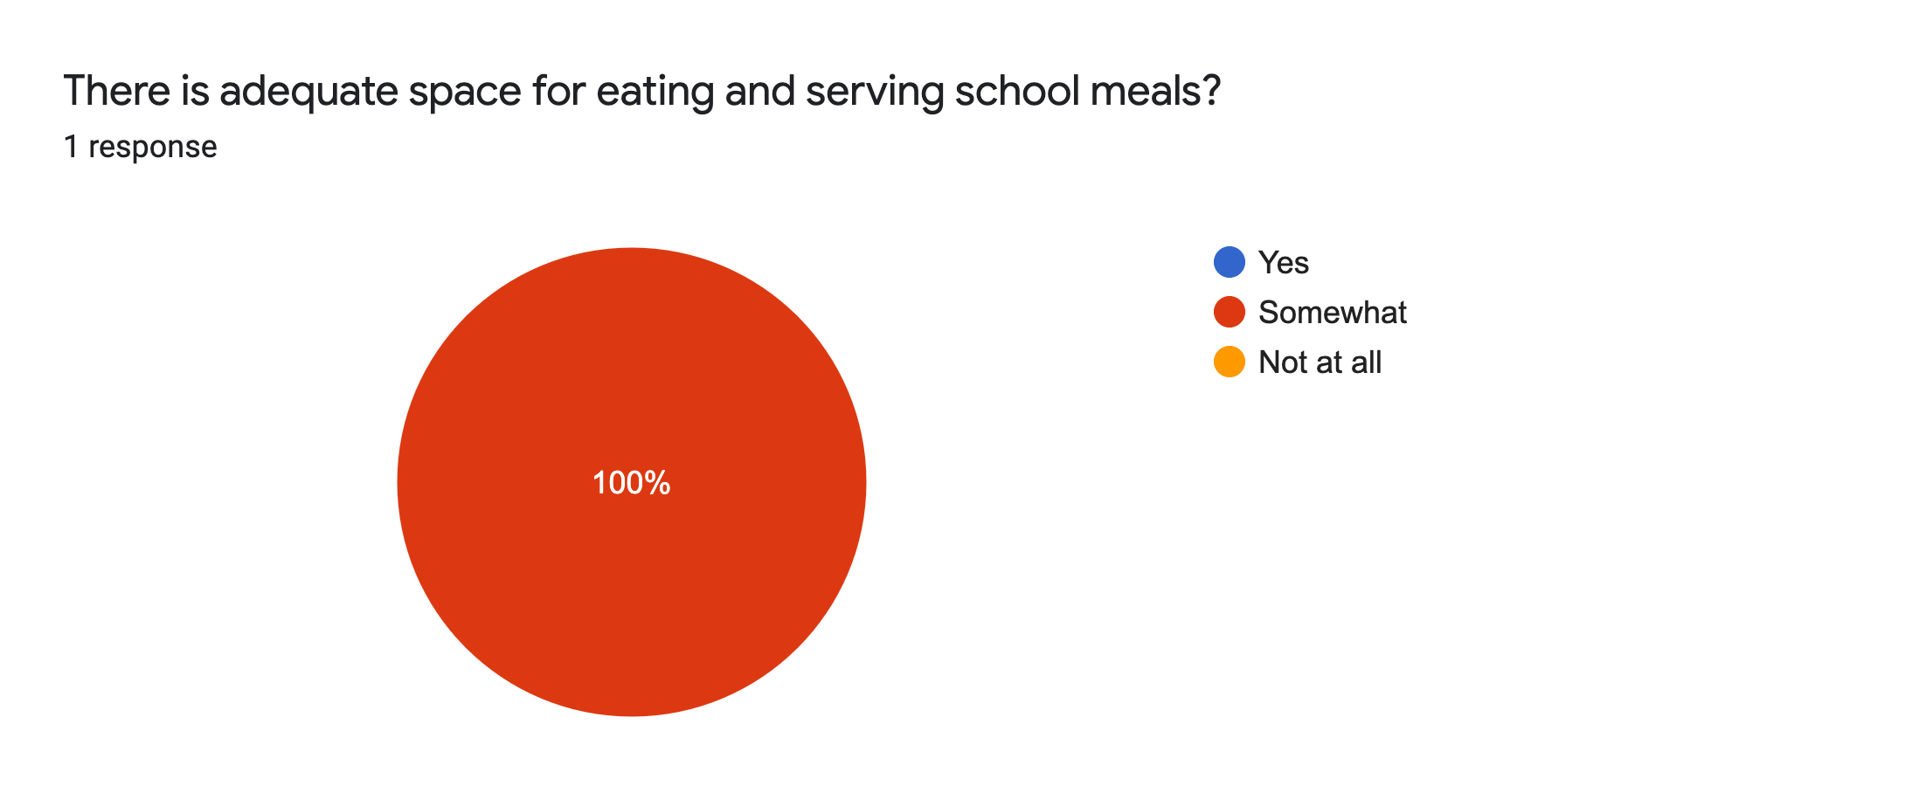
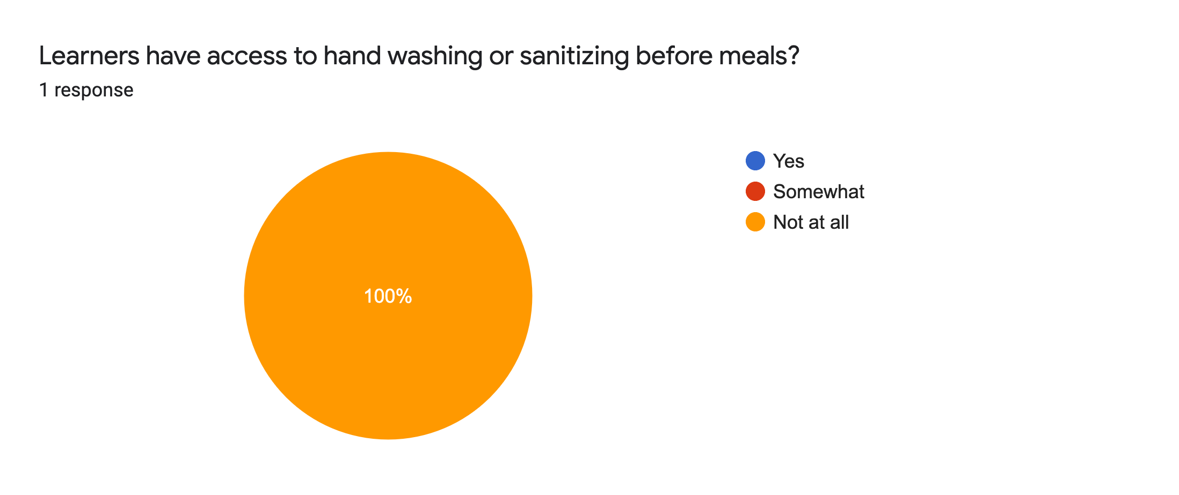
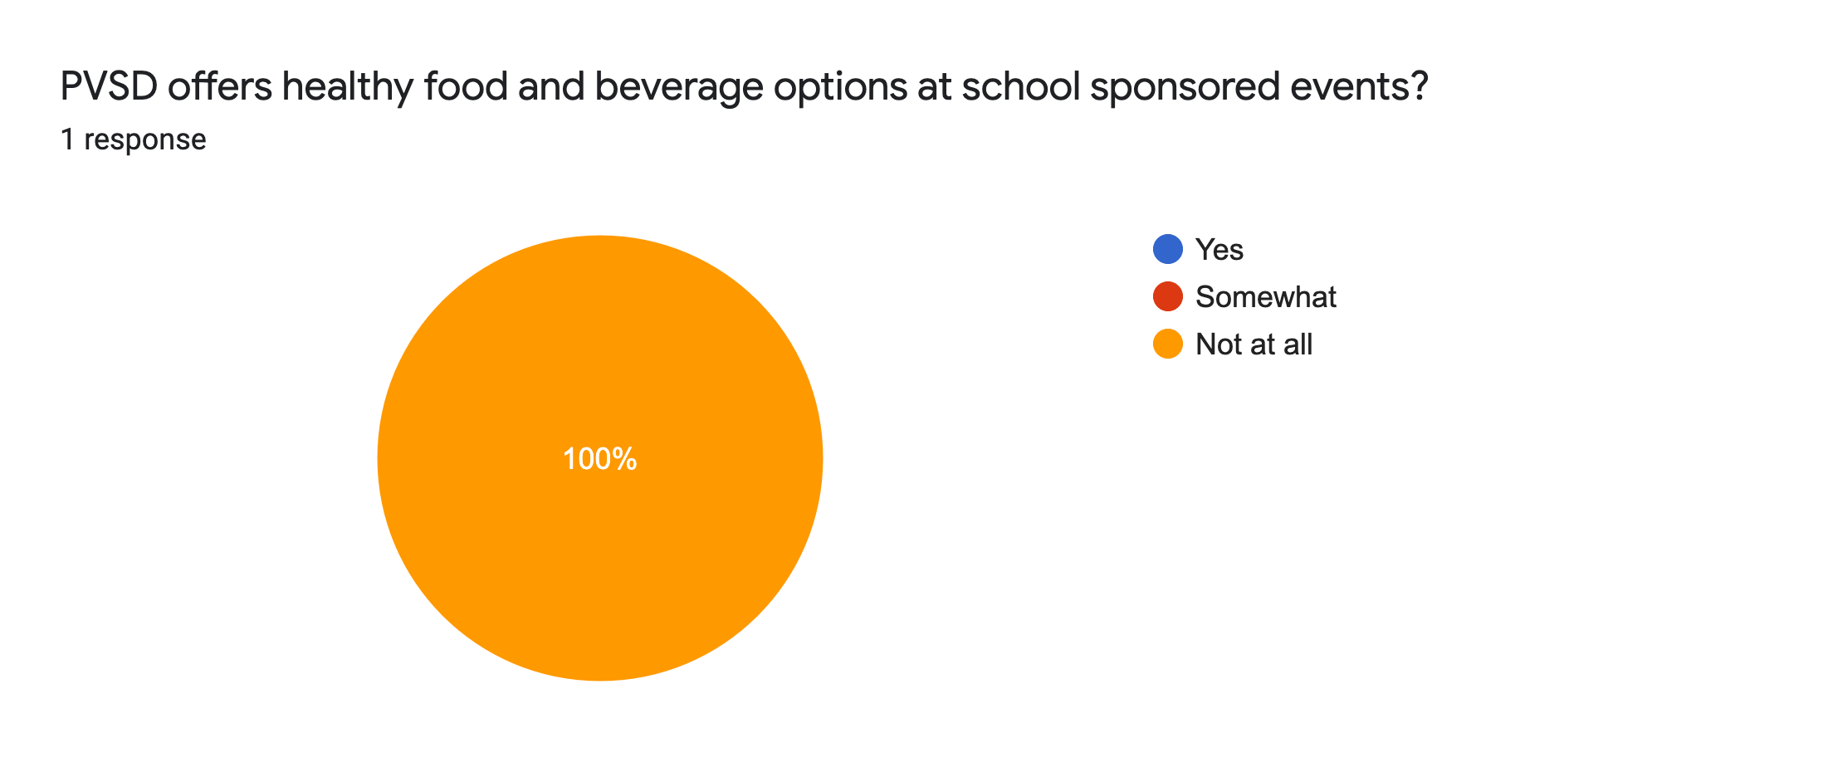
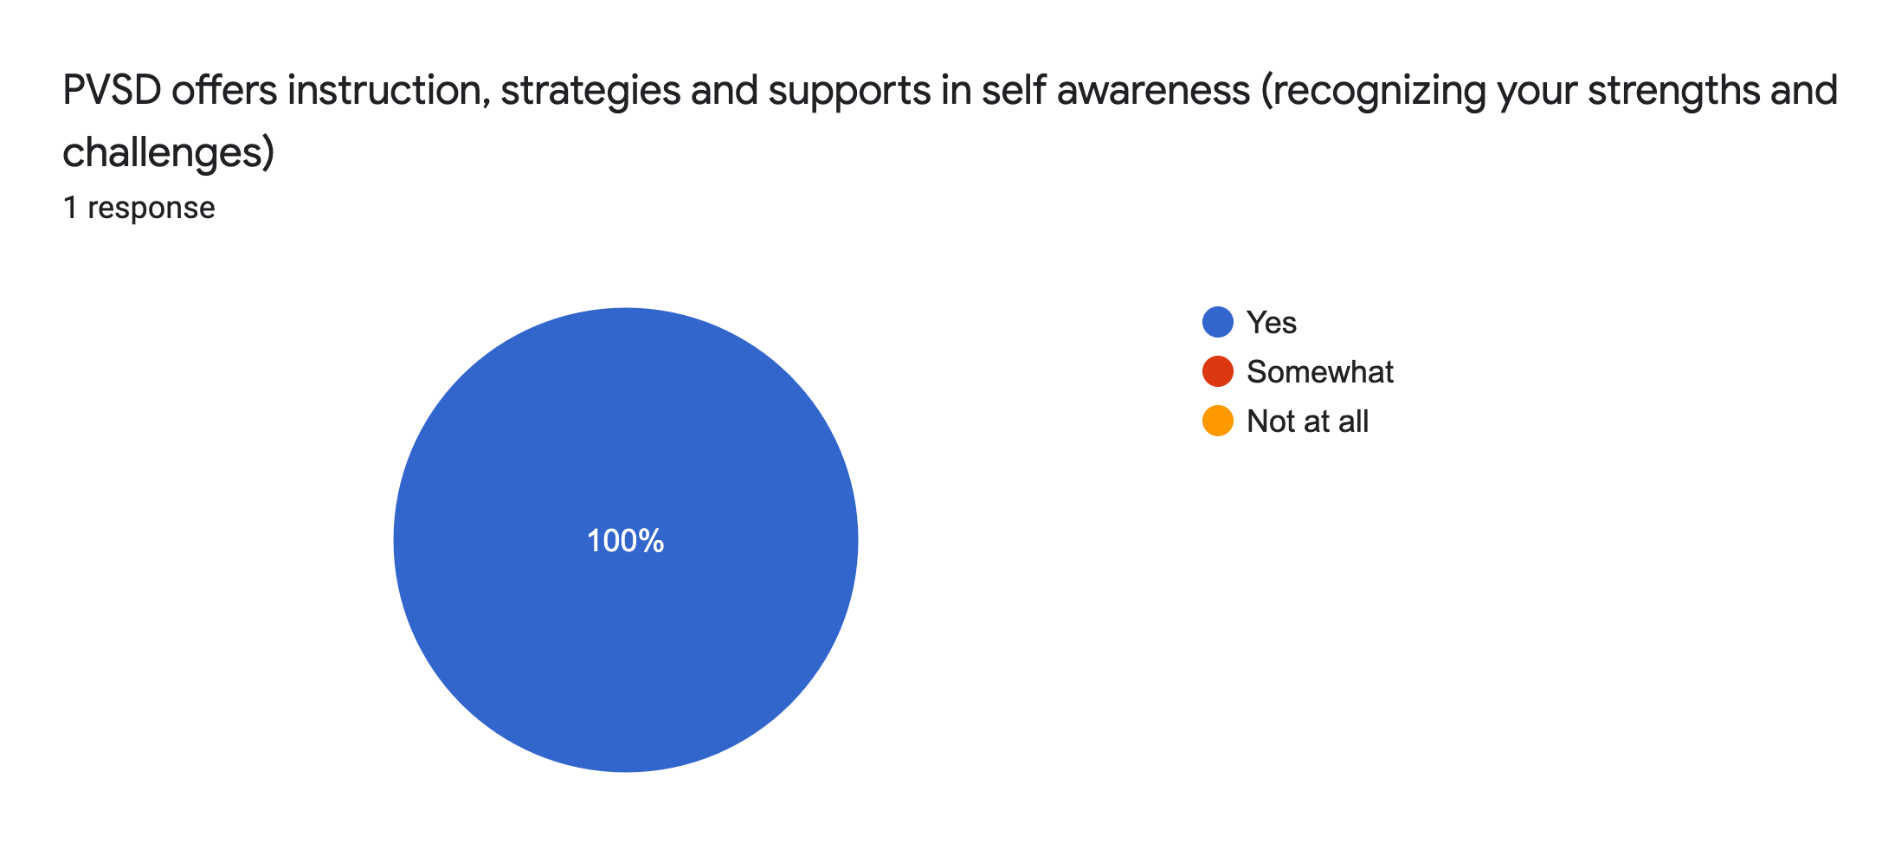
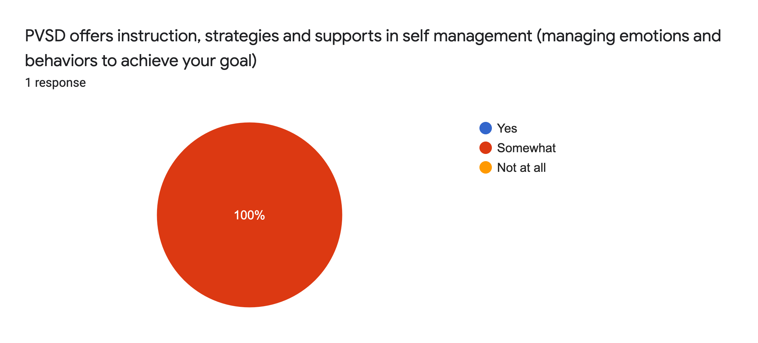
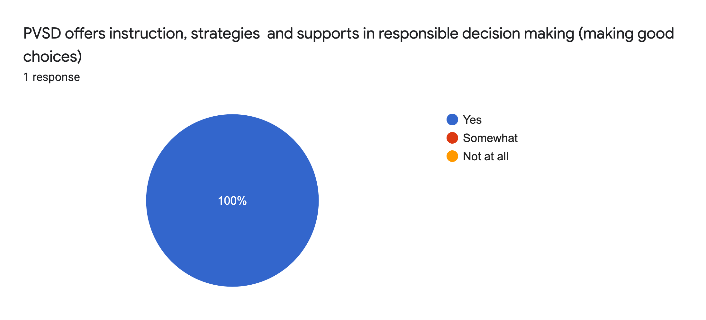
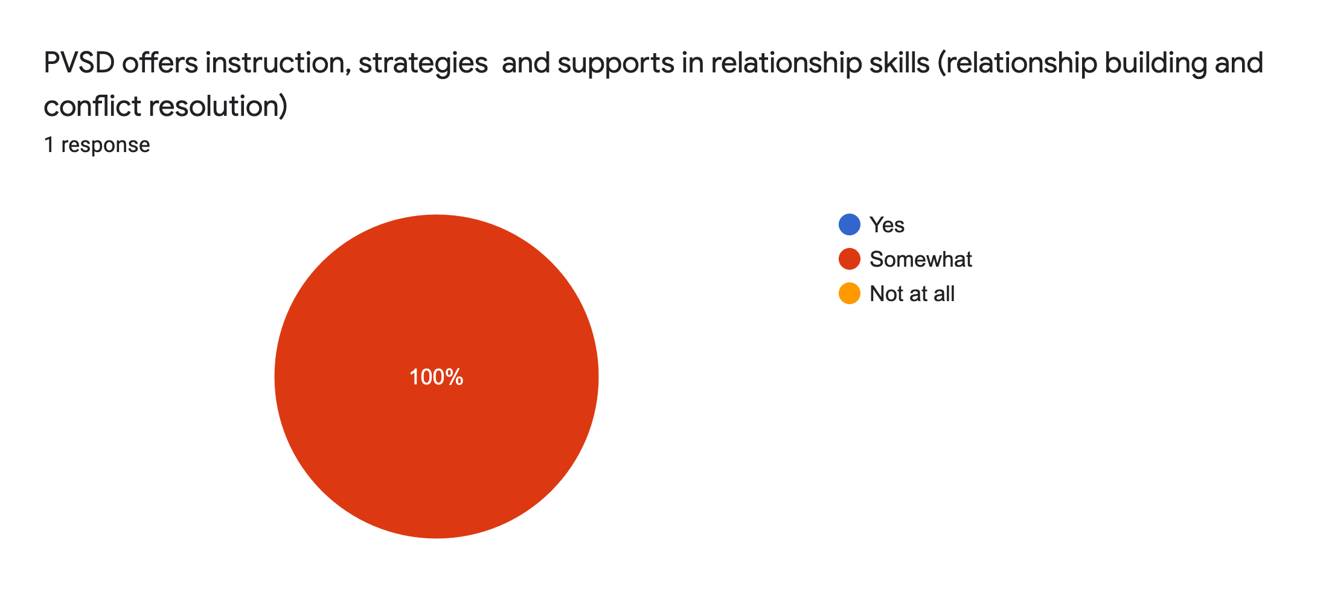

Suggestions for the Wellness Committee on Nutrition, Social Emotional and/or Physical Activities in our district?

As a student our daily routines are very sedentary. We sit for the first half of the day, get a thirty minute lunch where we sit some more and are often offered pizza or fried foods and then go sit for a couple more hours. It would be nice if lunches could be improved and light to moderate physical activities would be offered for short periods of time throughout the day.

