


College and Career
Awareness and Readiness!

Introduction: Explore Your Future with Xello 🇺🇸🇨🇦
Xello Login Instructions:
Log in through Classlink
Helpful tip: Do not use a phone or mobile device for Xello
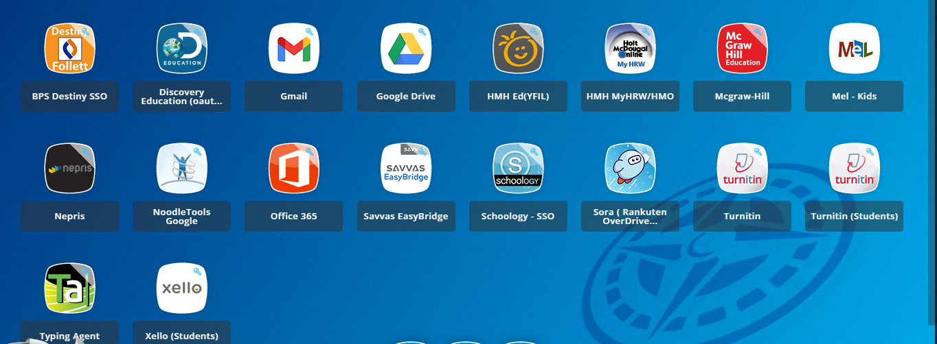

Take this opportunity to explore Xello and its capabilities (students will most likely not complete everything below). Xello is a tool you can take with you after graduation that can hold awards, photos, goals, plans, a resume and much more. Each year, all students Kindergarten through 12th grade complete a portion of their Xello. Look around in Xello for now and learn its components. There will be time in the school year to work with Mrs. Kondak to better understand this tool.
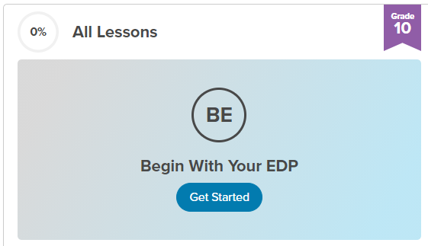
Sophomores
Click on the Blue “Get Started” oval to Begin With Your EDP
Items to complete for Sophomore Year:
- Matchmaker
- Personality Style
- Mission Complete
- 4 Favorite Cluster(s)
- 2 Experience(s)

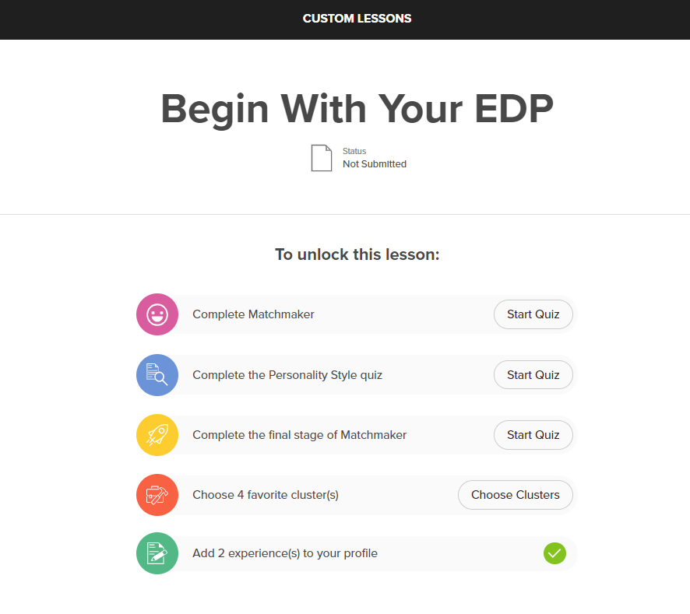
A ✔green check mark indicates you have completed the task.

Example:

Once all the items above have been completed, a reflection page will pop up asking you, “What is your Dream Job and Why” please complete this task with a couple of sentences and click the BLUE “TURN IN” Button. This will show the lesson as done and you are done!

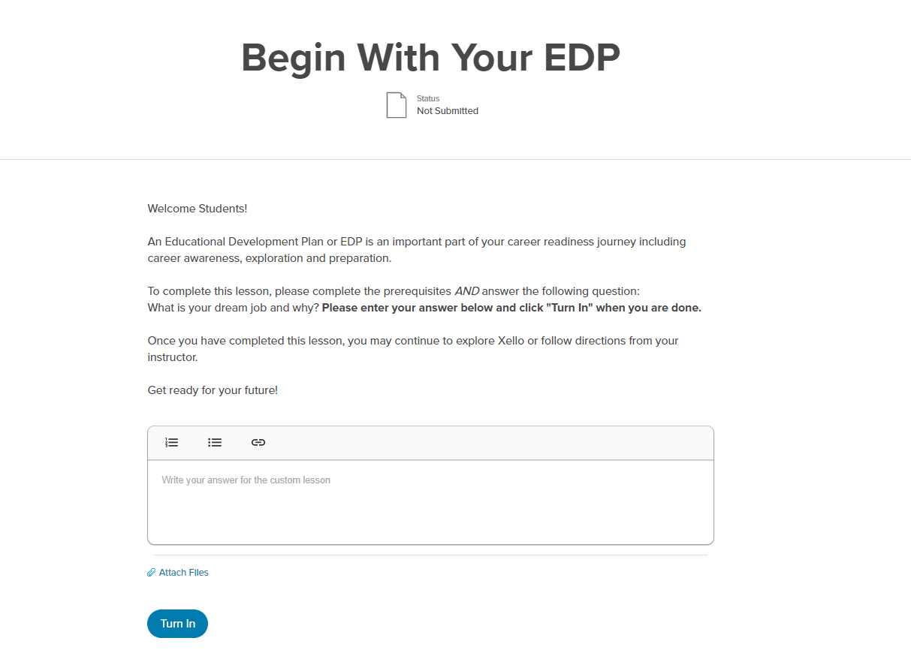

For additional information or questions, please contact Mrs. Kondak in the College & Career Center at: JKondak@birmingham.k12.mi.us.

