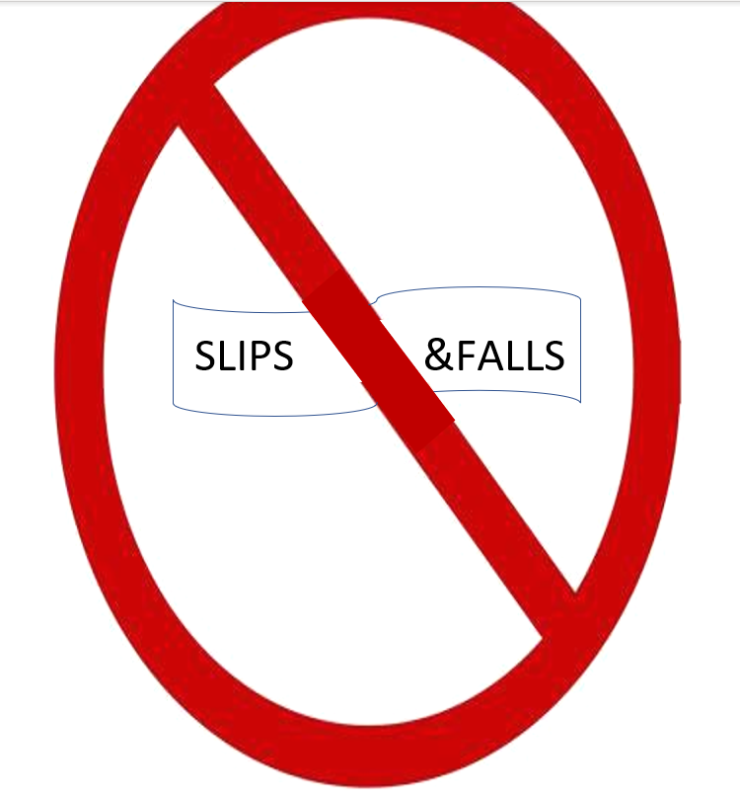

Fall (/fôl/): Anytime you find yourself on a supporting or lower surface and it was not your plan to be there.
WINTER MAINTENANCE:
- The School District should establish and implement an effective snow removal process to address clearing parking lots and sidewalks and spreading deicer and sand. Winter planning goes a long way to maintain safety between November and April.

The right pair of shoes changed Cinderella’s life.
FOOTWEAR:
- Shoes are your first defense in preventing a fall. What you put on your feet in the morning may determine what kind of day you will have!
- Wear shoes with good traction. Rubber soles are the best material to help prevent falls.
- Wear personal traction devices to help keep you on your feet during wintery conditions. Trekkers are ideal for icy conditions.

Wipe up to avoid a slip up.
Leaves are supposed to fall; people aren’t.
The MSGIA tracks injuries from slips and falls in an effort to eliminate those types of perils from the workplace. As it turns out, falls are the #1 injury in the Montana public schools. Between July 1, 2017, and June 30, 2022, the Montana Public Schools employees reported 2,965 slips, trips, and falls. These claims are reserved at $12,769,835.00. In an effort to prevent these claims, the surrounding tips have been provided.

You have control about the choices you make throughout the day. Be aware of your surroundings and take the extra steps needed to prevent slips, trips, and falls.

Don’t slip when carrying your breakfast or you’ll end up with egg on your face.
WORKING IN THE BUILDING:
- DO NOT stand on chairs!!!
- Step stools should be used to reach items on shelves and put up bulletin boards.
- Do not run cords in the aisle way and keep walking areas clear.
- Report and replace lights that are burned out in the classrooms, hallways, and parking lots.
- Breakup loads so they are easier to handle thereby preventing slipping.
- If working at a height of 6 feet or higher, you must use a safety harness. It is the law.
- Non-slip tape should be placed on the first two and the last two steps to prevent tripping.
- Spills need to be cleaned up immediately or marked so that others are aware of their presence.
- The best way to warn others of hazardous situations such as ice, water, and spills is to Communicate.
- Do not be afraid to slow down. A few extra minutes are ok if you get to your destination safely.

MANEUVERING PARKING LOTS, PLAYGROUNDS, AND SIDEWALKS:
- Most falls occur during the winter months when staff are walking from their vehicle to the building (parking lot).
- Only follow designated walkways that have already been cleared for safe passage.
- Widen your stance a bit and walk more deliberately; use the duck walk as a method to help prevent falling in slippery conditions.
- Never hold hands with students on ice or other slippery surfaces.
- Walkways should be properly maintained.

