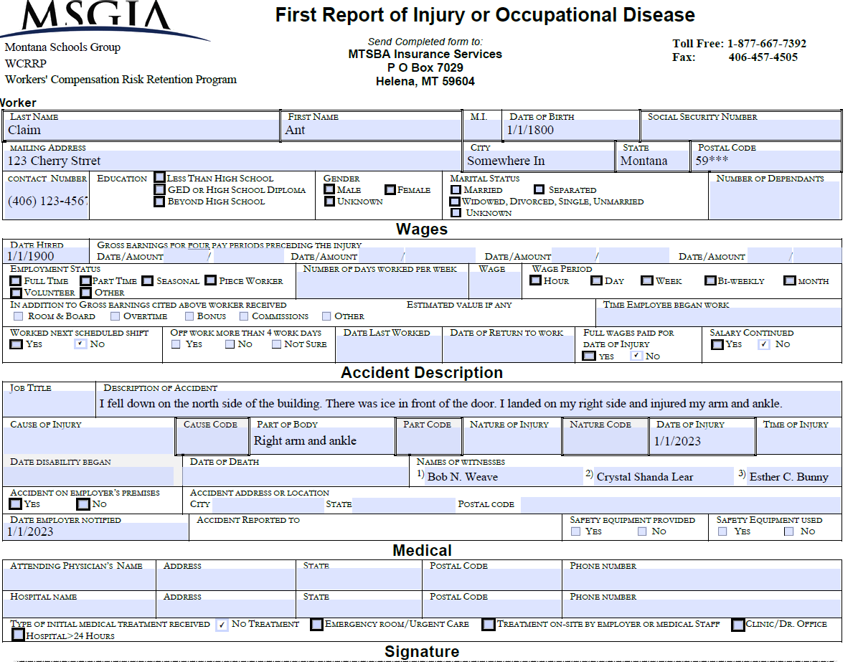
ACCIDENT REPORTING & INVESTIGATION

ACCIDENT REPORTING
Accidents should be reported Immediately:
- Employee to SUPERVISOR (principal, supt., maintenance supervisor, head of food services, etc.) - Leave a message if necessary
- MSGIA Workers’ Comp should receive that report within 6 days or less.
- There is a time requirement (claims not reported within 30 days may be denied)
When Filling Out the Report Be Specific – Details are IMPORTANT!!!
- What Body Part or parts were injured?
- What Equipment was being used at the time of the accident?
- What Task was Being Conducted at the time of the accident?
- Be Sure to SIGN the Form. This can be completed electronically.

INTENT OF ACCIDENT INVESTIGATIONS:
- Accident investigations are not conducted to find fault.
- Accident investigations are conducted to prevent reoccurrence of injury.
- Accident investigations are conducted to review and possibly implement:
- Different or Additional Procedures.
- Different or Additional Policies.
- Training; or
- Acquire or Repair Equipment.

If It Hurts Enough to Tell a Co-Worker About It …
It Hurts Enough to Report It!!!

