The MSGIA tracks injuries to help eliminate them from the workplace. In the last five years, employees in the Montana Public Schools reported 2,691 of these incidents. These claims are reserved at $3,217,295.00. The claims have resulted from being struck by students, falling objects, animal/insects, objects handled by others, etc. The number of claims from students is increasing and usually result in being hit, kicked, bitten, having hair pulled, etc. This may happen when the student is acting out. To assist in preventing “struck by” claims both from students and other causes the following information has been provided.
To help prevent injuries from students:
Remember that the most predictable thing about a student’s behavior is the student’s unpredictability. Be sure to document every incident. | Know the student and always have a backup plan.  Wear personal protective equipment (PPE). This may include long sleeves and bite shields. | Have and follow dress codes regarding hair, jewelry, etc. Long hair should be tied up and eye-catching clothing and jewelry should be avoided.
Do not step between students to break up a fight – try to separate them without getting between them. | Do not play with the students – there is a difference between demonstrating and playing. | Remember that if a student has sensory issues to a lot of stimulation it can cause problems – awareness of the disability is essential to preventing possible injuries.
Remember that not everyone wants to be touched and may react unexpectedly. Also, many students want/require a large circumference of personal space. | Shadowing is different than hovering. Don’t hover. Give the student some space. | Follow Bloodborne Pathogens procedures and proper protocol for encountering bodily fluids.
Know and be aware of your surroundings, the placement of furniture, and anything that can become a weapon. | Move the rest of the class during a meltdown and have a place to take them. This way the student does not have an audience and allows them some dignity. | Remember that for some students weekends and breaks from school are no vacation. School is exactly where they wish to be.
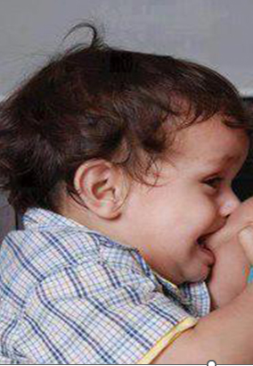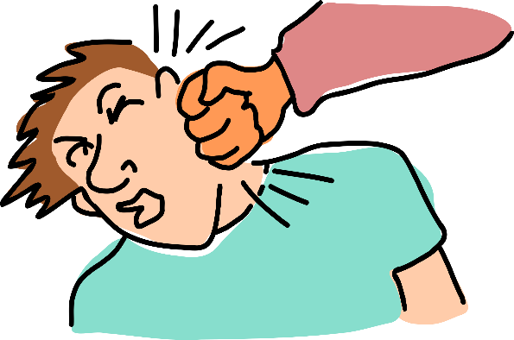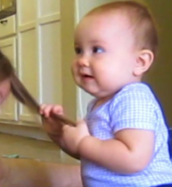

For struck by injuries not caused by students:
- Watch storage. Ensure that items will not fall onto you or others. | 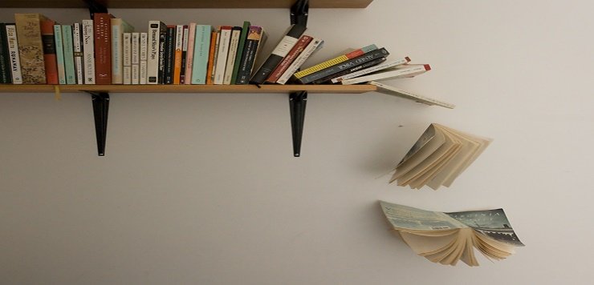
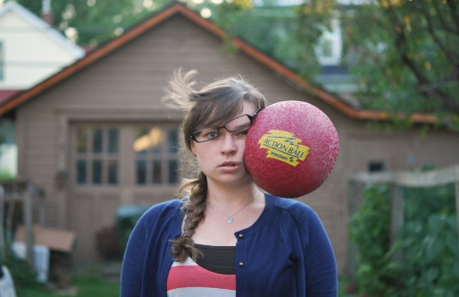 | - Be aware of your surroundings. Know that in gymnasiums and on playgrounds balls, frisbees, jump ropes and other moving things are likely to be in the air. Realize that any closed door may open unexpectantly.
- If someone yells “Duck,” go down first and then look why the warning was sent. | - Watch for the location/position of moving things.
- Be prepared that if something is attached to a wall it may be able to fall. | 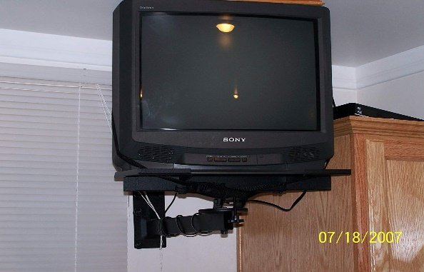
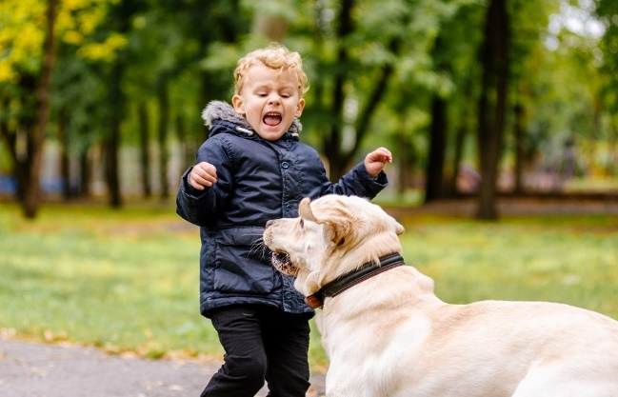 | - Animals and insects can cause a claim. Know your surroundings and the little critters that may take up residency. Avoid strange animals. It is unknown how they will react.
- Wind is a force! It can move doors and other items that may strike you. It may also cause you to let go of items that may strike you or others. | 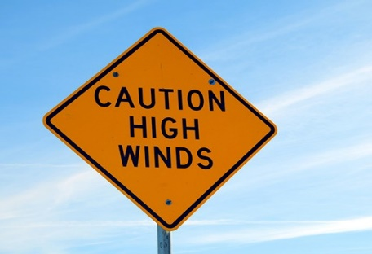
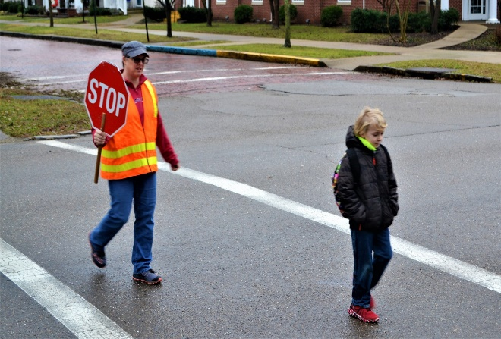 | - Unfortunately, school employees especially crossing guards have been struck by vehicles. If you can tell that a car is not going to stop, do your best to get out of its way.
- If you drop an item, try to get your toes out of the way. | - Be careful if you are standing under or bending under shelves, etc., that you do not stand and hit your head on them.
- Remember that all hand tools can catch while being used. This may cause hits and knicks to your hands and other body parts. | - Let those working around you know that you are present. This may prevent them running into you or accidently striking you with tools, etc.

There are excellent classes pertaining to many of these ideas on Safe Schools. To access these classes or for additional information, please contact your MSGIA Risk Management Associate. You may reach Harry and Annette at:
Harry Cheff  hcheff@mtsba.org | Annette Satterly  asatterly@mtsba.org



