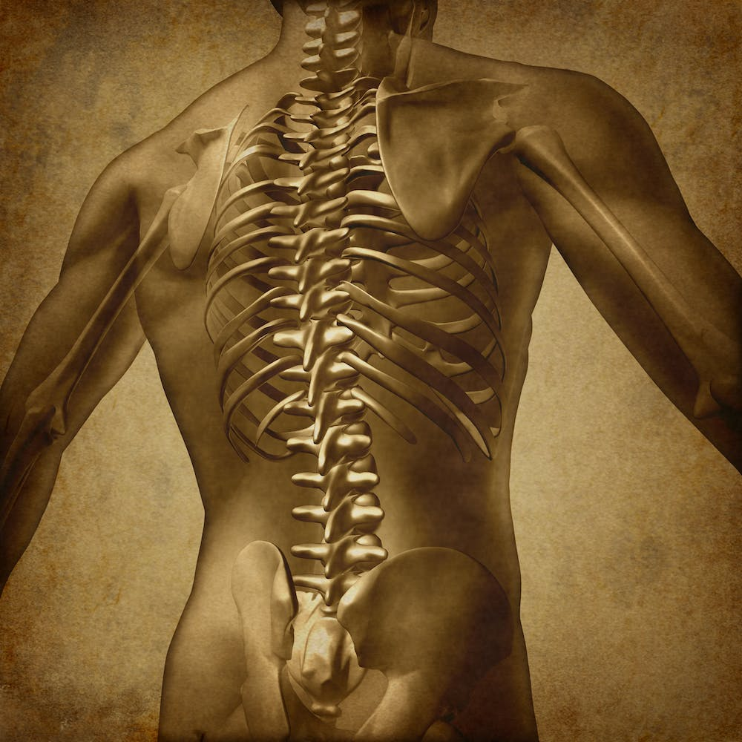
Bodily motion injuries may potentially occur when the body is in motion due to improper lifting, carrying, turning, reaching, pushing, pulling, etc. Often this is referred to as improper body mechanics. Proper body mechanics can help prevent back, shoulder, knee, and hip injuries as well as preventing and lessening strains.
Let’s prevent these injuries!!

PUSHING an object is better and safer for the back than PULLING an object.
- The best lift is one you never make.
- A good way to keep muscles warm throughout the day is to stretch.
- Never be afraid to ask for help.
CARRYING:
- Carry loads close to the body, preferably at waist level.
- When the weight of the load is unevenly distributed, make sure the heaviest portion is closest to the body.
- When putting loads down, when possible, place the load on shelves or other surfaces at waist level.
- If possible, place the heavy loads at waist level, the medium loads close to the ground and the light loads up higher.
- When two or more people carry a load, one person should act as the leader. Be sure that you can see where you are going.
- Move in the direction of the turn with your feet and legs.

LIFTING:
- Check the weight of the load with a “trial” lift.
- Stand square to the load and get as close as you can.
- Keep your legs about shoulder width apart for good balance.
- Bend the knees and hips, not the back. Do not twist at the waist.
- As you start the lift, raise your eyes, and look ahead. This will keep your spine in the correct alignment.
- Push with the hips and legs to lift the load.
- Never bend, lift, and twist at the same time.
- Put the load down by reversing the actions used to lift the object.
- Always use equipment such as handcarts, dollies, etc. to assist if it is available.

