Repetitive Motion Injuries are named for their apparent cause; conducting the same motion over and over without time for the muscles to recuperate. Ergonomics is a fancy word that loosely translated means the science of fitting the workplace to the worker.

Most people hear Ergonomics and immediately think about desks, computers, and offices. Ergonomics applies to these areas but can be adopted/used by every occupation/workstation. The idea is to fit the station to you, your body size, height, etc., rather than making your body adapt to the equipment it is working with and in. Granted this is more difficult with some equipment than others. It is also more difficult if more than one person is using the same work area.

The joints in the body all have a “neutral” position. This is the position that causes the least wear and tear on the joint. Our joints move in different directions and different positions but there is a place that is considered neutral. Each joint has a different neutral position. If the body can work in the neutral positions for much of the day, it lessens aches and pains.

Your body needs to move. Therefore, our breaks are essential. Even if we stand up and sit back down or sit down and stand back up, this is movement that will assist the body. The body hurts if it is held in one position too long. The body does not like static postures and will give warning signs such as pins and needles that it needs to move. Try to work in neutral positions but make sure that you are moving in and out of those positions throughout the day.

Key points to remember in every occupation are:
- Break up the day. Do not conduct the exact same motion repeatedly for excessive time periods.
- Take breaks and move around.
- Alternate motions. This is a different look at breaking up the day. Reversing the same motion may get the same results and allow the body time to recuperate. In the original movie of the “Karate Kid,” they mentioned wax-on, wax-off. They put the wax on the car rotating the arm to the left and took it off by rotating the arm to the right. It is a similar motion, but the muscles extend and contract differently giving time for recuperation.
- Try to lessen the force while gripping items. Studies show that we grip all items 4-5 times harder than is necessary.
- Try to set up work areas to avoid glare. The eyes are very picky and have much influence on the overall comfort of the body. The eye can trigger headaches and muscle tension.
- The proper positioning of the back may help position every other joint. Pay close attention to the back, its position, and its safety throughout the day.
- Make sure that you stretch throughout the day. There are three stretches pictured below that are helpful to all of us throughout the day.
- The Back Extension. This can be done standing or sitting. Most of us make this motion subconsciously. The stretch helps to realign your back and give a good framework for the body.
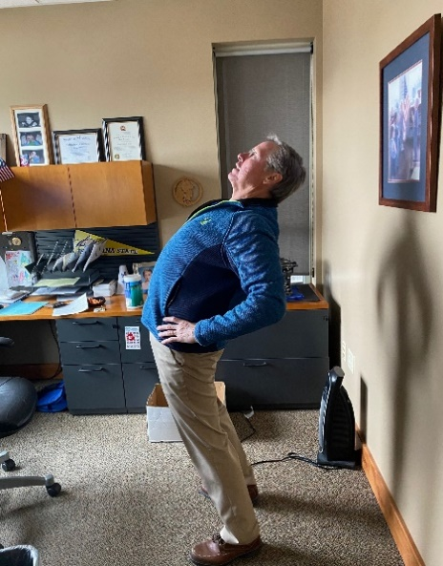
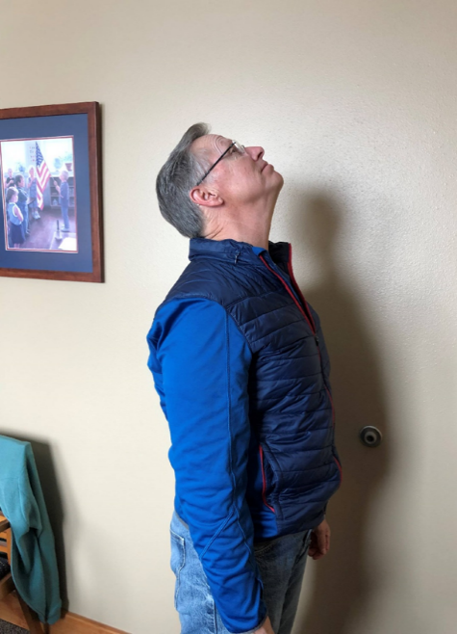

2. Look at the Ceiling. Throughout the day, we tend to lead with our head, and it then extends out in front of the rest of the body. If our head is not aligned over our shoulders, it is difficult to near impossible to tip the head back to look at the ceiling. This motion also helps realign the body for a good framework.

3.The third is wrist stretches. Pull down on the hand until you get a nice stretch. Then reverse the direction and conduct the same activity. Do not pull or push to the point of pain but to the point of feeling a nice stretch. We use many tiny motions throughout the day that may tighten these muscles. This gives some relief and believe it or not will again help to align the body putting it back into the neutral positions it wants.
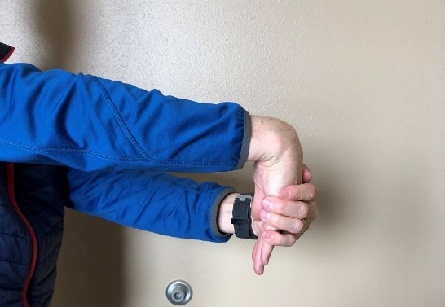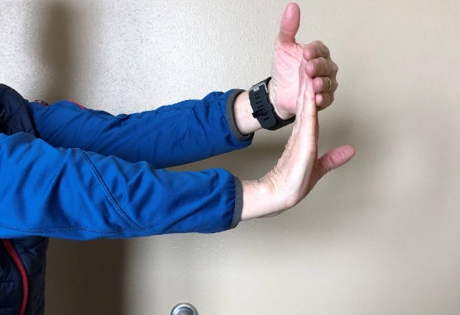
There are two very good classes that address much of this information in Safe Schools. The class titles are: Office Ergonomics and Back Injury and Lifting. For more information on ergonomics, to set up an ergonomic assessment, or for assistance accessing Safe Schools, please contact your MSGIA Risk Management Associate. You may reach Annette at 406-439-1271 or at asatterly@mtsba.org.



