6 Day Schedule ~ First Grade Stars
2019-2020
Day 1 | Day 2 | Day 3 | Day 4 | Day 5 | Day 6
Snack  9:55—10:05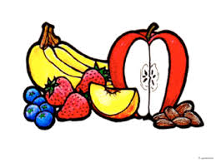 | Snack  9:55—10:05 | Snack  9:55—10:05 | Phys. Ed.  8:40 - 9:22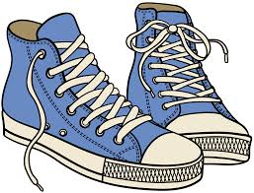 | Music  8:40 - 9:22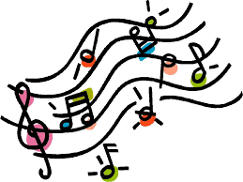 | Art  8:40 - 9:22
Library  10:10 – 10:52 | Phys. Ed.  10:10 – 10:52 | Music  10:10 – 10:52 | Snack  9:55—10:05 | Snack  9:55—10:05 | Snack  9:55—10:05
Recess/Lunch  11:30-12:15 | Recess/Lunch  11:30-12:15 | Recess/Lunch  11:30-12:15 | Recess/Lunch  11:30-12:15 | Recess/Lunch  11:30-12:15 | Recess/Lunch  11:30-12:15

Please remember to either wear or bring your sneakers on days 2 & 4.

