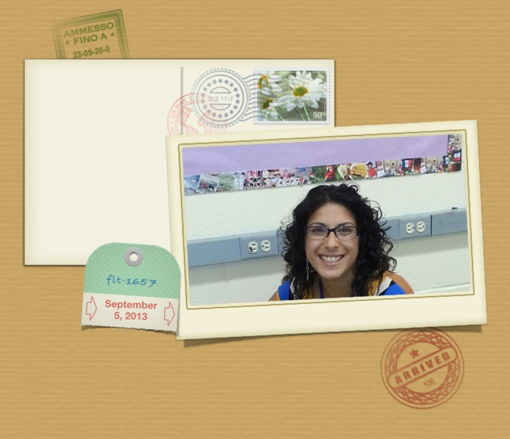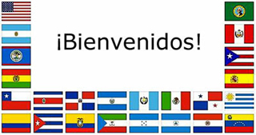
Education
SUNY New Paltz
~ Class of 2017
**Advanced Certification in TESOL

City College of New York ~ Class of 2013 **Master’s Degree in Student’s w/ Disabilities
Mount Saint Mary College ~ Class of 2009 **Bachelor’s Degree in Hispanic Studies and Adolescent Education
Pine Bush High School ~ Class of 1999
*Fun Fact: Met Former President Bill Clinton in 1998 as a Girl’s Nation Representative
*Fun Fact: I love to travel and have traveled to Greece, Italy, France, Portugal and Spain.
*Fun Fact: Originally went to Pace University for Political Science & Pre-Law
Goals
~I will create an inspiring, safe and comfortable classroom environment so all students can maximize their potential.
~I will communicate with every child and their parent/guardian to report out their strengths in their learning progress.
~I will respectfully share in the lifelong learning process as everyone in class will effectively learn, grow and reflect as 21st century learners.
“I believe that every student can and will succeed given an effective education in order to take on and conquer our rapidly changing world.”
Every child.
Every day.
Every classroom.

Yo soy 100% decente puertorriqueña. I am 100% Puerto Rican decent.

¡Hola! Yo soy la Señorita Ortiz ~ una maestra de español.
Hello! I am Ms. Ortiz ~ a Spanish Teacher

