How to use the IPad and Class Mode to upload artwork to Artsonia


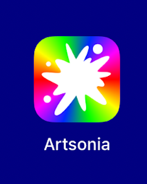
Select the Artsonia App
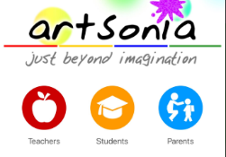
Choose Student

Enter the access code or scan the QR Code
Access Code:
CTXT-SCHK
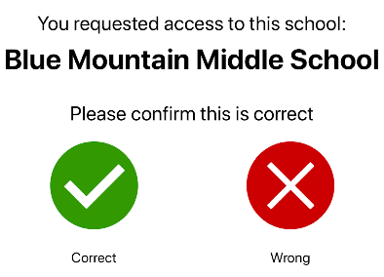

Confirm the school

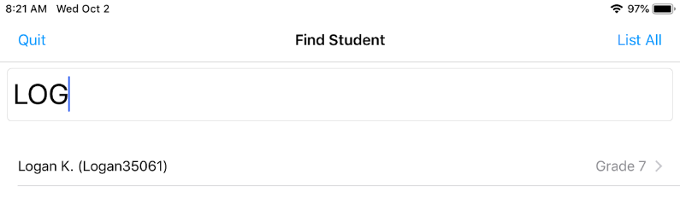

Start typing your first name until your first name, last initial, and grade appears. Select your name

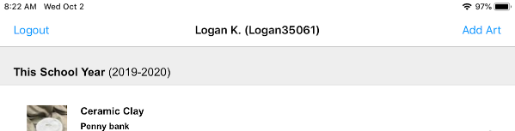
Select Add Art in the top right corner

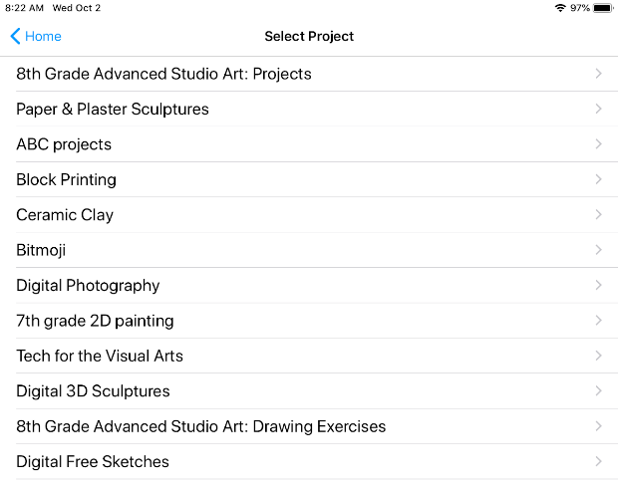

Select you Project

Photograph your image.
Tips for taking a good image:

-For 3D images place image in front of fabric backdrop
-For 2D images lay the project flat and hold the iPad straight above the artwork
-Tap the screen so the blue box appears to focus the image
-Hold the iPad straight and still

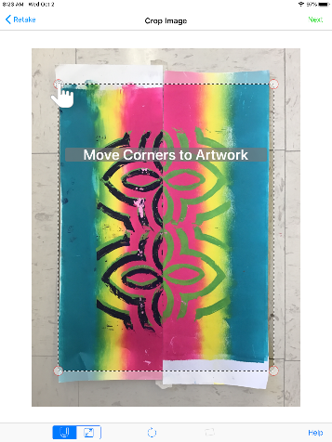
Edit your image
Drag each corner to fit your artwork
You can use the rectangular tool to make a box
around 3D artwork

Use the arrow to rotate artwork
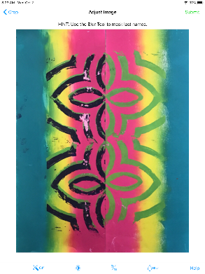
Select Next in the top right

Select Submit

For the Art Title and Art Statement Screens you can choose to add something
or select SKIP
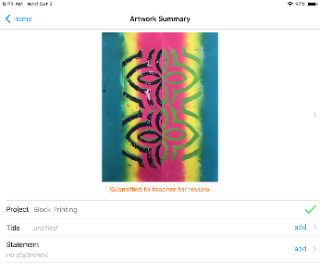

On the Art Summary Screen choose Home

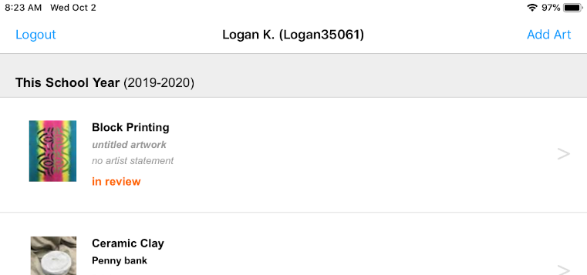

Select Logout

You know you have successfully logged out if
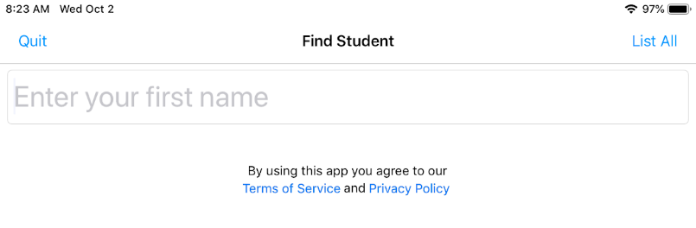
the Find Student Screen appears

