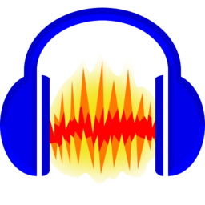
Audacity

Needing to use audio software with your students?
Audacity is free and now students can download it to their laptops or desktops.
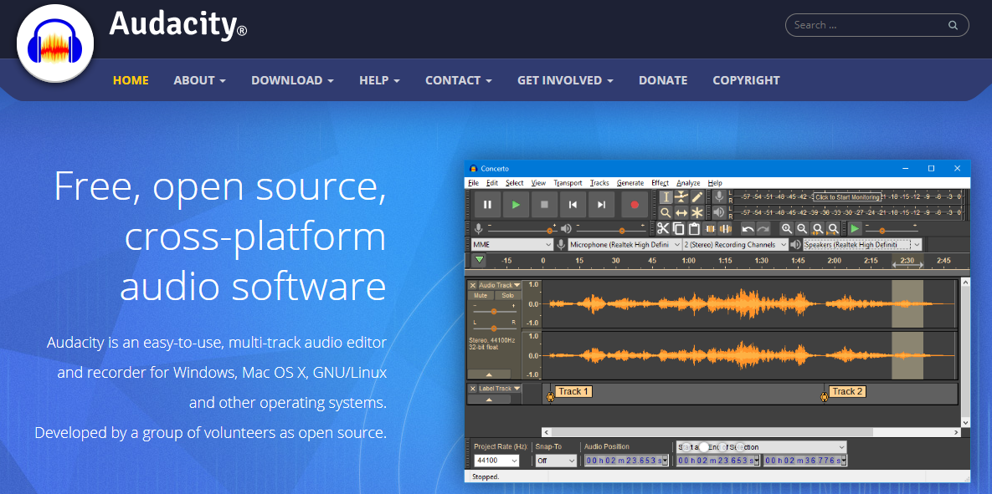
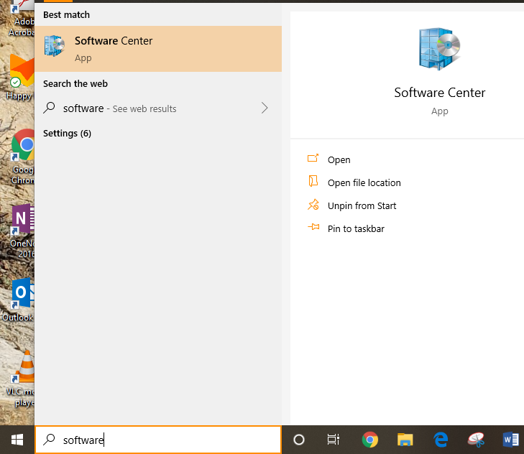
Go to the search bar and start typing “software center”.
Then open it up and look for Audacity. Click install. Follow further steps to keep the install going. Done!

