North East Elementary School ARRIVAL AND DISMISSAL PROCEDURES:
Welcome to the 2022-2023 School Year! For educational purposes and student safety, please note:

HOURS: Students are welcomed to NEES promptly at 8:45. Dismissal procedures begin at 3:30 on Monday, Tuesday, Thursday and Friday, and at 1:35 on Wednesday. We appreciate your assistance in limiting instructional interruptions by avoiding repeated late arrivals and early dismissals.
For appointments scheduled during the school day, arrive to the office before 3:15 with your ID in hand. After 3:15, we can add students to the walker door list to be called when the bell rings at 3:30.


Keep arrival and dismissal methods consistent to limit confusion for students and staff. Frequent and or last minute changes interrupt instruction, and stress the system for getting nearly 600 children home safely. Send a note in with your student to inform the teacher and office of the occasional alteration. Include the name of the contact, as listed on their emergency card, who will pick them up. If emailing the office, send your message (from the address we have on file to cgasdia@ccps.org , ccwright@ccps.org and cisaacs@ccps.org as one or more of us may be out of the office at times.
WALKERS: Parents of PreK – 2nd grade students should meet their children at the walker door at dismissal. 3rd – 5th grade students may walk alone unless parents notify the office otherwise.
BUS RIDERS: Those riding the bus to school are expected to ride the bus hoe (See above RE changes.)
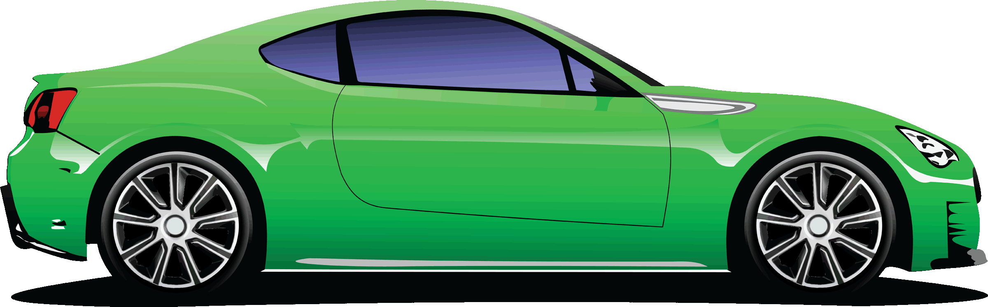
CAR RIDERS: Please adhere to the following procedures, and share with any other family members who may pick up or drop off:

- Return this form to the office to obtain car tags. Display this year’s tag so that it’s visible from the sidewalk.
- Drop off: Pull up as far as you can, reach the sidewalk area, and be sure staff members are outside before unloading students (on the sidewalk side of the car if possible.)
- Enter the car loop from the Thomas Avenue and make a “U” turn into the car loop: Right in/Right out ONLY
- Avoid left turns into the parking lot from 8:40 – 9AM and 3:20 – 3:45 PM (1:45 – 2:10 pm on Wednesday.)
- Follow staff directions, and avoid passing cars on the left in the car loop.
- It is Unsafe to drop students off in any area other than the car loop due to bus traffic and lack of supervision.
Clip and return the following as needed:


Will be transported by car in the afternoon.
My Child(ren)
Child | Grade | Homeroom Teacher

Guardian Signature: Date:

