Emergency Action Plan
For Monomoy Regional High School
Athletics Program

In case of an emergency, personnel responsibilities, locations of emergency equipment, and other emergency information such as 911 call instructions, addresses/directions to the venue, and a chain of command with important phone numbers have been listed here.
Table of Contents
Table of Contents
Personnel Involved in Development 4
Documentation of Recent Changes 5
Introduction 6
Staff Education 10
Chain of Command 10
Emergency Telephone Numbers 11
Emergency Situation Contact Tree 12
Emergency Equipment Locations 13
Monomoy Regional High School AED Location 14
General Plan of Action 15
Emergency Action Procedures 16
Gymnasium 16
MAC (Turf) 17
Whitehouse Field (Baseball) 18
Potter’s Field (Softball) 19
Brooks Park (Tennis, JV Baseball) 20
Front Fields 21
Tony Kent Ice Arena 22
Rehearsal Strategy 23
Documentation of Seasonal Coaches Educational Meeting 24
Documentation of Emergency Equipment Maintenance 25
Approval and Verification Page: 26

Personnel Involved in Development
The following individuals were involved with the creation of this Emergency Action Plan:
Taylor Murray, ATC, LAT, ITAT (athletic trainer)
Karen Guillemette (athletic director)
Cheryl Dufault MA, RN (school nurse)
Harwich EMS

Documentation of Recent Changes
As changes to the EAP are made, please list the change, page affected and date that the change was made.
Specific Changes Made | Page(s) Affected | Date

EMERGENCY ACTION PLAN FOR ATHLETICS
OVERVIEW

Introduction
Emergency situations may arise at any time during athletic events. Expedient action must be taken in order to provide the best possible care to the student athlete. The development and implementation of an emergency action plan will help ensure that the best care will be provided.
As emergencies may occur at any time and during any activity, all school activities personnel must be prepared. Athletic organizations have a duty to develop an emergency action plan that may be implemented immediately when necessary and provide appropriate standards of emergency care to all sports participants. This preparation involves formulation of an emergency action plan, proper coverage of events, maintenance of appropriate emergency equipment and supplies, utilization of appropriate emergency medical personnel, and continuing education in the area of emergency medicine and planning. Through careful pre-participation physical screenings, adequate medical coverage, safe practice and training techniques and other safety avenues, some potential emergencies may be averted. However, accidents and injuries are inherent with sports participation, and proper preparation on the part of the sports medicine team should enable each emergency situation to be managed appropriately and efficiently.
Components of an Emergency Action Plan
- Emergency Personnel
- Emergency Communication
- Emergency Equipment
- Roles of First Responder
- Venue Directions with a Map
- Emergency Action Plan Checklist for Non-Medical Emergencies
Emergency Personnel
The first responder in an emergency situation during an athletic practice or competition is typically a member of the sports medicine staff, such as a certified athletic trainer. However, the first responder may also be a coach or another member of the school personnel.
Certification in cardiopulmonary resuscitation (CPR), first aid, automated external defibrillator (AED), emergency action plan review, and prevention of disease transmission, and emergency plan review is required for all athletics personnel associated with practices, competitions, skills instructions, and strength and conditioning [including: athletic director, school nurse, certified athletic trainer, all coaches, etc.]. Copies of training certificates and/or cards should be maintained with the athletic director. All coaches are required to have CPR, First Aid, AED, and concussion management training certifications.
The emergency team may consist of physicians, emergency medical technicians, certified athletic trainers, athletic training students, coaches, managers, and possibly even bystanders. Roles of these individuals will vary depending on different factors such as team size, athletic venue, personnel present, etc.
The four basic roles within the emergency team are:
- Establish scene safety and immediate care of the athlete:
  - This should be provided by the most qualified individual on the medical team (the first individual in the chain of command).
- Activation of Emergency Medical Services:
  - This may be necessary in situations where emergency transportation is not already present at the sporting event. Time is the most critical factor and this may be done by anyone on the team.
- Equipment Retrieval:
  - May be done by anyone on the emergency team who is familiar with the types and locations of the specific equipment needed.
- Direction of EMS to the scene:
  - One of the members of the team should be in charge of meeting the emergency personnel as they arrive at the site. This person should have keys to locked gates/doors.

Activating Emergency Medical Services
Call 9-1-1
Provide information
- Name, address, telephone number of caller
- Nature of the emergency (medical or non-medical)*
- Number of athletes
- Condition of athlete(s)
- First aid treatment initiated by first responder
- Specific directions as needed to locate the emergency scene (i.e. “use the south entrance to the school off Asylum St.”)
- Other information requested by the dispatcher
- DO NOT HANG UP FIRST
*if non-medical, refer to the specified checklist of the school’s non-athletics emergency action plan

Emergency Communication
Communication is key to a quick, efficient emergency response. There is a pre-established phone tree to ensure all relevant parties are notified. Access to a working telephone line or other device, either fixed or mobile, should be assured. There should also be back-up communication in effect in case there is a failure of the primary communication. At every athletic venue, home and away, it is important to know the location of a workable telephone. Please see page 11 and 12 for emergency communication guidelines for Monomoy Regional High School.
Medical Emergency Transportation
Any emergency situation where there is loss of consciousness (LOC), or impairment of airway, breathing, or circulation (ABCs) or there is a neurovascular compromise should be considered a “load and go” situation and emphasis is placed on rapid evaluation, treatment, and proper transportation. Any emergency personnel who experiences doubt in their mind regarding the severity of the situation should consider a “load and go” situation and transport the individual.

Non-Medical Emergencies
For the non-medical emergencies (fire, bomb threats, violent or criminal behavior, etc.) refer to the school emergency action plan and follow instructions.
Post EAP Activation Procedures:
Documentation
Documentation must be done by ATC (or other provider) and coach immediately following activation of the EAP. Both an injury report and accident report form must be filled out.

Debriefing
A team comprising of the ATC, AD, coaches, nurse and one or two other school district employees not involved with the situation must discuss the event within 48 hours. This team must evaluate the effectiveness of the EAP and conduct a staff debriefing. A specific timeline for changes to EAP should be made for promptness.

Conclusion
The importance of being properly prepared when athletic emergencies arise cannot be stressed enough. An athlete’s survival may hinge on the training and preparation of healthcare providers. It is prudent to invest athletic department “ownership” in the emergency action plan by involving the athletic administration and sport coaches as well as sports medicine personnel. The emergency action plan should be reviewed at least once a year with all athletic personnel and local emergency response teams. Through development and implementation of the emergency plan Monomoy Regional High School helps ensure that the athlete will have the best care provided when an emergency situation does arise.

Staff Education
- Each season, every coach will receive a copy of the Emergency Action Plan (EAP)
  - Each coach will provide their signature to confirm they have read the documents and asked any potential questions
- A copy of the relevant EAP will be in each medical kit which is to be kept with the coach at every practice/event
- A copy of the EAP will be posted on the wall in the athletic training room.

Chain of Command
The athletic training should always act as primary care-givers at the site of the injury or accident (when on-site) and would manage the situation according to the following rank:
- Athletic Trainer
- EMS
- Sport Specific Coaches
- Athletic Director
- Parents/Guardians
In the event that a certified athletic trainer is not on-site at the time of injury the following chain of command would be used:
- EMS

CHAIN OF COMMAND
Most medically qualified

- Athletic Trainer (ATC)
- EMS
- Sport Specific Coaches
- Athletic Director
- Parents/Guardians

- Sport Specific Coaches
- Athletic Director
- Parents/Guardians

Emergency Telephone Numbers
This list is only to be used in case of an emergency.
Off Campus Contacts | Phone Number
Emergency | 911
Police department | 508-430-7541
Fire and Ambulance | 508-430-7546
Cape Cod Hospital | 508-771-1800
Falmouth Hospital | 508-548-5300
Hazardous Materials
Poison Control Center | 800-222-1222

On Campus Offices | Phone Number
Athletic Training Room
Nurse
Athletic Director
Main Office
Administrative Office
School Counselor Office

Title | Name | Office | Cell
Athletic Trainer | Taylor Murray | 5878 | 774-208-2563
Athletic Director | Karen Guillemette | 5838 | 774-212-7462
Principal | Jen Police | 5844 | 508-367-7329
Assistant Principal | Dave Alexander | 5831 | 774-722-7706
Assistant Principal | Jeff Sylvia | 5832
Nurse | Cheryl Dufault | 5856 | 774-722-579

Emergency Situation Contact Tree
Injury or Sudden Illness
Coach or First Responder on Scene
CARE
Life Threatening Condition
CALL
911
*Have coach get the AED
Call Parent/Guardian
Call Athletic Trainer
Call Athletic Director
(if warranted)
Call
Athletic
Trainer
Provide care until EMS arrives.
Do not leave victim.
Provide proper first aid and care until athletic trainer arrives.
Do not leave victim.
CARE
CARE
CARE
Non-Life Threatening Condition
CHECK
Call Principal
(if warranted)
After the situation is controlled: Contact Karen Guillemette by phone 774-212-7462 or email kguillemette@monomoy.edu

Athletic Trainer may at their discretion contact sports medicine physician for guidance

Emergency Equipment Locations
Emergency Equipment:
- Athletic Training Kit, Emergency Bag, Biohazard/First Aid Kit on site for events covered by ATC
- First Aid Kit located with coach
      - AED
        - Located with ATC for all covered events
        - Located with each sport specific coach as they must sign out an AED daily or for the season to bring with them to all practices due to various venues
        - Additional AEDs located outside Monomoy Regional High School Gymnasium in lobby or the lobby outside the Main office
      - Nearest phone
        - Athletic Trainer’s personal cell phone when covering events
        - Coaches’ personal cell phones (with emergency numbers attached here)
      - Rescue Inhaler
        - Coaches are responsible for each student who has an inhaler and is responsible for bringing the inhaler with them to all practices/games
        - Inhaler must be left with coach (labeled with name) during practices and games (not left in personal bag)
        - Athletic trainer may be given a backup inhaler by the parent or child to keep as a backup in the med kit.
      - Epi Pen
        - Coaches are responsible for each student who has an epi pen and is responsible for bringing their epi pen with them to all practices/games
        - Epi pen must be left with coach (labeled with name) during practices and games (not left in personal bag)
        - Athletic trainer may be given a backup Epi pen by the parent or child to keep as a backup in the med kit.
      - Splints
        - With ATC during events or in the ATR
      - Electrical Drill
        - With ATC during events or in the ATR
      - Spine boards/Cervical Collar
        - Will be provided by EMS upon arrival
        - Spine board can be found in ATR
      - Bio-hazard Materials
        - Red bags – in each med kit and in ATR
        - Disposal Bin – in ATR, Room B112
      - Bag- Valve Mask (BVM)
        - Can be Found in ATR or with ATC during events
      - Oxygen
        - Can be found in ATR in locked cabinet

Monomoy Regional High School AED Location
The main AED for inside Monomoy Regional High School is located outside the Gymnasium in the lobby.
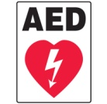
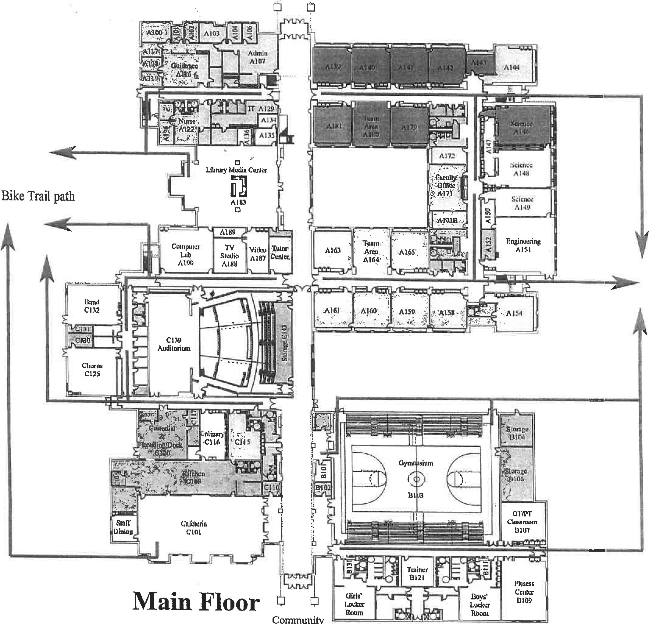

General Plan of Action
- Most medically qualified person will lead
- Check the scene – is it safe to help?
- Is the athlete breathing? Conscious? Pulse?
  - If NO instruct person to call 911 – LOOK PERSON DIRECTLY IN EYES and
make sure they call!
  - Check card for 911 call instructions for your location
- Perform emergency CPR/First Aid
  - If severe bleeding – instruct individual to assist with bleeding control
- Instruct coach or bystander to get AED
- Instruct coach or bystander to control crowd
- Contact the Athletic Trainer of Monomoy Regional High School if they are present at the school but not on scene
- Contact parents
- Contact Athletic Director
- Contact Principal/Vice Principal
- Instruct individual to meet ambulance to direct to appropriate site
- Assist with care as necessary
- Assistant coach must accompany athlete to hospital – either in ambulance or follow by car
- Document the event

Monomoy Regional High School

Emergency Action Plan

Gymnasium
Activate the EAP:
- Any loss of consciousness
- Possible Spine Injury
- Dislocation, Open Fracture, Displaced Closed Fracture
- Difficulty or absent breathing or pulse
- Uncertainty of if you have a medical emergency
Emergency Personnel:
Monomoy Regional High School’s Athletic Trainer will be on site for select practices and events or in direct communication with coaching staff. Emergencies during practices/games not covered, EMS should be contacted immediately.

Emergency Procedures:
- Check the scene
  - Is it safe for you to help?
  - What happened?
  - How many victims are there?
  - Can bystanders help?
- Instruct coach or bystander to call 911
-Provide the following information
- Who you are
- General information about the injury or situation
- Where you are (Provide: name, location of downed athlete, address, telephone #, number of individuals injured, type of injury that has occurred, treatment given, specific directions*).
- 75 Oak Street Harwich MA 02645
- Any additional information
- *STAY ON THE PHONE, BE THE LAST TO HANG UP*
- Perform emergency CPR/First Aid
  - Check airway/breathing/circulation, level of consciousness, and severe bleeding.
    - If athletic trainer is present, he/she will stay with athlete and provide immediate care.
    - If athletic trainer is not present, most qualified coach (training/certifications) will stay with athlete and provide immediate care.
  - Instruct coach or bystander to GET AED!!
- Designate coach or bystander to control crowd
- Contact the Athletic Trainer for Monomoy Regional High School if not present on scene
- Meet ambulance and direct to appropriate site
  - Athletic Director; Open Appropriate Gates/Doors
  - Designate an individual to "flag down" and direct to scene
  - Control injury site, limit care providers etc.
- Assist ATC and/or EMS with care as directed
  - Retrieve Necessary Supplies/Equipment
- An assistant coach must go with the athlete to the hospital or follow in a car if not allowed in ambulance
- Document event and debrief

Monomoy Regional High School
Emergency Action Plan
MAC (Monomoy Athletic Complex-Turf) 75 Oak Street Harwich MA 02645
Activate the EAP:
- Any loss of consciousness
- Possible Spine Injury
- Dislocation, Open Fracture, Displaced Closed Fracture
- Difficulty or absent breathing or pulse
- Uncertainty of if you have a medical emergency
Emergency Personnel:
Monomoy Regional High School’s Athletic Trainer will be on site for select practices and events or in direct communication with coaching staff. Emergencies during practices/games not covered, EMS should be contacted immediately.

Emergency Procedures:
- Check the scene
  - Is it safe for you to help?
  - What happened?
  - How many victims are there?
  - Can bystanders help?
- Instruct coach or bystander to call 911
-Provide the following information
- Who you are
- General information about the injury or situation
- Where you are (Provide: name, location of downed athlete, address, telephone #, number of individuals injured, type of injury that has occurred, treatment given, specific directions*).
- 75 Oak Street Harwich MA 02645
- Any additional information
- *STAY ON THE PHONE, BE THE LAST TO HANG UP*
- Perform emergency CPR/First Aid
  - Check airway/breathing/circulation, level of consciousness, and severe bleeding.
    - If athletic trainer is present, he/she will stay with athlete and provide immediate care.
    - If athletic trainer is not present, most qualified coach; (training/certifications) will stay with athlete and provide immediate care.
  - Instruct coach or bystander to GET AED!
- Designate coach or bystander to control crowd
- Contact the Athletic Trainer for Monomoy Regional High School if not present on scene
- Meet ambulance and direct to appropriate site
  - Athletic Director; Open Appropriate Gates/Doors
  - Designate an individual to "flag down" and direct to scene
  - Control injury site, limit care providers etc.
- Assist ATC and/or EMS with care as directed
  - Retrieve Necessary Supplies/Equipment
- An assistant coach must go with the athlete to the hospital or follow in a car if not allowed in ambulance
- Document event and debrief

Monomoy Regional High School
Emergency Action Plan
Whitehouse Field (Baseball) 75 Oak Street Harwich MA 02645
Activate the EAP:
- Any loss of consciousness
- Possible Spine Injury
- Dislocation, Open Fracture, Displaced Closed Fracture
- Difficulty or absent breathing or pulse
- Uncertainty of if you have a medical emergency
Emergency Personnel:
Monomoy Regional High School’s Athletic Trainer will be on site for select practices and events or in direct communication with coaching staff. Emergencies during practices/games not covered, EMS should be contacted immediately.

Emergency Procedures:
- Check the scene
  - Is it safe for you to help?
  - What happened?
  - How many victims are there?
  - Can bystanders help?
- Instruct coach or bystander to call 911
-Provide the following information
- Who you are
- General information about the injury or situation
- Where you are (Provide: name, location of downed athlete, address, telephone #, number of individuals injured, type of injury that has occurred, treatment given, specific directions*).
- 75 Oak Street, Harwich MA 02645
- Any additional information
- *STAY ON THE PHONE, BE THE LAST TO HANG UP*
- Perform emergency CPR/First Aid
  - Check airway/breathing/circulation, level of consciousness, and severe bleeding.
    - If athletic trainer is present, he/she will stay with athlete and provide immediate care.
    - If athletic trainer is not present, most qualified coach; (training/certifications) will stay with athlete and provide immediate care.
  - Instruct coach or bystander to GET AED!!
- Designate coach or bystander to control crowd
- Contact the Athletic Trainer for Monomoy Regional High School if not present on scene
- Meet ambulance and direct to appropriate site
  - Athletic Director; Open Appropriate Gates/Doors
  - Designate an individual to "flag down" and direct to scene
  - Control injury site, limit care providers etc.
- Assist ATC and/or EMS with care as directed
  - Retrieve Necessary Supplies/Equipment
- An assistant coach must go with the athlete to the hospital or follow in a car if not allowed in ambulance
- Document event and debrief

Monomoy Regional High School
Emergency Action Plan
Potter’s Field (Softball) 75 Oak Street Harwich MA 02645
Activate the EAP:
- Any loss of consciousness
- Possible Spine Injury
- Dislocation, Open Fracture, Displaced Closed Fracture
- Difficulty or absent breathing or pulse
- Uncertainty of if you have a medical emergency
Emergency Personnel:
Monomoy Regional High School’s Athletic Trainer will be on site for select practices and events or in direct communication with coaching staff. Emergencies during practices/games not covered, EMS should be contacted immediately.

Emergency Procedures:
- Check the scene
  - Is it safe for you to help?
  - What happened?
  - How many victims are there?
  - Can bystanders help?
- Instruct coach or bystander to call 911
-Provide the following information
- Who you are
- General information about the injury or situation
- Where you are (Provide: name, location of downed athlete, address, telephone #, number of individuals injured, type of injury that has occurred, treatment given, specific directions*).
- 75 Oak Street Harwich MA 02645
- Any additional information
- *STAY ON THE PHONE, BE THE LAST TO HANG UP*
- Perform emergency CPR/First Aid
  - Check airway/breathing/circulation, level of consciousness, and severe bleeding.
    - If athletic trainer is present, he/she will stay with athlete and provide immediate care.
    - If athletic trainer is not present, most qualified coach; (training/certifications) will stay with athlete and provide immediate care.
  - Instruct coach or bystander to GET AED!!
- Designate coach or bystander to control crowd
- Contact the Athletic Trainer for Monomoy Regional High School if not present on scene
- Meet ambulance and direct to appropriate site
  - Athletic Director; Open Appropriate Gates/Doors
  - Designate an individual to "flag down" and direct to scene
  - Control injury site, limit care providers etc.
- Assist ATC and/or EMS with care as directed
  - Retrieve Necessary Supplies/Equipment
- An assistant coach must go with the athlete to the hospital or follow in a car if not allowed in ambulance
- Document event and debrief

Monomoy Regional High School
Emergency Action Plan
Brooks Park (Tennis, FR/JV Baseball) 1 Oak Street Harwich MA 02645
Activate the EAP:
- Any loss of consciousness
- Possible Spine Injury
- Dislocation, Open Fracture, Displaced Closed Fracture
- Difficulty or absent breathing or pulse
- Uncertainty of if you have a medical emergency
Emergency Personnel:
Monomoy Regional High School’s Athletic Trainer will be on site for select practices and events or in direct communication with coaching staff. Emergencies during practices/games not covered, EMS should be contacted immediately.

Emergency Procedures:
- Check the scene
  - Is it safe for you to help?
  - What happened?
  - How many victims are there?
  - Can bystanders help?
- Instruct coach or bystander to call 911
-Provide the following information
- Who you are
- General information about the injury or situation
- Where you are (Provide: name, location of downed athlete, address, telephone #, number of individuals injured, type of injury that has occurred, treatment given, specific directions*).
- 1 Oak Street Harwich MA 02645
- Any additional information
- *STAY ON THE PHONE, BE THE LAST TO HANG UP*
- Perform emergency CPR/First Aid
  - Check airway/breathing/circulation, level of consciousness, and severe bleeding.
    - If athletic trainer is present, he/she will stay with athlete and provide immediate care.
    - If athletic trainer is not present, most qualified coach; (training/certifications) will stay with athlete and provide immediate care.
  - Instruct coach or bystander to GET AED!!
- Designate coach or bystander to control crowd
- Contact the Athletic Trainer for Monomoy Regional High School if not present on scene
- Meet ambulance and direct to appropriate site
  - Athletic Director; Open Appropriate Gates/Doors
  - Designate an individual to "flag down" and direct to scene
  - Control injury site, limit care providers etc.
- Assist ATC and/or EMS with care as directed
  - Retrieve Necessary Supplies/Equipment
- An assistant coach must go with the athlete to the hospital or follow in a car if not allowed in ambulance
- Document event and debrief

Monomoy Regional High School
Emergency Action Plan
Front Fields (Soccer, Football, Field Hockey) 75 Oak Street Harwich MA 02645
Activate the EAP:
- Any loss of consciousness
- Possible Spine Injury
- Dislocation, Open Fracture, Displaced Closed Fracture
- Difficulty or absent breathing or pulse
- Uncertainty of if you have a medical emergency
Emergency Personnel:
Monomoy Regional High School’s Athletic Trainer will be on site for select practices and events or in direct communication with coaching staff. Emergencies during practices/games not covered, EMS should be contacted immediately.

Emergency Procedures:
- Check the scene
  - Is it safe for you to help?
  - What happened?
  - How many victims are there?
  - Can bystanders help?
- Instruct coach or bystander to call 911
-Provide the following information
- Who you are
- General information about the injury or situation
- Where you are (Provide: name, location of downed athlete, address, telephone #, number of individuals injured, type of injury that has occurred, treatment given, specific directions*).
- 75 Oak Street Harwich MA 02645
- Any additional information
- *STAY ON THE PHONE, BE THE LAST TO HANG UP*
- Perform emergency CPR/First Aid
  - Check airway/breathing/circulation, level of consciousness, and severe bleeding.
    - If athletic trainer is present, he/she will stay with athlete and provide immediate care.
    - If athletic trainer is not present, most qualified coach; (training/certifications) will stay with athlete and provide immediate care.
  - Instruct coach or bystander to GET AED!!
- Designate coach or bystander to control crowd
- Contact the Athletic Trainer for Monomoy Regional High School if not present on scene
- Meet ambulance and direct to appropriate site
  - Athletic Director; Open Appropriate Gates/Doors
  - Designate an individual to "flag down" and direct to scene
  - Control injury site, limit care providers etc.
- Assist ATC and/or EMS with care as directed
  - Retrieve Necessary Supplies/Equipment
- An assistant coach must go with the athlete to the hospital or follow in a car if not allowed in ambulance
- Document event and debrief

Monomoy Regional High School
Emergency Action Plan
Tony Kent Ice Arena (Boys Ice Hockey) 8 South Gages Way, Dennis MA
Activate the EAP:
- Any loss of consciousness
- Possible Spine Injury
- Dislocation, Open Fracture, Displaced Closed Fracture
- Difficulty or absent breathing or pulse
- Uncertainty of if you have a medical emergency
Emergency Personnel:
Monomoy Regional High School’s Athletic Trainer will be on site for select practices and events or in direct communication with coaching staff. Emergencies during practices/games not covered, EMS should be contacted immediately.

Emergency Procedures:
- Check the scene
  - Is it safe for you to help?
  - What happened?
  - How many victims are there?
  - Can bystanders help?
- Instruct coach or bystander to call 911
-Provide the following information
- Who you are
- General information about the injury or situation
- Where you are (Provide: name, location of downed athlete, address, telephone #, number of individuals injured, type of injury that has occurred, treatment given, specific directions*).
- 8 South Gages Way, Dennis MA
- Any additional information
- *STAY ON THE PHONE, BE THE LAST TO HANG UP*
- Perform emergency CPR/First Aid
  - Check airway/breathing/circulation, level of consciousness, and severe bleeding.
    - If athletic trainer is present, he/she will stay with athlete and provide immediate care.
    - If athletic trainer is not present, most qualified coach; (training/certifications) will stay with athlete and provide immediate care.
  - Instruct coach or bystander to GET AED!!
- Designate coach or bystander to control crowd
- Contact the Athletic Trainer for Monomoy Regional High School if not present on scene
- Meet ambulance and direct to appropriate site
  - Athletic Director; Open Appropriate Gates/Doors
  - Designate an individual to "flag down" and direct to scene
  - Control injury site, limit care providers etc.
- Assist ATC and/or EMS with care as directed
  - Retrieve Necessary Supplies/Equipment
- An assistant coach must go with the athlete to the hospital or follow in a car if not allowed in ambulance
- Document event and debrief

Rehearsal Strategy

The athletic trainer will be responsible for reviewing the EAP annually and rehearsing it prior to each sport season.
Coaches at Monomoy Regional High School will be educated on the EAP prior to their first season of coaching during each academic year. The meeting will be a requirement for all coaches, of all levels, of each sport.
The meeting will be directed by the athletic trainer and will include a power point presentation for recent updates along with a hands-on portion. The hands-on portion will run through different scenarios to ensure the coaches understand the EAP. All coaches will be provided the opportunity to ask any and all questions and the athletic trainer will be responsible for ensuring a proper and adequate answer to all questions.
All coaches must sign in to prove their attendance, see following page. The documentation of attendance will be stored with the athletic trainer.
The athletic director(s) will be provided with a copy of the EAP and will be required to attend one of the meetings with the coaches. Athletic directors must sign in to prove attendance.

Documentation of Seasonal Coaches Educational Meeting
Topic: EAP Rehearsal
Sign in Sheet
Coach Name (printed) | Sport | HS | MS | Signature
Notes:

Documentation of Emergency Equipment Maintenance
AED
Responsible Party for ensuring AED Maintenance:
AEDs should be checked every month
Date | AED # | Status | Notes

Approval and Verification Page:
This document has been read and revised by the Monomoy Regional High School athletic trainer, team physician and athletic director.
Team Physician: _____________________________________ Date: _____________________
Athletic Trainer: ______________________________________ Date: _____________________
Athletic Director: _____________________________________ Date: _____________________

----------------------------------------------------------------------------------------------------------------------------------------------------------------
I _____________________________________________________________ (print coach name/sport) have read and understand the Emergency Action Plan for Athletics. I understand my roles and responsibility should an emergency occur in my presence. I have also rehearsed this Emergency Action Plan and understand my role in an emergency situation with an athletic trainer present and without. I have been given the opportunity to ask all questions and have received the proper answers to my questions.
I also understand that I must keep my CPR/AED and First Aid Certifications up to date and that it is my responsibility to ensure a lapse does not occur. I am also aware that I must be trained in concussion management and it is my responsibility to ensure a lapse does not occur.

Coach Name (print) _________________________________________ Sport _________________________

Signature _________________________________________________ Date _________________________

