Sports

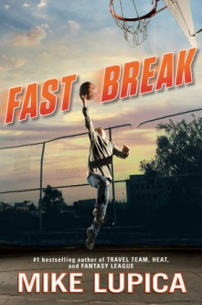 | Fast Break  Author: Mike Lupica  Call Number: FIC BRE  Interest Level: 7th -10th  12-year-old Jason’s mom is dead, no dad, and he is living on the streets until social services catch up with him and place him with a family who grew up in the same projects.
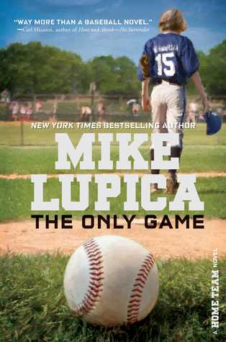 | The Only Game: A Home Team Novel  Author: Mike Lupica  Call Number: FIC LUP  Interest Level: 7th -10th  12 year old Jack, quits his little league team, dashing their hopes for a championship. He keeps his reasons a secret and tries to find his way through his grief and guilt for his brother’s death by helping coach a girls’ team and training a new friend to play ball.
 | Conviction  Author: Kelly Gilbert  Call Number: FIC GIL  Interest Level: 11th -12th  Braden’s family has fallen apart and slowly as the book progresses you learn the secrets that caused the rift. An abusive, controlling father, an absent brother, a strong pitching arm, and the hope a bargain with god.

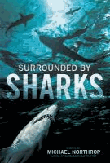
Surrounded by Sharks
Author: Michael Northrop
Interest Level: 7th through 12th
Call Number: FIC NOR

On the first day of vacation thirteen-year-old Davey Tsering wakes up early, slips out of his family's hotel room without telling anyone, and heads for the beach and a swim in the warm Floridian waters--and a fateful meeting with a shark.


The Crossover
Author: Kwame Alexander
Interest Level: 7th and 8th
Call Number: FIC ALE

Fourteen-year-old twin basketball stars Josh and Jordan wrestle with highs and lows on and off the court as their father ignores his declining health.


Perfect Season: a Football Genius Story
By Tim Green
Interest Level: 7th through 10th
Call Number: FIC GRE

A friendship is tested and a new one formed as Troy White, the football genius, gets to play varsity football for the first time, on a team that has to end its losing streak.


Foul Trouble
By John Feinstein
Interest Level: 7th through 10th
Call Number: FIC FEI

College recruiters are clambering to sign up Terrell Jamerson, the #1 high school basketball player in the country. But not all of these recruiters are straight shooters, and Terrell will have to think fast if he wants to stay in the game.


Crash Into You
By Katie McGarry
Interest Level: 11th and 12th
Call Number: FIC MCG

Rachel Young, a rich good girl, begins a romance with Isaiah Walker, a poor but street-smart foster kid.


Darius & Twig
By Walter Dean Myers
Interest Level: 11th and 12th
Call Number: FIC MYE

Two best friends, a writer and a runner, deal with bullies, family issues, social pressures, and their quest for success coming out of Harlem.


Winger
By Andrew Smith
Interest Level: 11th and 12th
Call Number: FIC SMI

Two years younger than his classmates at a prestigious boarding school, fourteen-year-old Ryan Dean West grapples with living in the dorm for troublemakers, falling for his female best friend who thinks of him as just a kid, and playing wing on the Varsity rugby team with some of his frightening new dorm-mates.
 | Ghost (Track, #1)  Author: Jason Reynolds  Interest Level: 7th and 8th  Call Number: FIC REY  Ghost wants to be the fastest sprinter on his elite middle school track team, but his past is slowing him down. He meets Coach, and ex-Olympic Medalist who sees something in Ghost. Can Ghost harness his raw talent for speed, or will his past finally catch up to him?
 | Patina (Track, #2)  Author: Jason Reynolds  Interest Level: 7th and 8th  Call Number: FIC REY  A newbie to the track team, Patina “Patty” Jones must learn to rely on her family and teammates as she tries to outrun her personal demons.

