Science Fiction/Fantasy
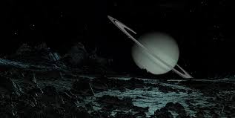

 | The Girl From Everywhere (The Girl From Everywhere #1)  Author: Heidi Heilig  Interest Level: 9th and 10th  Call Number: FIC HEI  As the daughter of a time traveler, Nix has spent sixteen years sweeping across the globe and through the centuries aboard her father’s ship but when her father gambles with her very existence, it all may be about to end.
 | Scythe (Arc Of the Scythe, #1)  Author: Neal Shusterman  Interest Level: 11th through 12th  Call Number: FIC SHU  A world with no hunger, no disease, no war, no misery: humanity has conquered all those things, and has even conquered death. Now Scythes are the only ones who can end life—and they are commanded to do so, in order to keep the size of the population under control.
 | Warcross  Author: Marie Lu  Interest Level: 9th through 12th  Call Number: FIC LU  When coder Emika hacks into the opening tournament of the championships, she glitches herself into the game and a sinister plot with major consequences for the entire Warcross empire.

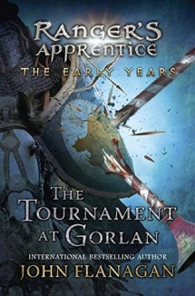 | The Tournament at Gorlan. Ranger’s Apprentice: The Early Years  Author: John Flanagan  Call Number: FIC FLA  Interest Level: 7th -12th  Halt and Crowley lead a group of displaced Rangers to stop the Baron of Gorlan , Morgarath, from stealing the throne.
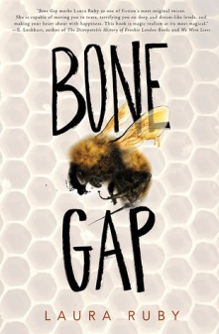  Fantasy | Bone Gap  Author: Laura Ruby  Call Number: FIC RUB  Interest Level: 11th -12th  When Rosa disappears, only Finn witnesses her abduction and he is unable to describe her captor. He is also unsure if she left by force or choice. Will he be able to save her?
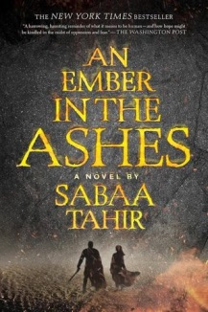 | An Ember in the Ashes  Author: SabaaTahir  Call Number: FIC TAH  Interest Level: 11th -12th  Laia is a slave. Elias is a soldier. They both want to be free of the Empire – sort of a dystopian Roman Empire type of setting with magic thrown in. However, defiance will be met with death.
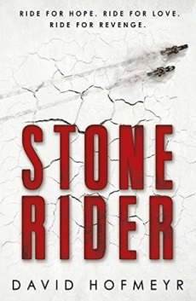 | Stone Rider  Author: David Hofmeyr  Call Number: FIC HOF  Interest Level:9th -12th  Adam races the Blackwater Trail, on a futuristic motorcycle, to win a way off the dust-bowl surface and he meets two other lone riders who could change his life.
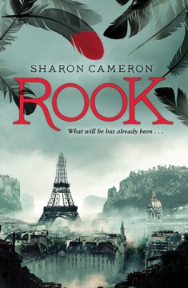 | Rook  Author: Sharon Cameron  Call Number: FIC CAM  Interest Level: 9th -12th  In a far future, post-apocalyptic Paris, where many are put to the blade, the Red Rook is the sole hope of change. Sophia must protect here secret identity while trying to save her financially ruined family by marrying a handsome young man who has secrets of his own.
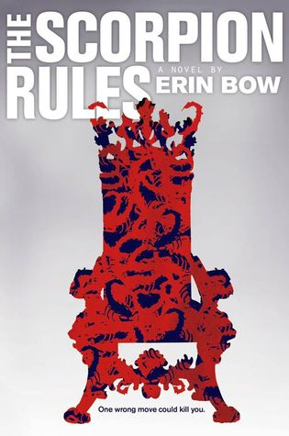 | The Scorpion Rules  Author: Erin Bow  Call Number: FIC BOW  Interest Level: 9th -12th  400 years ago an AI took control of the world and decided to stop war by holding Gustafson Stuart, Duchess of Halifax and Crown Princess of the Pan Polar Confederation, is a seventh generation hostage and a new arrival causes her to question everything she’s been trained to believe. Can she change the world?
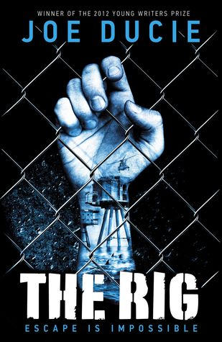 | The Rig  Author: Joe Ducie  Call Number: FIC DIC  Interest Level: 11th -12th  In a slightly distant future, 15 year-old Will Drake, has arrived at the juvenile prison, that is located on an old oil rig in the Arctic Ocean. He immediately starts to plan an escape and discovers the rig is more than a prison.
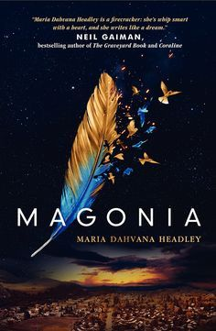 | Magonia  Author: Maria Dahvana Headley  Call Number: FIC HEA  Interest Level: 11th -12th  Aza has trouble breathing in our world and discovers she really belongs in Magonia, a sky world where she feels normal and strong. Unfortunately, the two worlds are headed for conflict and all those Aza loves are on the ground.
 | The Darkest Part of the Forest  Author: Holly Black  Call Number: FIC BLA  Interest Level: 9th -12th  Hazel and her brother, Ben, live where humans and the Folk exist side-by-side and there, inside a glass coffin, is a horned boy with pointed ears. Despite years of trying awaken him, nothing has happened until now. The coffin is broken and the boy is gone.
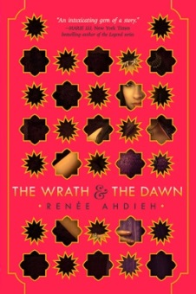 | The Wrath & the Dawn  Author: Renee Ahdieh  Call Number: FIC AHD  Interest Level: 11th-12th  Shahrzad offers herself as a bride to an 18 year-old king who takes a new bride every night and has her murdered at dawn. She plans to use her wit and charm him to stay alive and exact her revenge for the death of her friend by killing her new husband.
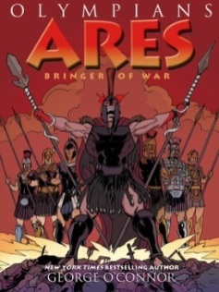 | Olympians: Ares, Bringer of War  Author: George O’Connor  Call Number: FIC OCO  Interest Level: 7th -12th  Ares and Athena are compared: thee gods interfere in the lives in humans and demigods as thy watch the events of the Trojan War unfold.

 | Seriously Wicked  Author: Tina Connolly  Call Number: FIC CON  Interest Level: 11th -12th  Cam’s determined not to be a witch, but her adopted mother has unleashed a demon at Cam’s school where there is a hidden phoenix about to explode and her classmates are acting like mindless drones. What can she do to save them all?
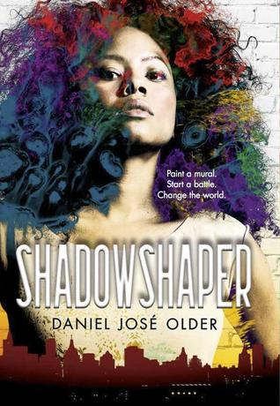 | Shadowshaper  Author: Daniel Jose Older  Call Number: FIC OLD  Interest Level: 9th -12th  Sierra discovers her Puerto Rican family has a heritage of the power of Shadowshaping, bring energy to shadows aligned with her energy though art, just in time to try and stop the destruction of all the Shadowshapers.
 | Sweet  Author: Emmy Laybourne  Call Number: FIC LAY  Interest Level: 7th -12th  A cruise to promote a new weight loss product becomes a nightmare when side effects from the drug turn passengers bloodthirsty. Can Tom and Larel, who have not taken the cure, survive?

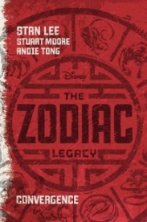 | Zodiac Legacy Book One: Convergence  Author: Stan Lee  Call Number: FIC LEE  Interest Level: 7th -12th  Two factions each comprised of people, primarily teens, who harness animal power from the Chinese zodiac, fight to control the world.
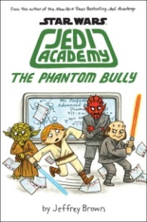 | Star Wars Jedi Academy Book 3: The Phantom Bully  Author: Jeff Brown  Call Number: FIC BRO  Interest Level: 7th -10th  Year three at the academy for Roan where he worries about graduating, tests, and his friendships. To make things more complicated someone is setting him up for trouble.
S | Star Wars: The empire Strikes Back: So You Want to be a Jedi?  Author: Adam Gidwitz  Call Number: FIC GID  Interest Level: 7th -10th  A Jedi in-training manual told though Luke Skypewalker’s second-person narration with the other stars playing a part.
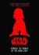 | Star Wars: Return of the Jedi: Beware the Power of the Dark Side  Author: Tom Angleberger  Call Number: FIC ANG  Interest Level: 7th -10th  A retelling that is told with LOTS of enthusiasm.
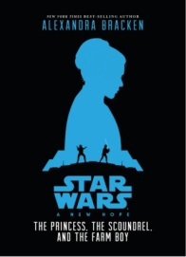 | Star Wars: A New Hope. The Princess, the Scoundrel, and the Farm Boy  Author: Alexandra Bracken  Call Number: FIC BRA  Interest Level: 7th and 8th  A retelling that goes deeper into the characters.
 | Beastly Bones: A Jackaby Novel  Author: William Ritter  Call Number: FIC RIT  Interest Level: 7th through 12th  Sequel to Jackaby. In 1892, Abigail Rook and supernatural investigator Jackaby are called to investigate the murder of a women in a distant rural town. More bodies turn up, puncture wounds are found, dinosaur bones are stolen, and a monster is on the loose
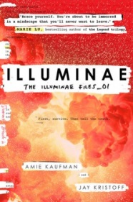 | The Illuminae Files Book One  Author: Aimie Kaufman and Jay Kristoff  Call Number: FIC KAU (Or FIC KRI)  Interest Level: 11th and 12th  In 2575, Kady and Ezra, just broke up, and their illegal mining planet home is destroyed by rival mega corporations. They barely escape, fleeing with other refugees on a trio of damaged space ships. Unfortunately a mutating virus is causing havoc and the AI has taken over the lead ship.

  Science Fiction | The Devil’s Engine Book One: Hellraisers  Author: Alexander Gordon Smith  Call Number: FIC SMI  Interest Level: 11th and 12th  Marlow makes a deal to help stop demons from overtaking the world in exchange for superhuman powers for 666 hours.
 | Need  Author: Joelle Charbonneau  Call Number: FIC CHA  Interest Level: 9th-12th  16 year old Kaylee and her students at her high school start joining a new social networking site, NEED, where, in exchange for completing a task, they are rewarded with their desired need. The tasks become more and more malicious and people start to die.

 | The Nest  Author: Kenneth Oppel  Call Number: FIC OPP  Interest Level: 7th-10th  Steve has a sick new baby brother, and his dreams are filled with a wasp queen offering to “fix” the baby, but if Steve agrees how horrible is the price? Creepy, haunting, psychological thriller.

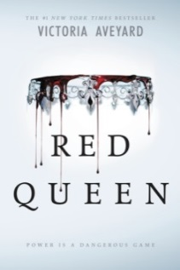 | Red Queen  Author: Victoria Aveyard  Call Number: FIC AVE  Interest Level: 11th and 12th  17-year-old Mare Barrow’s life is determined by blood color. Reds serve the Silver, a genetically gifted group of people with supernatural abilities. After a chance encounter with the prince she discovers she is Red and Silver, and could be just the spark to start a rebellion against the oppression.

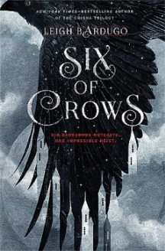 | Six of Crows  Author: Leigh Bardugo  Call Number: FIC BAR  Interest Level: 9th through 12th  Set in the same world as the Grisha Trilogy, a group of six outcasts take a chance on a deadly heist that will make them rich—if they survive.

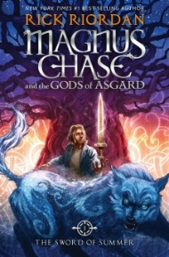 | Magnus Chase and the Gods of Asgard Book One: The Sword of Summer  Author: Rick Riordan  Call Number: FIC RIO  Interest Level: 7th and 8th (and beyond)  Magnus turns 16 and discovers he is a demi-god; his father is a Norse god. Now he must find his father’s sword and do what he can to stop Ragnarok with the help of his new companions. Fun adventure in the same tone as Percy Jackson.

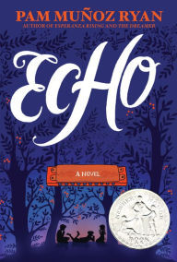 | Echo, A Novel  Author: Pam Munoz Ryan  Call Number: FIC RYA  Interest Level: 7th and 8th  During the years surrounding WWII, three lives are connected by a quest involving a prophecy, a promise, and a harmonica.

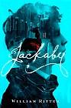
Jackaby
By Ritter R. William
Interest Level: 7th through 12th
Call Number: FIC WIL

Newly arrived in 1892 New England, Abigail Rook becomes assistant to R. F. Jackaby, an investigator of the unexplained with the ability to see supernatural beings, and she helps him delve into a case of serial murder which, Jackaby is convinced, is due to a nonhuman creature.

Egg & Spoon
By Gregory Maguire
Interest Level: 7th through 12th
Call Number: FIC MAG

"Impoverished Russian country girl Elena Rudina and the aristocratic Ekatrina meet and set in motion an escapade that includes mistaken identity, a monk locked in a tower, a prince traveling incognito, and the witch Baba Yaga"--OCLC.

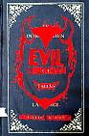
Evil Librarian
By Michelle Knudsen
Interest Level: 9th through 12th
Call Number: FIC KNU

Cynthia Rothschild has discovered that the new, very goodlooking librarian is a demon and it is up to her to save her best friend Anne, who has become a librarian monitor, and the rest of the school from the evil Mr. Gabriel.

The Fourteenth Goldfish
By Jennifer L. Holm
Interest Level: 7th through 8th
Call Number: FIC HOL

Ellie's scientist grandfather has discovered a way to reverse aging, and consequently has turned into a teenager--which makes for complicated relationships when he moves in with Ellie and her mother, his daughter

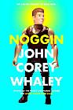
Noggin
By John Corey Whaley
Interest Level: 9th through 12th
Call Number: FIC WHA

After dying at age sixteen, Travis Coates' head was removed and frozen for five years before being attached to another body, and now the old Travis and the new must find a way to coexist while figuring out changes in his relationships.

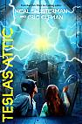
The Accelerati Trilogy: Tesla’s Attic
By Neal Shusterman
Interest Level: 7th through 9th
Call Number: FIC SHU

"With a plot combining science and the supernatural, four kids are caught up in a dangerous plan concocted by the eccentric inventor Nikola Tesla"--Provided by publisher.


The Winner’s Curse
By Marie Rutkoski
Interest Level: 9th through 12th
Call Number: FIC RUT

An aristocratic girl who is a member of a warmongering and enslaving empire purchases a slave, an act that sets in motion a rebellion that might overthrow her world as well as her heart.
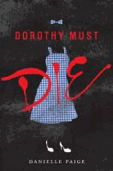
Dorothy Must Die
By Danielle Paige
Interest Level: 9th through 12th
Call Number: FIC PAI

"Amy Gumm, the other girl from Kansas, has been recruited by the Revolutionary Order of the Wicked to stop Dorothy who has found a way to come back to Oz, seizing a power that has gone to her head -- so now no one is safe!"-OCLC.

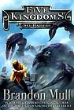
Five Kingdoms One: Sky Raiders
By Brandon Mull
Interest Level: 7th through 12th
Call Number: FIC MUL

Whisked through a portal to The Outskirts, an in-between world, sixth-grader Cole must rescue his friends and find his way back home--before his existence is forgotten.

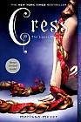
The Lunar Chronicles Book Three: Cress
By Marissa Meyer
Interest Level: 7th through 12th
Call Number: FIC MEY

"Cinder and Captain Thorne are fugitives on the run, now with Scarlet and Wolf in tow. Together, they are plotting to overthrow Queen Levana and prevent her army from invading Earth. Their best hope lies with Cress, a girl trapped on a satellite since childhood who has only ever had her netscreens as company. All that screen time has made Cress an excellent hacker. Unfortunately, she is being forced to work for Queen Levana, and she has just received orders to track down Cinder and her handsome accomplice"--Provided by publisher.

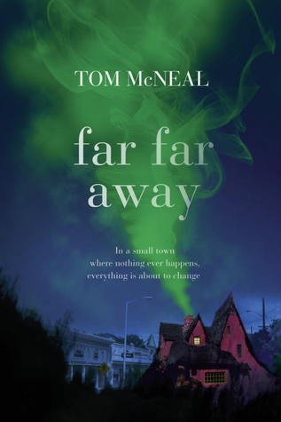
Far Far Away
By Tom McNeal
Interest Level: 9th through 12th
Call Number: FIC MCN

When Jeremy Johnson Johnson's strange ability to speak to the ghost of Jacob Grimm draws the interest of his classmate, Ginger Boltinghouse, the two find themselves at the center of a series of disappearances in their hometown.

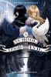
The School for Good and Evil
By Soman Chainani
Interest Level: 7th through 10th
Six Traits of Writing (Helps Improve): Conventions and Fluency
Call Number: FIC CHA

Best friends Sophie (princess wannabe) and Agatha (witchy loner) are headed (via kidnapping) to the School for Good and Evil, but their assumed destinies are reversed.

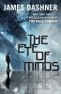
The Eye of Minds
By James Dashner
Interest Level: 7th through 12th
Call Number: FIC DAS

Michael is a skilled internet gamer in a world of advanced technology. When a cyber-terrorist begins to threaten players, Michael is called upon to seek him and his secrets out.

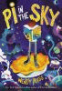
Pi in the Sky
By Wendy Mass
Interest Level: 7th through 9th
Call Number: FIC MAS

Joss, the seventh son of the Supreme Overlord of the Universe, must team up with a human girl to re-create Earth, when the planet is accidentally erased from existence.

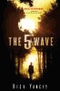
The 5th Wave
By Rick Yancey
Interest Level: 9th through 12th
Call Number: FIC YAN

Cassie Sullivan, the survivor of an alien invasion, must rescue her young brother from the enemy with help from a boy who may be one of them.

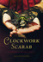
The Clockwork Scarab
By Colleen Gleason
Interest Level: 9th through 12th
Call Number: FIC GLE

In 1889 London young women are turning up dead, and Evaline Stoker, relative of Bram, and Mina Holmes, niece of Sherlock, are summoned to investigate the clue of the not-so-ancient Egyptian scarabs--but where does a time traveler fit in?

 | The Secret History of Us  Author: Jessi Kirby  Interest Level: 9th through 12th  Call Number: FIC KIR  Olivia wakes up to realize she doesn’t remember. Not just the accident—but anything from the last four years. Not high school. Not Matt, the guy who is apparently her boyfriend. Not the reason she and Jules are no longer friends. Nothing.
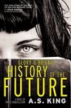   | They Both Die at the End  Author: Adam Silvera  Interest Level: 9th through 12th  Call Number: FIC SIL  Death calls just after midnight. Mateo and Rufus will die today. They don’t know each other yet, but their paths will cross on this last day of their lives.  Glory O’Brien’s History of the Future  Author: A.S. King  Interest Level: 11th and 12th  Call Number: FIC KIN  As her high school graduation draws near, Glory O'Brien begins having powerful and terrifying visions of the future as she struggles with her long-buried grief over her mother's suicide

