

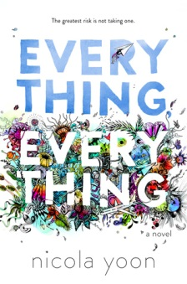 | Everything, Everything  Author: Nicola Yoon  Call Number: FIC YOO  Interest Level: 11th -12th  17 year old Maddy’s grown up isolated from the outside world, allergic to everything! Then Olly, the new boy next-door arrives, and her heart knows what it wants
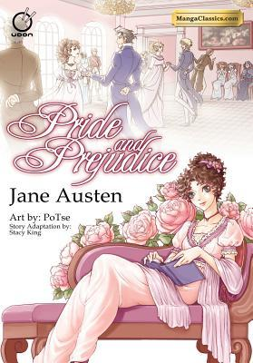 | Pride and Prejudice  Author: Jane Austen, Adapted by Stacy King  Call Number: FIC AUS  Interest Level: 7th -12th  Manga version of the classic book. There are other classics available from this publisher in manga format.

Tell Me How a Crush Should Feel
Author: Sara Farizan
Interest Level: 9th through 12th
Call Number: FIC FAR

High school junior Leila's Persian heritage already makes her different from her classmates at Armstead Academy, and if word got out that she liked girls life would be twice as hard, but when a new girl, Saskia, shows up, Leila starts to take risks she never thought she would, especially when it looks as if the attraction between them is mutual, so she struggles to sort out her growing feelings by confiding in her old friends


The Kiss of Deception
Author: Mary Pearson
Interest Level: 9th through 12th
Call Number: FIC PEA
On the morning of her wedding, Lia flees to a distant village. She settles into a new life, hopeful when two mysterious and handsome strangers arrive—and unaware that one is the jilted prince and the other an assassin sent to kill her. Deception abounds, and Lia finds herself on the brink of unlocking perilous secrets—even as she finds herself falling in love.

To All the Boys I’ve Loved
Author: Jenny Han
Interest Level: 7th through 12th
Call Number: FIC HAN

Lara Jean writes love letters to all the boys she has loved and then hides them in a hatbox until one day those letters are accidentally sent.

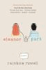
Eleanor and Park
Author: Rainbow Rowell
Interest Level: 9th through 12th
Call Number: FIC ROW

Set over the course of one school year in 1986, this is the story of two star-crossed misfits--smart enough to know that first love almost never lasts, but brave and desperate enough to try.


Wild Cards
Author: Simone Elkeles
Interest Level: 11th and 12th
Call Number: FIC ELK

Told from two viewpoints, Derek Fitzpatrick, kicked out of boarding school, must move with his stepmother to her childhood home in Illinois, where he meets Ashtyn Parker, who may be able to achieve her dream of a football scholarship with bad boy Derek's help.

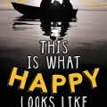 | This Is What Happy Looks Like  Author: Jennifer E. Smith  Interest Level: 9th through 12th  Call Number: FIC SMI  Perfect strangers Graham Larkin and Ellie O'Neill meet online when Graham accidentally sends Ellie an e-mail about his pet pig, Wilbur. The two 17-year-olds strike up an e-mail relationship from opposite sides of the country and don't even know each other's first names. What's more, Ellie doesn't know Graham is a famous actor, and Graham doesn't know about the big secret in Ellie's family tree. When the relationship goes from online to in-person, they find out whether their relationship can be the real thing


Crash Into You
Author: Katie McGarry
Interest Level: 11th and 12
Call Number: FIC MCG

Rachel Young, a rich good girl, begins a romance with Isaiah Walker, a poor but street-smart foster kid.


The Selection
Author: Kiera Cass
Interest Level: 9th and 10th
Call Number: FIC CAS

Sixteen-year-old America Singer is living in the caste-divided nation of Illea, which formed after the war that destroyed the United States. America is chosen to compete in the Selection--a contest to see which girl can win the heart of Illea's prince--but all she really wants is a chance for a future with her secret love, Aspen, who is a caste below her"--Provided by publisher.


Burned
Author: Ellen Hopkins
Interest Level: 11th and 12th
Call Number: FIC HOP

Seventeen-year-old Pattyn, the eldest daughter in a large Mormon family, is sent to her aunt's Nevada ranch for the summer where she temporarily escapes her alcoholic, abusive father and finds love and acceptance, only to lose everything when she returns home.


An Abundance of Katherines
Author: John Green
Interest Level: 9th through 12th
Call Number: FIC GRE

Having been recently dumped for the nineteenth time by a girl named Katherine, recent high school graduate and former child prodigy Colin sets off on a road trip with his best friend to try to find some new direction in life while also trying to create a mathematical formula to explain his relationships.

If I Stay
Author: Gayle Forman
Interest Level: 9th through 12th
Call Number: FIC FOR

While in a coma following an automobile accident that killed her parents and younger brother, seventeen-year-old Mia, a gifted cellist, weights whether to live with her grief or join her family in death.

Thirteen Reasons Why
Author: Jay Asher
Interest Level: 9th through 12th
FIC ASH

High school student Clay Jenkins receives a box in the mail containing seven cassette tapes recorded by his crush, Hannah Baker, who committed suicide, and spends a bewildering and heartbreaking night crisscrossing their town, listening to Hannah's voice recounting the events leading up to her death.


Will Grayson, Will Grayson
Author: John Green
Interest Level: 9th through 12th
Call Number: FIC GRE

When two teens, one gay and one straight, meet accidentally and discover that they share the same name, their lives become intertwined as one begins dating the other's best friend, who produces a play revealing his relationship with them both.


Nick and Norah’s Infinite Playlist
Author: Rachel Cohn
Interest Level: 9th through 12th
Call Number: FIC COH

High school student Nick O'Leary, member of a rock band, meets college-bound Norah Silverberg and asks her to be his girlfriend for five minutes in order to avoid his ex-sweetheart.

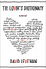
The Lover’s Dictionary
Author: David Levithan
Interest Level: 9th through 12th
Call Number: FIC LEV

A nameless narrator relates his experiences with love and being a part of a couple through a series of dictionary entries.

Every Day
Author: David Levithan
Interest Level: 9th through 12th
Call Number: FIC LEV

Every morning A wakes in a different person's body, in a different person's life, learning over the years to never get too attached, until he wakes up in the body of Justin and falls in love with Justin's girlfriend, Rhiannon.

