Realistic Fiction

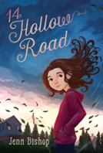 | 14 Hollow Road  Author: Jenn Bishop  Interest Level: 7th and 8th  Call Number: FIC BIS  Rising seventh-grader Maddie is consumed by her long-term crush on classmate Avery until a tornado destroys her home and her family must move in with his.
 | All’s Faire in Middle School  Author: Victoria Jamieson  Interest Level: 7th and 8th  Call Number: FIC JAM  Homeschooled by Renaissance Fair enthusiasts, eleven-year-old Imogene has a hard time fitting in when her wish to enroll in public school is granted
 | Always and Forever, Lara Jean (To All the Boys I’ve Loved Before, Book 3)  Author: Jenny Han  Interest Level: 11th and 12th  Call Number: FIC HAN  Lara Jean is having the best senior year a girl could ever hope for. Lara Jean will be graduating high school and leaving for college and leaving her family—and possibly the boy she loves—behind.
 | Amina’s Voice  Author: Hena Khan  Interest Level: 7th and 8th  Call Number: FIC KHA  A Pakistani-American Muslim girl struggles to stay true to her family’s vibrant culture while simultaneously blending in at school after tragedy strikes her community.
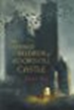 | The Charmed Children of Rooksill Castle  Author: Janet Fox  Interest Level: 7th and 8th  Call Number: FIC FOX  The castle is a temporary boarding school for children escaping the Blitz, but soon it’s clear there is something terribly wrong. When the children in the castle’s temporary boarding school begin disappearing, it’s a race against the clock for twelve-year-old Kat Bateson, her two younger siblings, and their new best friend.
 | Dress Codes for Small Towns  Author: Courtney C. Stevens  Interest Level: 9th through 12th  Call Number: FIC STE  As the tomboy daughter of the town’s preacher, Billie McCaffrey has always struggled with fitting the mold of what everyone says she should be.
 | The Epic Fail of Arturo Zamora  Author: Pablo Cartaya  Interest Level: 7th through 8th  Call Number: FIC CAR  Save the restaurant. Save the town. Get the girl. Make Abuela proud. Can thirteen-year-old Arturo Zamora do it all?
 | Falling Over Sideways  Author: Jordan Sonnenblick  Interest Level: 7th through 12th  Call Number: FIC SON  Claire loves dancing and playing the saxophone. Her life is just one big joke. Until something tragic happens that makes her life…well, fall over sideways.
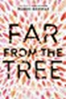 | Far From the Tree  Author: Robin Benway  Interest Level: 9th through 11th  Call Number: FIC BEN  Interweaving story of three very different teenagers connected by blood explores the meaning of family in all its forms—how to find it, how to keep it, and how to love it. Fans of “This is Us”.
 | Words in Deep Blue  Author: Cath Crowley  Interest Level: 9th through 12th  Call Number: FIC CRO  Teenagers Rachel and Henry find their way back to each other while working in an old bookstore full of secrets and crushes, love letters and memories, grief and hope.

 | Ghost (Track, #1)  Author: Jason Reynolds  Interest Level: 7th and 8th  Call Number: FIC REY  Ghost wants to be the fastest sprinter on his elite middle school track team, but his past is slowing him down. He meets Coach, and ex-Olympic Medalist who sees something in Ghost. Can Ghost harness his raw talent for speed, or will his past finally catch up to him?
 | Goodbye Days: A Novel  Author: Jeff Zentner  Interest Level: 9th through 12th  Call Number: FIC ZEN  Looks at a teen’s life after the death of his best friends and how he navigates through the guilt and pain by celebrating their lives—and ultimately learning to forgive himself.
 | Insignificant Events in the Life of a Cactus  Author: Dusti Bowling  Interest Level: 7th and 8th  Call Number: FIC BOW  Aven is an adopted child born without arms, yet she is a problem-solver. She befriends classmates Connor, a boy with Tourette's Syndrome and Zion an overweight boy and they have a mystery to solve.
 | Patina (Track, #2)  Author: Jason Reynolds  Interest Level: 7th and 8th  Call Number: FIC REY  A newbie to the track team, Patina “Patty” Jones must learn to rely on her family and teammates as she tries to outrun her personal demons.
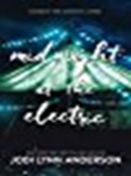 | Midnight at the Electric  Author: Jodi Lynn Anderson  Interest Level: 9th through 12th  Call Number: FIC AND  Kansas 2065: Adri has been handpicked to live on Mars.  Oklahoma, 1934: Amid the fear and uncertainty of the Dust Bowl, Catherine’s family’s situation is dire.  England, 1919: In the recovery after World War I, Lenore tries to come to terms with her grief for her bother.  While their stories span thousands of miles and multiple generations, Lenore, Catherine, and Adri’s fates are entwined in ways both heartbreaking and hopeful.

 | Once and for All: A Novel  Author: Sarah Dessen  Interest Level: 9th through 12th  Call Number: FIC DES  Is it really better to have loved and lost? Louna’s summer job is to help brides plan their perfect day, even though she stopped believing in happily-ever-after when her first love ended tragically. But charming girl-magnet Ambrose isn’t about to be discouraged now that he’s met the one he really wants.
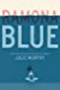 | Ramona Blue  Author: Julie Murphy  Interest Level: 9th through 12th  Call Number: FIC MUR  Ramona Blue has to be the adult of her family while questioning if she is a lesbian or bisexual when she develops feelings about her friend Freddie.
 | Refugee  Author: Alan Gratz  Interest Level: 8th through 12th  Call Number: FIC GRA  Although separated by continents and decades, Josef, a Jewish boy living in 1930s Nazi Germany; Isabel, a Cuban girl trying to escape the riots and unrest plaguing her country in 1994; and Mahmoud, a Syrian boy in 2015 whose homeland is torn apart by violence and destruction, embark on harrowing journeys in search of refuge.
 | Restart  Author: Gordon Korman  Interest Level: 7th and 8th  Call Number: FIC KOR  Chase does not remember falling off the roof, in fact he does not remember anything about himself, and when he gets back to middle school he begins to learn who he was through the reactions of the other kids.
 | Salt to the Sea  Author: Ruta Sepetys  Interest Level: 9th through 12th  Call Number: FIC SEP  This is a heart-breaking WWII novel about a lesser-known maritime tragedy, the sinking of the Wilhelm Gustloff, a German ship filled mostly with civilians trying to escape the advancing Russian (or Red) Army.
 | Scythe (Arc Of the Scythe, #1)  Author: Neal Shusterman  Interest Level: 11th through 12th  Call Number: FIC SHU  A world with no hunger, no disease, no war, no misery: humanity has conquered all those things, and has even conquered death. Now Scythes are the only ones who can end life—and they are commanded to do so, in order to keep the size of the population under control.
 | The Secret History of Us  Author: Jessi Kirby  Interest Level: 9th through 12th  Call Number: FIC KIR  Olivia wakes up to realize she doesn’t remember. Not just the accident—but anything from the last four years. Not high school. Not Matt, the guy who is apparently her boyfriend. Not the reason she and Jules are no longer friends. Nothing.
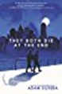 | They Both Die at the End  Author: Adam Silvera  Interest Level: 9th through 12th  Call Number: FIC SIL  Death calls just after midnight. Mateo and Rufus will die today. They don’t know each other yet, but their paths will cross on this last day of their lives.
 | Turtles All the Way Down  Author: John Green  Interest Level: 9th through 12th  Call Number: FIC GRE  Sixteen-year-old Aza never intended to pursue the mystery of fugitive billionaire Russell Pickett, but there’s a hundred-thousand-dollar reward at stake and her Best and Most Fearless Friend, Daisy, is eager to investigate.
 | Warcross  Author: Marie Lu  Interest Level: 9th through 12th  Call Number: FIC LU  When coder Emika hacks into the opening tournament of the championships, she glitches herself into the game and a sinister plot with major consequences for the entire Warcross empire.

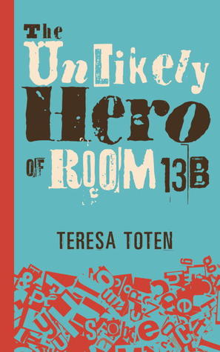 | The Unlikely Hero of Room 13B  Author: Teresa Toten  Call Number: FIC TOT  Interest Level: 11th -12th  OCD teen, Adam, falls in love with Robyn in group and decides this might just help him be normal. Howver, a hoarder mom and a divorced dad with a new baby complicate things.
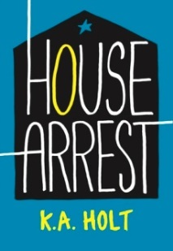 | House Arrest  Author: K.A. Holt  Call Number: FIC HOL  Interest Level: 7th -10th  Timothy is on probation. He must check in weekly with a probation officer and a therapist, and keep a journal for an entire year. But when he must take drastic measures to help his struggling family, staying out of trouble proves more difficult than Timothy ever thought it would be.
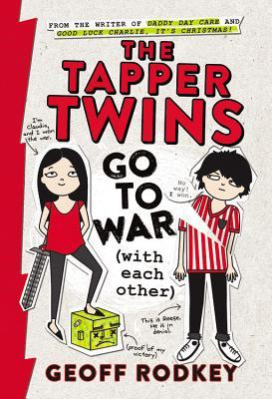 | The Tapper Twins Go to War (With Each Other)  Author: Geoff Rodkey  Call Number: FIC ROD  Interest Level: 7th -10th  6th grade twins, Claudia and Reese, blame each other for a missing Pop Tart and start a campaign of getting even.
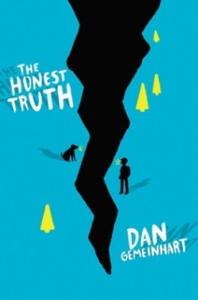 | The Honest Truth  Author: Dan Gemeinhart  Call Number: FIC GEM  Interest Level: 9th -12th  12-year-old Mark has been battling cancer and wants on last adventure, so he takes his dog and camera and runs away to Mt. Rainier and climb to the top if it’s the last thing he does.
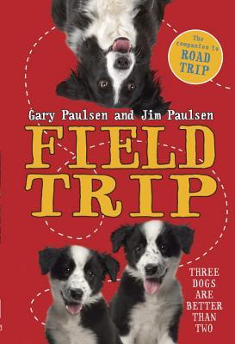 | Field Trip  Author: Gary Paulsen and Jim Paulsen  Call Number: FIC PAU  Interest Level: 7th -12th  In this companion to Road Trip, Ben, his dad, and a variety of characters including three border collies, starts off to catch-up with the school field trip but end up on a journey of their own
 | Geek Girl  Author: Holy Smale  Call Number: FIC SMA  Interest Level: 9th -12th  First in a new series. Harriet attends a fashion show just to make her best friend happy and is accidentally discovered by a modeling agent.
 | Under a Painted Sky  Author: Stacey Lee  Call Number: FIC LEE  Interest Level: 9th through 12th  It’s 1849 and Samantha, a Chinese American girl, kills a man who tries to rape her after her father is killed and runs away with Annamae, a slave. Disguising themselves as boys, the two end up on the Oregon Trail headed for California when they join up with three cowboys for the journey west.


Since You’ve Been Gone
Author: Morgan Matson
Interest Level: 7th through 12th
Call Number: FIC MAT

Quiet Emily's sociable and daring best friend, Sloane, has disappeared leaving nothing but a random list of bizarre tasks for her to complete, but with unexpected help from popular classmate Frank Porter, Emily gives them a try.


The Truth About Alice
Author: Jennifer Mathieu
Interest Level: 9th through 12th
Call Number: FIC MAT

When ugly rumors and lies about Alice Franklin start after one of the guys she allegedly slept with at a party dies in a car accident, questions about truth arise in her small town.


I’ll Give You the Sun
Author: Jandy Nelson
Interest Level: 9th through 12th
Call Number: FIC NEL

A story of first love, family, loss, and betrayal told from different points in time, and in separate voices, by artists Jude and her twin brother Noah.


Road Rash
Author: Mark Huntley Parsons
Interest Level: 9th through 12th
Call Number: FIC PAR
When teen drummer, Zach, signed up to spend the summer on tour with a rock band, he didn't realize the stairway to heaven was such a bumpy ride.


We Are the Goldens
Author: Dana Reinhardt
Interest Level: 9th through 12th
Call Number: FIC REI

Since their parents' divorce when they were young, Nell and her sister Layla have been each other's stability and support. When Layla starts to pull away, Nell discovers a secret: Layla is involved with one of their teachers. Nell struggles with what to do.

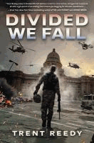
Divided We Fall
Author: Trent Reedy
Interest Level: 9th through 12th
Call Number: FIC REE

Danny Wright, seventeen, joined the Idaho Army National Guard to serve the country as his father had, but when the Guard is sent to an anti-government protest in Boise and Danny's gun accidently fires, he finds himself at the center of a conflict that results in the federal government declaring war on Idaho.


If You’re Reading This
Author: Trent Reedy
Interest Level: 7th through 12th
Call Number: FIC REE

For a responsible sixteen-year-old, Michael Wilson has a lot of problems--his father was killed in Afghanistan in 2005, his overworked and overprotective mother will not talk about their situation, and does not want him playing football, and he has suddenly started to receive letters that his father wrote before his death.


Hunt for the Bamboo Rat
Author: Graham Salisbury
Interest Level: 7th through 12th
Call Number: FIC SAL

Includes bibliographical references (page 321). Zenji Watanabe, seventeen, is sent from Hawaii to the Philippines to spy on the Japanese during World War II and, after he is captured and tortured, must find a way to survive months of being lost in the jungle behind enemy lines.

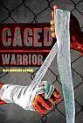
Caged Warrior
Author: Alan Lawrence Sitomer
Interest Level: 9th through 12th
Call Number: FIC SIT

From age three, McCutcheon Daniels, now sixteen, has been trained in Mixed Martial Arts and must keep winning to feed his five-year-old sister and father, but chance presents an opportunity to get out of the Detroit slums using his brain instead of his fighting skills.

The Scar Boys

Author: Len Vlahos
Interest Level: 9th through 12th
Call Number: FIC VLA

Written as a college admission essay, eighteen-year-old Harry Jones recounts a childhood defined by the hideous scars he hid behind, and how forming a band brought self-confidence, friendship, and his first kiss.

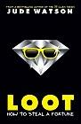
Loot: How to Steal a Fortune
Author: Jude Watson
Interest Level: 7th through 9th
Call Number: FIC WAT

When Alfie McQuinn, the notorious jewel thief, is killed on a job, his last words to his son, March, are to "find jewels" and this instruction leads the boy to Jules, the twin sister he never knew he had--and the perfect partner to carry on the family business.

Revolution

Author: Deborah Wiles
Interest Level: 7th through 9th
Call Number: FIC WIL
It's 1964 in Greenwood, Mississippi, and Sunny's town is being invaded by people from up north who are coming to help people register to vote. Her personal life isn't much better, as a new stepmother, brother, and sister are crowding into her life, giving her little room to breathe.

 | Simon Versus the Homo Sapiens Agenda  Author: Becky Albertalli  Call Number: FIC ALB  Interest Level: 11th and 12th  16 year-old, Simon, hasn’t come out. Martin sees a series of emails between Simon and another boy and learns his sec ret blackmails Simon into helping get a girlfriend.
 | All the Bright Places  Author: Jennifer Niven  Call Number: FIC NIV  Interest Level: 11th and 12th  Finch and Violet meet on the school’s bell tower, both considering jumping, but they save each other and a journey begins in alternating viewpoints.
 | All American Boys  Author: Jason Reynolds and Brendan Kiely  Call Number: FIC REY (or FIC KIE)  Interest Level: 9th -12th  Two teens—one black, one white—grapple with the repercussions of a single violent act that leaves their school, their community, and, ultimately, the country bitterly divided by racial tension.
 | Dumplin’  Author: Julie Murphy  Call Number: FIC MUR  Interest Level: 11th and 12th  Willowdean is confident, funny, and comfortable in her own skin, even though some people would call her fat. Then she falls for Bo, who seems to like her back. A Texas beauty pageant, changing friendships, new romance, and a protagonist who loves Dolly Parton.
 | Orbiting Jupiter  Author: Gary Schmidt  Call Number: FIC SCH  Interest Level: 7th and 8th  In rural Maine, 12 year-old, Jack, and his family take in troubled Joseph, who became a father at 13, but has never seen his daughter, and is fighting to find her.
 | Goodbye Stranger  Author: Rebecca Stead  Call Number FIC STE  Interest Level: 7th and 8th  Four friends struggle with the changes Middle School and family issues bring to their lives.

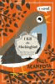 | I Kill the Mockingbird  Author: Paul Acampora  Interest Level: 7th through 9th  Call Number: FIC ACA  When best friends Lucy, Elena, and Michael receive their summer reading list, they are excited to see 'To Kill A Mockingbird' included. But not everyone in their class shares the same enthusiasm. So they hatch a plot to get the entire town talking about the well-known Harper Lee classic.

The Crossover
Author: Kwame Alexander
Interest Level: 7th and 8th
Call Number: FIC ALE

Fourteen-year-old twin basketball stars Josh and Jordan wrestle with highs and lows on and off the court as their father ignores his declining health.


The Impossible of Memory
Author: Laurie Halse Anderson
Interest Level: 9th through 12th
Call Number: FIC AND

Hayley Kincaid and her father move back to their hometown to try a 'normal' life, but the horrors he saw in the war threaten to destroy their lives.


The Doubt Factory
Author: Paolo Bacigalupi
Interest Level: 9th through 12th
Call Number: FIC BAC

When a radical band of teen activists claim that Alix's powerful father covers up wrongdoing by corporations that knowingly allow innocent victims to die in order to make enormous profits from unsafe products, she must decide if she will blow the whistle on his misdeeds.


Shipwreck Island
Author: S.A. Bodeen
Interest Level: 7th through 9th
Call Number: FIC BOD

When her father remarries, Sarah Robinson gets a new stepmom and two stepbrothers, and when the new family takes a vacation to get to know each other by sailing for a few days near Fiji things go horribly wrong.

Torn Away

Author: Jennifer Brown
Interest Level: 7th through 12th
Call Number: FIC BRO

In the aftermath of a tornado that has devastated her hometown of Elizabeth, Missouri, sixteen-year-old Jersey Cameron struggles to overcome her grief as she is sent to live with her only surviving relatives.
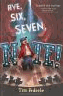
Five, Six, Seven, Nate!
Author: Tim Federle
Interest Level: 7th through 9th
Call Number: FIC FED

Now on Broadway as second understudy for E.T., Nate Foster keeps in close contact with his best friend, Libby, as he faces his nemesis, Jordan Rylance, and his own insecurities as the cast member with the least training and experience.
To All the Boys I’ve Loved

Author: Jenny Han
Interest Level: 7th through 12th
Call Number: FIC HAN

Lara Jean writes love letters to all the boys she has loved and then hides them in a hatbox until one day those letters are accidentally sent.

Conversion
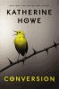
Author: Katherine Howe
Interest Level: 9th through 12th
Call Number: FIC HOW

When girls start experiencing strange tics and other mysterious symptoms at Colleen's high school, her small town of Danvers, Massachusetts, falls victim to rumors that lead to full-blown panic, and only Colleen connects their fate to the ill-fated Salem Village, where another group of girls suffered from a similarly bizarre epidemic three centuries ago.

Glory O’Brien’s History of the Future
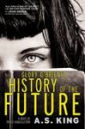
Author: A. S. King
Interest Level: 9th through 12th
Call Number: FIC KIN

"As her high school graduation draws near, Glory O'Brien begins having powerful and terrifying visions of the future as she struggles with her long-buried grief over her mother's suicide"--Provided by publisher.

The Chapel Wars
Author: Lindsey Leavitt

Interest Level: 7th through 12th
Call Number: FIC LEA

Sixteen-year-old Holly's grandfather leaves her his financially-strapped Las Vegas wedding chapel in his will, along with a letter asking her to reach out to Dax, the grandson of her family's mortal enemy and owner of the chapel next door, who is both cute and distracting.

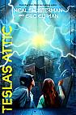
The Accelerati Trilogy: Tesla’s Attic
Author: Neal Shusterman
Interest Level: 7th through 9th
Call Number: FIC SHU

With a plot combining science and the supernatural, four kids are caught up in a dangerous plan concocted by the eccentric inventor Nikola Tesla.
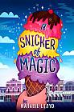
A Snicker of Magic
Author: Natalie Lloyd
Interest Level: 7th through 9th
Call Number: FIC LLO

The Pickles are new to Midnight Gulch, Tennessee, a town which legend says was once magic--but Felicity is convinced the magic is still there, and with the help of her new friend Jonah the Beedle she hopes to bring the magic back.

The Truth About Alice
Author: Jennifer Mathieu
Interest Level: 9th through 12th
Call Number: FIC MAT

"When ugly rumors and lies about Alice Franklin start after one of the guys she allegedly slept with at a party dies in a car accident, questions about truth arise in her small town.

I’ll Give You the Sun
Author: Jandy Nelson
Interest Level: 9th through 12th
Call Number: FIC NEL

"A story of first love, family, loss, and betrayal told from different points in time, and in separate voices, by artists Jude and her twin brother Noah.

We Are the Goldens
Author: Dana Reinhardt
Interest Level: 9th through 12th
Call Number: FIC REI

Since their parents' divorce when they were young, Nell and her sister Layla have been each other's stability and support. When Layla starts to pull away, Nell discovers a secret: Layla is involved with one of their teachers. Nell struggles with what to do.

If You’re Reading This
Author: Trent Reedy
Interest Level: 7th through 12th
Call Number: FIC REE

For a responsible sixteen-year-old, Michael Wilson has a lot of problems--his father was killed in Afghanistan in 2005, his overworked and overprotective mother will not talk about their situation, and does not want him playing football, and he has suddenly started to receive letters that his father wrote before his death.

Caged Warrior
Author: Alan Lawrence Sitomer
Interest Level: 9th through 12th
Call Number: FIC SIT

From age three, McCutcheon Daniels, now sixteen, has been trained in Mixed Martial Arts and must keep winning to feed his five-year-old sister and father, but chance presents an opportunity to get out of the Detroit slums using his brain instead of his fighting skills.

The Scar Boys
Author: Len Vlahos
Interest Level: 9th through 12th
Call Number: FIC VLA

Title proper from title frame.;Mode of access: World Wide Web.;Description based on print version record. Written as a college admission essay, eighteen-year-old Harry Jones recounts a childhood defined by the hideous scars he hid behind, and how forming a band brought self-confidence, friendship, and his first kiss.

A Mad, Wicked Folly
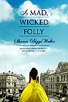
Author: Sharon Biggs
Interest Level: 9th through 12th
Call Number: 813 BIG

Includes bibliographical references (pages 425-427). In 1909 London, as the world of debutante balls and high society obligations closes in around her, seventeen-year-old Victoria must figure out just how much is she willing to sacrifice to pursue her dream of becoming an artist.

Revolution
Author: Deborah Wiles
Interest Level: 7th through 9th
Call Number: FIC WIL

Includes bibliographical references. "It's 1964 in Greenwood, Mississippi, and Sunny's town is being invaded by people from up north who are coming to help people register to vote. Her personal life isn't much better, as a new stepmother, brother, and sister are crowding into her life, giving her little room to breathe"--From publisher's description.


Belzhar
Author: Meg Wolitzer
Interest Level: 9th through 12th
Call Number: FIC WOL

Jam Gallahue, fifteen, unable to cope with the loss of her boyfriend Reeve, is sent to a therapeutic boarding school in Vermont, where a journal-writing assignment for an exclusive, mysterious English class transports her to the magical realm of Belzhar, where she and Reeve can be together.

 | Every Hidden Thing  Author: Kenneth Oppel  Interest Level: 9th through 12th  Call Number: FIC OPP  he hunt for a dinosaur skeleton buried in the Badlands, bitter rivalries, and a forbidden romance come together in this beautifully written new novel that’s Romeo and Juliet meets Indiana Jones.

