If You Like Diary of a Wimpy Kid, Check Out These Titles
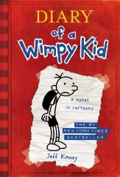
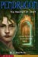 | The Merchant of Death Pendragon Series Book 1  Author: D. J. MacHale  Interest Level 7 – 8 (Some books may contain adult content)  Call Number: FIC MAC  Fourteen-year-old Bobby Pendragon, having learned he is a Traveler--someone who can ride "flumes" through time and space, is soon off to the alternative dimension of Denduron where he teams up with Loor, a girl his age from the warrior-territory of Zadaa, in an attempt to save the gentle Milago people from slavery.
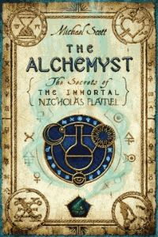 | The Alchemyst Secrets of the Immortal Nicholas Flamel Series Book 1  Author: Michael Scott  Interest Level 7-9  Call Number: FIC SMI  Fifteen-year-old twins, Sophie and Josh, find themselves caught up in the deadly struggle between rival alchemists, Nicholas Flamel and John Dee, over the possession of an ancient book that holds the secret formulas for alchemy and everlasting life
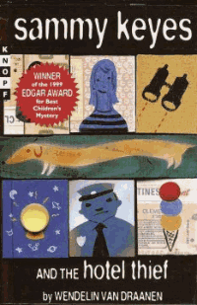 | Sammy Keyes and the Hotel Thief Sammy Keyes Series Book 1  Author Wendelin Van Draanen  Interest Level 7 – 8  Call Number: FIC VAN  Thirteen-year-old Sammy's penchant for speaking her mind gets her in trouble when she involves herself in the investigation of a robbery at the "seedy" hotel across the street from the seniors' building where she is living with her grandmother.
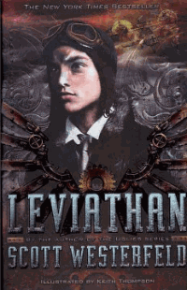 | Leviathan Leviathan Trilogy Book 1  Author: Scott Westerfield  Interest Level 7 – 8  Call Number: FIC WES  In an alternate 1914 Europe, fifteen-year-old Austrian Prince Alek, on the run from the Clanker Powers who are attempting to take over the globe using mechanical machinery, forms an uneasy alliance with Deryn who, disguised as a boy to join the British Air Service, is learning to fly genetically-engineered beasts.
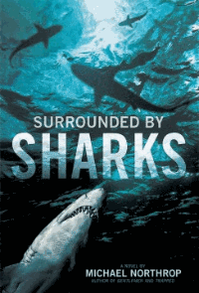 | Surrounded by Sharks  Author: Michael Northrop  Interest Level 7 – 9  Call Number: FIC NOR  On the first day of vacation thirteen-year-old Davey Tsering wakes up early, slips out of his family's hotel room without telling anyone, and heads for the beach and a swim in the warm Floridian waters--and a fateful meeting with a shark.
 | Perfect Season  Author: Tim Green  Interest Level 7 – 9  Call Number: FIC GRE  "A friendship is tested and a new one formed as Troy White, the football genius, gets to play varsity football for the first time, on a team that has to end its losing streak
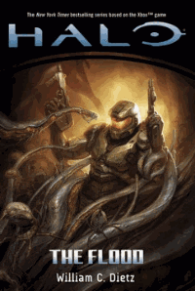 | Halo: The Flood  Author: William Dietz  Interest Level 9 – 12  Call Number: FIC DIE  he human crew of the "Pillar of Autumn" tries to hide from the hostile aliens in Slipspace, where they uncover an ancient mystery and the long-lost race that inhabits a massive, artificial ring-world, but after they are forced to crash-land on its surface, the humans get caught in middle of a violent struggle for control of the land.
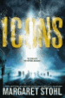 | Icons  Author: Margaret Stohl  Interest Level 7 – 9  Call Number: FIC STO  After an alien force known as the Icon colonizes Earth, decimating humanity, four surviving teenagers must piece together the mysteries of their pasts--in order to save the future.
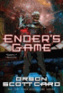 | Ender’s Game  Author: Orson Scott Card  Interest Level 7 – 8  Call Number: FIC CAR  After the Earth is twice attacked by aliens, the world government begins breeding military geniuses, one of whom is Ender Wiggin.
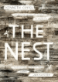 | The Nest  Author: Kenneth Oppel  Interest Level 7-9  Call Number: FIC OPP  "When wasps come to Steve in a dream offering to fix his sick baby brother, he thinks all he has to do is say yes. But yes may not mean what Steve thinks it means"
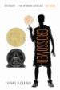 | The Crossover  Author: Kwame Alexander  Interest Level 7 – 9  Call Number: FIC ALE  Fourteen-year-old twin basketball stars Josh and Jordan wrestle with highs and lows on and off the court as their father ignores his declining health.
 | Cosmic  Author: Frank Cottrell Boyce  Interest Level 7 – 8  Call Number: FIC BOY  Twelve-year-old Liam, who looks like he is thirty and is tired of being treated like he is older than he actually is, decides he is going to pose as the adult chaperone on the first spaceship to take civilians into space, but when he ends up in outer space with a group of kids and no adult supervision, he must think fast to make things right.
 | Ungifted  Author: Gordon Korman  Interest Level 7 -8  Call Number: FIC KOR  Due to an administrative mix-up, troublemaker Donovan Curtis is sent to the Academy of Scholastic Distinction, a special program for gifted and talented students, after pulling a major prank at middle school.
 | Eighth Grade Bites Chronicles of Vladimir Tod Series Book 1  Author: Heather Brewer  Interest Level 7 – 8  Call Number: FIC BRE  Thirteen-year-old half-vampire Vladimir Tod struggles to navigate the ups and downs of eighth grade while keeping his untested powers and impulses under control.
 | First Kill Slayer Chronicles Book 1  Author: Heather Brewer  Interest Level 7 – 8  Call Number: FIC BRE  The summer before ninth grade, when Joss sets off to meet his uncle and hunt down the beast that murdered his younger sister three years earlier, he learns he is destined to join the Slayer Society.
 | Middle School the Worst Years of My Life Middle School Series Book 1  Author: James Patterson  Interest Level 7 – 8  Call Number: FIC PAT  When Rafe Kane enters middle school, he teams up with his best friend, "Leo the Silent," to create a game to make school more fun by trying to break every rule in the school's code of conduct.
 | Coaltown Jesus  Author: Ronald Koertge  Interest Level 9 – 12  Call Number: FIC KOE  Walker finds his life forever changed when Jesus appears in his bedroom after the death of his seventeen-year-old brother, Noah.
 | Mind Games  Author: Kiersten White  Interest Level 7 – 12  Call Number: FIC WHI  "Seventeen-year-old Fia and her sister, Annie, are trapped in a school that uses young female psychics and mind readers as tools for corporate espionage--and if Fia doesn't play by the rules of their deadly game, Annie will be killed"--Provided by publisher.
 | Hunger Games Hunger Games Trilogy Book 1  Author: Suzanne Collins  Interest Level 7 – 12  Call Number: FIC COL  Sixteen-year-old Katniss Everdeen accidentally becomes a contender in the annual Hunger Games, a grave competition hosted by the Capitol where young boys and girls are pitted against one another in a televised fight to the death.
 | Flame in the Mist  Author: Kit Grindstaff  Interest Level 7 – 9  Call Number: FIC GRI  Thirteen-year-old Jemma finds herself in a race for her life when she discovers an ancient prophecy that reveals the truth about her past and an unimaginably great and dangerous destiny--to defeat the evil Agromonds and restore peace and sunlight to Anglavia.
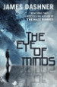 | The Eye of Minds  Author: James Dashner  Interest Level 7 – 12  Call Number: FIC DAS  "Michael is a skilled internet gamer in a world of advanced technology. When a cyber-terrorist begins to threaten players, Michael is called upon to seek him and his secrets out"--Provided by publisher.
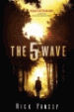 | The 5th Wave 5th Wave Trilogy Book 1  Author: Richard Yancey  Interest Level 7 – 9  Call Number: FIC YAN  "Cassie Sullivan, the survivor of an alien invasion, must rescue her young brother from the enemy with help from a boy who may be one of them"--Provided by publisher.
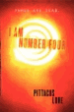 | I Am Number Four  Author: Pittacus Lore  Interest Level 7 – 8  Call Number: FIC LOR  In rural Ohio, friendships and a beautiful girl prove distracting to a fifteen-year-old who has hidden on Earth for ten years waiting to develop the Legacies, or powers, he will need to rejoin the other six surviving Garde members and fight the Mogadorians who destroyed their planet, Lorien.
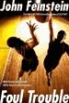 | Foul Trouble  Author: John Feinstein  Interest Level 7 – 8  Call Number: FIC FEI  "College recruiters are clambering to sign up Terrell Jamerson, the #1 high school basketball player in the country. But not all of these recruiters are straight shooters, and Terrell will have to think fast if he wants to stay in the game"--Provided by publisher.

