CAASPP Electronic Student Score Reports in Parent Portal
Student score reports are now available in Parent Portal. The change from paper reports to paperless reports provide convenient, quick, secure access to student’s scores for teachers and parents. Student score reports will be screen readable, provide adequate color contrast, and will be available in multiple languages.
Current results will be available for English language arts/literacy (ELA) and mathematics in grades three – eight and grade eleven during the summer. If your child took the Science assessment in grades five, eight, or twelve, results will be provided to you in late fall of 2019.

What if I don’t have access to a desktop computer?
You can view the reports through the parent portal on any device connected to the internet, such as a computer, tablet, or smart phone. If you are unable to access the report, visit your child’s school, and the office staff will be available to help you. We understand that not everybody has access to a computer or is able to come to school to view the student score report. If you have been unable to view the report online by August 5th, please notify the school office and staff will print and mail a copy to your home address.
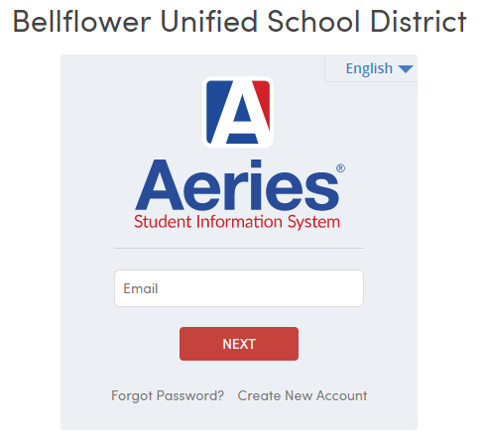
How do I get a Parent Portal Account?
Information for creating a Parent Portal account can be found on the Bellflower USD website under the parent tab: https://busd.k12.ca.us.
How do I access Parent Portal?
A link to BUSD’s Parent Portal can be found on the BUSD website or at this link: https://parentportal.busd.k12.ca.us

Where can I find more information to help me understand my child’s Student Score Report?
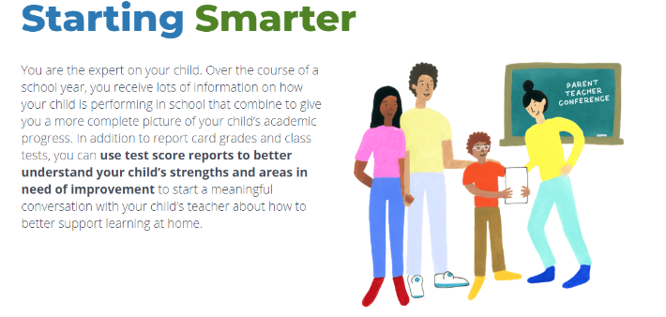
Visit https://ca.startingsmarter.org to find information regarding student score reports, test question samples, free resources to support your child’s learning.
The student score report for 11th grade students will include an Early Assessment Program (EAP) status report showing your child’s readiness for credit-bearing, college-level courses in ELA and mathematics. Visit https://www.csustudentsuccess.org for more information.

Please contact your child’s school office if you have questions regarding your child’s student score report.

