Instructions for Accessing Student Score Reports in Parent Portal

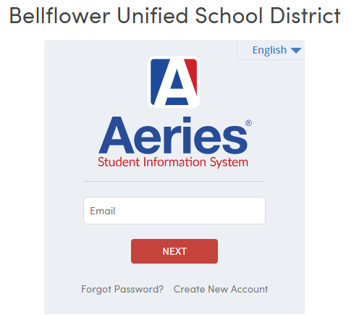
How do I get a Parent Portal Account?
Information for creating a Parent Portal account can be found on the Bellflower USD website under the parent tab: https://busd.k12.ca.us.
How do I access Parent Portal?
A link to BUSD’s Parent Portal can be found on the BUSD website or at this link: https://parentportal.busd.k12.ca.us

Once logged in, click on “Test Scores” and select “State Test Scores Reports.”
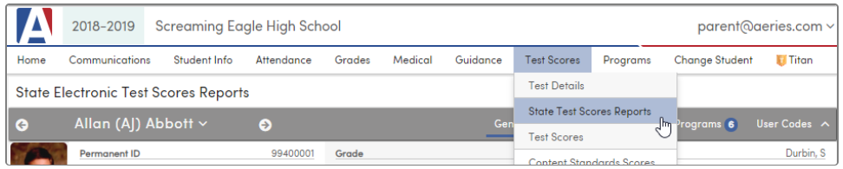

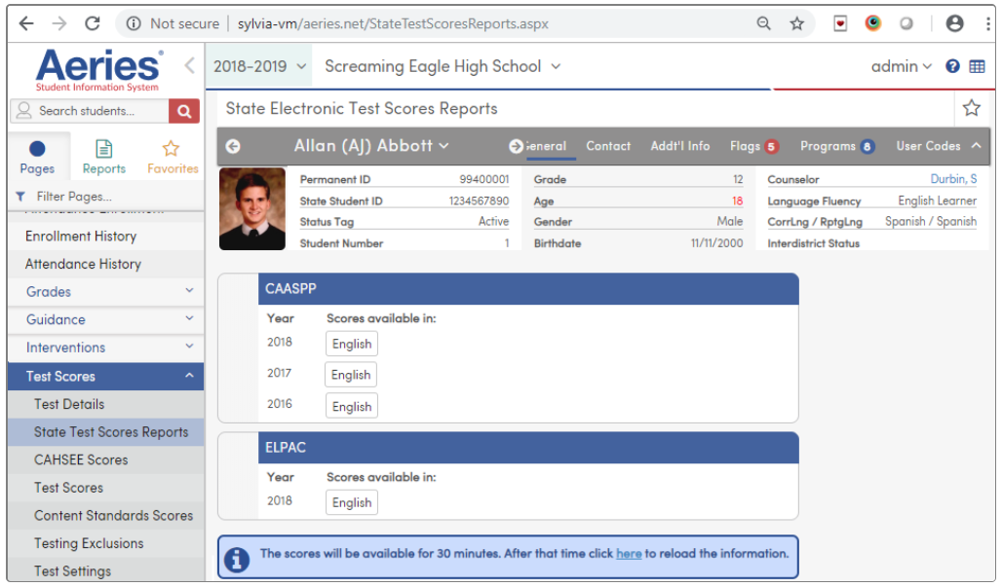
The State Electronic Test Scores Reports page will open and score reports will be listed as seen below:

Score reports will only be available for 30 minutes. After that, the link will expire and a new link will need to be requested by clicking on the “here” link in the blue information box.

