Student Name______________________________ Date____________________

SAE Monitor: _______________________________ Academic Quarter 1 2 3 4

Killingly Agriculture Education
Quarterly SAE Progress Report & Evaluation
Year in Ag (Circle One): Ag I Ag II Ag III Ag IV
Record your S.A.E. hours in the chart below; be sure to place the number of hours in the correct column(s).
 | Volunteer | Placement | Entrepreneur | Research | Exploratory | Improvement
Quarter 1
(July – October)
Quarter 2
(November – January)
Quarter 3
(February – March)
Quarter 4
(April – June)

TOTALS

GRAND TOTAL HOURS of S.A.E. Projects: _______________________

Reflect on what you have learned and on the progress you’ve made towards your S.A.E. learning objectives. Use this space to summarize skills learned, growth of your SAE project and your achievements for this quarter. Be specific and thorough; use all the space provided. (You may continue on additional sheets of paper if necessary).
____________________________________________________________________________________________________________________________________________________________________________________________________________________________________________________________________________________________________________________________________________________________________________________________________________________________________________________________________________________________________________________________________________________________________________________________________________________________________________________________________________________________________________________________________________________________________________________________________________________________________________________________________________________________________________________________________________________________________________________________________________________________________________________________________________________________________________
Self-assess your S.A.E. Project with the SAE Evaluation Rubric on the reverse side of this page.
SAE Evaluation Rubric
 | Exemplary  (10) | Goal  (9-8) | Proficient  (7-6) | Limited  (5-3) | No Growth  (2-0) | Evaluation
SAE Plan and Learning Objectives | Student maintains a complete and current SAE plan in AET for each SAE Project. The plan is detailed and includes realistic but challenging objectives that focus on growth and learning. | Student has completed and current SAE plans recorded in AET for most or all SAE projects. Learning objectives are recorded. | Student developed an approvable SAE plan but some sections are incomplete OR obviously not current. | Student developed a limited/incomplete SAE plan that lacks details, clarity, and/or appropriate learning objectives. | Student does not have an approved and current SAE plan recorded in AET.
Quality of Records | Journal and financial entries are all detailed, clearly and correctly recorded in AET in a timely manner; including hours. | Journal entries and financial entries are all recorded in AET clearly and logically. | Journal entries and financial entries are complete, but there are inaccuracies in the entries, and/or they lack detail. | Some journal and financial entries are inaccurate or incomplete. | Journal entries and financial entries are missing or largely incomplete.
Skill Development | Student documents through pictures, journal entries and SAE visits evidence of advanced skill development. | Student uses journal entries to show evidence of skills. | Student shows some evidence of skills. | Student shows little evidence of skills. | Student shows poor evidence of skills.
SAE Hours | Student vastly exceeds 25 hours this quarter. | Student meets or exceeds 25 hours this quarter. | Student recorded more than 15 hours this quarter. | Student recorded less than 15 hours this quarter. | Student did not record SAE hours this quarter.
Evidence, Documents and Photos | Student provides thorough evidence including 2 current quality dated and captioned photos of each SAE project . | Student provides adequate evidence of each SAE Project including at least two quality dated and captioned photos. | Student provides some photographic or electronic evidence uploaded to AET. | Some required documents, evidence or photos are not on file. | None of the required evidence, documents and photos are on file.
Student Reflection | Student demonstrates high levels of progress toward learning objectives, achievement and new learning. | Student demonstrates moderate progress toward learning objectives, achievement and new learning. | Student demonstrates some progress toward learning objectives, achievement and new learning. | Student demonstrates limited progress toward learning objectives, achievement and new learning. | Student demonstrates little or no progress toward learning objectives, achievement and new learning.
SAE Monitor Evaluation | Student has taken full advantage of opportunities and gained new knowledge and experience demonstrating exceptional effort, growth and rigor. | Student is taking advantage of opportunities to gain new knowledge and experience demonstrating effort, growth and rigor. | Student has taken advantage of some opportunities to gain new knowledge and experience demonstrating some effort and growth. | Student has taken limited advantage of opportunities presented; demonstrating little effort or growth. | Student has not taken advantage of opportunities and is not demonstrating growth.

Total Points/SAE Grade __________
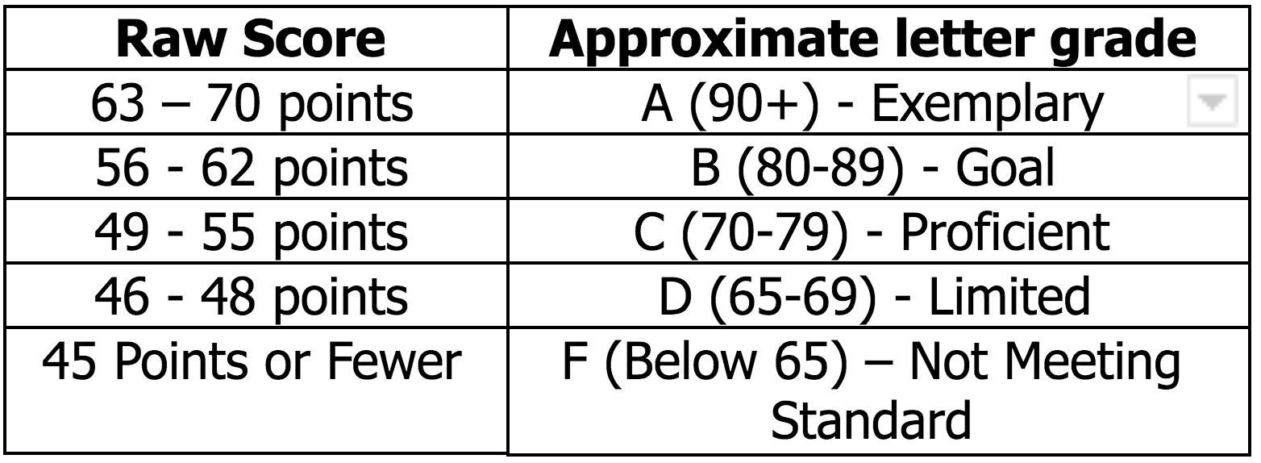
SAE MONITOR COMMENTS:

