G. W. Hewlett High School Theater Company Presents
Marvin’s Room
by
Scott McPherson
Wednesday, February 5, 2014 at 4:00 pm
Thursday, February 6, 2014 at 4:00 pm
Friday, February 7, 2014 at 8:00 pm

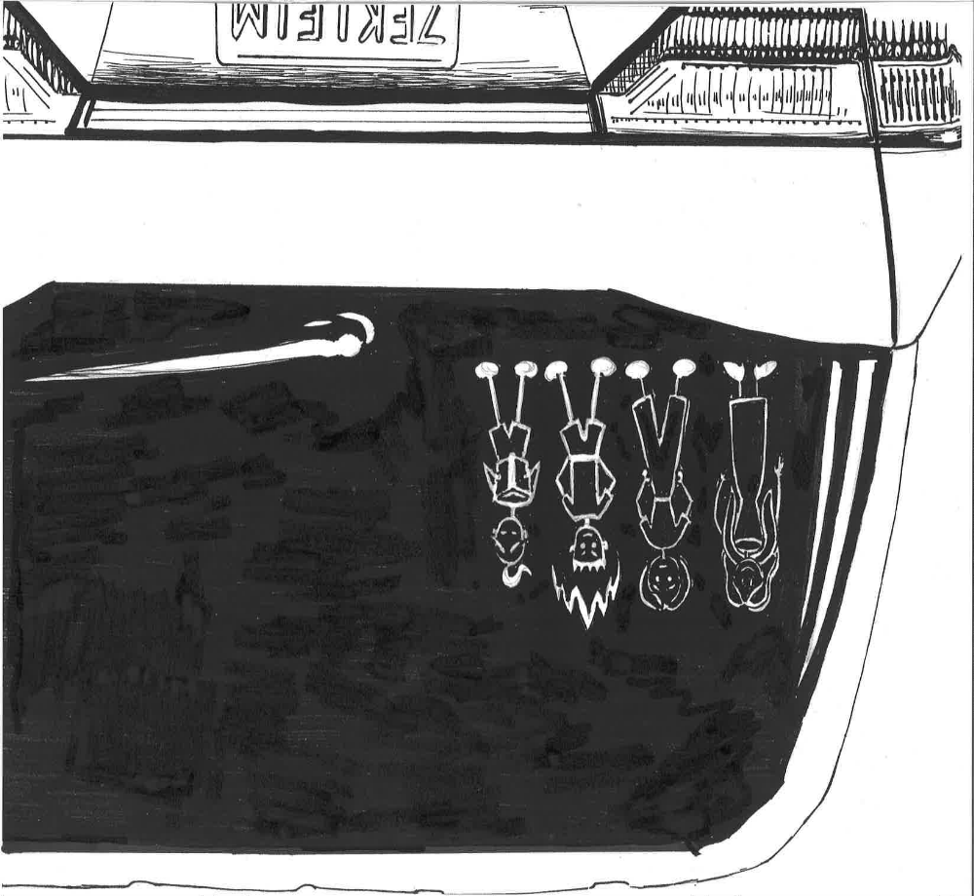

Wednesday, February 4 2015 at 4:00 pm
Thursday, February 5, 2015 at 4:00 pm
Friday, February 6, 2015 at 8:00 pm
Saturday, February 7, 2015 at 8:00pm
Tickets will be on sale February 2 and 3 after school in the Student Commons and 30 minutes before each performance

Tickets: $10 Adult/Student and $5 Senior Citizen/Child (under 12)

The Little Theater at G. W. Hewlett High School

