 Allergy Agreement and Action Plan
FORM 6
The roman catholic Archdiocese of Washington – Catholic Schools
Student’s Name: |  |  |  |  |  |  |  | Sex: |  |  |  | Birth Date:
 |  |  |  |  | Print Student’s Name |  |  | Male Female mm/dd/yyyy
 | Allergies:
 | Weight: |  |  |  |  | Asthma: | YES (higher risk for severe reaction) NO
 | Teacher’s Name: |  |  |  |  |  | Grade:

PART I: To be completed and signed by Parent/Guardian and Physician/LHCP

Extremely reactive the following allergens: .

THEREFORE:
☐ If checked, give epinephrine immediately if the allergen was LIKELY eaten, for ANY symptoms.
☐ If checked, give epinephrine immediately if the allergen was DEFINITELY eaten, even if no symptoms are apparent.
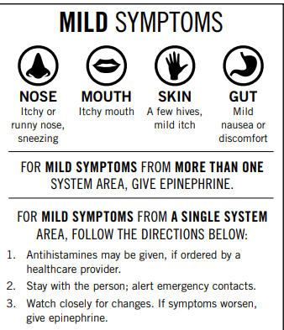
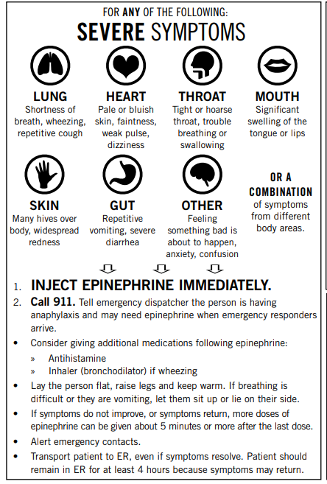
Medications/Doses
Epinephrine Brand or Generic:

Epinephrine Dose: 0.1 mg IM 0.15 mg IM 0.3 mg IM

Antihistamine Brand or Generic:
Antihistamine Dose:

Other (e.g. inhaler-bronchodilator if wheezing):

EMERGENCY CONTACT INFORMATION
Mother/Guardian Name: |  |  | Phone: | ( ) -
Father/Guardian Name: |  |  | Phone: | ( ) -
OTHER #1 Name: |  |  | Phone: |  | ( ) -
OTHER #2 Name: |  |  | Phone: |  | ( ) -
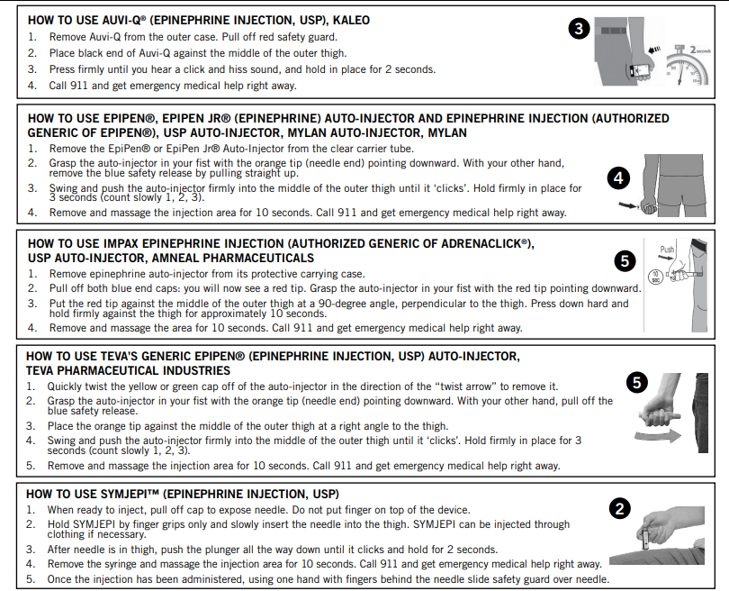
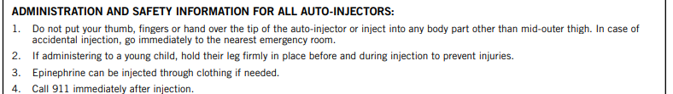

For completion by the student’s physician/HCP:

Check ONE of the two boxes below:
I recommend that the school permit the student to carry and, if necessary, self-administer the auto injector. I believe that this student has received adequate information on how and when to use Auto injector, has demonstrated its proper use, and has the capacity to use the injector in an emergency.
- The student is to carry an auto injector during school hours with principal and/or nurse approval.
- The student can use the auto injector properly in an emergency
- One additional dose, to be used as backup, should be kept in clinic or other designated location in the school.

I recommend that the auto injector be kept in the school clinic or other school-approved location.

Licensed Healthcare Provider: |  | Phone: | ( ) -

Signature of LHCP: |  | Date

This form is an adapted version of the Food Allergy and Education (FARE), Food Allergy and Anaphylaxis Emergency Care Plan.

Parent Signature: _____________________________________ Date: ________

Physician/
HCP Authorization Signature: ___________________________ Date: ________

PART II: Information about Medication Procedures
Parent/Guardian Consent & Permission for Emergency Treatment

- In no case may any health, school, or staff member administer any medication outside the framework of the procedures outlined herein, in the Roman Catholic Archdiocese of Washington Catholic Schools Policies, and district, state, and/or professional guidelines.

- Schools do NOT provide medications for student use. The student’s parent/guardian is responsible for providing the school with any medication the student needs, and for removing any expired or unnecessary medication for the student from the school.

- Medication must be kept in the school health office or other location approved by the principal during the school day. All medication in the school’s possession will be stored in a locked cabinet or refrigerator, within a locked area, accessible only to authorized personnel, except in the case of the student being authorized to self-carry certain medication (e.g., inhaler or Epi-pen). For such a case, the school recommends that the parent/guardian provide the school with a backup medication to be kept by the school.

- All prescription medications, including physicians’ samples, must be in their original containers and labeled by a licensed health-care professional (LHCP) or pharmacist, and must not have passed its expiration date. Within one week after the expiration of the LHCP’s order for the medication, or on the last day of school, the parent/guardian must personally collect any unused portion of the medication. Medications not so claimed will be destroyed.

- The student’s parent/guardian is responsible for submitting a new Allergy Agreement and Action Plan to the school at the start of the school year and each time there is a change in the dosage or the time or method of medication administration.

- In the event the parent/guardian named below cannot be contacted, I, the undersigned parent/guardian, do hereby authorize Don Bosco Cristo Rey to obtain emergency medical treatment for the health of my child, ____________________________________. I will not hold Don Bosco Cristo Rey responsible for the emergency care and/or emergency transportation for the said student.

- I approve of this Allergy Action Plan, and I give permission for school personnel to perform and carry out the tasks as outlined above. I consent to the release of the information contained in this plan to all staff members and others who have custodial care of my child and who may need to know this information to maintain my child’s health and safety.

- I hereby request designated Don Bosco Cristo Rey personnel to administer medication, including epinephrine, as directed by this authorization. I agree to release, indemnify, and hold harmless the Roman Catholic Archdiocese of Washington and its parish and/or school personnel, employees, and agents from any lawsuit, claim, expense, demand or action, etc., against them relating to or arising out of the administration of this medication. I have read the procedures outlined above and assume responsibility as required. I am aware that the medication may be administered by someone who is not a health professional.

 | Name of Parent/Guardian:
 | Signature of Parent/Guardian: |  |  |  |  | Date
 | Signature of Student (Required for student to carry auto injector):

PART III: Agreement, Release and Wavier of Liability

This AGREEMENT, RELEASE AND WAIVER OF LIABILITY (hereinafter referred to as “Release”) is made by and between, Don Bosco Cristo Rey High School, a Roman Catholic high school of the Roman Catholic Archdiocese of Washington. Don Bosco Criso Rey High School and _______________________________ , parents of __________________________________.
Name of Parent/Guardian Name of student

1. We the undersigned parents/guardians of the above Student request that the school enroll our child, who has allergies, for the current 2023-2024 school year. We request that the school work with us to develop a plan to accommodate the student’s needs during school hours.
2. The parties understand, acknowledge, and agree that it is beyond the school’s ability to guarantee an allergen-free environment.
3. The parties understand, acknowledge, and agree that it is beyond the school’s ability to monitor or supervise Student’s compliance with personal food restrictions or other restrictions and that the school will not do so.
4. The parties understand, acknowledge, and agree that it is beyond the school’s ability and resources to prevent contamination of Student’s food and to provide allergen-free surfaces on all desks and tables where Student may be seated.
5. The parties understand and acknowledge that the school does not have a full-time nurse or any other medical professional on staff.
6. We have provided the School with an Allergy Action Plan which was completed by Student’s physician. It includes parental permission authorizing School personnel to assist in the administration of that Allergy Action Plan, in the form attached hereto as Exhibit A, which is subject to the school’s review and acceptance.
7. We have executed and submitted a Medical Information Form and Permission for Emergency Treatment for Student, which is included in the Allergy Action Plan, attached hereto as Exhibit A.
8. We understand that the school reserves the right to cancel Student’s enrollment if it is determined that the allergy condition and related consequences are a significant detriment to the student’s ability to benefit from the academic program or to the teachers’ ability to maintain order and teach the other students.
9. We hereby indemnify, release, hold harmless and forever discharge the school, its employees and agents from any and all responsibility and/or liability for any injuries, complications or other consequences arising out of or related to Student’s food allergy condition.
10. This Release, along with the documents which are incorporated by reference, supersedes, and replaces all prior negotiations and all agreements proposed or otherwise, whether written or oral, concerning all subject matters covered herein related to Student’s food allergy condition.
11. This Release shall also constitute an estoppel against any and all legal or equitable claims concerning all subject matters covered herein related to Student’s food allergy condition; and we, the undersigned parents/guardians, shall further hold harmless and indemnify the school in the event any claim is asserted by any third party against the parties covered by this agreement. The indemnification includes all costs and attorneys’ fees.
12. The reference in this Release to the term “the school” includes Don Bosco Cristo Rey High School and Church, the Roman Catholic Archdiocese of Washington, a corporation sole, and their affiliates, successors, officers, employees, agents and representatives.

AGREED AND SIGNED
PARENTS/GUARDIANS
Name of Parent/Guardian:
Signature of Parent/Guardian: |  |  | Date
Name of Parent/Guardian:
Signature of Parent/Guardian: |  |  | Date
PRINCIPAL
Name of Principal:
Signature of Principal: |  |  | Date

PART IV: To be completed by principal and nurse

Student’s Name: |  | Grade: |  | Teacher:

CHECKLIST FOR ALLERGY ACTION PLAN
Part I fully completed and signed by parent/guardian and physician/LHCP |  |  |  |  | Yes |  | No
Part II fully completed and signed by parent/guardian |  |  |  |  | Yes |  | No
Part III fully completed and signed by parent/guardian and principal |  |  |  |  | Yes |  | No |  | N/A
Medication is appropriately labeled. The date one week after expiration of LHCP’s order is: __________. |  |  |  |  | Yes |  | No |  | N/A
Medication maintained in school designated area (Area:____________________) |  |  |  |  | Yes |  | No |  | N/A
(If LHCP recommends that student self-carry) Nurse has reviewed proper use of medication with student. |  |  |  |  | Yes |  | No |  | N/A
Copies of page 1 of Allergy Agreement and Action Plan have been reviewed with and distributed to following school staff:
Educational Support Agencies working with the student |  |  |  |  | Yes |  | No |  | N/A
After-school program |  |  |  |  | Yes |  | No |  | N/A
Coach/Athletic club supervisor |  |  |  |  | Yes |  | No |  | N/A
Food Service provider |  |  |  |  | Yes |  | No |  | N/A
Staff trained in medication administration |  |  |  |  | Yes |  | No |  | N/A
Name: |  |  | Date Trained: |  |  | Location:
Name: |  |  | Date Trained: |  |  | Location:
Name: |  |  | Date Trained: |  |  | Location:
EXPIRATION of medication(s):

Name of Principal:
Signature of Principal: |  |  |  |  | Date:
Name of Nurse:
Signature of Nurse: |  |  |  |  | Date:
PRINCIPAL and NURSE APPROVAL

