School for the Deaf Supply List

Elementary (PK-5th grades):
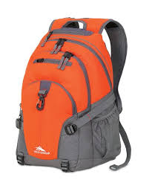
Bookbag
Pencils with erasers
Pencil Box or Bag—to contain all writing utensils
1 pack glue sticks
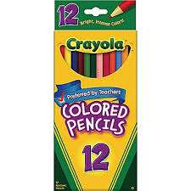
4 Spiral Notebooks
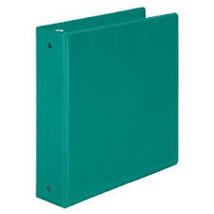
2 2-Pocket folders
Crayons
Colored pencils
Rain Jacket or an Umbrella

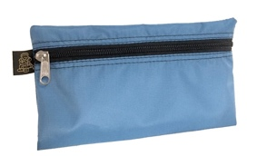
Middle (6th-8th grades):
Bookbag
Pencils with erasers
Lined notebook paper
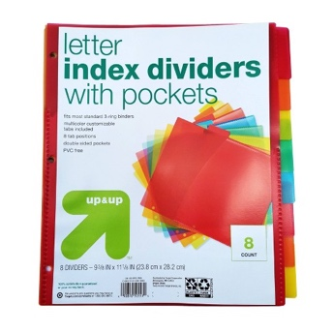
2-inch binder with tab dividers
Pencil box or bag (for any writing utensils)
Highlighters
Water bottles
Pair of scissors (needs to fit their hand size)
Glue sticks
Small sized umbrella

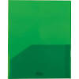
High School (9th-12th grades):
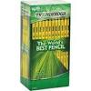
Book Bag
3 2-inch 3-Ring Binders
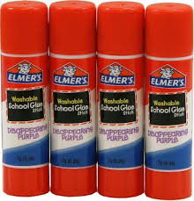
3 packs of 5-Tab Dividers
College rule loose leaf notebook paper
2 packs of Graph Paper
Highlighters
1 Composition notebook
USB thumb drive for MacBook
2 packs of Index Cards
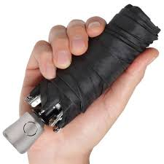
1 pack Colored Pencils
2 packs of #2 Pencils
1 pack Black or Blue Ink Pens
4 Pocket Folders

