APH Census

The APH Annual Census of Persons who are Blind or Visually Impaired occurs once a year, starting the first Monday in January. The State Vision Consultant will send a notice each year when the Census is active on the website, indicating that you may begin updating and adding new students. This notice will also include the deadline for updating/adding records, which usually falls in the first week of March.

To access the Annual Census, log in to the IRC website and click on the “Administration” link on the left-hand navigation pane. Please note this option will only be available during Open Census and only if you are registered as an APH Census Designee for your district. Please call or email the IRC at 864-577-7731 or IRC@scsdb.org to be registered as an APH Census Designee.
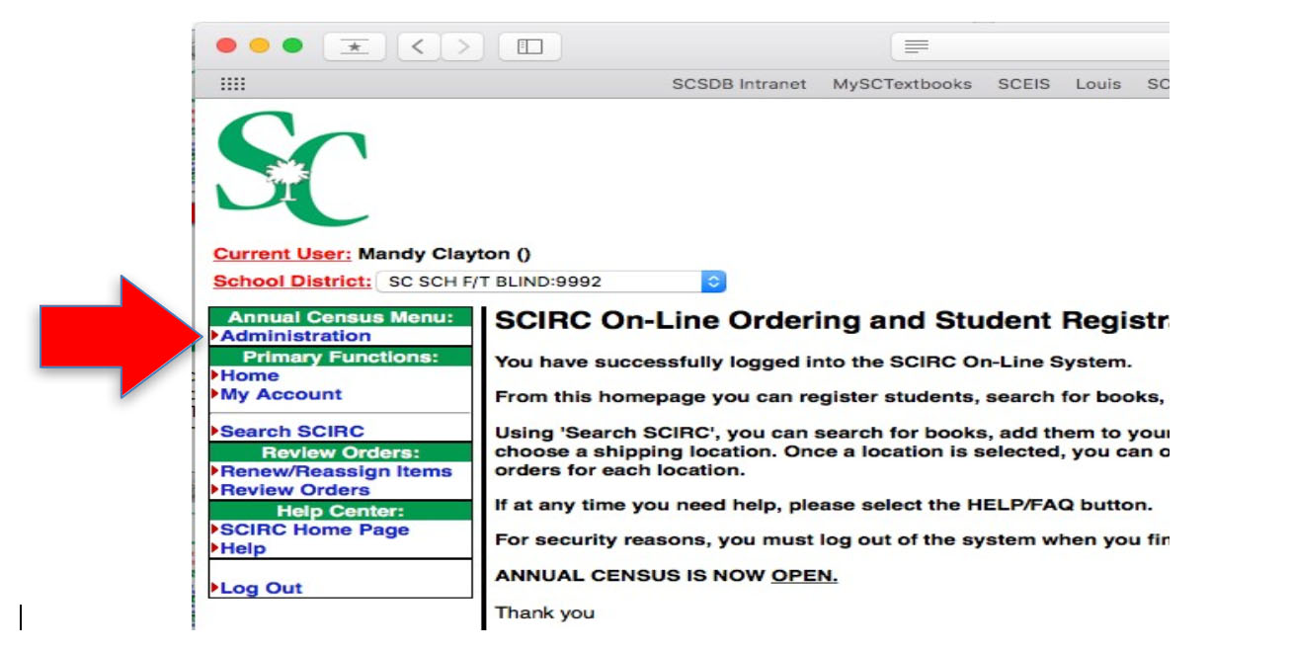
Pro Tip: Before you start editing your records, it will be helpful to have your student information readily available. This includes any eye reports, IEP reports and all general student information.
All information for student records should be based on the student’s status on the first Monday in January. Please only register/edit students who were on your caseload at that time.
Once you are in the Annual Census Administration section, please click on the “View Students” button.
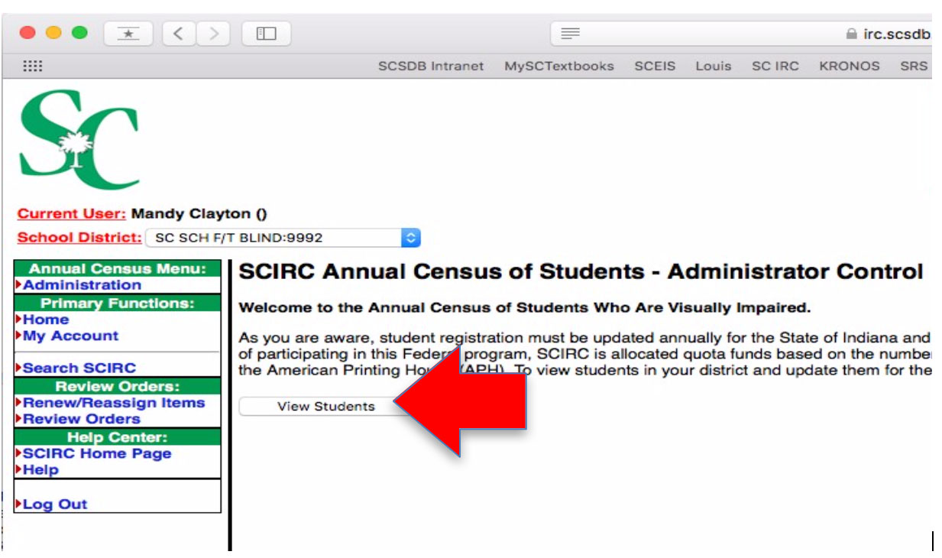
If you are an APH Census Designee for more than one district, each district will be listed on the next screen. Select the district you wish to edit; the student list for that district will open and you may begin editing, adding or deleting records.
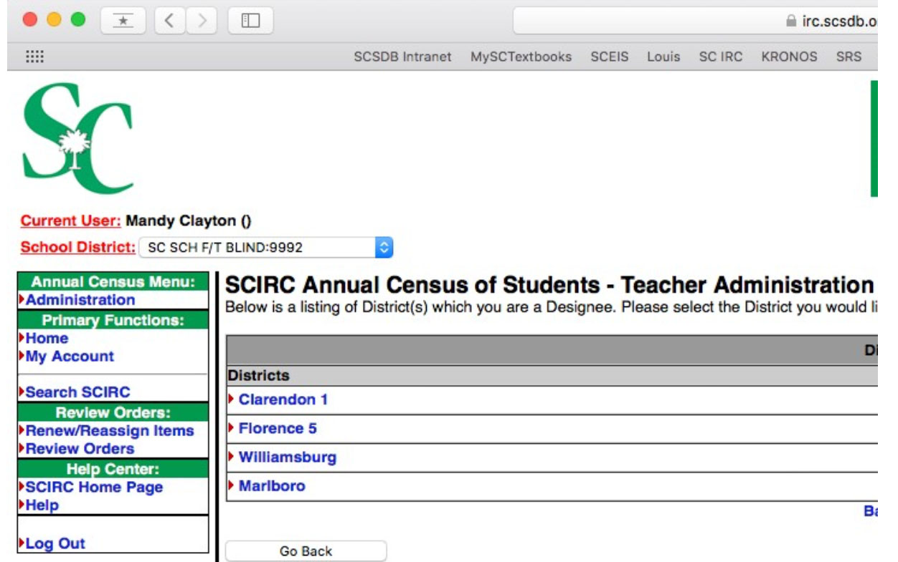
Updating Records on the Census

Once you have entered the “Teacher Administration” portion of the APH Census, records that need to be updated for your district will appear in the “Incomplete Student List.”

Only students currently registered for the APH Census or the Low Vision list in your district will appear on the Incomplete Student List. If there is a student you believe is registered in another district that you were serving on the first Monday in January of the current year, please call or email the IRC at 864-577-7731 or IRC@scsdb.org and we will update the record so it appears on your list. DO NOT add the student as new if you believe this is the case.

If you are in a district with multiple TVI’s, records for all students registered for the APH Census or Low Vision List for your district will appear on the district’s list. Please update all records of students for whom you are responsible.

As you edit current students’ records, they will move from the “Incomplete Student List” to the “End of Year Student Edits” list. Your district’s census is not complete until all records have been removed from the “Incomplete Student List.”

Pro Tip: You may only edit a student’s record once. If you are unsure of information for a particular student, do not submit the updates until you have all the information correct to the best of your knowledge. If you submit a record in error, call or email the IRC at 864-577-7731 or IRC@scsdb.org and we will unlock the record for editing.
To update records for students currently on the census, click the “update” button next to the student name you wish to edit on the list of students on the “Incomplete Student List.”
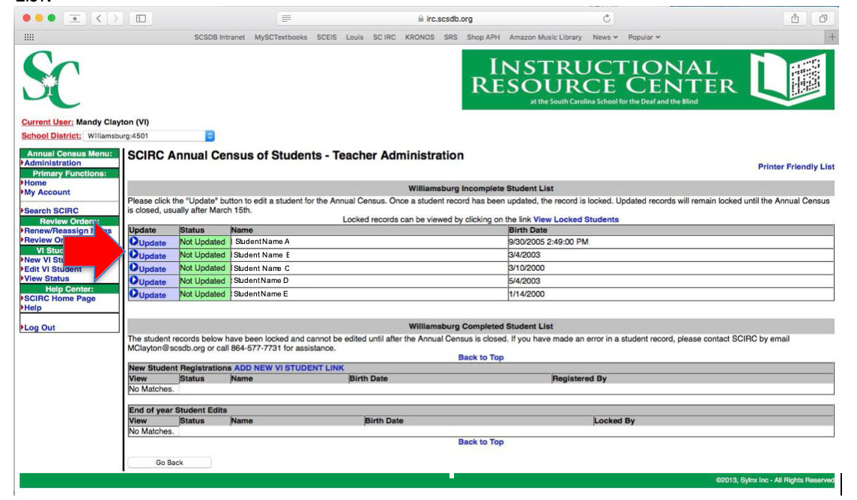
Once you have selected the student you wish to edit, the student’s current information will appear in an editable form.

Any asterisked items are required information. Please make sure you have all pertinent information before you begin filling out the form.

Update any information that has changed, check the “I agree” box at the bottom of the form and click the “Continue” button.
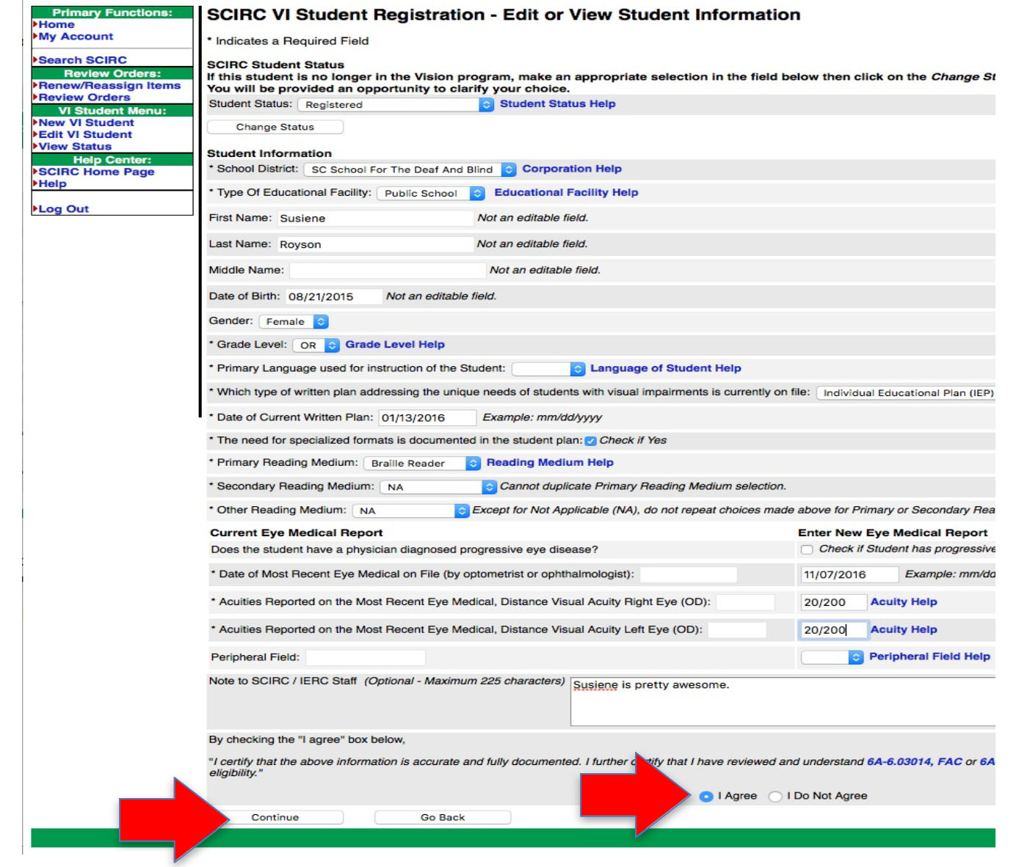
Pro Tip: Under the acuities section, you must enter the “new” acuities in the right- side boxes. The left-side boxes are for eye reports currently on file with the IRC, but will appear blank if the IRC does not have acuities on file.
After you click the “Continue” button, all errors on the form (if any) will appear on a pop-up window. Click the “Cancel” button, correct the errors and resubmit the form until all errors clear. If the system is misidentifying an error, click “OK” to bypass the error.
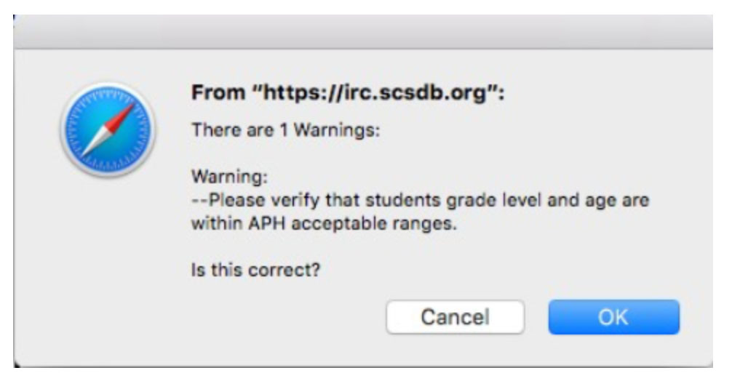
If you have no errors, please review the student record on the next screen and then click the “Submit” button at the bottom of the record. To correct any errors, click the “Go Back” button.
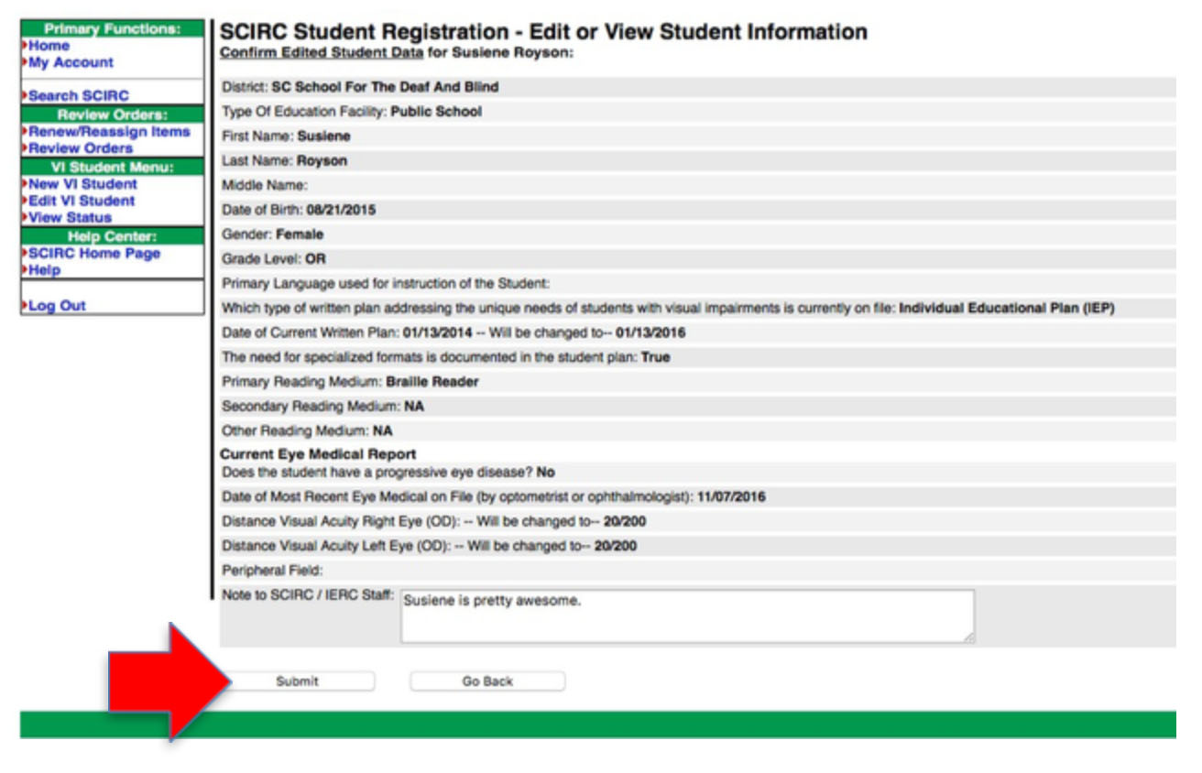

Below is a list of the fields on the form and a brief description. If you need additional help, please call or email the IRC at 864-577-7731 or IRC@scsdb.org.

School Corporation: District where the student is currently being served, chosen from the drop-down list. If you are serving a charter or virtual school student, please call or email the IRC at 864.577.7731 or IRC@scsdb.org to have that “district” added to your list.

Type of Educational Facility: Choose one option from the drop-down list. Charter and Virtual Schools are considered “public.”

First Name: Legal first name of student. Please do not use punctuation or nicknames.

Last Name: Legal last name of student. Please do not use punctuation.

Middle Name: Legal middle name of student. Not required.

Date of Birth: Student’s date of birth. Must be in mm/dd/yyyy form.

Gender: Please select an option from the drop-down list.

Grade Level: Please select an option from the drop-down list.

- IP Infants: (APH Federal Quota Registration only): Children of preschool age served by infant programs (Birth to age three [3]).
- PS (Pre-K) Preschool Students: Children of preschool age served by preschool programs.
- KG Kindergarten Students: Children enrolled in kindergarten classes.
- 01-12 Students of School Age: As determined by state law, in regular academic grades 1 through 12. Select specific grade placement.
- AN Academic Non-graded: Students of school age, as determined by state law, who are working to establish grade placement in an academic program (e.g., students who are working to acquire skills necessary for placement in regular grades).
- FC Functional Curriculum: Students in Grades 01-12 working toward a graduation certificate or non-traditional diploma.
- TR Transition: Students of school age, as determined by state law, in secondary instructional programs designed to supplement the traditional curriculum.
- OR Other Registrants: Students of school age, as determined by state law, who do not fall into any of the above placements (e.g., students enrolled in classes for nonacademic students).
- AD Adult Students: Adults above school age, as determined by state law, in educational programs of less than college level (Note requirement of at least 20 hours instructional programming per week).
Primary Language used for instruction of the Student: Please select an option from the drop- down list.
Written Plan: Student must have a written plan (IEP or 504) on file with the district to be eligible for the Census. Please select an option from the drop-down list.

The need for specialized formats…: The written plan must include the need for specialized formats to be eligible for large print or braille textbooks. Please check “yes” if applicable.

Primary Reading Medium: The method of obtaining information most used by the student. Please select an option from the drop-down list.
- V Visual Readers: Students primarily using print in their studies
- B Braille Readers: Students primarily using braille in their studies
- A Auditory Readers: Students primarily using a reader or auditory materials in their studies
- P Pre-readers: All infants and preschoolers; students working on or toward a readiness level; older students with reading potential
- N Non-readers: Non-reading students; students who show no reading potential; students who do not fall into any of the above categories

Secondary Reading Medium: An alternative method of obtaining information used by the student. Must not duplicate or contradict Primary Reading Medium. Please select an option from the drop-down list.

Other Reading Medium: An alternative method of obtaining information used by the student. Must not duplicate or contradict Primary or Secondary Reading Medium (except for NA). Please select an option from the drop-down list.

Progressive Eye Disease: Check “yes” if the student has a physician-diagnosed progressive eye disease. If no, leave blank.

Date of Most Recent Eye Medical on File: Date listed on student’s current eye medical report on file with district. Must be in mm/dd/yyyy form. Please note that a current eye medical report must be on file in the district’s special education office. Please do not send eye medical reports to the IRC.

Acuities…Right/Left Eye: Best corrected vision in each eye of the student.
20/xxx Distance Vision with maximum correction using the Snellen Chart (e.g., 20/70, 20/200 or 20/400)
- VF Visual Field: Restricted field of 20 degrees or less (e.g., VF 20, VF 6)
- CF Counts Fingers: Should be used only when an eye specialist finds it is not possible to obtain an acuity using the Snellen Chart.
- FDB Functions at the Definition of Blindness: Should be used when visual functioning is reduced by a brain injury or dysfunction and visual acuity is not possible. To determine using the Snellen Chart. To qualify for APH Federal Quota dollars, the students must meet the legal definition of blindness.
HM Hand Movements: Should be used only when an eye specialist finds it is not possible to obtain an acuity using the Snellen Chart
- OP Object Perception
- LP Light Perception
- NIL Totally Blind

Peripheral Field: Not required, unless the student has a restricted visual field of 20 degrees or less. Enter that information (e.g. VF 20, VF 6) if provided by the eye specialist. This information is essential if either acuity is better than 20/70. If the medical eye report does not indicate that the peripheral fields are restricted, leave this section blank.
Note to SCIRC: Any additional information the SCIRC may need about a student. If the student is a twin, triplet, etc. with another student on your caseload, please note that information here, along with the sibling’s name(s).
Adding New Students to the Census

To add a new student to the APH Census during open enrollment, click on the “Add New VI student Link” on the “SCIRC Annual Census of Students - Teacher Administration” page.
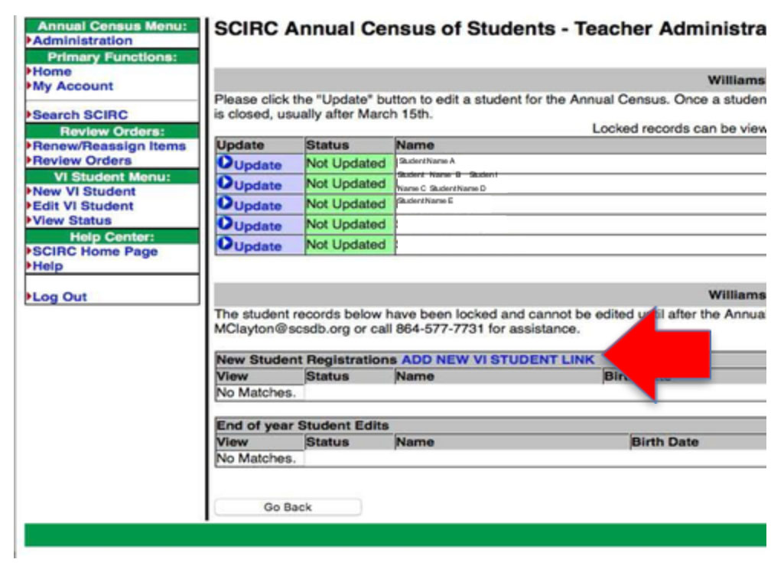
Read the information on the next screen, then click “I agree” to open a blank, fillable online form.
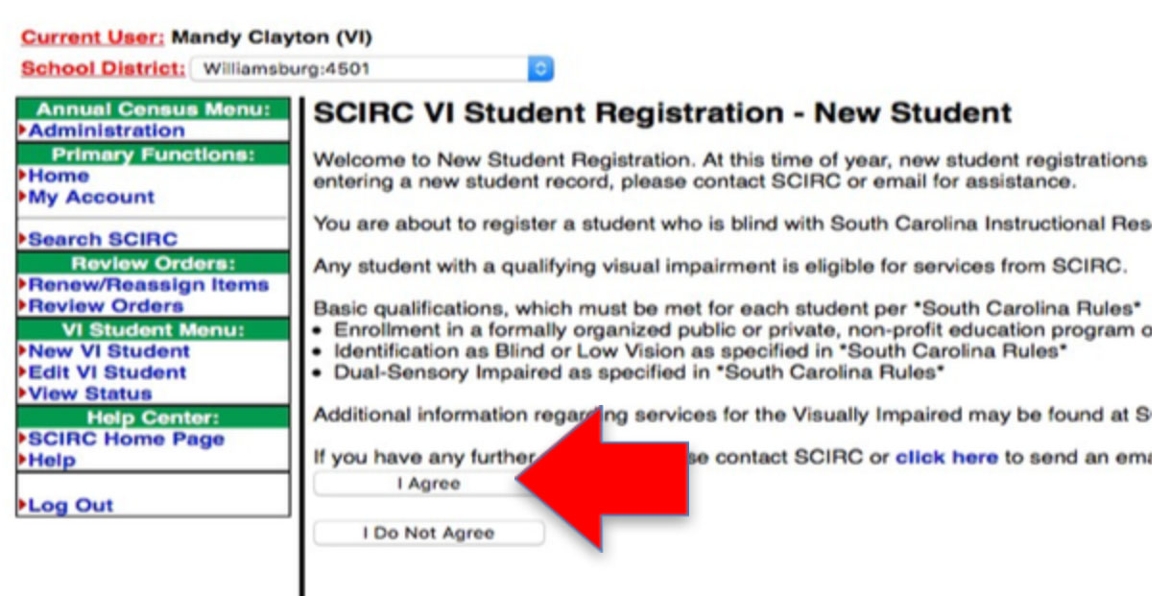
Any asterisked items are required information. Please make sure you have all pertinent information before you begin filling out the form.

When you have completed the form, select the “I agree” radio button at the bottom of the form, then click the “Continue” button.
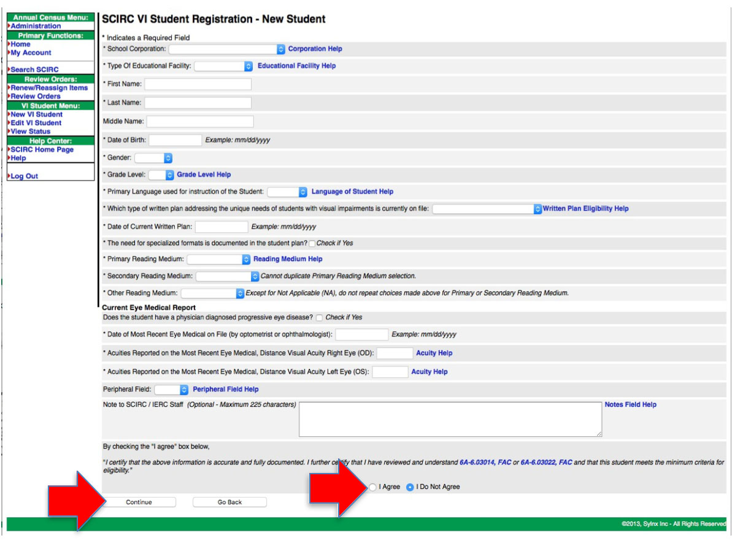

After you click the “Continue” button, all errors on the form (if any) will appear on a pop-up window. Click the “Cancel” button, correct the errors and resubmit the form until all errors clear. If the system is misidentifying an error, click “OK” to bypass the error. If you get an error message notifying you that the student may already be on the APH Census, do not submit the form and please call or email the IRC at 864.577.7731 or IRC@scsdb.org.
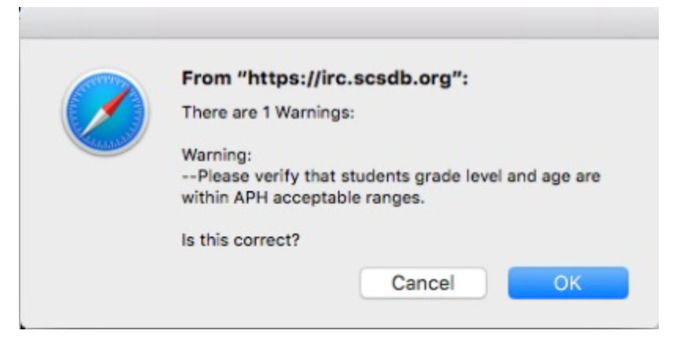
If you have no errors, please review the student record on the next screen, and then click the “Submit” button at the bottom of the record. To correct any errors, click the “Go back” button.
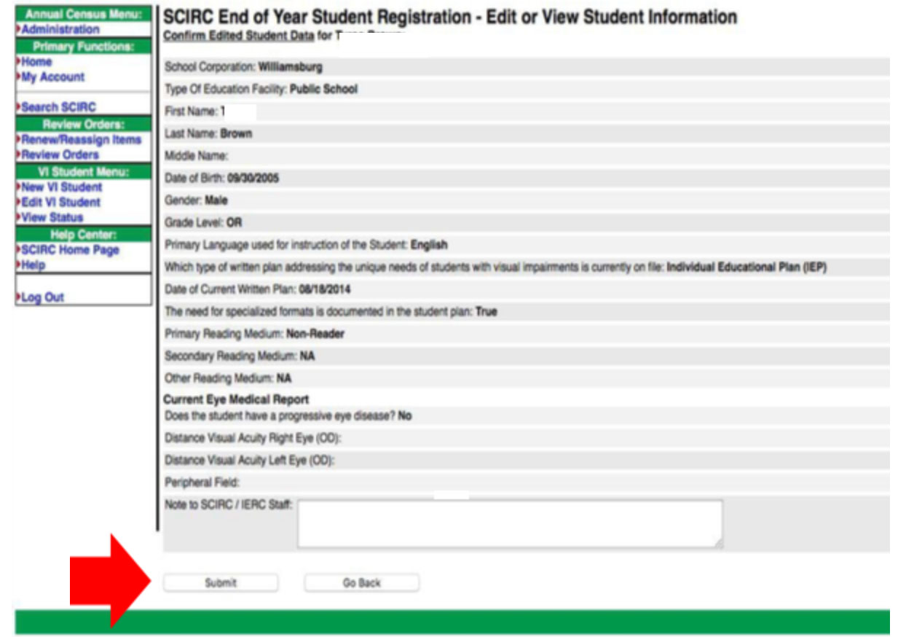

Pro Tip: Newly added students will not show up on your list until the IRC approves the addition and assigns a student number.

Below is a list of the fields on the form and a brief description. If you need additional help, please call or email the IRC at 864.577.7731 or IRC@scsdb.org.

School Corporation: District where the student is currently being served, chosen from the drop-down list. If you are serving a charter or virtual school student, please call or email the IRC at 864.577.7731 or IRC@scsdb.org to have that “district” added to your list.

Type of Educational Facility: Choose one option from the drop-down list. Charter and Virtual Schools are considered “public.”
First Name: Legal first name of student. Please do not use punctuation or nicknames.
Last Name: Legal last name of student. Please do not use punctuation.
Middle Name: Legal middle name of student. Not required.

Date of Birth: Student’s date of birth. Must be in mm/dd/yyyy form.

Gender: Please select an option from the drop-down list.

Grade Level: Please select an option from the drop-down list.
- IP Infants (APH Federal Quota Registration only): Children of preschool age served by infant programs (Birth to age three [3]).
- PS (Pre-K) Preschool Students: Children of preschool age served by preschool programs.
- KG Kindergarten Students: Children enrolled in kindergarten classes.
- 01-12 Students of School Age: As determined by state law, in regular academic grades 1 through 12. Select specific grade placement.
- AN Academic Non-graded: Students of school age, as determined by state law, who are working to establish grade placement in an academic program (e.g., students who are working to acquire skills necessary for placement in regular grades).
- FC Functional Curriculum: Students in Grades 01-12 working toward a graduation certificate or non-traditional diploma.
- TR Transition: Students of school age, as determined by state law, in secondary instructional programs designed to supplement the traditional curriculum.
- OR Other Registrants: Students of school age, as determined by state law, who do not fall into any of the above placements (e.g., students enrolled in classes for nonacademic students).
- AD Adult Students: Adults above school age, as determined by state law, in educational programs of less than college level (Note requirement of at least 20 hours instructional programming per week).

Primary Language used for instruction of the Student: Please select an option from the drop- down list.

Written Plan: Student must have a written plan (IEP or 504) on file with the district to be eligible for the Census. Please select an option from the drop-down list.

The need for specialized formats…: The written plan must include the need for specialized formats to be eligible for large print or braille textbooks. Please check “yes” if applicable.

Primary Reading Medium: The method of obtaining information most used by the student. Please select an option from the drop-down list.
- V Visual Readers: Students primarily using print in their studies
- B Braille Readers: Students primarily using braille in their studies
- A Auditory Readers: Students primarily using a reader or auditory materials in their studies
P Pre-readers: All infants and preschoolers; students working on or toward a readiness level; older students with reading potential
- N Non-readers: Non-reading students; students who show no reading potential; students who do not fall into any of the above categories

Secondary Reading Medium: An alternative method of obtaining information used by the student. Must not duplicate or contradict Primary Reading Medium. Please select an option from the drop-down list.

Other Reading Medium: An alternative method of obtaining information used by the student. Must not duplicate or contradict Primary or Secondary Reading Medium (except for NA). Please select an option from the drop-down list.

Progressive Eye Disease: Check “yes” if the student has a physician-diagnosed progressive eye disease. If no, leave blank.

Date of Most Recent Eye Medical on File: Date listed on student’s current eye medical report on file with district. Must be in mm/dd/yyyy form. Please note that a current eye medical report must be on file in the district’s special education office. Please do not send eye medical reports to the IRC.

Acuities…Right/Left Eye: Best corrected vision in each eye of the student.
- 20/xxx Distance Vision with maximum correction using the Snellen Chart (e.g., 20/70, 20/200 or 20/400)
- VF Visual Field: Restricted field of 20 degrees or less (e.g., VF 20, VF 6)
- CF Counts Fingers: Should be used only when an eye specialist finds it is not possible to obtain an acuity using the Snellen Chart.
- FDB Functions at the Definition of Blindness: Should be used when visual functioning is reduced by a brain injury or dysfunction and visual acuity is not possible to determine using the Snellen Chart. To qualify for APH Federal Quota dollars, the students must meet the legal definition of blindness.
- HM Hand Movements: Should be used only when an eye specialist finds it is not possible to obtain an acuity using the Snellen Chart
- OP Object Perception
- LP Light Perception
- NIL Totally Blind

Peripheral Field: Not required, unless the student has a restricted visual field of 20 degrees or less. Enter that information (e.g. VF 20, VF 6) if provided by the eye specialist. This information is essential if either acuity is better than 20/70. If the medical eye report does not indicate that the peripheral fields are restricted, leave this section blank.
Note to SCIRC: Any additional information the SCIRC may need about a student. If the student is a twin, triplet, etc. with another student on your caseload, please note that information here, along with the sibling’s name(s).

Deleting Students from the Census

To delete a student from your APH census, click the “update” button next to the student name you wish to delete on the list of students under “Incomplete Student List.”
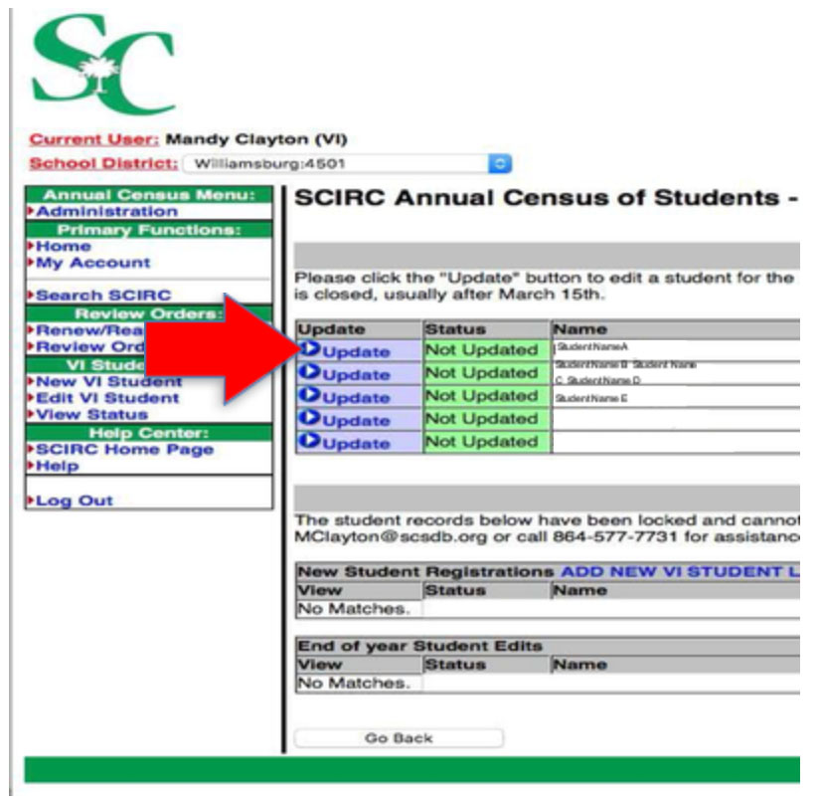
Once you have opened the student’s record, click the drop-down list next to “Student Status” and select “Graduated,” “Moved” or “Delete.” If you are unsure of the reason a student left your district, select “Delete.”
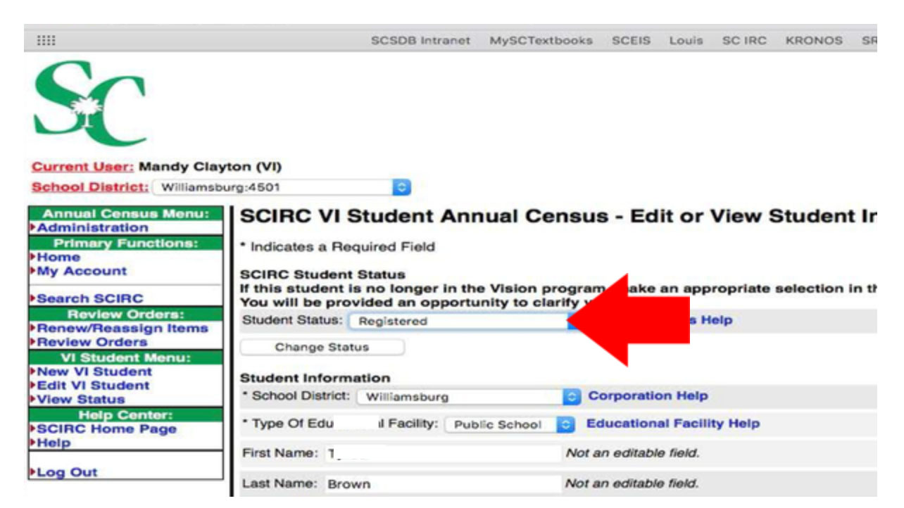
After you have select the correct status, click the “Change Status” button below the “Student Status” drop-down menu.
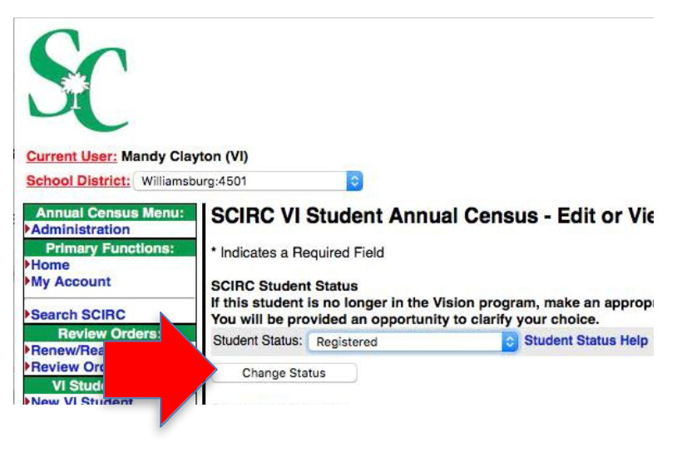

Read and confirm the information on the next screen, then click the “Submit” button.
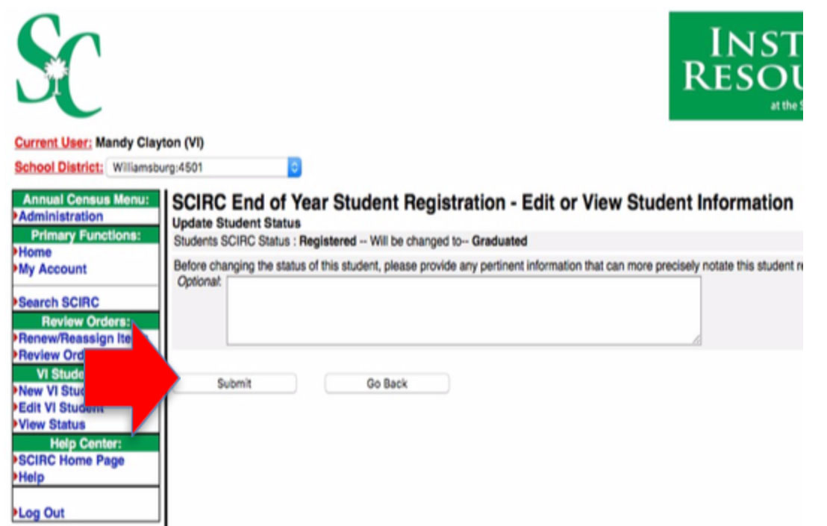

As you delete current students’ records, they will move from the “Incomplete Student List” to the “End of Year Student Edits” list. Your district’s census is not complete until all records have been removed from the “Incomplete Student List.”

Registering Low Vision Students

The South Carolina Department of Education requires that in addition to Legally Blind students registered for the APH Census, all Low Vision students who are served by your district must be registered with the IRC. Please follow directions for adding, deleting and editing Census records to register your Low Vision students.

Pro Tip: If you are registering a low vision student for whom you do not have an eye report, use 00/00 as both left and right acuities to assure they will not be added to the APH Census.

Adding/editing Student Records when APH Census is Closed

You may add or edit a student at any time of the year if needed. Instead of using the APH Census Administration link, click on “New VI Student” to add or “Edit VI Student” to edit records from the left-hand navigation menu. Follow the instructions for adding or editing a student found in the APH Census section of this manual beginning on page 8.
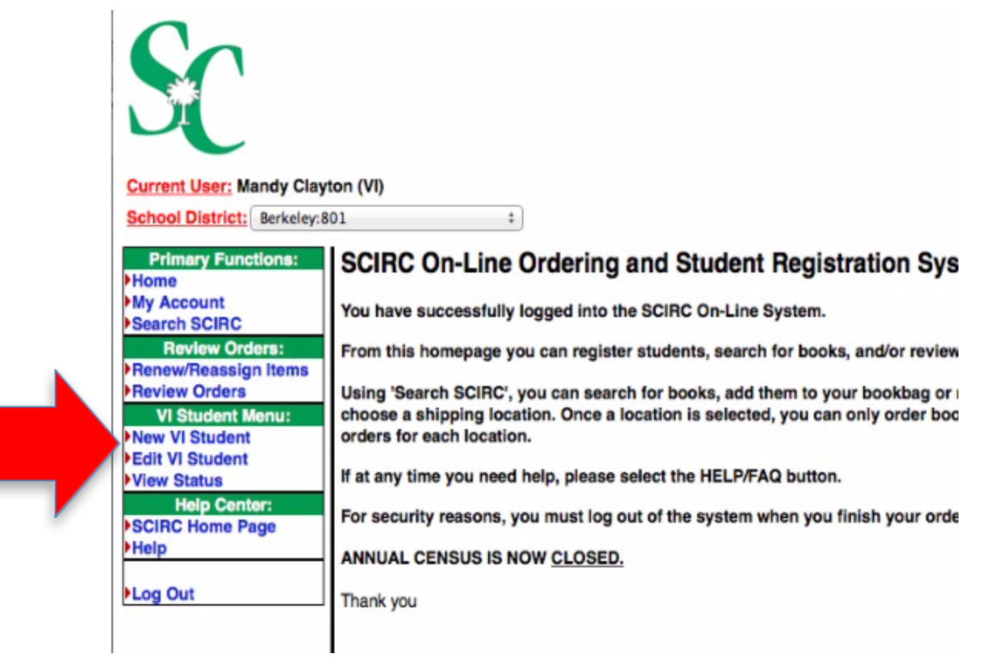
If you will immediately need a student number for ordering purposes, please call or email the IRC at 864-577-7731 or IRC@scsdb.org to let us know you have added a new student (no student information required for email).

