Allergy Awareness at Pearl Creek

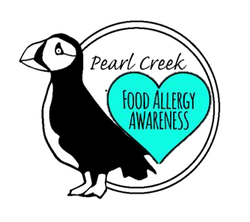

As an Inspired, Compassionate and Involved community, we are committed to increasing our awareness and response to children and families affected by food and environmental allergies. Please look for our Allergy Aware Proud Puffin during school and community events to find food options and allergy safe alternatives.

