To access Seesaw through ClassLink:

Download the ClassLink app or access it through an internet browser at the following web address: https://launchpad.classlink.com/login
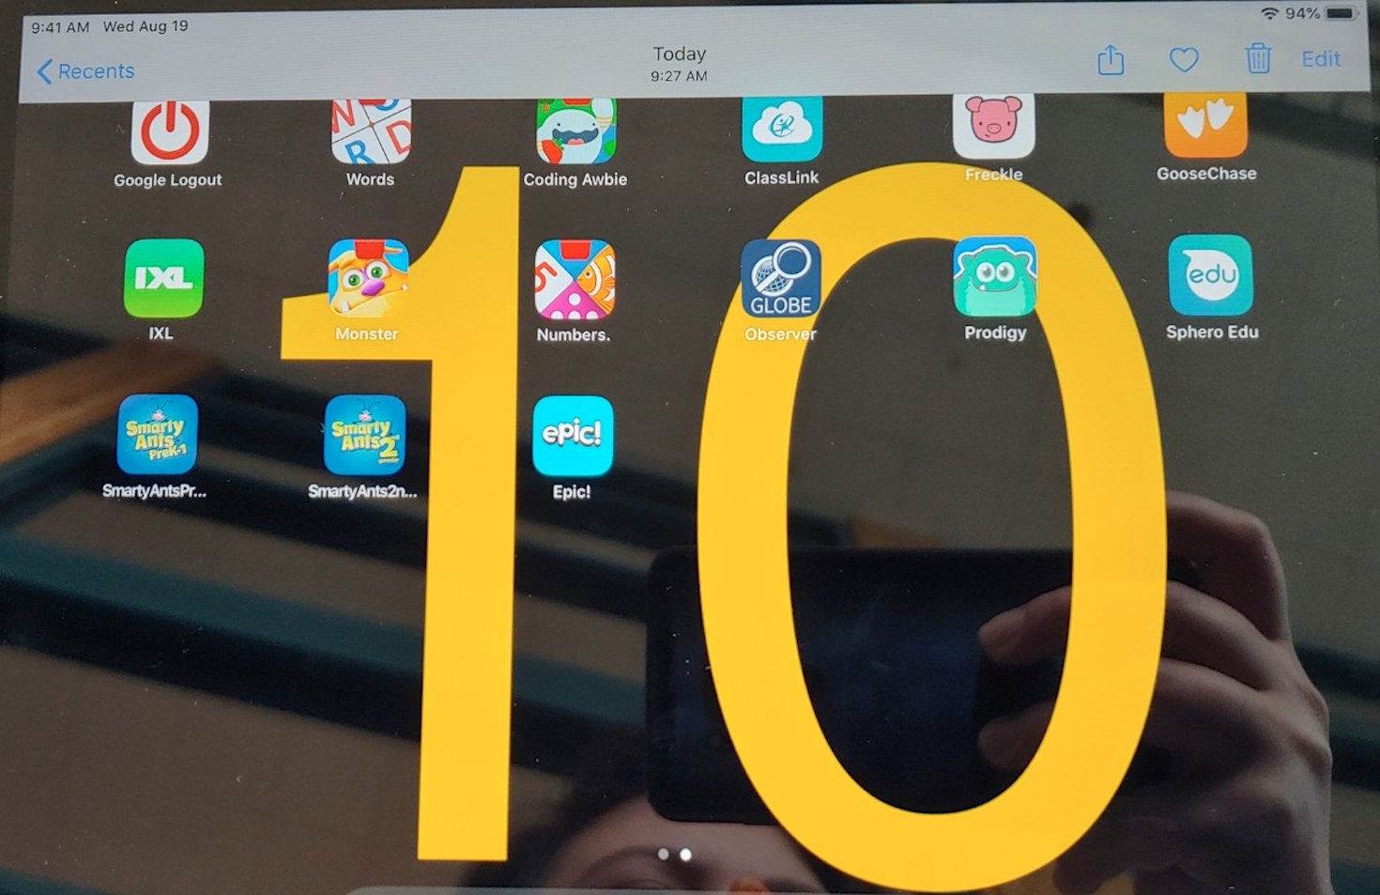

Choose the option, “sign in using your Google account.” Your child’s google account will be their s#@student.k12northstar.org. The login credentials are in this email.
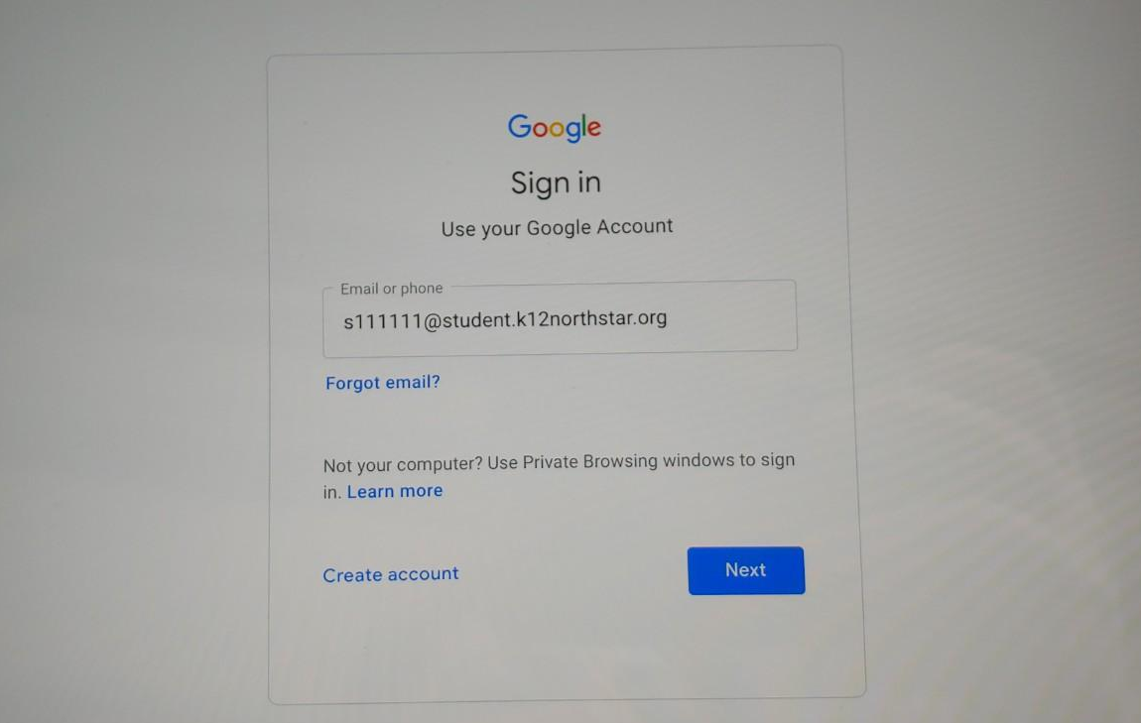

Once in ClassLink, select the Seesaw app. You may be prompted to download the Seesaw app.

Login to Seesaw as a student using the login credentials provided. A separate email was sent inviting you to join “Seesaw for Families” for you and me to communicate. As a parent or guardian, you can message me or your child through text or voice clips. You can also view your child’s work and send them comments!
