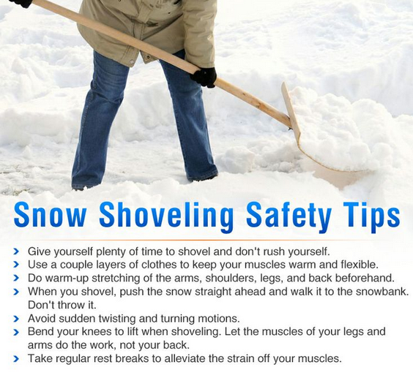
For additional safety information on snow shoveling please visit the following link:
http://www.nsc.org/nscdocuments_corporate/safetyobservancesdocuments/snow-shoveling.pdf

