Mrs. E’s Spelling Menu’s for the Year by Month
(September to June)

Choose 3 to complete a week in your spelling book (if applicable) and hand in on Friday. Keep the menu for the month.



ss

Rainbow writes  Write 10 of your words with a crayon or colored pencil. Then trace the word at least two more times with a new color each time. | Fancy Fonts  Write 10 of your words with fancy letters or type them on the computer with a different font and print. | Around and Around!  Start writing your words in a large circle. Continue until you reach the middle of the circle.
Get Dirty!  Use a cookie tray to trace words in salt (Q-tips work well) or shaving cream to write letters. | Practice Test  Have an adult give you a practice test at home. Be sure the test is checked and signed by the adult. | Red, Write, and Blue!  Write 10 of your spelling words with the consonants in blue and the vowels in red.
Spelling Puzzles  Go to the website:  http://www.puzzlemaker.com  And make a word search using your spelling  words. Once you are done, print it out and  complete it. | Flash Cards  Make flash cards for words you need to practice. Draw a picture of the word on one side and spell the word correctly on the other side. Use the cards to practice. | Amazing Sentences  Write a sentence for 3 spelling words with a capitol letter and period. Underline the spelling word(s) in each sentence.


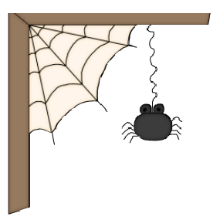


Red, Write, and Blue!  Write 10 of your spelling words with the consonants in blue and the vowels in red. | Fancy Fonts  Write 10 of your words with fancy letters or type them on the computer with a different font and print. | Flash Cards  Make flash cards for words you need to practice. Draw a picture of the word on one side and spell the word correctly on the other side. Use the cards to practice.
Hit the street…  Use sidewalk chalk to write your spelling words outside | Practice Test  Have an adult give you a practice test at home. Be sure the test is checked and signed by the adult. | ABC Order  Write 5 of your spelling words in ABC order.
Pyramid Writing  Write 5 of your words in pyramid form.  f fo  foo food | Around and Around!  Start writing your words in a large circle. Continue until you reach the middle of the circle. | Amazing Sentences  Write a sentence for 3 spelling words with a capitol letter and period. Underline the spelling word(s) in each sentence.




Spelling Puzzles  Go to the website:  http://www.puzzlemaker.com  And make a word search using your spelling  words. Once you are done, print it out and  complete it. | Pyramid Writing  Write your words in pyramid form.  f fo  foo  food | Flash Cards  Make flash cards for words you need to practice. Draw a picture of the word on one side and spell the word correctly on the other side. Use the cards to practice.
Write all words 3x each | Practice Test  Have an adult give you a practice test at home. Be sure the test is checked and signed by the adult. | Rainbow write  Write your words with a crayon or colored pencil. Then trace the word at least two more times with a new color each time.
Fancy Fonts  Write each of your words with fancy letters or type them on the computer with a different font and print. | Around and Around!  Start writing your words in a large circle. Continue until you reach the middle of the circle. | Amazing Sentences  Write a sentence for 5 spelling words with a capitol letter and period. Underline the spelling word(s) in each sentence.

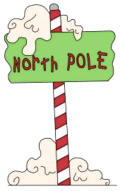
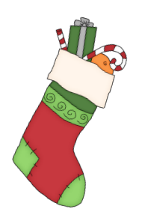
Spelling Puzzles  Synonyms  Choose 10 spelling words. Next to each word, write a word that means the same thing. | Pyramid Writing  Write your words in pyramid form.  f fo  foo food | Flash Cards  Make flash cards for your  words. Draw a picture of the word on one side and spell the word correctly on the other side. Use the cards to practice.
Rhyme Time  Choose 10 words to write. Next to each word, write a rhyming word. (Parents: try to help your child think of rhyming words that follow the same spelling pattern.) | Practice Test  Have an adult give you a practice test at home. Be sure the test is checked and signed by the adult. | ABC Order  Write 10 of your spelling words in ABC order.
Fancy Fonts  Write each of your words with fancy letters or type them on the computer with a different font and print. | Practice Test  You give a sibling or friend a practice test at home.  Include it 😉 | Amazing Sentences  Write a sentence for 8 spelling words with a capitol letter and period. Underline the spelling word(s) in each sentence.




Practice Test  You give a sibling or friend  a practice test at home. | Spelling Puzzles  Go to the website:  http://www.puzzlemaker.com  And make a word search using your spelling  words. Once you are done, print it out and  complete it. | Rhyme Time  Choose 10 words to write. Next to each word, write a rhyming word. (Parents: try to help your child  think of rhyming words that follow the same spelling pattern.)
Flash Cards or Get Dirty!  Make flash cards for your words. Draw a picture of the word on one side and spell the word correctly on the other side. Or practice tracing words in rice. | Practice Test  Have an adult give you a practice test at home. Be sure the test is checked and signed by the adult. | Around and Around!  Start writing your words in a large circle. Continue until you reach the middle of the circle.
Fancy Fonts  Write each of your words with fancy letters or type them on the computer with a different font and print. | ABC Order  Write ALL of your spelling words in ABC order | Amazing Sentences  Write a sentence for 5 spelling words with a capitol letter and period. Underline the spelling word(s) in each sentence.




ABC Order  Write 10 of your spelling words in ABC order. | Spelling Puzzles  Go to the website:  http://www.puzzlemaker.com  And make a word search using your spelling  words. Once you are done, print it out and  complete it. | Rhyme Time  Choose 10 words to write. Next to each word, write a rhyming word. (Parents: try to help your child  think of rhyming words that follow the same spelling pattern.)
Get Dirty!  Use a cookie tray to trace letters in salt (Q-tips work well) or shaving cream to write  letters in the bath tub. | Write your words  3x each | Around and Around!  Start writing your words in a large circle. Continue until you reach the middle of the circle.
Fancy Fonts  Write each of your words with fancy letters or type them on the computer with a different font and print. | Hidden Picture  Draw a picture and try to hide  10 of your spelling words in  the picture. | Amazing Sentences  Write a sentence for 5 spelling words with a capitol letter and period. Underline the spelling word(s) in each sentence.





Hidden Picture  Draw a picture and try to hide  10 of your spelling words in  the picture. | Fancy Fonts  Write each of your words with fancy letters or type them on the computer with a different font and print. | Rhyme Time  Choose 10 words to write. Next to each word, write a rhyming word. (Parents: try to help your child think of rhyming words that follow the same spelling pattern.)
Write words  3x each | Practice Test  Have an adult give you a practice test at home. Be sure the test is checked and signed by the adult. | Spelling Puzzles  Go to the website:  http://www.puzzlemaker.com  And make a word search using your spelling  words. Once you are done, print it out and  complete it.
Amazing Sentences  Write a sentence for 10 spelling words with a capitol letter and period or question mark. Underline the spelling word(s) in each sentence. | ABC Order  Choose 10 spelling words to write in  ABC order. | Adult Practice Test  Give an adult a test using your spelling words. Correct any mistakes. (Adults: make a few mistakes for extra practice!)

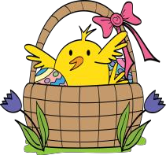


Red, White and Blue!  Write 10 spelling words with the consonants in blue and the vowels in red. | Fancy Fonts  Write 10 spelling words with fancy letters or type them on the computer with a different font and print. | Hit the street…  Use sidewalk chalk to write your spelling words outside
ABC Order  Choose 10 words and write them in ABC order. | Practice Test  Have an adult give you a practice test at home. Be sure the test is checked and signed by the adult. | Synonyms  Choose 10 spelling words. Next to each word, write a word that means the same thing.
Amazing Story  Write a story using as many of your spelling words as possible. Underline the words you use. | Spelling Puzzles  Go to the website:  http://www.puzzlemaker.com  And make a word search using your spelling words. Once you are done, print it out and  complete it. | Adult Practice Test  Give an adult a test using your spelling words. Correct any mistakes. (Adults: make a few mistakes for extra practice!)



Around and Around!  Start writing your words in a large circle. Continue until you reach the middle of the circle. | Fancy Fonts  Write 10 of your words with fancy letters or type them on the computer with a different font and print. | Hidden Picture  Draw a picture and try to hide  10 of your spelling words in  the picture.
Red, Write, and Blue!  Write 10 of your spelling words with the consonants in blue and the vowels in red. | ABC Order  Write 10 of your spelling words in ABC order. | Amazing Story  Write a story using as many of your spelling words as possible. Underline the words you use.
Antonyms  Choose 10 spelling words. Next to each word, write a word that means the opposite. | Spelling Puzzles  Go to the website:  http://www.puzzlemaker.com  And make a word search using your spelling  words. Once you are done, print it out and  complete it. | Adult Practice Test  Give an adult a test using your spelling words. Correct any mistakes. (Adults: make a few mistakes  for extra practice!)


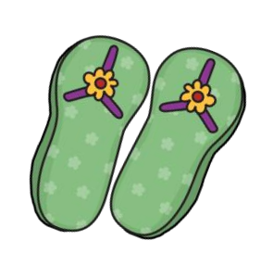

Hit the street…  Use sidewalk chalk to write your spelling words outside in a circle | Amazing Story  Write a story using half  of your spelling words as possible. Underline the words you use. | Synonyms  Choose 5 spelling words. Next to each word, write a word that means the same thing.
Red, Write, and Blue!  Write 10 of your spelling words with the consonants in blue and the vowels in red. | Spelling Puzzles  Go to the website:  http://www.puzzlemaker.com  And make a word search using your spelling  words. Once you are done, print it out and  complete it. | Fancy Fonts  Write 10 of your words with fancy letters or type them on the computer with a different font and print.
Write your spelling words  3x each | ABC Order  Write 10 of your spelling words in ABC order. | Adult Practice Test  Give an adult a test using your spelling words. Correct any mistakes.!)

