Buckner Elementary School Council
Oldham County Schools
REGULAR CALLED MEETING
A G E N D A
https://meet.google.com/cfw-krai-wso

August 28, 2023
3:00 p.m.

- Call to Order

- Agenda Approval

- Approval of the Minutes from the July 3rd, 27th and August 1st and 7th special called meetings

- Principal’s Report
- Update on Enrollment and Budget Impact (Enclosure A)

- Council Action Items
  - Review/ Approve Review / Discuss SBDM Committee Assignments for the 23-24 school year (Enclosure B)

- Adjourn

Buckner Elementary School Council
Oldham County Schools
SPECIAL CALLED MEETING
Council Minutes

Principal’s Office
July 3, 2023
8:00 a.m.

Google Meet joining info
https://meet.google.com/rhi-kshs-sra
join by phone, dial +1 802-328-1855 and enter this PIN: 461 931 156#
The Buckner Elementary School Council advertised a special called meeting at the front of school. The meeting was held virtually. The following members were in attendance 1.Richard Parrott 2. Heather McDonald 3. Melissa Riggs 4. Julie Brown 5. Raine Rogers 6. Ryan Hamilton

- Call to Order

- The meeting was called to order at the 445th meeting at 8:07 a.m.

- Agenda Approval

- Approval of agenda by Mrs. Brown and then Mrs. Rogers

- Review/Approve Fundraising Requests (Enclosure A)

- Council reviewed and approved the fundraising request for the 23-24 school year.

- Enter Closed Session to Discuss Certified & Classified Personnel Selection per KRS 61.801 (1)(f)
- Upon returning from closed session the recommendation to hire Dylan Kopp to Bear Care was shared.

- Adjourn

- Having no further business, the council adjourned at 8:17 a.m.

Buckner Elementary School Council
Oldham County Schools
SPECIAL CALLED MEETING
Council Minutes

July 27th, 2023
8:00 a.m.
https://meet.google.com/mon-qgvn-ygp
Phone, +1 240-623-1185 and enter this PIN: 802 566 290#

The Buckner Elementary School Council advertised a special called meeting at the front of school. The meeting was held in the principal’s office. The following members were in attendance 1.Richard Parrott 2. Heather McDonald (Virtual) 3. Melissa Riggs(Virtual) 4. Julie Brown (Virtual) 5. Raine Rogers(Virtual) 6. Ryan Hamilton

- Call to Order
- Meeting was called to order at 8:07 a.m.

- Agenda Approval
- Sign of approval for the agenda. First by Mr. Hamilton and second by Ms. McDonald.

- Principal’s Report
- Update on Enrollment (Enclosure A)
- Mr. Parrott informed the council of the number of students enrolled at each grade level and the current number of teachers in each grade. He also shared the ratios. The council took the report under advisement.

- Council Action Items
  - Review/ Approve Emergency Management Plan for the 2023-2024 school year (Enclosure B)
- Ms. Rousos shared the safe schools plan with the council.
- The council approved the safe schools plan.

- Enter Closed Session to Discuss Certified & Classified Personnel Selection per KRS 61.801 (1)(f)
- Upon return from closed session Mr. Parrott shared that Mrs. Kristin Kazunas and Mrs. Kala Anderson were recommended for hire.

- Adjourn
With no further business the council adjourned at 8:26 a.m.
Record of Council Proceedings (Minutes)

Buckner Elementary School Council
Oldham County Schools
SPECIAL CALLED MEETING
A G E N D A

August 1st, 2023
8:15 a.m.
https://meet.google.com/hwm-wcsu-ixh
phone, dial +1 605-865-2195 and enter this PIN: 150 220 205#
The Buckner Elementary School Council advertised a special called meeting at the front of school. The meeting was held in the principal’s office. The following members were in attendance 1.Richard Parrott 2. Heather McDonald 3. Melissa Riggs 4. Julie Brown 5. Raine Rogers 6. Ryan Hamilton 7. Roderick Pack (Virtual) and 8. Devan Lindemier(Virtual).

- The meeting was called to order at 8:18 a.m., the 454 meeting of BES SBDM

- The council reviewed and approved the agenda. First motion by Mr. Hamilton and the seconded by Mrs. Rogers.

- Mr. Parrott informed the Council of the following personnel actions.

Recommendations:
The council was informed that Ann Marie Elwell resigned
Gabby Celebreeze and Terri Waller for Kindergarten Instructional aides.
Jean Hatfeild for ECS aide.

- Motion to adjourn the meeting at 8:24 a.m. Mr. Hamilton motioned to adjourn with Ms. McDonald to follow.

Buckner Elementary School Council
Oldham County Schools
SPECIAL CALLED MEETING
Council Minutes

August 7th, 2023
3:45 p.m.
https://meet.google.com/ieh-acrx-ymh
The Buckner Elementary School Council advertised a special called meeting at the front of school. The meeting was held in the principal’s office. The following members were in attendance 1.Richard Parrott 2. Heather McDonald 3. Melissa Riggs 4. Julie Brown 5. Raine Rogers 6. Ryan Hamilton (Virtual) 7. Roderick Pack

- Call to Order
- The meeting was called to order at the 445th meeting at 3:49 p.m.

- Agenda Approval
- Approval of agenda by Mrs. Riggs then Mrs. Rogers

- Council Action Items
  - Review/discuss and approve changes to staffing allocation. (Enclosure A)
- Council Reviewed and approved the reduction in staffing from 6 second grade teachers to 5. Council approved the ratio of 25:1.

  - Review/ Approve Review / Discuss “Your Duty Under the Law” and “Managing Public Records” (Enclosure B)
- Council reviewed Open Records and Open Meetings Act. Reviewed Duty Under Law and signed certificate of receipt.

  - Sign Student Free Speech and Religious Liberty Rights
- Council reviewed free speech and Religious Liberty Rights

  - Sign Code of Ethics

  - Review/ Approve Calendar of Meetings for the upcoming school year
(Enclosure C)
- Council reviewed the proposed dates for regular called meetings and approved meeting dates.

  - Review/ Approve Social Emotional Learning Teacher and additional interventionist positions. (Enclosure D)
- Council approved a part time instructional interventionist and part time SEL interventionist.

- Adjourn
- Having no further business, the council adjourned at 4:07 p.m.

Enclosure A
August 28, 2023

Buckner Elementary School Council
Oldham County Schools

CONCERN:

Review the current enrollment

DISCUSSION:

As of August 26th our current enrollment number is 658 enrolled. We are close to the projected enrollment given to us by the central office in the spring.

Grade | Total  Enrolled | # of teachers | # of students per teacher in the building | State  Cap-size
5th grade | 137 | 5 | 28:1 | 29
4th grade | 96 | 4 | 24:1 | 28
3rd grade | 115 | 5 | 23:1 | 24
2nd grade | 125 | 5 | 25:1 | 24
1st  grade | 90 | 4 | 23:1 | 24
Kinder-  garten | 95 | 4 | 24:1 | 24

RECOMMENDATION:
Take this report under advisement.

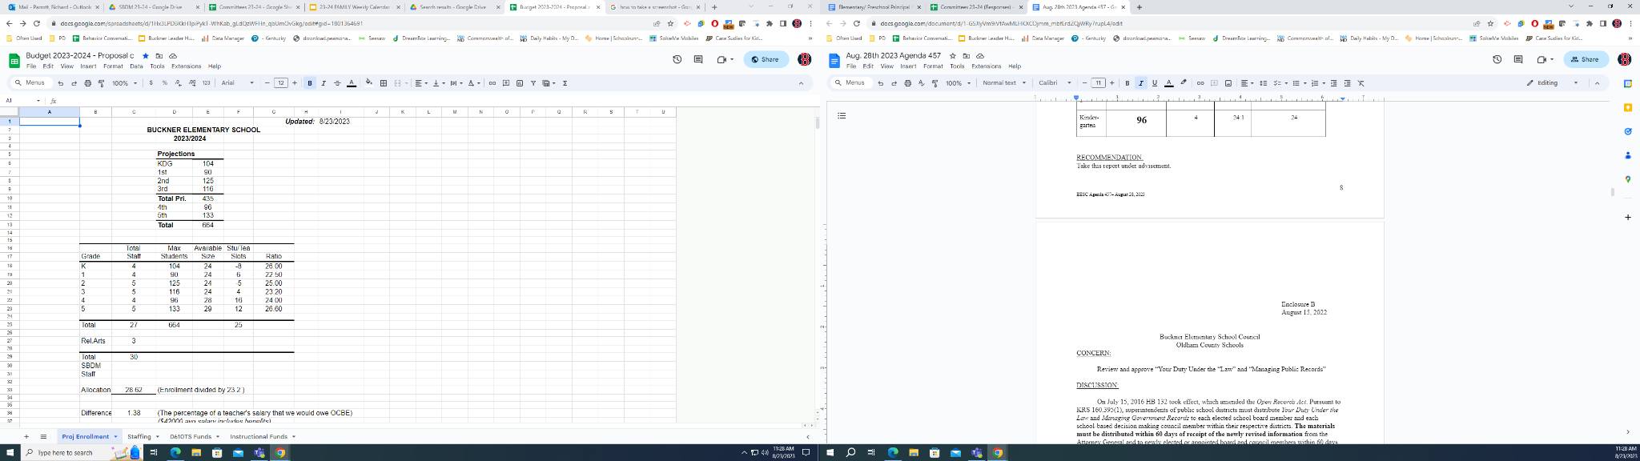

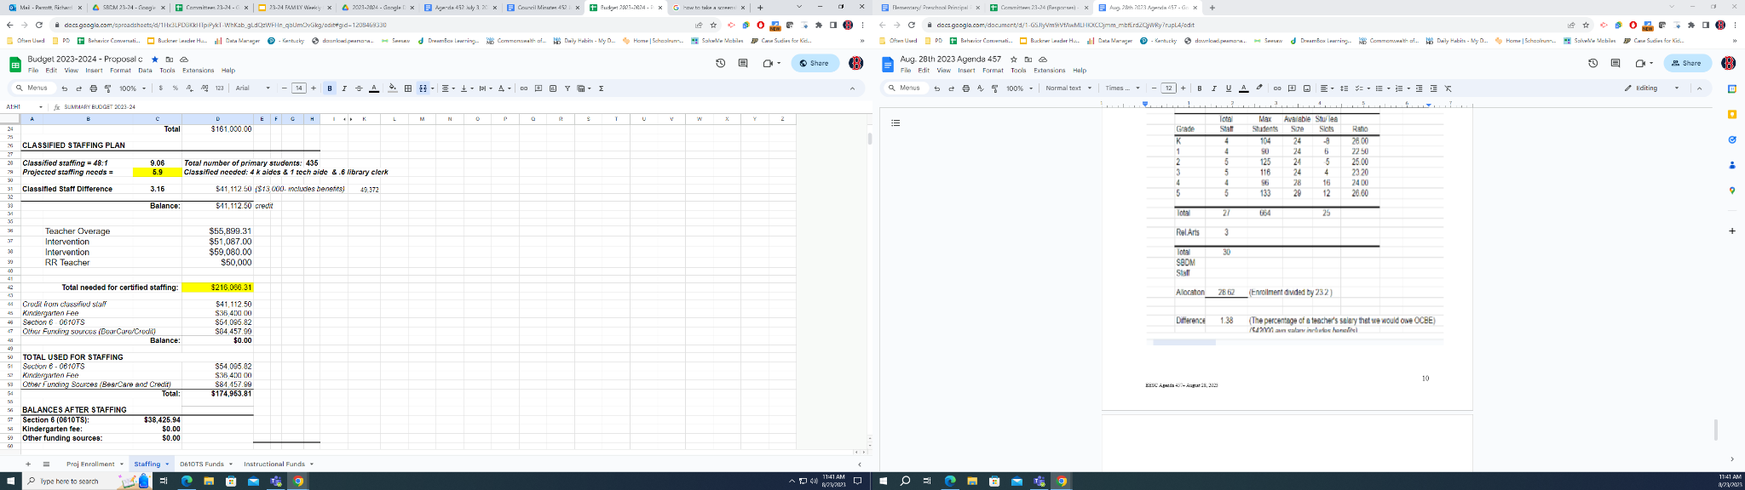

Enclosure B
August 28, 2023

Buckner Elementary School Council
Oldham County Schools

CONCERN:

Review the 23-24 Committee assignments.

DISCUSSION:

Discuss the committee and their purposes. Share the decision on certified placement and the opportunity offered to classified staff.

