Clayton Points of Pride
Quarter 4 Interim Assessment
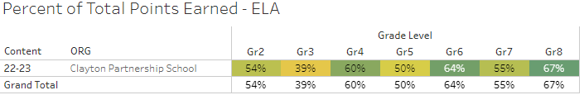
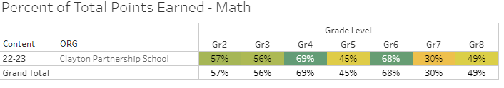
Cougar Pride New Traditions:
Volleyball Game: 8th Grade vs Teachers
You have pictures from Lorraine
4 Pillars of Pride Monthly Assemblies
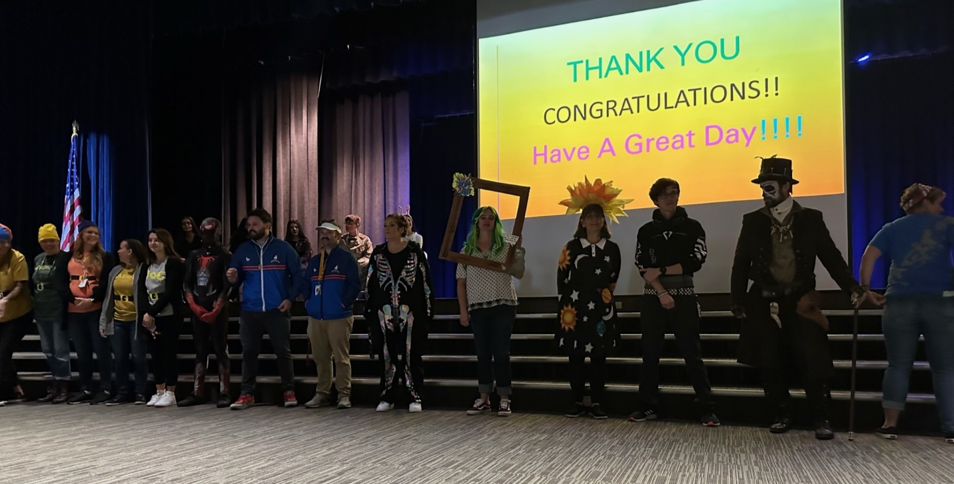
Student Council
