Dear Parent/Guardian, Date_______________

As recommended by the Virginia Board of Education, the York County School Division is sending home educational material for parents to identify the children grades 5, 7 & 9 who have abnormal curvature of the spine (scoliosis). According to current medical information, 7 to 10 of every 100 children may develop scoliosis; 1 to 3 of that group will require treatment. Scoliosis most commonly occurs in children 9-14 years of age. If the condition is detected early and appropriately treated, progressive spine deformity can be prevented.

If you are interested there is a simple procedure for screening in which the screener (Health Services personnel and/or the trained physical education teacher) looks at the child’s back while he or she is standing or in the forward bending position. Boys and girls will be screened separately in an area that accommodates the needs for privacy. It is recommended that students wear gym clothes. Boys should remove clothing above the waist and girls should wear a bra or swim suit top under their clothes.

Afterwards if your child has a possible curvature, you will be notified and asked to take your child to your primary healthcare provider for further evaluation and diagnosis. If your child is under active treatment for spinal problems and/or you have any questions about the screening process, please do not hesitate to call your school nurse.

If you want your child screened after reviewing the educational material please contact your School’s Nurse.

Sincerely,
_____________________________________
Health Services Personnel
_____________________________________
School 757-_______________
What is Scoliosis?
Scoliosis is an abnormal curvature of the spine. Named for a Greek word meaning “crookedness,” scoliosis refers to a curved or crooked back. It generally occurs in otherwise healthy children during the growth years, 10-15. Progressive curves occur more frequently in girls than in boys. Scoliosis tends to run in families and if scoliosis is diagnosed, other siblings should be evaluated. In most cases, the cause of scoliosis is unknown.
Why Screen for Scoliosis?
Screening is important in order to detect scoliosis at an early stage when treatment can be most effective. If untreated, the abnormal curvature may progress resulting in poor range of motion and endurance, back pain, deformity, and in severe cases, impairment of heart and lung function.
What is Scoliosis Screening?
The screening procedure is a simple, painless process which takes about 1 minute. Boys should stand with shirts off and girls may wear a halter top or bra. The screener observes the child’s spine, first in a standing position with arms hanging freely at the sides, and then with the child bending forward and away from the screener with arms extended toward the floor. If the child’s back, shoulders or hips seem uneven further evaluation is recommended. Only a Health Care Provider can diagnose scoliosis through examination and x-rays.
What are Potential Treatments?
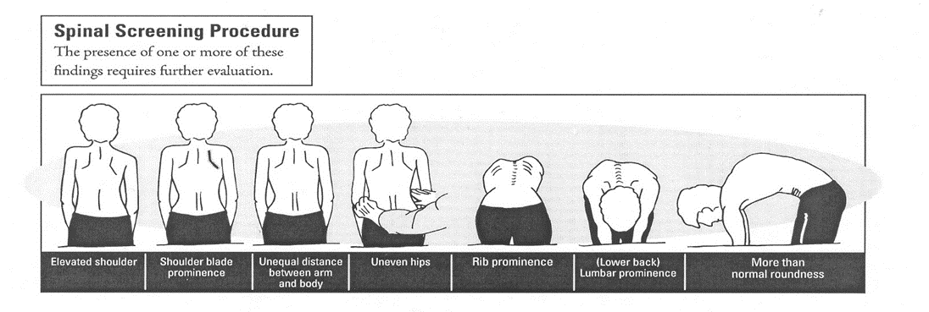
If a diagnosis of scoliosis is made, treatment options include exercise/physical therapy, bracing, and in severe cases, spinal surgery. Mild spinal curves often require no treatment.

