

Dartmouth Public Schools BYOD Wifi
How to connect to the BYOD Network

Connecting Your Personal Android Phone / Tablet
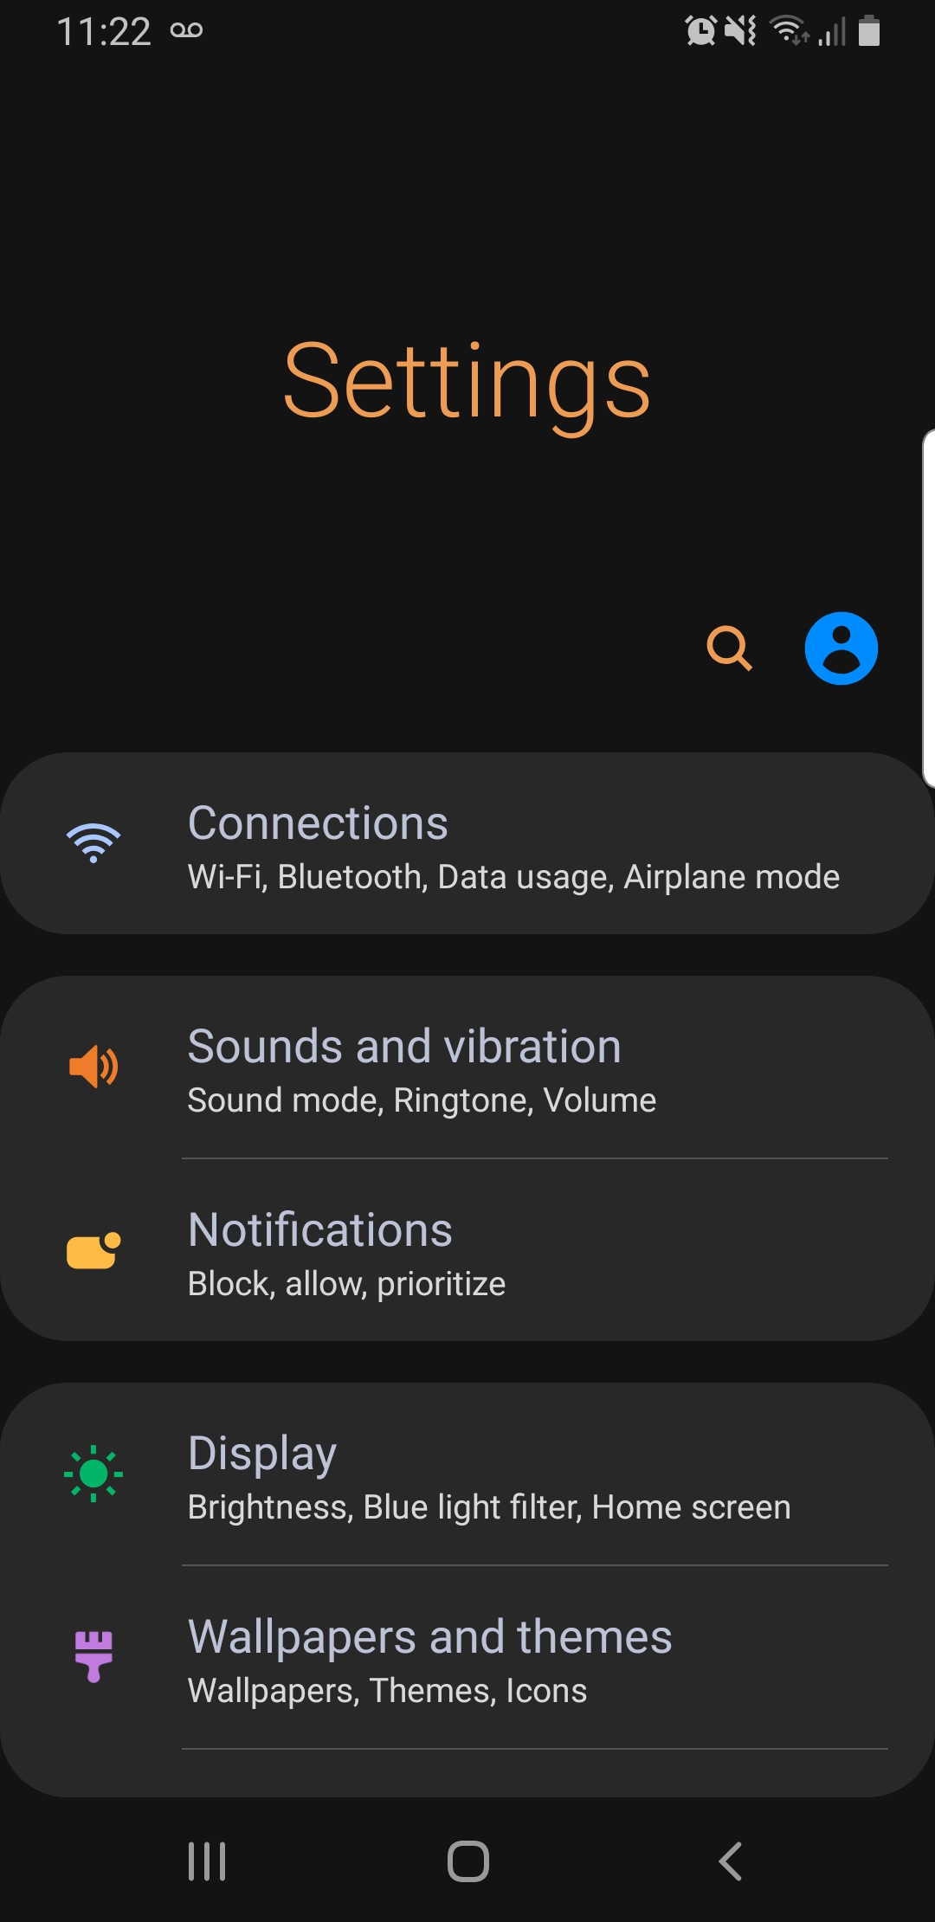
- Go to your Phone / Tablet Settings and select “Connections”
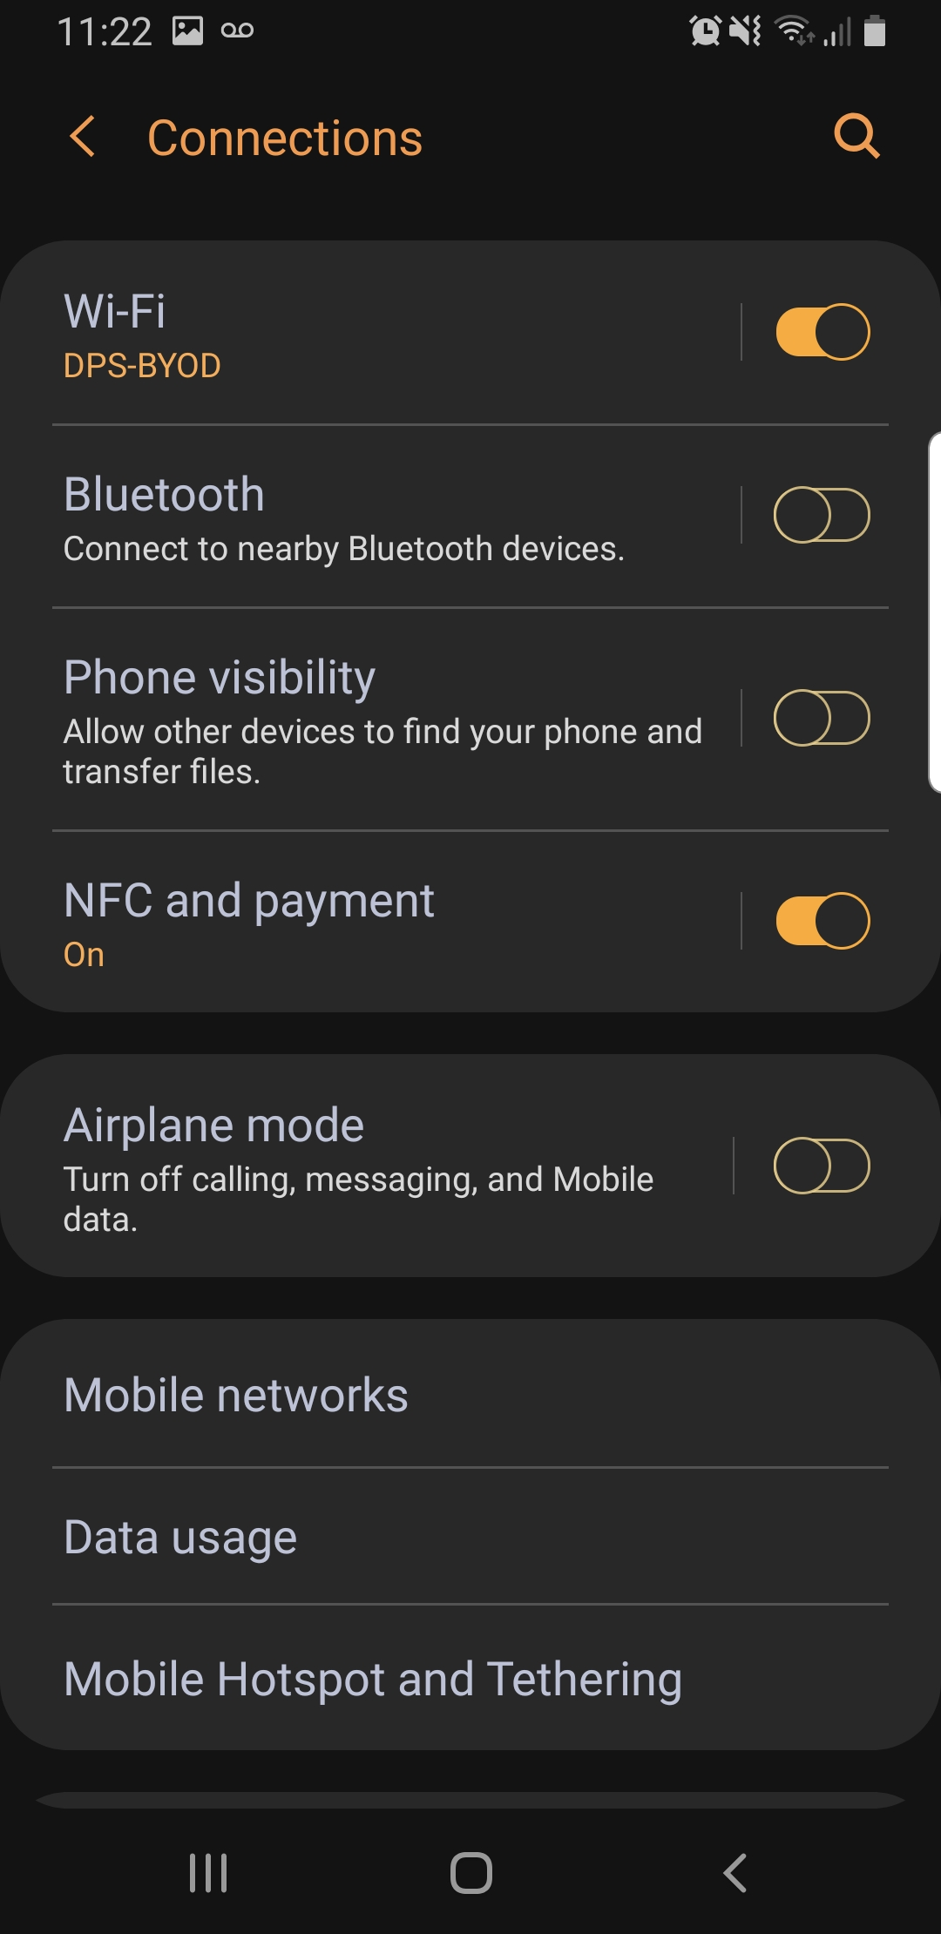
- In the Connections page Select “WiFi”
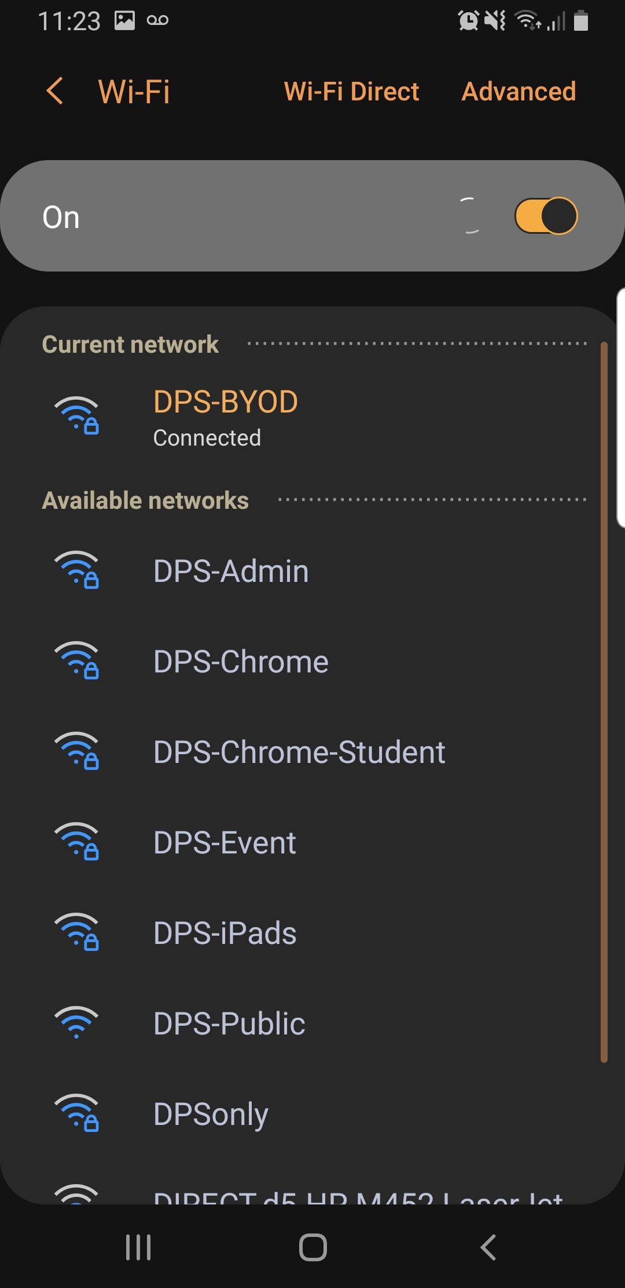
- Once you see the list of Wireless SSID (Wifi Names) Select “DPS-BYOD”
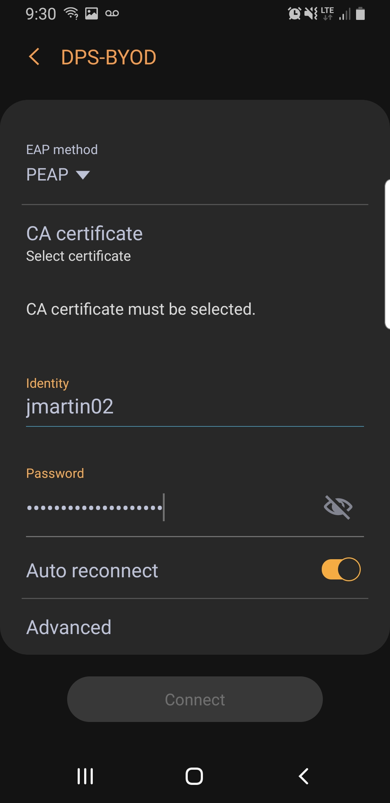
- You will then be asked to enter your user name and password (This is the same username and password as your Windows Laptop)
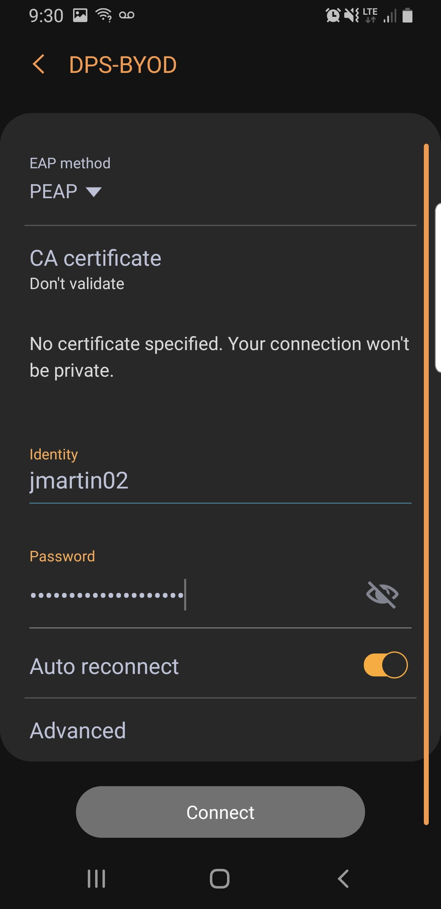
- VERY IMPORTANT STEP After entering your user name select CA certificate and change it to “Don’t Validate”
- Now Select Connect and you should now have access to the “DPS-BYOD” Wifi

Connecting Personal iPhone / iPad
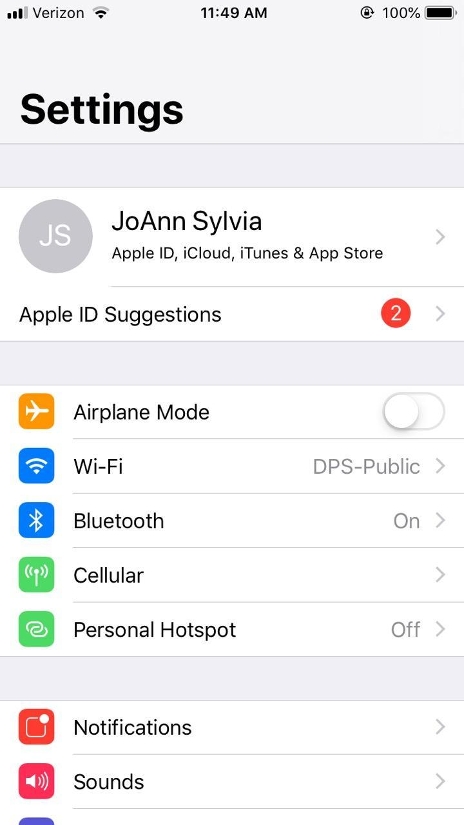
- Go to your Phone / Tablet Settings and select “Wifi”
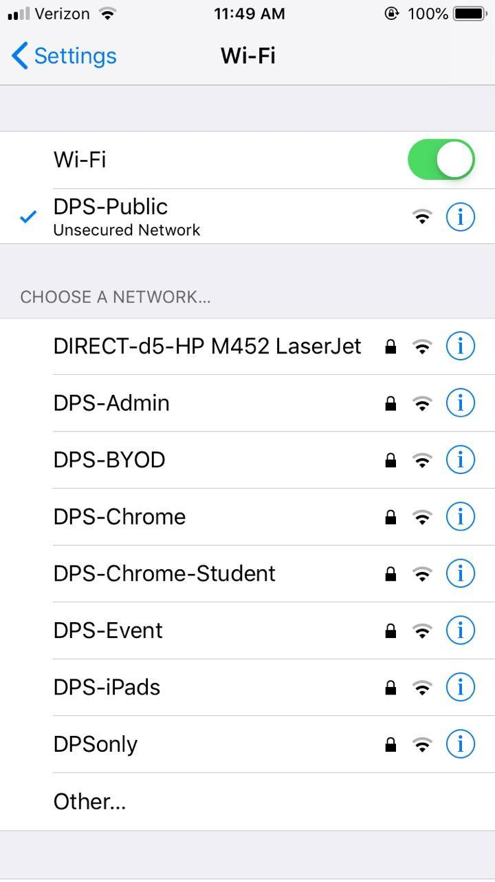
- Once you see the list of Wireless SSID (Wifi Names) Select “DPS-BYOD”
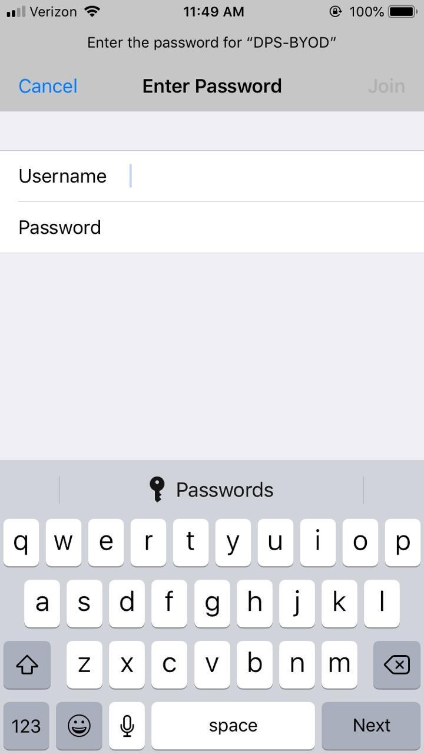
- You will then be asked to enter your user name and password (This is the same username and password as your Windows Laptop)
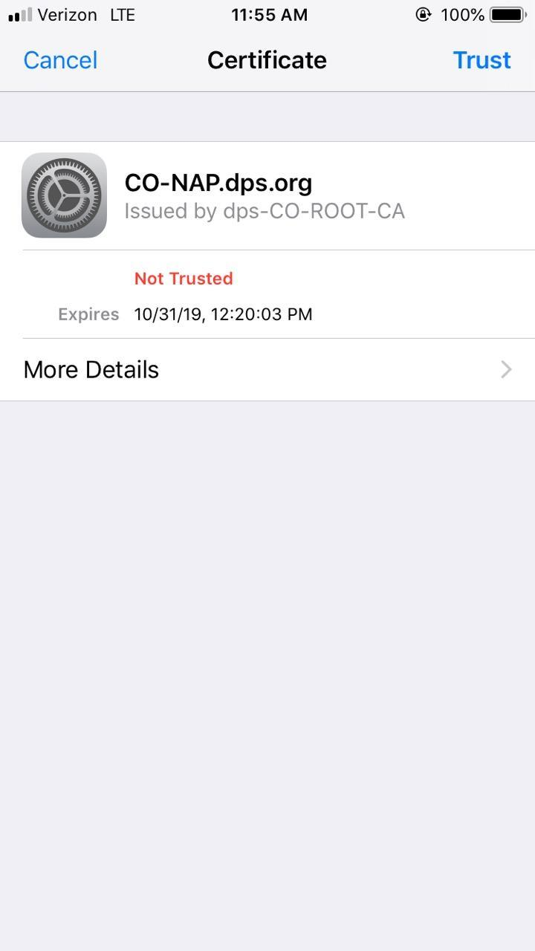
- Once you have entered your correct username and password in select “Join” in the top right. You will then be prompted about a certificate. Please select “Trust” in the top right of your screen.
- You should now have access to the “DPS-BYOD” Wifi

