
Cougar STAR
- Safe 
This Photo by Unknown Author is licensed under CC BY-NC
- Engage only in school-appropriate interactions

- Thoughtful 
- Consider how your words & actions affect others

- Accepting 
- Be kind to others and accept your differences

- Responsible 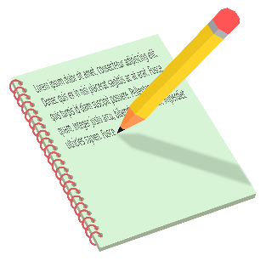
- Be on time, prepared, productive and engaged in learning
- Politely follow adult instructions

